EDITORIAL SEPTEMBER 1989

After a long spell typing out the Newsletter, with great faithfulness, Jackie has finally given up the task. At times she has found it difficult to fit in, but now, with further commitments, she has reluctantly admitted that she would like to be relieved of the job completely, and we have all agreed. Thanks Jackie, from all of us and especially me.

It is thanks to Susan Moody that we have some respectable typing this month, instead of my one-finger stuff, that always also requires half a pint of correcting fluid before it is fit to photocopy. Susan is the daughter of Club Members Leonard and Mabel Moody, who are well advanced with their Box restoration. Sue helped us out once before when we were in a spot and is a - proper typist,

Thank you, again, to contributors, especially Jane and David - and also to Glyn who reliably presents me with an interesting 'Secretarial' month after month without the Editor having to threaten blackmail or violence.

As I write it still looks and feels like Summer, but there are signs that Autumn is on the way. As some of our best Club Runs have been in the Autumn we will have much still to enjoy in the months ahead. This month's cover picture is of an Autumnal Scene which appeared on the cover of the 'Autocar' in October 1931. Bernie found the picture for us, but denies that that's him in the foreground in woolly trousers. I'm not so sure it isn't.

John

SECRETARIAL Hi Gang,

There was an excellent turn out of Austins for the concours of Dudsbury last Club Night, where we all parked on the lawn in front of the pub. It
is a beautiful setting though the weather, for a change, decided to be a little fickle. The landlady was pressed in to judge which car she liked the best, and would most like to own. First prize went to Paul Mainzer for his Chummy and second prize to Mr. Nunn with his Grasshopper Special.

The weather once again looked a little doubtful for our forest run last month, for whilst waiting at Ringwood Car Park the clouds turned black, and some hoods were rapidly put up; but thankfully it soon cleared and Brian Williams led us off on a pretty run through the forest lanes to Brockenhurst for coffee and then on to his lovely home in Burley, where we swam in his heated pool and got 'steamed' in his sauna - and on his champagne! Many thanks to Brian and Wanda for making us so welcome. -

The second run again found us meeting at Ringwood. This time in hot sunshine. Gary was our leader for the day and took us through very pretty villages and by-ways to The Cartwheel at Whitsbury where we all enjoyed an excellent lunch and a fine selection of ales. The walk afterwards helped the bread pudding to settle ready for the journey home.

Another trip I did in the Tickford last month was to Bedford, when I used it for my son's wedding. By taking out the passenger seat we managed to squeeze the bride and groom into the back; just. During a photo session in a local beauty spot there was another newly wed couple with a vintage Rolls Royce, a superb car, though the Austin got all the attention!

See you Club Night. Glyn

I don't quite know how I came to do the write up, but anyway -

THE EXTRA RUN TO BRIAN WILLIAMS' HOME SUNDAY 13th AUGUST

A bit cloudy here and there but we had sunshine all the way:: Well it seemed like it. The usual Ringwood (just made it in time) meet and off 'Can we stop for petrol'.' Guess who. Yes Dusty, no points given here as Bernie wanted petrol too.

A gentle meander through all those little lanes that I never know the names of, to forest views, horses and donkeys. The brilliance of the morning sunshine dancing over the heathers changing their colours in a flash. A most enjoyable drive and on to the well-timed coffee stop - The Cloud Hotel - where we met up with John and Gay. After being refreshed we proceeded via forest, the ornamental drive and Burley, to arrive at Brian's home. All safely in the drive and no trouble on the way. Now, the edited version of the rest

Have you ever watched Dallas?
Well it goes like this, you know the pool? (please use your imagination here::) around the pool the tables and chairs were set, the cushions plumped and the wine served and all that was left for us to do was begin the fun. All the children seemed to know this was the moment to enter (dive in) the pool. The picnic hampers were unpacked, the swimwear was on and it was contemplated either to swim and then eat, or eat and then swim - so we all did - both, that is - although I don't know who did what when. Not forgetting the constant supply of liquid refreshment!! Dusty so enjoyed his swimming lesson with the help and advice from all. His swimming award presented by Amy and Kimberley has taken pride of place on the mantelpiece; a treasured memento. Then there was the Sauna and/or Badminton, Oh! enough, enough, I hear you cry - so it only remains for me to say a very big THANK-YOU.

One of my dreams came true .... to drink champagne in a pool has been fulfilled.

Thank you to Brian and your family for a perfectly wonderful day.
Jane Whibley
P.S. Copyright, I should like to mention here, is definitely reserved on all photographic evidence (Why has Hilary gone on holiday and left me to explain all!!!)

AN AWFUL WARNING
A married couple drove into a shopping complex, only to have their car break down in the parking area. The husband told his wife to go on ahead and do the shopping whilst he fixed the car.

Some time later, the wife returned to find a small knot of tittering people surrounding her husband's vehicle. Looking down, she saw a pair of legs stretched out underneath the chassis, attired in shorts but no underpants.

Not to put too fine a point on it, things were visible. Unable to stand the embarrassment any longer, the wife dutifully stepped forward and promptly tucked everything back into place.

On regaining her feet, the wife looked across the car bonnet and found herself staring at her husband, standing idly by. The repair man had to have three stitches inserted in his head.

(Reprinted from A40 Car Club of Australia Newsletter)
THE WHITSBURY RUN 20th AUGUST 1989

Eight Austins and an XR3i assembled at Ringwood on a nice sunny morning for our run to Whitsbury. Gary had planned the route using a map so we were not sure exactly what we could expect.

With the roof down and sidescreens out we set off with the wind in our hair for an excellent run through the Dorset countryside going through villages including Edmondsham, Cranborne, Morten and Stratford Tony to our final watering hole being the Cartwheel at Whitsbury which was a very good choice of. pub.

The large selection of beers was very welcome. Several of us asked for pints of Broins which to anybody outside, would have sounded very strange.
The food was good apart from very mixed views on the bread and butter pudding. Glyn decided to embarrass himself by complaining to the landlord that the pool table did not work, only to find that the cost of a game of pool had increased by 507 since he last played for 30p. It reminds me of that story we hear so often, 'Did you know I learnt to drive in an Austin 7 when petrol was only 2 shillings a gallon:'

After lunch we went for a walk following closely a handwritten map prepared by Phil who was unfortunately not able to come on the run. The walk started by climbing a hill to see Whitsbury Church which was beautiful overlooking fields all around, We then walked around Whitsbury Stud Farm from where many prize winning racehorses have come. We finished with a meander through Whitsbury itself.

Thank you very much to Gary for organising such a good run and the weather - and to Phil for providing the map for such an enjoyable walk. .
David Jervis
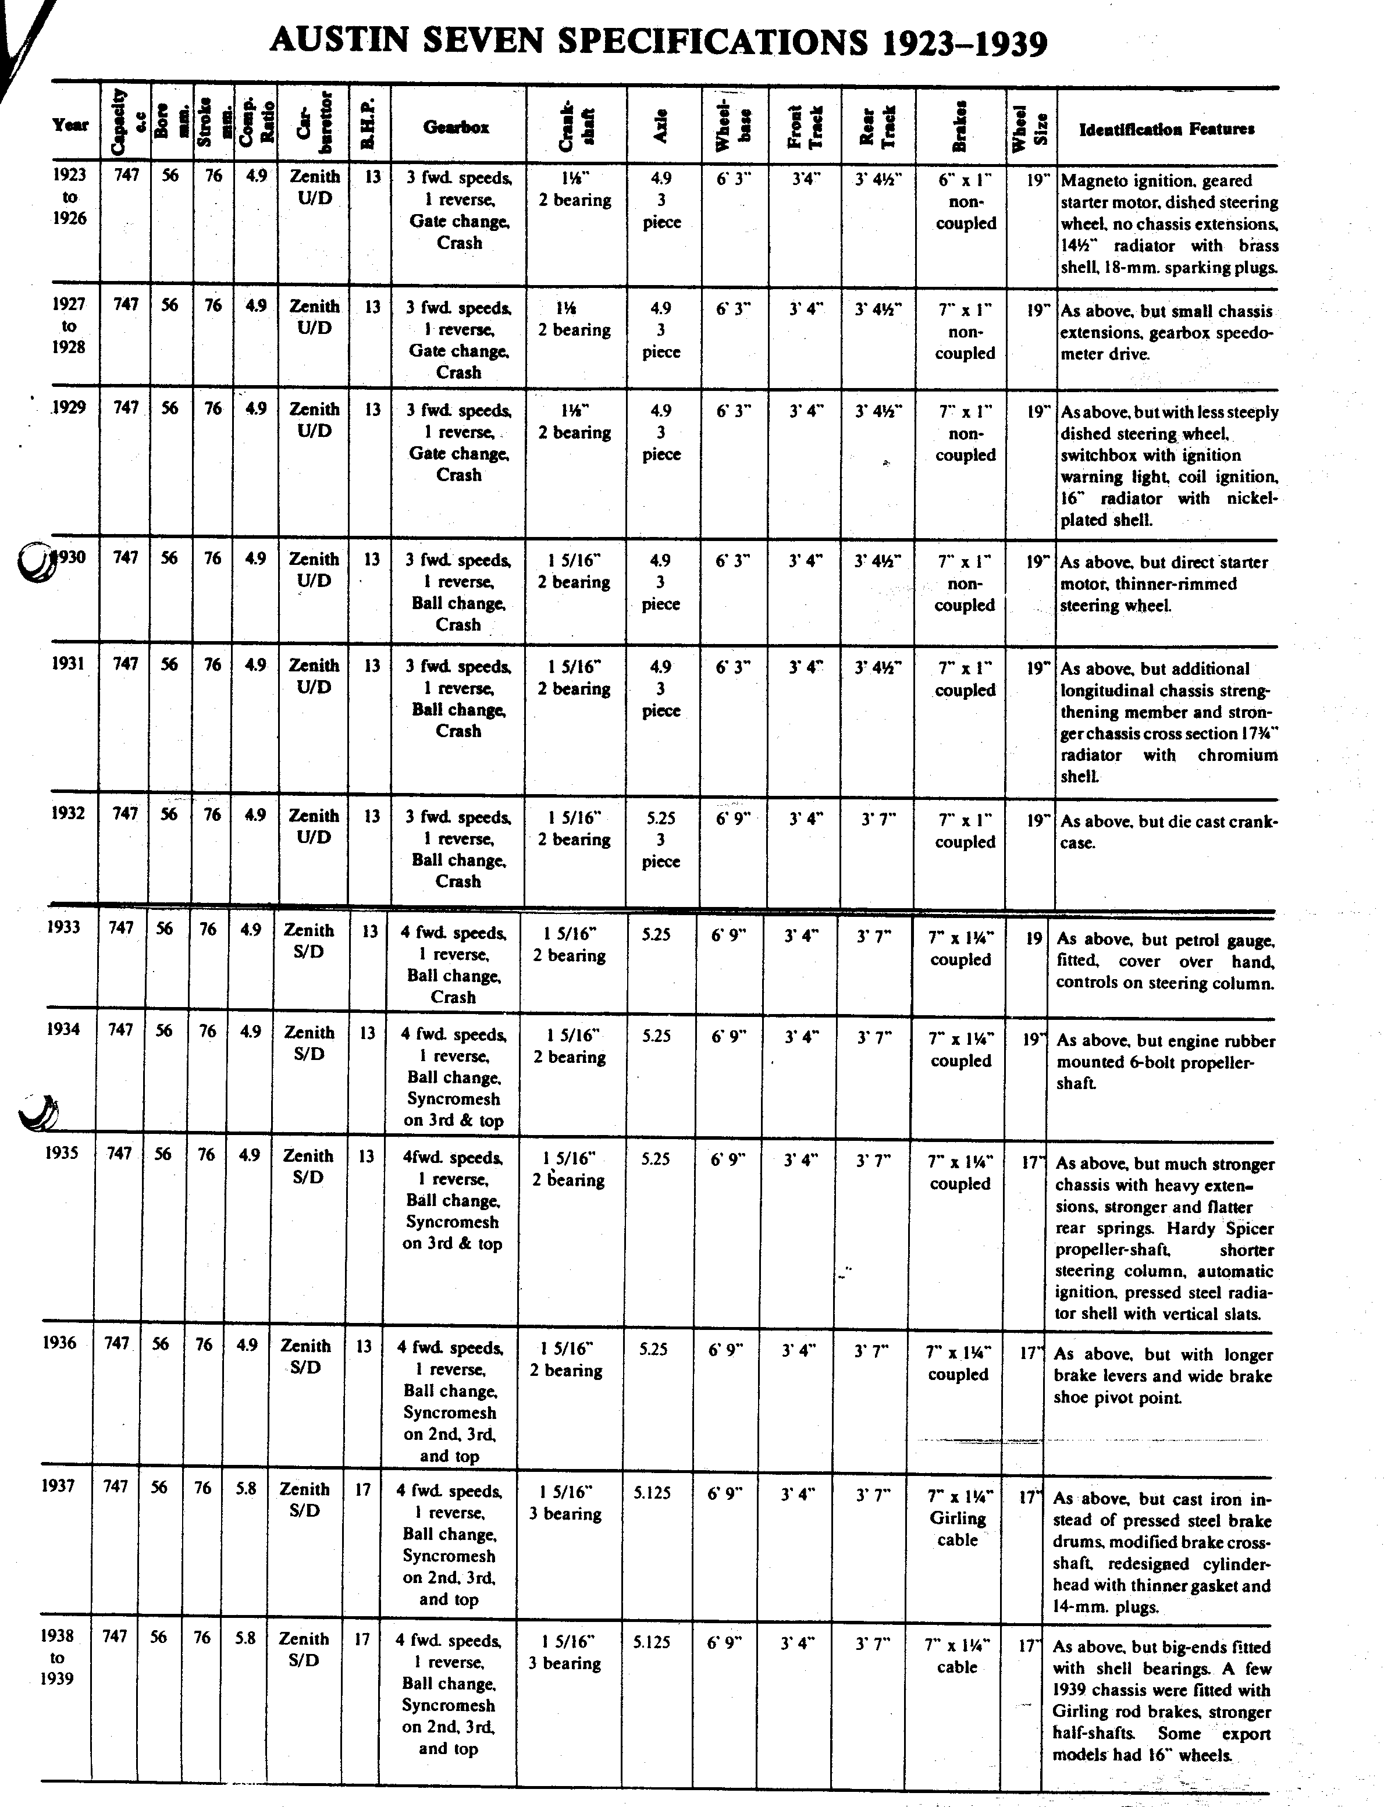

The old slogan still rings true - perhaps even more so today as more and more investors are acquiring post vintage cars. By all accounts Austin Seven prices are rising steadily. Think what your car could be worth in ten years time!
EVENTS

SEPTEMBER Thursday 21st September - CLUB NIGHT at The Dudsbury. Spares Evening . All Club spares plus a selection of second-hand items available. 8.00 p.m.

Sunday 24th September - CLUB RUN to West Dorset. Meet at Wimborne Square at 10.15 for 10.30 a.m.

OCTOBER Thursday 5th October -'9 to Late' - The Cottonwood Hotel,, East Cliff, Bournemouth. (For those who want to meet for a natter.)

Thursday 19th October - CLUB NIGHT - ANNUAL GENERAL MEETING., All Club Members are urged to attend. 8.00 p.m.

Sunday 22nd October - CLUB RUN to Sherborne + Cider still. Details next month.

FOR YOUR DIARY - PRELIMINARY NOTICE
Saturday 25th November - ANNUAL CLUB SKITTLES EVENING at The Monmouth Ash, Verwood - 7.30 p.m. Further details in the October Newsletter.

GOODS AND SERVICES
* MUNWELLYNS for all Austin 7 Mechanical and Electrical Re airs/Renovations ' Gary:Poole 683848 or Glyn:New Milton 613080

* BRAKE AND CLUTCH LININGS - 8 Brake Shoes £18 - Clutch Linings £14.50 ^ Bernard:Wimborne 88766 (Postage and-Packing £2.50)

• REGAR ENGINEERING for Crankshaft Regrinding,Con.Rod Remetaling, Rebores
, and General Machining. Columbia Road, Bournemouth - g 526866

* UPHOLSTERY AND TRIMMING - Colin Morris a Bournemouth 524671 ,

• CAR TRANSPORTER TRAILER AND 8'x4' BOX TRAILER FOR HIRE - Available with Towing Vehicle and Driver or Self Towing. Cheap Rates. 'Q Chris:Ringwood 478066

• STARTERS AND DYNAMOS overhauled by P.A.MacCarty - 35 Warwick Road, Boscombe. , OZ Bournemouth 421556

* KINGSTON RADIATOR REPAIR SERVICES LTD. = 20 Kingston Road, Southampton. Southampton 225959

DORSET AUSTIN 7 CLUB SWEATSHIRTS £8 -:TEESHIRTS £4.50 - CLUB TIES £4.50 , Contact Pat Llewellyn on Club Night.

(Mention Club when contacting any of these services)

