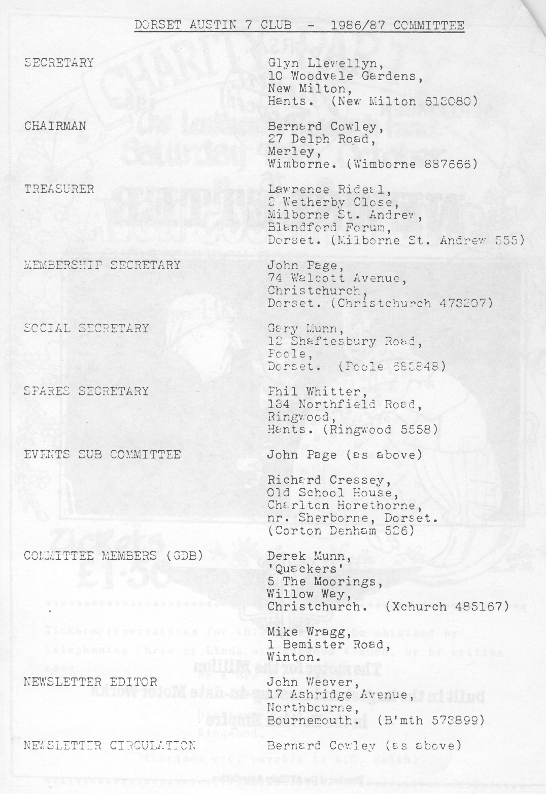
'EDITORIAL SEPTEMBER 1987

My first encounter with pure and uncontrolled rage and frustration was at the age of ten when I stood by as a friend attempted to repair
a puncture in the rear tyre of his brand new swanky bicycle. The first patch didn't take properly and this was compounded by the fact that the tyre lever split the inner tube as the outer cover was being replaced. Off came the tyre again and both the puncture and the split were then satisfactorily repaired, but the tyre lever did its dirty work again. On discovering this, after the outer cover was taken off for the third time, my friend changed colour several times, wept, spat, kicked me (for offering advice) and then hurled the bicycle into an innocent bed of flowers. It was an awesome sight and, I suppose, a fairly common happening still today.
I assume that hurling an Austin Seven is just about possible, but
., probably less common because it's easy to remove a wheel - even a rear one. I hope that this month's article on tyre maintenance, including
how to deal with a puncture, may help to protect wives, dogs, other living things and elderly vehicles from assault.
Life seems pretty hectic at this time of year with the various rallies, events and exhibitions plus the demands of house and garden. As I write Gay, and I are still drying out having survived the fourth day's weather at the Great Dorset Steam Fair at Stourpaine Bushes. It was the first
` time we had entered 'Gabrielle J.' and despite the final wet day enjoyed it very much. Dave Lovering and his team of helpers certainly made the running of the Vintage Vehicles section into an example of excellent organisation. The devotion, planning and sheer physical effort were plain to see and to good effect. Thanks, Dave and Co. on behalf of the 'Dorsets' who were there.
By the time this Newsletter reaches you the annual Beaulieu Autojumble
will have come and gone. Perhaps we might have news of purchases next month ?

John Weaver.
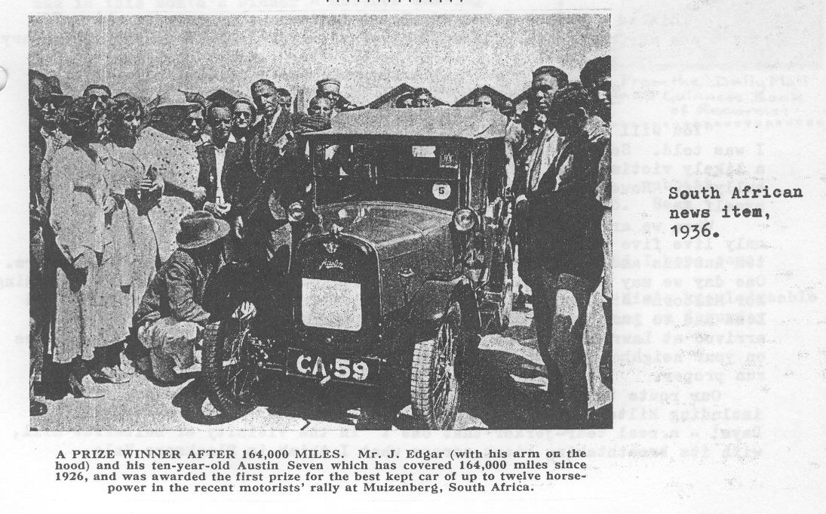
SECRETARIAL Hi Gang :

Gary and I went up to Birmingham to the Midlands A7 Club Rally at Longbridge the other week where we met Andrew Lowe who is casting our club car badges, and guess what ? Yes, I have a couple of samples. One can be seen on Club Night bolted on front of my Ruby: the other, guess where, bolted on the front of Gary's Box : Andrew says he would be prepared to cast them in lots of 24, as it is laborious work and he can't face doing 50 or 100 at a time. The price will be F,6. So if you want one see Gary or myself on Club Night with your money and we will get in an initial order.
We had a super turn out last Club Night for our run to the Royal Oak at Gorley where we were made most welcome by our hosts, the landlord and his wife. It was great to see Fred Bailey in his Box. He was telling me that he was worried about his charge rate and battery condition, so hope he made it home O.K. with the lights on.
The Club Run on Sunday 23rd was organised by Lawrence and Margaret whom we met at Lawrence's home after a short run from Wimborne Square. Unfortunately Lena and Gordon had to drop out before we got there as Gordon had brake problems. Hope the Ruby is O.K. now.
It won't be long to the A.G.M. We desperately need an Events Organiser,,_{,1} so give it some hard thought and if you are willing to help let me know.
Everyone seems to be selling Specials lately. Gary sold his the other day and Mike Wragg is selling his I understand.
This month's Club Night is back at the Elm Tree at Hightown for a Noggin and Natter and Spares Evening, so see you there.

Glyn.
New Club Members since August 1986

Welcome to :
J.Savage, L.Rumbol, A.Turner, P.Lloyd, J.Powell, S.Kane, J.Wilde, P.Adams, L.Cox, C.Nichols, L.Moody, M.Topham, J.Moss, J.Chesney, A,.Cross and D.Kydd O.B.E.

This is a rather belated welcome for some, but not for all. If there are any omissions please forgive and inform the Membership Secretary. ++++++++++++++++++++
THE NORTH/WEST/SOUTH DORSET RUN - 23RD AUGUST

"You will have to find someone to write a report on Sunday's Run,"
I was told. So armed with instructions as to the best way to 'persuade' a likely victim I set off confident that someone would succumb to my bullying. However, I failed miserably and here I am writing the report . myself :
When we arrived at Wimborne Square, last as usual, even though we
only live five minutes up the road, there was a very good turn out of
ten Austins and a Morgan - this month managing to almost block the Square. One day we may manage to block it completely : Our convoy set off, heading for Milborne St. Andrew to pick up our leader. Unfortunately Gordon and Lena had to turn back due to some brake trouble; but the remaining ten arrived at Lawrence's safely and after a demonstration of 'How to impress on your neighbours your great interest in Austin 7s' we set off on the run proper.
Our route took us through some very pretty countryside and villages including Milton Abbas, scene of the T.V. series 'To Serve Them All My Days' - a real tear-jerker that one 1 In the vicinity of Bulbarrow Hill, with its breathtaking views across what I think is Blackmore Vale,
Lawrence had found three really spectacular hills to climb up and down.
On one in particular I nearly put my foot through the floor doing my 'secondary braking' and showing my great faith in the Chummy's braking system. On the way down this one, trying to dodge the potholes, we passed a very surprised horseman. I think he was used to having this lane to himself. It's a good job you turned back Gordon - the consequences could have been tragic if your brakes had given up on that hill :! The weather was very kind to those of us enjoying open top motoring and we eventually arrived at the Brace of Pheasants at Plush for our lunch stop.
All having enjoyed a good meal in pleasant surroundings we set off again in the direction of Abbotsbury via Dorchester and the Hardy Monument. We had a short stop here, ate ice cream despite the chilling wind, looked at the panoramic view of Portland plus the Chesil Bank and viewed the rather ugly tower erected to the memory of Admiral Hardy of "...Kiss me Hardy" fame. It was a short drive down the hill to Abbotsbury village where we left the cars and had a much needed walk to work off the excesses of lunchtime. I really should not have had that fudge cake ! We viewed the ancient St. Catherine's Chapel from afar - as to reach it meant a steep climb uphill - and arrived eventually at the Chesil Bank. Some of our party braved the waves and paddled and got wet trousers but the majority sat, or rather flopped, and watched an approaching black raincloud over the sea, gathering their strength for the return walk.
On returning to the village we pressed on home, but I believe the
" others partook of cream teas to round off an enjoyable day. Thank you Lawrence for arranging a really lovely run. Also thanks to Mike for taking Clare as his passenger most of the day. She really enjoyed the ride apart from the cow muck that splattered up her arm. Oh, the joys of open-top
motoring !: ,
Competition Result
The second batch of ten radiators (August Newsletter) were even tougher to identify than those of the previous month. Despite this
Kim Reason managed to recognise seven correctly and is this month's winner - another amazing result ! Bill Quayle was still in the hunt coming a close second. I shall be calling for a dope test, of course.
Kim will be awarded the Radworld Stage Two
Challenge Cup. I believe that the All England Metal Detector Club is still searching for the Preliminary Cup and I'm sure that the Stage Two Cup will be with it when it's found.
' The correct answers were :
11. Alvis 12. Belsize 13. Horstman 14. Vulcan 15, cubbitt
16. Hispano-Suiza 17, Armstrong Siddeley (14 H.P.) 18. Bean 19. Arroll-Johnston 20. Vauxhall
Many thanks to Bill and Kim for their entries and I hope some others may have enjoyed the challenge.
Incidentally it was a pleasant surprise to hear Kim's knowledgeable
commentary on the Vintage Vehicles as they entered the ring on Saturday at Stourpaine.
TYRE MAINTENANCE_
T HE only regular attention required by the tyres is verification of the pressures so that the ill-effects of under-inflation, as described in our first article, are obviated.
The tyre pressures should be checked each week, without fail, with a gauge applied directly to the valves, and more air given if necessary to make up for the loss. We give a table of tyre pressures for all current Austin models.
Another attention which should be given fairly frequently is examination of the tyre treads for _{cuts} or embedded flints, which should be picked out before they work into the tyres.
The small cuts can be readily filled with a stopping compound, after being cleaned with petrol, but extensive cuts, or any incision deep enough to expose the cord foundation of the tyre, should be vulcanised, which is the work of an expert repairer with special equipment. This should be done as soon after discovery as possible, as the cords adjacent to the cut will rot if water is allowed to reach them.
Oil or grease, as mentioned in the previous article, is also harmful if allowed to remain on the tyres, and it should be promptly removed with petrol, sparingly used, for petrol itself is a solvent of rubber. Paraffin should not be used.
Although in these days it is rare to have two punctures in quick succession, to find the driver without a spare, it is as well for every owner to know_ how to repair a puncture should this emergency arise. But, before it is assumed that
'
a puncture is the cause of deflation, it is as well to examine the valve, as the valve-inside may be at fault, in which event the trouble can be easily remedied by fitting a new inside or turning it slightly so that it can make a new seating. This part, in any event, is likely to require replacement annually, and it is as well to have spares handy.
The valve-inside is easily unscrewed for removal, either by the slotted top of the valve cap, or by the special key provided, according to type.
If the valve seems to be in order examine the cover for visible signs of the puncture and, if located, mark the tyre wall for future reference.
Then unscrew the valve nut from the valve body and push the valve into the tyre. Unless the puncture is peculiarly placed, the outer edge of the tyre should be removed from the rim for access to the tube, as then the wheel will rest flat on the ground, with the hub centre uppermost, while the work is in progress. First break the contact of tyre and rim and work the tyre edges into the base of the rim at a point diametrically opposite the valve. The rim base serves as a reduced diameter and, on inserting a small tyre lever under the edge of the cover near the valve, the cover can be levered over the rim edge. Force, which might damage the cover, is quite unnecessary for this operation if the part of the cover diametrically opposite to the valve is kept well down in the rim base. The lever can next be worked round the rim to bring an
arc of the tyre cover outside until the rest of the cover edge can be pulled off by hand. The next requirement is to determine the location of the puncture, if not already discovered. The mark previously made on the tyre wall will help in this respect, but if the puncture is a slow one and cannot be detected with certainty, it may be necessary to inflate the tube and immerse it in water so that the leak is rendered apparent by the escaping bubbles. When a substantial puncture occurs, as from a nail or such-like, it is well to examine both sides of the tube, as there may be another puncture.
The actual preparation of the damaged area of the tube for the reception of the patch is best done with a wire brush or a piece of glass paper. In an emergency, the abrasive surface of the edge of a box of non-safety matches will do. This mechanical roughening of the surface of the rubber provides an excellent grip for the solutioned patch and will enable it to adhere more closely than when the surface is prepared merely by cleaning with petrol. The solution can then be applied evenly round the puncture, and if allowed to dry for five or ten minutes the adhesion of the patch will be so much the better.
After detaching its backing, curl the selected patch slightly so that its centre touches the middle of the solutioned area first. Then release the patch and press onto the tube with the thumbs working from the centre outwards.
When dusted with a little French chalk, the tube is ready for replacement in the cover,
providing the interior of the cover has been thoroughly examined and the puncturing agent located.
A bad gash in the tube should not be patched, but left to a vulcanising expert to repair.
The rubber rim band should be examined and replaced if it has been damaged by the spoke heads. Rusty places in the rim should be rubbed down and, if time permits, brushed over with a little black lead or graphite.
To reassemble, inflate the tyre slightly, replace the tyre valve through its hole in the rim and place the tube evenly inside. Then fit the edge of the cover starting from a point diametrically opposite the valve, again pushing it down into the base of the rim until the last inch or two of its periphery can be levered over the rim by the valve.
A glance round each side of the rim, pressing the tyre edge away from it, will reveal if the tube has been nipped and a bounce or two on the floor will allow the tube and cover to settle into their correct relative positions.
The guide rings on the outer walls of the tyre should then, as previously mentioned, be concentric with the wheel, and all that remains to be done is for the tube to be fully inflated to its correct pressure and the valve cap refitted.

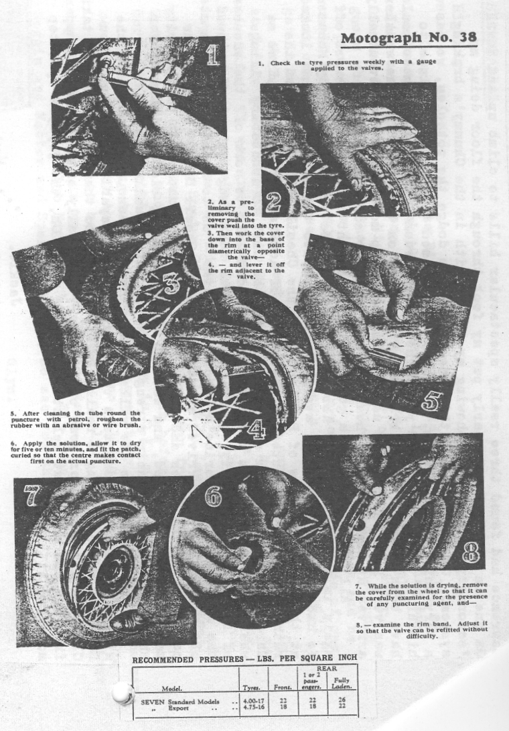
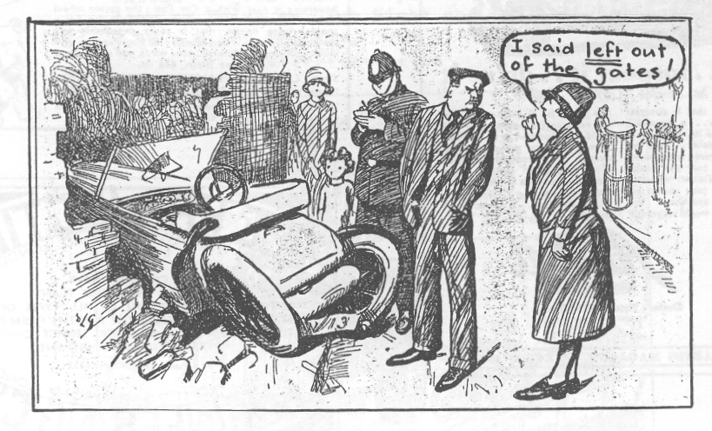
THE HALL AND WOODHOUSE BREWERY VISIT - 3RD SEPTEMBER

Now we know what it takes to prompt a mass turn out of club members I There were too many Club A7s and 'moderns* to count, certainly, at least, after the event. It was a long and eager stream of cars that left Wimborne Square and there were even others waiting at the brewery gates.
Our visit began with a detailed tour of the plant with an amiable guide who managed to confuse some of us completely as time went on, but who provided plenty of opportunities for us to wonder at the size and scope of one of our well-known local breweries and to poke our heads into some wondrously vast and yeasty spaces. Perhaps one of the greatest wonders was to look down on the enormous F* million canning plant which fills cans eight hundred times faster than G*r* and G*y* can empty one. Amazingly this complex was operated by only four men. We heard, among other things, of the artesian well beneath the site, of barley and mash, of yeast, fuggles and finings and we boggled at the thought of a storage tank (one of three) that held the equivalent _{of} 750 barrels of beer. As
a barrel _{equals} 36 gallons that tank would defy even the DA7C at its driest.
We heard the rueful story of the Customs and Excise and the enormous Government rake- off. Then after considering the importance of specific gravity we picked our way over some pipes and puddles and into the splendidly appointed hospitality room, complete with parquet flooring and BAR.
At this point the gathering became exceedingly vibrant with anticipation, but our guide, who must have been some kind of sadist, insisted on serving the ladies first - or at least he tried to S Just imagine, absent friend, here was a bar with an unrestricted supply of beer and no till !!
First I tried the Tanglefoot, but realising my responsibility to
sample a wider range of the brewery's products then went on to try some ....
lager ..., the name of which escapes me. I remember that it was a strong wun and was glad to be able to tern to the chiss and pikkled unions, wich with biskitts und crips were their fore our delite. Stranjely the noyse level went UP und as the bier continyude to floe peeple began to sit down hevily becos the flooor had begun to sloap and then o dear a grass slipt of the taible and bloke its self on the flor but no wun disgraced his self and even the grils nokking back the Stingos were a credit to the D¢AC A7D9 QR¢A RBA? D7AC. "Phew :" I went arfterwords "Phew :"
Thanks, Gary, for fixing up such a memorable (partly memorable) visit and to those who saw us home safely.
WE HEAR THAT somebody's renowned Talbot is up for sale. Surprise, surprise I

HAVE YOU HEARD about John Page's semi-automatic A7 ? Start
in 1st and it soon obligingly drops into 2nd. Change to 3rd or Reverse and the gravity feed comes in again. Need a qualified mechanic, John, or a super lightweight
. gear lever ?

DA7C LAPEL BADGES are now available from Bernard on Club Night at 40p, apiece.

HAVE YOU SEEN the new headlights on Nick Place's Nippy ? Very smart.

JUMBLE SALE ADDICTS please note that our Chairman is in need of a neat, second-hand leotard. Jackie reports that he is considering Keep Fit Classes.

B.S.F. BOLTS AND STUDS are hard to come by, but Barlow Fastenings, Nuffield Industrial Estate, Poole (near B & Q Auto) presently have a large stock of 1/4 and 5/16 to clear at Z3 per kilo. Gary can tell you more.

++++++++++++

WANTED An AUSTIN SEVEN PRODUCTION TOURER (1928 - 35) needing work or restoration.
Ring Gary Munn - Poole 683848 (Evenings).
++++++++++++
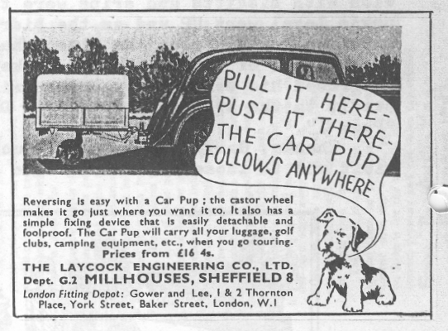
EVENTS SEPTEMBER
Thursday 17th Sept. *Club Night at the Elm Tree at 8.00 p.m. Noggin and Natter and Spares (including some additions).

Sunday 20th Sept. Club Run to Shaftesbury. Meet at Wimborne Square at 10.15 a.m, for 10.30 a.m. (details in the August Newsletter).
Thursday 24th Sept. Committee Meeting at the AVON CAUSEWAY 8.30 p.m. Note change of venue.

OCTOBER
Sunday 4th Oct. Extra Club Run (See details below).

Thursday _{15th} Oct. Club Night at the Elm Tree at 8.00 p.m. ANNUAL GENERAL MEETING - all members urged to attend.

Sunday 18th Oct. Club Run. 'A Wiltshire Wander'. Meet at the Furlong Car Park, Ringwood, at 10.15 a.m, for 10.30

Thursday 22nd Oct. Committee Meeting. 8.30 p.m.

Saturday 24th Oct. Charity Party/Disco in aid of Leukemia Appeal. 8 p.m. - 1 a.m. Avon Country Club.

NOVEMBER
Saturday 14th Nov. Preliminary Notice. Club Skittles Evening at the Old Barn Farm Inn. 8.00 p.m. Details next month.
+++++++++++++++
EXTRA RUN (See above) John Page and Brian Toalster are arranging
a Run on Sunday 4th October to Bath, with either a guided walking tour or an open top bus tour of the city. If you intend to join this run please state your preference to John or Brian on Club Night and meet at Wimborne Square at 9.30 a.m, on the day.
+++=+++++++++++
