NEWSLETTER
October 1998

The Dorset Austin Seven Club gives due notice of the 22nd.

AGM
8.30pm 15th. October 1998

Tyrrell’s ford hotel

The motor for the Million
Built in the largest and most up-to-date Motor Works in the British Empire

Member of the A7 Clubs Associati

DORSET AUSTIN SEVEN CLUB

COMMITTEE MEMBERS 1998
CONTENTS

Club Contacts 1
Editorial 2
Secretarial 2
Club Run 4
Letters Page 8
Committee Business 9
The Way We Were 9
Here & There 10
Future Events 11

FEATURES

AGM Agenda 3
Technical Torque 5
Pit Stop 7

Chairman Bernard Cowley
27 Delph Road, Merley
Wimborne, Dorset, BH21 1RS (01202 887666)

Secretary Glyn Llewellyn
10 Woodvale Gardens
New Milton, Hants, BH25 5EE (01425 613080)

Treasurer Lawrence Rideal
12 Redwood Close, Dibden Purlieu,
Southampton, Hants, SO4 5SN (01703 207191)

Membership John Page
Secretary 74 Walcott Avenue
Christchurch, Dorset, BH23 2NG (01202 473207)

Spares Phil Whitter
Secretary 134 Northfield Road
Ringwood, Hants, BH24 1SY (01425 475558)

Events Dusty Whibley
Secretary 1166 Ringwood Road, Bear Cross
Bournemouth, Dorset, BH11 9LG (01202 575167)

Newsletter Gary Munn
Distribution 12 Shaftesbury Road
Poole, Dorset, BH15 2LT (01202 683848)

General Pat Llewellyn
Committee 10 Woodvale Gardens
New Milton, Hants, BH25 5EE (01425 613080)

General Roger Ballard
Committee Kea House
Laverstock Pk.
Salisbury, Wilts, SP1 1QL (01722 323570)

General Mike Wragg
Assistance 67 Uplands Road, West Moors

CLUB NIGHTS
are held on the third Thursday of every month at The Tyrrell’s Ford Hotel, Avon (on the Ringwood/Christchurch Road)
B3347
& Raffles Ferndown, Dorset, (01202 895622)

Newsletter David Whetton
Editor 129 Lonnen Road,
Wimborne, Dorset (home: 01202 848743)
BH21 7AU (Fax: 01202 876661)
(Email: davidw@fernup.dorset.sch.uk)

Club Regalia Jackie Cowley (01202 887666)

LAST YEAR’S CUP WINNERS - PLEASE BRING THEM TO THE AGM!

EDITORIAL

COME COME COME to the AGM - SEE Lawrence perform the Treasurer’s Report, HEAR Phil review the massively successful spares department, RE-LIVE with Dusty the year’s activities, AMAZE as John once again explains how we have exactly 100 members every year and CHEER over the glittering prizes. Boy do we have fun? The agenda appears on page 3 and previous cup holders need to remember to bring back the silverware.

This month’s Newsletter once again resounds with Members’ activities and contributions. The letter page even features a photo! TECHNICAL TORQUE has gone back to basics, not so much for its technical contribution but more for historical interest. However, it might remind someone that a little overdue job awaits them in the garage! And to cheer up a dark Autumn evening there’s another contribution to the EMBARRASSING PICTURES series. (Any further contributions very welcome and always treated in confidence!) Following another successful BEAULIEU AUTOJUMBLE it is interesting to read the account Phil wrote for the Newsletter 21 years ago.

Finally, please remember to share with us your summer’s AUSTIN 7 activities - it could be an opportunity for your first contribution. Don’t always leave it to others.

David

PS: Note change in my E-mail address

Deadline for the next issue is 23/10/98 . Please send material to me by post, fax or E-mail (NEW ADDRESS) or pass it over at Clubnight.

SECRETARIAL

Hi Gang

Due to a holiday in North Wales, Pat and I missed the kite run organised by Bern and Jackie which I understand was rather wet but, going by the write up last month, was good fun.

Club night in September was a great evening with a forum hosted by our own Vince Leek. I learned a lot and was particularly interested in the section on the front axle and steering. Our editor arrived clutching a jar of horrible looking liquid which turned out to be a mixture of oil and water out of the sump of his Austin 7 Racer ! 'What's caused this"? he asked. It turned out to be a cracked block, but he hopes to keep it going long enough to race on 27th September. Good luck mate.

I had a telephone call from Holland the other day from a chap called Feiko De Vries It turned out that he has an Austin 7 Tickford but is missing all the Tickford bits and he wants photos so he can get them reproduced. Sounds a bit of a daunting task.

My Tickford has gone in for its new hood and the woodwork in the hood has also got to be replaced, but I still hope to have the car back in October sometime.

Don't forget that the October club night includes the AGM. Do come along and have your say. We also present the various club awards on this occasion. So if you won a cup last year, be sure to bring it back on club night.
Glyn

DORSET AUSTIN SEVEN CLUB - COMMITTEE

POST | CURRENT HOLDER
Chairman | Bernard Cowley
Secretary | Glyn Llewellyn
Treasurer | Lawrence Rideal
Membership Secretary | John Page
Spares Secretary | Phil Whitter
Events Secretary | VACANCY
Newsletter Distribution | Gary Munn
General Committee | Pat Llewellyn
General Committee | Roger Ballard
General Assistance & Raffles | Mike Wragg
Newsletter Editor | David Whetton

DORSET AUSTIN SEVEN CLUB
22nd AGM
15/10/98
8.30 pm Opening remarks Chairman
Officers’ reports
Secretary
Membership secretary
Spares secretary
Events secretary incl. Swanage Rally
Treasurer

Acceptance of Treasurer's report Chairman

Election of Officers

Presentation of cups nominated by the Committee:
Vic Steele Cup for the person who has done most for the Club
Ladies' Cup
Ballard Trophy for attendance at Club Runs
The Editor's Cup for contributions to the Newsletter

Closing remarks Chairman

Voting for the Bob Burrow's Cup "CLUBMAN OF THE YEAR"

oOo
RICHARD’S WILTSHIRE RUN
20th September 1998

Three Austin 7's left Wimborne quite early, so I'm told, on & beautiful September morning. It was the first Sunday of the Indian Summer of 1998 - Ben and Marion, Dusty and Jane with Sue and Brian all in their Boxes trundled along to the Mill at Sturminster Newton. There they were joined by Richard and Margaret, our organisers also in their box and Sue and Merv in the newly renovated VW Beetle

We took the main road from Sturminster Newton towards Marnhull and just past the cross- roads at East Stour went up Witch Lane. The sun grew warmer as we journeyed along the lanes to Madjeston, Eccliffe and Bugley. Richard stopped the procession to show us a quaint little church at Langham, it had a thatched roof.

Off we drove again around the outskirts of Gillingham through Milton-on-Stour to more leafy lanes to Mere. Then up a steep hill past some very unfit cyclists on some sponsored venture. Suddenly we turned left onto a farm track towards White Sheet Hill. The going was muddy and rough but the little Sevens and the Beetle were more than able to cope. We had an enjoyable but brief stop to watch the paragliders in the sunshine - Or were they kite flyers whose kites were out of control! There were model aircraft enthusiasts too enjoying the sunny day. The track improved as we went downhill and reached the pub – The Red Lion at Kilmington. We received a warm welcome and enjoyed the refreshing drinks and eats.

In the afternoon Richard led us to King Arthur’s Tower and we had a pleasant stroll through nearby woods. It was a lovely day’s outing, well organised by Richard and Margaret on a memorable September day at the end of Summer ’98 - the one that never was!

Sue and Merv Frampton
and many many thanks to too little-seen but well-loved Club “old timers” – Ed.
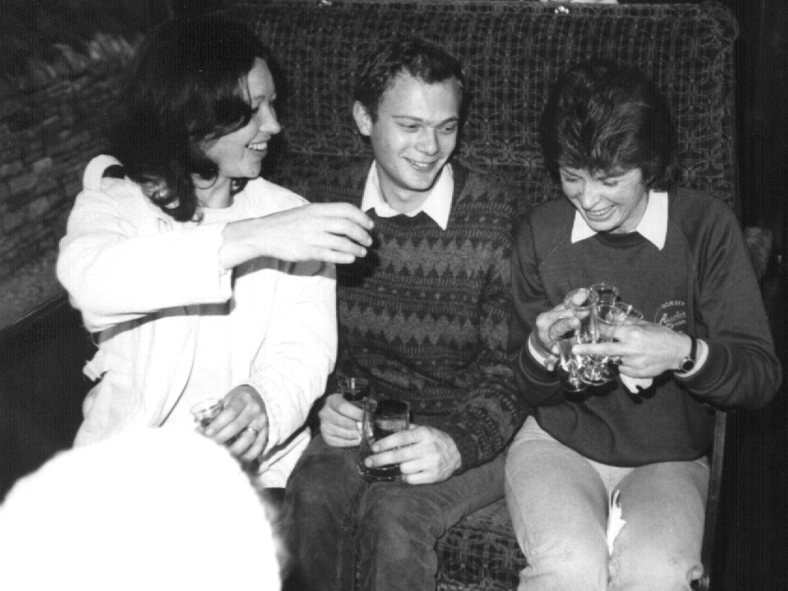
Club Embarrassing Picture No.2 ~ Does nothing change ???
Kindly provided by an anonymous donor.


“AUSTIN SEVEN LUBRICATION


SIMPLY EXPLAINED”

from a very early pamphlet probably sponsored by

(Loaned by Mr Books himself – Bernard.)
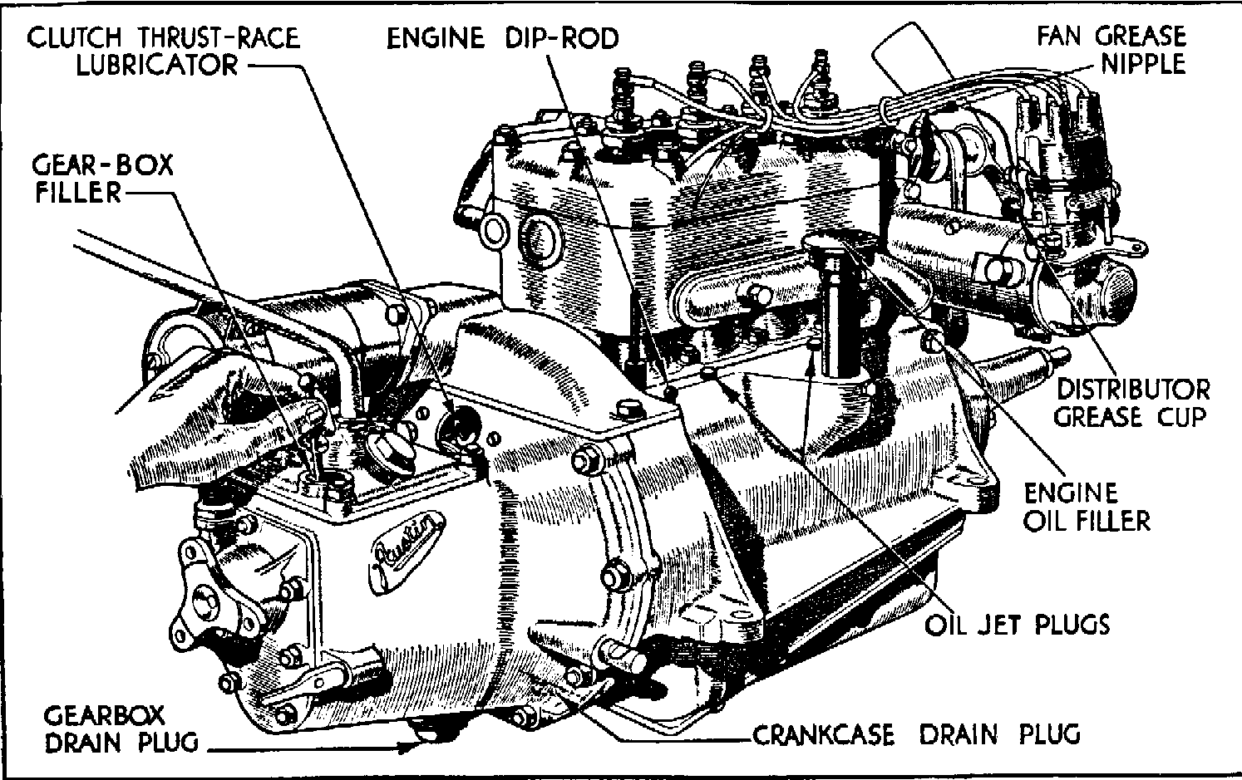
fig.1

For the Austin Seven the following Lubricants are approved by Austin Motors
Engine CASTROL XL.
Gear Box CASTROL XL.
Rear Axle.. CASTROL "D" Gear Oil.
Wheel Hubs Wakefield CASTROLEASE Medium.
Universal Joint CASTROL UNIJOYNT.
Chassis Grease & Gun Nipples CASTROLEASE Medium.
Electrical Equipment Wakefield OILIT.

Above are outlined the units which require periodical attention. These are dealt with separately in the following paragraphs, which deal with every detail of the Austin Seven Lubrication requirements.
continued .........

Engine.

Before starting the engine each day, check the oil level in the sump by means of the dip-rod provided and add CASTROL XL until oil reaches the "full" mark on the rod (Fig. 1) When your Austin Seven is new the crank-case should be drained after the first 500 miles running and replenished with fresh oil.

How to Drain the Crankcase.
Whilst the oil is still warm after a run remove the drain plug situated beneath the crankcase (Fig. 1) and allow the oil to drain off completely, then replace the plug and refill with fresh oil of correct grade as above.

Changing the oil.
Because even the best oil tends to become contaminated and diluted with fuel after it has been in use some time; it is necessary to drain the crankcase every 1,000 miles after the first 500, and replenish with fresh oil.

Cleaning the Oil Reservoir.
It is advisable every 3,000 miles to remove the lower half of the crankcase (or oil reservoir). The gauze oil tray will then be accessible. This should be removed and together with the oil reservoir scrupulously cleaned with paraffin or petrol. When replacing, carefully remake the oil-tight joint with the packing washer which should be covered with grease on both sides.

Oil Flow Indicator.
This is situated on the Instrument Board, and when the engine is running the button should always protrude under pressure of oil. If the button falls to protrude the engine should be immediately stopped and the cause ascertained.

Oil Jets.
Lubrication of the big ends is effected by oil forced from jets incorporated in the crankcase webs above the crankshaft. Every 1,000 miles use this method to ensure that the jets are clean: Remove the plugs situated over these jets and protruding above the cylinder head water jacket, and insert a stiff piece of wire not exceeding 1/16 in. diameter through the jets. Two of these plugs appear in Fig. 1, which illustrates their accessibility for this operation.

The Clutch.

Every 250 miles apply three or four drops of CASTROL XL to the clutch thrust race. To reach this swing back the oval clutch cover plate after loosening retaining screws (See Fig. 1).

It is well to remember that the clutch surfaces being of fabric material must be kept free from oil and grease, or clutch slip will soon be in evidence. For this reason care should be exercised when applying oil to the thrust race.

........... next month we move underneath the car

DORSET BOYS IN ACTION

AT SNETTERTON

PIT STOP

SNETTERTON is a long hard circuit for Sevens and the Paddock looked like a car-breaker’s at the lunch break. Dorset Dave’s championship rival, Graham Chambers, went out of practice with water in number 1 pot, changed head, gasket, several studs, carbs and exhaust manifold but only managed 3 laps in the afternoon. Even Vince, on a very welcome return to the circuits ON HIS 60TH BIRTHDAY, had the engine in bits managing a limp first in the afternoon. Boy racer Dave was running on neat Radweld due to a cracked block from Cadwell in spite of changing his Speedex head to a well-trimmed Ruby one and using lots of Instant Metal, Instant Gasket and Instant Silicon. In a closely contested race with late-returner Asplin, DD pressed him into outbraking himself at the chicane under the gasping spectators in the grandstand. Straight across the curbs and grass, flying and swerving like Toad of Toad Hall, Asplin’s distributor was shaken out of its socket and the way was clear. Unfortunately, in the penultimate race of the year with the Championship at stake, ED BRADLEY decided to have an outing in his Class A Ulster. Ed is so fast he races with the Lotuses and Skateboard boys and Our Boy was left with only 12 points after the race of his life.

Penelope Pitstop

750 TROPHY CHAMPIONSHIP TABLE AFTER 9 ROUNDS – BEST OF 8 RESULTS
Points  best of  8 | Class | Driver | Mallory  22/3/98 | Lydden  25/4/98  2 rounds | Mallory  31/5/98 | Pembrey  18/7/98  2 rounds | Cadwell  16/8/98  2 rounds | Snettert’n  26/9/98 | S'stone  17/10/98
84 | A | David Whetton | 10 | 20 | 9 | 20 | 22 | 12
80 | A | Graham Chambers | 1 | 26 | 13 | 26 | 13 | 1
31 | A | David Asplin | 12 | 18 |  |  |  | 1
32 | A | Ed Bradley | 16 |  |  |  |  | 16
10 | A | Graham Goode |  |  | 10
TEN THINGS A NIPPY OWNER OF 47 YEARS WOULD SAY

1. Weather guaranteed fine today. . we'll take her.

2. No. You should know by now we only take either the picnic basket or the camp stools.

3. Yes it’s windy... wear your Ena Sharples and goggles. Biggles always looked OK

4. No. It doesn’t matter that your track suit clashes with BRG. It's a car show not a floor show.

5. Yes, I know Gary and Glyn said the brakes are good, but just keep your foot hard under the rear wheel until I return.

6. What do you mean, now it's dark and raining harder can we have the windscreen closed, switch on the lights, use the wipers and put the hood up?

7. What wipers?

8. What lights ?

9. What hood ?

10. Of course I must leather her down and clean the engine and chassis BEFORE we eat.

Bill Quayle - who should know – in reply to Lawrence’s efforts last month. Any more anyone? - Ed.

Dear David,

Bernard’s kite flying and picnic run was not accompanied by the best of weather but it was very enjoyable all the same. There were many and varied kites which were flown before the rain really set in. We were forced to have our picnics in the cars (See photo). Afterwards, Bernard led us on a very scenic route through some wonderful Dorset countryside and villages finishing at a pub. By the time Marlies and I arrived home in Exeter we had covered 187 miles - an excellent Austin day. Thanks Bernard.
Richard Bishop
LETTER BOX



Policeman (to lady who has caused all the damage) : “Name please ?”
Lady driver : “Prudence”
COMMITTEE BUSINESS
By popular demand, BREAMORE is to be re-instated under the good offices of Roger Ballard! (But at a slightly different time of year now) Talking of Roger, it will be interesting to see who wins the new BALLARD TROPHY for the most number of Club Runs attended. The Xmas arrangements have been finalised and orders are now being taken by Pat. (See flyer with this newsletter – Ed.) The price of £15.95 per head includes a free raffle, free entertainment plus staff gratuities.

THE WAY WE WERE - a blast from the past
From the Club magazine for October 1977:

“It is now a year since we went official although, of course, the first meeting was in February 1976. It has been a year of steady growth with two road runs and membership has grown to 36. There is to be an Austin Seven Clubs Association meeting on 20th October and it is to be hoped that the DA7C will be voted into the Association. The magazine will be 75p per year if you wish to have it. At the AGM it will be proposed that the subs stay at £2 plus the optional 75p. - Bernard

BEAULIEU AUTOJUMBLE REPORT
After getting up at a ridiculous hour on Sunday Bernard and I set off with Pete in his Ruby and made good time to Beaulieu arriving in the queue at 8 am. Surely only the English would form a queue at that time in the morning! When we reached the entrance we were amazed at being asked £15 for entry but were a little happier when we learnt that we could get most of it back at 11 o'clock.
In a short time Bernard had picked up a pair of new C.A.V. headlamp fronts, a nice vacuum wiper and best or all a pair of unused early Chummy sidescreens, even with the XL part no. on the frames! By 10 o'clock all I had crossed off my list was a pair of scuttle vents.
It is interesting to see the changes that nave taken place at the autojumble over the last six years or so. Firstly it seems that a lot of useful stuff changes hands between stall holders on the Saturday when things are being set up. Secondly, the A7 spares available are mainly Ruby and it is difficult to find such parts as a gate box or C.A.V. dynamo as these type of spares are moved between club members, and never reach Beaulieu. I only managed to find one original Lucas headlamp out of 800 stalls. Who will pay £3 for four hose clips or even £l2 for an early carb? Vintage enthusiasts remember vintage prices and it is difficult to get them to part with a lot of money.
We all enjoy a bargain at the end of the day and a front axle for £1 is better than taking it home and surely this is what Autojumble is all about. - Phil Whitter”



NEW MEMBER
A big welcome to Alec Huet from Weymouth with his 1936 Opal. (Only the very best people have had Opals – Ed!)

FOR SALE
NEW TYRES 400x17 now back in stock (imported) £35; tubes for above £5; Tyre and tube purchased together £38.50; set of 5 tyres and tubes £185. Could deliver to Club Night - Vince Leek 01985-847658 (day) 01985-216632 (eve)

1938 RUBY blue, MOT, regular use, recon engine £3500 ono Gary Fatt 01202-572621

1927 REAR AXLE complete (except hubs) - ring Bernard 01202-887666.

oO CLUB DIARY Oo

October

Thursday 15th Oct. Club Night AGM and Awards . BE THERE!

AGM SPECIAL OFFERS

10% OFF SPARES

HALF PRICE REGALIA

(Stock Items Only – No Orders)

Sunday 18th Oct. Club Run & Treasure Hunt by Peter Treliving. 10.30am QE School, Wimborne finishing at the Fox at Ansty.

Thursday 22nd Oct. Committee Meeting. Tyrell's Ford

oO FUTURE EVENTS Oo

NOVEMBER

Thursday 5th Nov. 8 – til- Late Three Tuns Hotel, Bransgore.

Thursday 19th Nov. Club Night is AUCTION NIGHT. - Clean items only please, 10% of sales goes to Club Funds. Spares by prior arrangement only

Thursday 22nd. Nov. Glyn’s Club Run - Details later.

XMAS CALENDAR

December 3rd 8-til-Late
December 12th Club Xmas Dinner - see flyer this month.
December 17th Club Night – Noggin & Natter in the Bar
December 20th Club Run – Gary’s traditional pre-Xmas buzz
January 1st Glyn & Pat’s infamous New Year’s Day Treasure Hunt.



Happy Motoring

