EDITORIAL
Hello All,
What a varied year this has been! The Eurotour, JOGLE and sundry static rallies should have provided for all tastes. I hope that everyone has been able to enjoy this 70th anniversary of the Seven in their own way. The Dorset "year" closes with the AGM when members have their say in the running of the Club, the annual awards are handed out and plans for the coming year are made.
Those lucky enough to be at the last Club Night will have enjoyed Chris Wood's talk on transport in Bournemouth. The slides were excellent and the trolley buses brought back memories to many. I especially enjoyed the paddle steamers. Many thanks to the Bournemouth Vintage Transport Association.
The proceeds from the raffle that night were donated, as agreed, to Mervyn as a contribution to his fund raising for cancer and leukaemia research. Well done everyone. Full details will emerge on the epic trip to Spain, suffice to say here that Merv covered 1566 miles in 24 days and 5 hours, taking 11 days to reach Barcelona.
Club membership continues to grow and on your behalf, I would like to welcome Richard Donne, Andrew Walls, Mrs Jo Sunter and Peter Jones. I hope to meet you all at the AGM.

Lastly, reminder. I try to get this newsletter to the Phil the printer for the 1st Monday of the month which means if I haven't got your material by the Friday before, its too late! BFN, Miles.

SECRETARIAL

Well Folks,
Fresh back from Europe, what a great time we all had. Not exactly what I would call a holiday in the usual sense, extremely tiring at times, but I think we all agree we wouldn't have missed it for the world!
Many a breakdown in the first few days, I began to wonder if any of us would make it but luckily once the bad apples were sorted - as it were - not too many problems thereafter.
The hospitality of our European friends was great, many thanks to them all. You will be able to read more about our experiences elsewhere in the Newsletter.
I haven't heard any reports of Longbridge, unfortunately marred some what by awful weather - don't I know as we spent 10 hours on the ferry on the Sunday on what was supposed to be an hours gentle crossing - enough said!
Stalwart ex members David and Mary Jervis, sadly now up country, have given news of a recent offspring, Rachel Louise, 8 lbs 4 oz on 3rd September. Good on you both, you'll have to get the baby seat in the back of the Austin - teach 'em young!
We had a good skittles evening recently against the Bristol Club. They won this year but I think a bit of creative adding up was going on! Nice to see you all again.

Finally, congratulations to Mervyn on completing his marathon charity cycle ride to Barcelona and back. He's offered to share his experiences with us at a club night soon.

That's it for another month, See you all at the AGM,

Cheers Gary

BEAULIEU 30
Many years ago a local newspaper arts critic reported most favourably on the first night of the latest production to hit town, describing the play and performances in great detail. Unfortunately he didn't go - the theatre burnt down at half time and he got the sack!

Whilst I did go to Beaulieu I will confess now that I was only able to be there for a couple of hours in the morning and have relied on others to fill me in on the afternoon's activities. Strictly no dramatic invention on my part.

The day started cloudy but the weather improved gradually and temperatures rose. The turnout of cars was most impressive: Some Sevens had travelled vast distances across Europe to be there, others travelling vast distances across the New Forest. It was pleasing to see some favourites from previous years - I remember particularly the baker's van complete with crusty loaves and jam tarts and also to welcome the newer restorations together with the cars which have previously been kept under wraps. For the first time, I think for many years, there were 3 Swallows including a very presentable, and original, car from Jersey which still sported original lighting equipment and one tail lamp.

Spares were much in evidence as usual - I bought Doug Woodrow's hefty Austin Seven manual to brush up my own "expertise". They call it the idiot's guide and so far I'm getting on well with it!

Not a bad year's results-wise for the Dorsets:
Glyn Llewellyn - 1st Prize in Transport Class
Roger Ballard - 1st Prize in the Concours
Dusty Whibley's Team came somewhere in the Driving Tests.

Lawrence
Other Rally Successes

Dorsets have been very active again this season and a number of members have won prizes. Congratulations go to Arthur Cox who was awarded the Car of the Show title at the Purbeck rally for his immaculate Austin Heavy 12 Burnham and to Biddy Brown who took the Reliability Prize at the RNLI Run circuit of Middle Wallop. Several members also won awards at Spye Park but sadly, these results are not to hand at the time of writing. If you know of any other prize winners, please let me have details or photos at the next Club Night.

750 MC EUROTOUR 1992

Each of the participants on the Tour was provided with a short diary by the organizers and most kept some form of log of their journey. We are particularly fortunate that Glyn Llewellyn has made his notes available. You will see that to have kept notes after all the efforts of long day was a notable achievement. Now read on....

Day 1 - New Milton to Dover
The Tickford stood outside our house, loaded up in every nook and cranny with camping equipment, tools and spares, heavily down on the rear springs, as we awaited the arrival of the other Dorset members for the trip to Dover. Phil Whitter and phoned earlier to say that they and the Whibleys would make their own way as Dusty and Jane's dog Holly was in the act of giving birth!
Mike and Sue Topham in their Pearl Cabriolet were the first to arrive, closely followed by George and Joy Mooney in the Cambridge Special, then on the dot of 9.30 Gary and Paul arrived in the Special. We were to meet Bernard and Jackie en route at Cadnam.
The route to Dover was via Winchester, Petersfield, Midhurst, Billinghurst, Haywards Heath, Hythe and finally Dover. After lunch at Ansty, we arrived at the Castle Guest House, Dover, at around 6 pm.
Days Mileage – 186

Day 2 Dover/Ostende to Gent
After a good breakfast we all set off for the ferry to cross to Ostende, there seemed to be Austins appearing from all directions and we were soon shepherded together on the quay where Ken Cooke gave us last minute instructions and said a few words of thanks to the 750 MC members who had helped but were not going on the tour. Name badges and rally plaques were issued to everyone: suddenly we were off. The crossing was a good opportunity to meet our fellow travellers and make new friends as well as a study of the route book.
The scene at Ostende had to be seen to be believed! There were Austins everywhere, rushing about in different directions. Pat and I were to led the Dorsets on the first leg of the journey to Gent. Well, after going round Ostende a couple of times, a friendly taxi driver put us on the right road, passing through Brugge and on to Gent where we again became hopelessly lost. We were stopped in a lay-by when a kind Belgian gentleman in a Subaru pulled up and asked us if we were lost and could he help. He then led us around the City and right into the camp site, "what a very nice man!" This was a phrase that we were to use many times in the next two weeks.
A reception was held at the local Rover Dealers garage in the City centre where free drinks and bickies were available. We succeeded in getting lost again on the way back but eventually got to the camp site .
Days Mileage - 62. Total to date - 248
Day 3- Gent to Luxembourg

We left the camp site fairly early for the trip to Luxembourg, passing through Mons where we again got lost. Once more we were led through the city by another "very nice man" and then on through Beaumont where we had lunch. After lunch we started out for Phillipsville where we took a wrong turning and ended up crossing the frontier into France. This turned out to be a short cut and we shortly after re-crossed the border and rejoined the route. The scenery in this part of Belgium is not very impressive so after a short stop to look at a few shops and buy an ice cream, we pressed on into Luxembourg and the camp site where we had a good meal in the camp restaurant and the odd beer or two.
Days Mileage - 186. Total to date - 434

Day 4 Luxembourg
After a leisurely breakfast we motored into the city of Luxembourg to explore. We parked in a huge underground car park and then set off on a walking tour of the city. which was very clean and seemed very prosperous with lots of banks and financial institutions. The local people were very well dressed in expensive clothes. Before returning to the camp site we visited a supermarket where we stocked up with food, wine and beer for a Barbecue in the evening.

Day 5 - Luxembourg to Stuttgart
We were on the road bright and early for this long haul into Germany. The rain poured down as we made our way through the city and it wasn't until about 11 am that the sun appeared; it was soon lovely and hot. We had a picnic lunch and then continued to Muhlaken where a reception had been organised by the German Austin 7 Club, with free tea, coffee and gorgeous home made cakes.
After a very pleasant hour, we started off again and then while climbing a long, quite steep hill, Mike and Sue Topham pulled off the road signalling that there was a problem with the car. It was soon diagnosed that No 4 big end had gone, Mike had noticed high oil pressure earlier. There was nothing for it but to wait for one of the hack up vehicles to tow the car the remaining 30 miles to the camp site at Tubingen, just north of Stuttgart where we arrived in a thunderstorm, very tired at 10 pm.

Days Mileage - 210. Total to date - 644 To be continued next month
AUSTIN SEVEN BEGINNINGS - 26 - A Story of Austin Folk JANET AND JOHN STONE

Know car JD 5627, then you'll know John and Janet. Look back to a previous story (little job for a dark evening) and you'll see a mention of them and their two children having a cuppa with the Quayles and Browns on the return from Longbridge Rally of 1982. Had you been lucky enough to have been at Longbridge 1992 then you would have had tremendous admiration for these two, for not only did they camp in what could only be called 'weather most fowl' but emerged out of their wet cold tent in admirable bandbox condition, danced the night away and looking not a jot older than they did ten years ago! Good advert for Austin Sevening, don't you think?

But .... how did they become Austin Seveners in the first place? Another case of 'just happened to..' be camping at Lyndhurst at the same time as Austin folk who were heading to the Beaulieu July meeting. J and J just popped along to see what was what, chat to a few people etc, etc, got hooked and bought the inevitable 'box of bits'. Good fun except that it meant John taking up night classes of the 'learn-to-weld' variety; which in all honesty he didn't really have the time to do. Fortunately another 'just happened to' happened - this time in the guise of a meeting with Bernard Cowley who said ' I know a runner....' and Hey Presto; the non welded bits were sold off, Christmas card buying completely ignored despite the date being 19 December, and the 1935 Ruby was bought.

Janet, good lass that she is, refurbished the inside. Now we can all remember the famous What's my Line' and will no doubt recall the famous Sagger makers bottom knocker. Well, did you know that one has to get the sag just right in the door pocket of the Austin 7? Well, you do. Phil Whitter came along to aid and abet this perfection by lending Janet an authentic pocket for copying. As Janet says the first was just about 1/8" out on one of the seams ...but...the second was spot on! All seams, sags and bags in their proper place. Roof lining all immaculately executed, the seat upholstery likewise. In this case, Janet patched what she could of the original and refurbished what was too far gone.

The mechanical side demanded attention to things like back springs, crankcase, pistons etc. No problem for in John's capable hands it was Hey Presto, back in business. Good honest paid up members of Dorset Austin 7 Club. The whole thing had become a family venture with Karen and Peter, aged 6-.and 9 respectively being equally enthusiastic passengers, campers, ralliers, whatever family Austin Seveners are.

Some of you may well be saying that you cannot recall these good folk. That is because in 1983 they moved jobs and houses nearer to Bristol where they joined the local club. However, somehow their hearts are still with the Dorsets and about a year ago they rejoined us.

Never will they sell their Ruby but they are buy restoring a 1934 Box which they hope the children will be driving along side them in their rallying, camping and holidaying. Already the body has been off, ten coats of paint added.... you name it and its being lovingly done. As Janet says 'if it makes John happy, that's what its all about'. Also the whole family so it would seem. Isn't it one of the strong features of the Dorset Club, a family for all ages.

See you, John and Janet, at the next big Longbridge Rally, with two cars!

BB Sept 92
THE AUTUMN TREASURE HUNT

The September Club Run is often a treasure hunt and this year was no exception. Twelve teams turned out, Bob and friend in the Special, Joe and Maggie Stalker with their newly completed Box, the Tophams in their Pearl Cabriolet, Ben and Marion Trimby in their Box, Arthur Cox with the Heavy 12, the Wilbournes in their Box, John and Cynthia Page in the Pearl, Biddy and Gordon Brown in their pair of Rubies, Jane and Rebecca Symonds with their Opal, Scot and Michelle in the Ulster Rep and Bernard and Jackie Cowley in their modern. Keeping all more or less in order from the Morris Traveller was Hon Editor.

For a change, the weather was warm and sunny as everyone set off, puzzling over the cryptic clues and complicated route in search of feathers, beer mats and so forth. The route lead through some very pretty west Dorset countryside around Milton Abbas, with a call into the Fox at Ansty before doubling back through Blandford Forum to the Tarrant Keynston Fruit Farm. Few managed to get back in the time allowed and the organiser was beginning to worry about organising a search party but everyone eventually made it in the end.

Results were a bit mixed but the Pages emerged as clear winners with 96 points, the Wilbournes were second with 82 and Arthur Cox third with 70 points. Everyone else came fourth! The answers to all the questions will be available to contestants at the next Club Night. I just hope everyone enjoyed the run as much as I did setting it!

FOR SALE

Club Goodies

Sweat Shirts, Polo and Tee shirts are available from Margaret Seymour (phone number inside front cover). Sizes and colours to suit all ages and tastes.

Index to Association magazines 1980A to 1989D are. now available from Bernard. This excellent publication covers photos as well as articles, advertisers and authors, a really comprehensive reference to the second decade of the Assn Magazine. Absolutely essential to all Mastermind contestants and anyone who wants to get the better of Mervyn at Quiz Nights! Only £1.

FORD TRANSIT MOTOR CARAVAN
1977 (Petrol} Sheldon Hard Top - 2 Berth; Twin batteries, fridge, oven, hobs, grill. Portaloo and tent, water tank with electric pump to sink plus many extras. Entirely self contained. 20250 miles since replacement engine
£2350 ono Why pay more? Viewing welcomed. John and Gaye Weaver (0202) 573899 17 Ashridge Avenue, Northbourne, Bournemouth

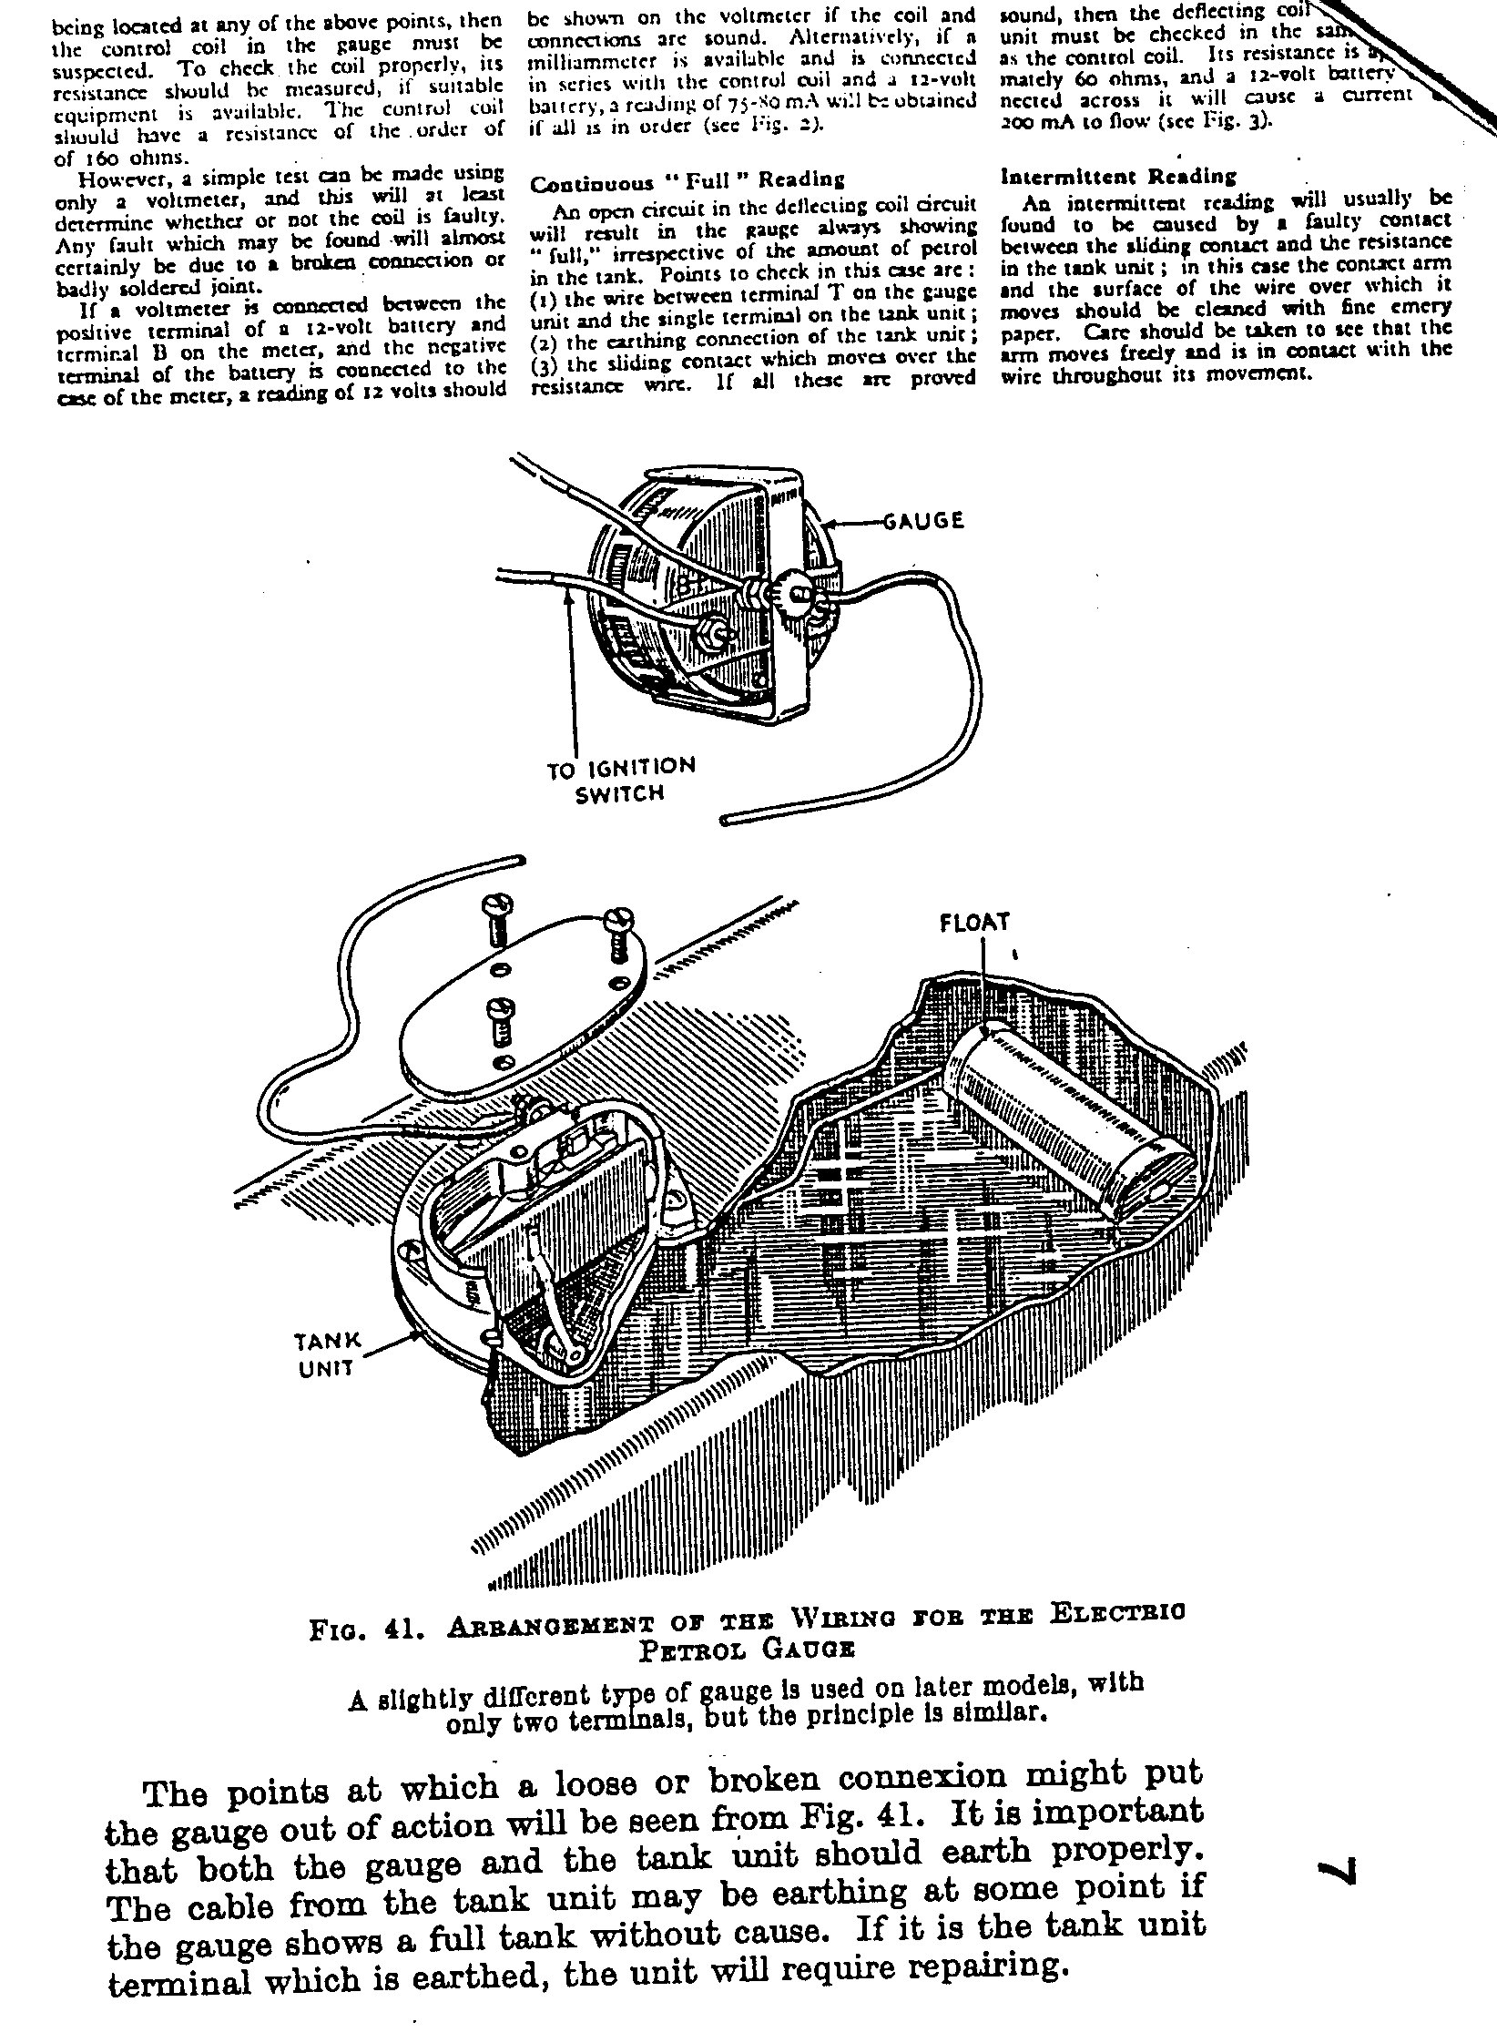
CLUB EVENTS

OCTOBER

Thursday 15 Oct Club Night. The Annual General Meeting will be held at the Elm Tree. Official business includes the election of the Clubman of the Year but should not take all evening! See notice on page XX. Spares will be available, too.

Sunday 18 Oct Club Run. Note revised start point and time. Meet at the Ringwood car park at 10.00 for a 10.15 sharp start. Ben Trimley and Brian Wilbourne are arranging a trip to Eling for look around this fascinating Tide Mill.

Thursday 22 Oct Committee Meeting. Tyrell's Ford 8.30 pm

NOVEMBER

Thursday 5 Nov Nine til Late. Those who meet up for a pint and a natter will be at the Coach and Horses, Poole Road.

Thursday 19 Nov Club Night. The Elm Tree will once again be the venue when Bernard and Phil will be running the Auction so dust off all those useful goodies to recycle.

Sunday 22 Nov Club Run. Meet at the Safeways car park, Wimborne, at 10.15 for a 10.30 start. John Page will be conducting the outing.

LOOKING AHEAD .

Saturday 12 Dec Christmas Dinner. The Club Christmas Dinner will be held at the Elm Tree on Sat 12 December. The cost is expected to be £12 per person, including wine. Full details and booking form next month.

EASTER 1993 Club Trip to France. A run to France is being arranged for next Easter. Leaving Poole on the evening of Thurs 8th April, spending 4 nights at Granville (approx 60 miles from Cherbourg) and return to Poole on the evening of Tue 13th April. Approx cost is £110 per person for 2 people and car with 4 nights B&B in a 2 star hotel. Onboard accommodation is £10 per berth or £3 per reclining chair. Anyone seriously interested please contact John Page on 0202 473207 ASAP. Booking have to be made soon to be sure of
reserving accommodation at this busy time.

-000-

OTHER EVENTS
Sunday 14 Nov FBHVC Annual General Meeting. Held at the RREC Centre at Towcester. I will be attending to represent the Club but if you wish to attend as an observer, please let me know by 20 Oct.

