EDITORIAL OCTOBER 1991 Many of us have insured our A7s through the Association scheme with the Richardson Hosken Group. Some kind person recently sent me a clutch of MA7C Newsletters and in one of them I learnt that there had been some concern over the Insurers' instruction that the car 'must be kept in a locked garage.' No problem at home, perhaps, but what about attendance at rallies etc., which require a stay overnight? In response to an enquiry the Insurers say!
"We would advise that it is a condition of the policy for the vehicle to be garaged at all times whilst at the home address. However, it is appreciated that whilst on the course of a journey or on holiday it may not be possible for you to do so. In these circumstances Underwriters request that every precaution is taken to immobilise and safeguard the vehicle against theft." You have been warned!

In another of the Midland Newsletters was an article on the electric petrol gauge. If yours is like mine it often requires threats and kicks to keep it going. That article (it could be helpful) is within, plus all the usual features and two interesting offerings by Phil.

See you at the A.G.M.!

John
NOVEMBER NEWSLETTER
Items welcome by
28th October

Yet another rally season nearly over. It doesn't seem five minutes ago that it was all just starting.

But don't forget your Club continues its activities throughout the winter with a Sunday run after each Club Night, and will no doubt organise several super social events. Keep your eyes on the Newsletter.

Talking of Club Meetings, this month's is the A.G.M., when your vote is
important so please try to attend. We now have three Club trophies to hand out: the usual Bob Burrows for Clubman (person?) of the year (please give this some thought), plus two more recent additions from dear old Vic Steele, one for Lady Member Driver of the Year and another to be awarded to the person who we feel has achieved the best project of the Year. Your Committee will come up with some ideas and sound them to you on the night. So please give this some thought.

Next year should be very interesting as it marks a milestone for our cars, with I believe several large static rallies and some long hauls. Keep your eyes peeled.

I have decided to spend the winter constructing a special - if anyone knows of a rolling chassis, or part of one for sale, I would like to hear from you.

Enough of the adverts, must sign off now and get back to my pint. See you Club Night.

Gary
2
Pat and I in the Nippy, followed by Brian Clapperton in his Ford Corsair (his Rid Saloon is not finished yet), set off on a bright Sunday morning to join the other 'Dorsets' at the Cat and Fiddle, Hinton for a Run through the Hampshire countryside. On arrival we joined Bob Stanley, John and Cynthia Page, George and Joy (Pegleg) Mooney, Gordon and Biddy Brown, Gary Capon with son Luke and Ben and Marion.
We had to leave the Cat and Fiddle promptly at 10 o'clock in order to meet
our leader for the day, Lawrence Rideal with son Guy, at Swan Green, Lyndhurst. On then via leafy lanes through Emery Down and Minstead, the sky growing ever darker. Biddy stopped to put up the hood on the Opal. I thought that it would only be a short shower and decided not to bother with ours, but guess what, the rain came down like stair rods and soaked through, unable to see, I managed to find the side of the road and stop to put up the very tatty rag of a hood on the Nippy. "Well it should keep the worst off", I explained as we set off again, yes, in blazing sunshine - it had stopped raining!
On then through Romsey and skirting Winchester up and down some steep hills and through very picturesque countryside, we suddenly came upon a sight to excite any 'Sevener', a very deep ford. Pat and I watched as John and Cyn Page in their Box slowly sank from sight before appearing on the other side. Oh well, we're already wet so go for it, I thought. In we went, rubber mats and carpets floating around our knees, to appear on the other side with water pouring out of the doors and all other orifices! We jumped out and rushed back to watch the others. We were secretly hoping that someone would get stuck in the middle and have to get out and rush. Of course not, perish the thought. We all got through safely, even the Corsair with its strange V4 engine didn't miss a beat. Just around the next bend we came across the Bush Inn, Ovington our chosen lunch stop.
We piled into the bar and I overheard the barman telling John Page that they had no beer!! You can imagine my feelings. "Good job Bernard's not here", Pat said. Anyway one look at our faces and the bar staff somehow managed to get some barrels fitted up and all was well. Phew, a close call that. There were no tables free inside as they had all been reserved so as the sun was shining we all trooped out into the garden where there were plenty of tables. The food was very expensive so the men got together and decided that the women could cook Sunday lunch in the evening when we got back and that a snack would do - along with a drop of liquid refreshment.
Suitably refreshed we piled back into the cars for the short Run to Alresford Station and the Watercress Line Steam Railway. The party now split into two: one half to visit local interests and the other for a trip to Ropley on the steam train, honing to visit the engine sheds there. Owing to new health and safety regulations we were unable to go into the engine sheds however, so we contented ourselves with a walk around the rolling stock before our return trip to Alresford and the cars, whence we made our ways home.
An extremely enjoyable day. Many thanks Lawrence. Glyn.

Beaulieu Autojumble Report
If soon comes around again and perhaps with thought of bargains to be had in the recession many of us repeated our annual pilgrimage to Lord Montague's principal money spinner.
In terms of the number of people there, the weather must have helped to break all records, but in terms of Austin 7 goodies most prices were high and some were even laughable - did you see the restored two bearing engine on a stand for £1,200? the box chassis for £700? or perhaps you also picked up a rusty block in the bottom of the motorcycle field which was £50!
Austin 7 parts at Beaulieu are becoming increasingly difficult to find - you are probably better off at one of the large Austin 7 rallies.
In the more realistic range, I saw a complete working mag. engine for £200, I bought a closed centre wheel for £15, but had to pay £37 for a Chummy dynamo (but it did have a new armature with it!)

Other prices noted were a coil engine for £60, a few crankcases at £15 each, and a pair of Chummy headlights minus rims for £15.
I went there primarily to buy firstly an overtaking (who overtakes in an Austin 7!) mirror for the Chummy (found one from a 1926 Morris - brand new - very expensive!) and secondly electrical spares for the Club.
I found some dynamo brushes for Rubies and a few Box rotor arms, but I was unable to find any condensers, so if any of you out there have any surplus stocks of early or late condensers, the Club will pay you £2 each for them.

Well that's all for now,
Happy spares hunting,
Phil Whitter

WANTED
A box-type trailer up to 4' 6". Second hand MIG and tools.
Ring David Whetton (0202) 520507 mm
SUE WHETTON has joined the jolly band of car restorers, according to David, by starting on a very dilapidated Vitesse 2 litre convertible.
She needs a decent bonnet. If anyone can help please ring Sue, as above.

MIKE WRAGG continues to make the monthly raffle a success and we are grateful to him. Likewise, Mike has particularly asked that we thank those Club Members who have contributed prizes. He says that we have recently had some particularly generous offerings. Anyone, of course, can donate raffle prizes - they will always be welcome.

WELCOME to new Club Members R. Day and A. Fairbrother. Be sure to make yourselves known at Club Meetings. Our Membership continues to grow.
AUSTIN SEVEN BEGINNINGS – 13 A story of Austin folk.
Marion & Ben Trimby
Very proud owners of 1933 Longbase Box YD 8341, Just how did they get involved/started?.
Ben had sadly been made redundant, that is the first time around, for life has sadly recently repeated itself. However the silver lining to the first occasion was that he then got a job with Poole Council. His boss travelled weekly from Essex where he owned and garaged a 1934 Austin 10 and a 1936 Talbot AND then bought YD 8341 for running around this area during the week! Through the office window, Ben saw and coveted the car to such an extent that he asked Marion what she thought about his buying an old car. Marion assured him that he could do whatever he pleased with his own money. (Permission to live, what!!) Nothing came of the idea.... until his boss let it be known that he had one car too many! the Austin. Ben could not believe his luck quickly becoming the very proud, not to say amazed, owner of the one car that he had come to so admire.
"I'll give you some idea of just how much he thinks of that car" says Marion laughing affectionately in her normal jolly fashion. "After he had been made redundant for the second time, the family were having a heartfelt discussion on the enforced monetary situation. Our daughter-in-law suggested that the Austin could always be sold. Without hesitation, Ben replied "Sell it!..WHAT? I'd rather sell Marion first."!!
They joined the club in September 1989, That is after much looking around without much success in finding a club. Fortunately the car was seen by one of the neighbours who worked with Jeff Bridge....! Their first run with the club in 1990 almost ended in a disaster when one of the wheels came off!
Final words go to Ben, "I'll never part with it and l have one or two things l want to do to it when I finally retire. OH! yes and one big joy it gives me is that it doesn't answer back!"
I left them grinning openly at this, obviously, much-made-comment. Thank you both,
BB June 1991

Dusty Beats Them All!

While most of us were hunting for impossible bargains at Beaulieu Autojumble, Dusty and Jane were visiting the Countryside Cavalcade at the Bath and West Show.

One of the attractions was an 'against the clock' driving test put on by the Capri Owners Club. Here a selection of moderns including hot Capris, a GT6 and a rally E-type Jaguar were contesting for the fastest time.

The Jag's best time was 37 seconds with penalties. In spite of the dry conditions the Whibleys decided to have a go which caused much smirking amongst the gathered company!

After a few runs the intrepid duo got down to 32.7 seconds no less! At
this point Jane got out to allow Dusty to be able to lean out of the passenger window. The result? 30.9 seconds with no penalties! Smirks changed to smarts! Fastest time of the day wins trophy and diploma for 1931 SWB box!
Dusty told me afterwards that knowing he and Jane were soon going on holiday to Cornwall in the car, he had to 'take it carefully'.
(P.S. No wonder he has invested in a Phoenix crank for his Ulster'.)
Phil Whitter

IT SEEMS that there has been some nostalgic drooling over Jackie's Lemon Cheesecake, so here's the recipe, by special request. Thanks Jackie.

LEMON CHEESECAKE

6 ozs Digestive Biscuits 1 Lemon Jelly
3 ozs Butter 6 ozs Boiling Water
6 ozs Philadelphia Cheese 2 Lemons
8 ozs Castor Sugar 4 Large Tin Evaporated Milk, Chilled

METHOD
1. Crumble biscuits and mix melted butter to make base for a 10" flan case, leave to chill in fridge while making filling.
2. Cream together cheese and sugar, add dissolved jelly and the juice of two lemons slowly to creamed mixture. Mix well.
3. Whisk evaporated milk as thick as possible, fold into lemon mixture.
4. Pour onto biscuit base and leave in fridge overnight.
5. Decorate with Kiwi or any fruits of your choice.

FOR SALE 1937 Austin Seven Ruby
Resprayed maroon and black, new head lining, good mechanically.
New MOT. 6 months tax £4,200
Contact Gary (0202) 633348 or Glyn (0425) 613080
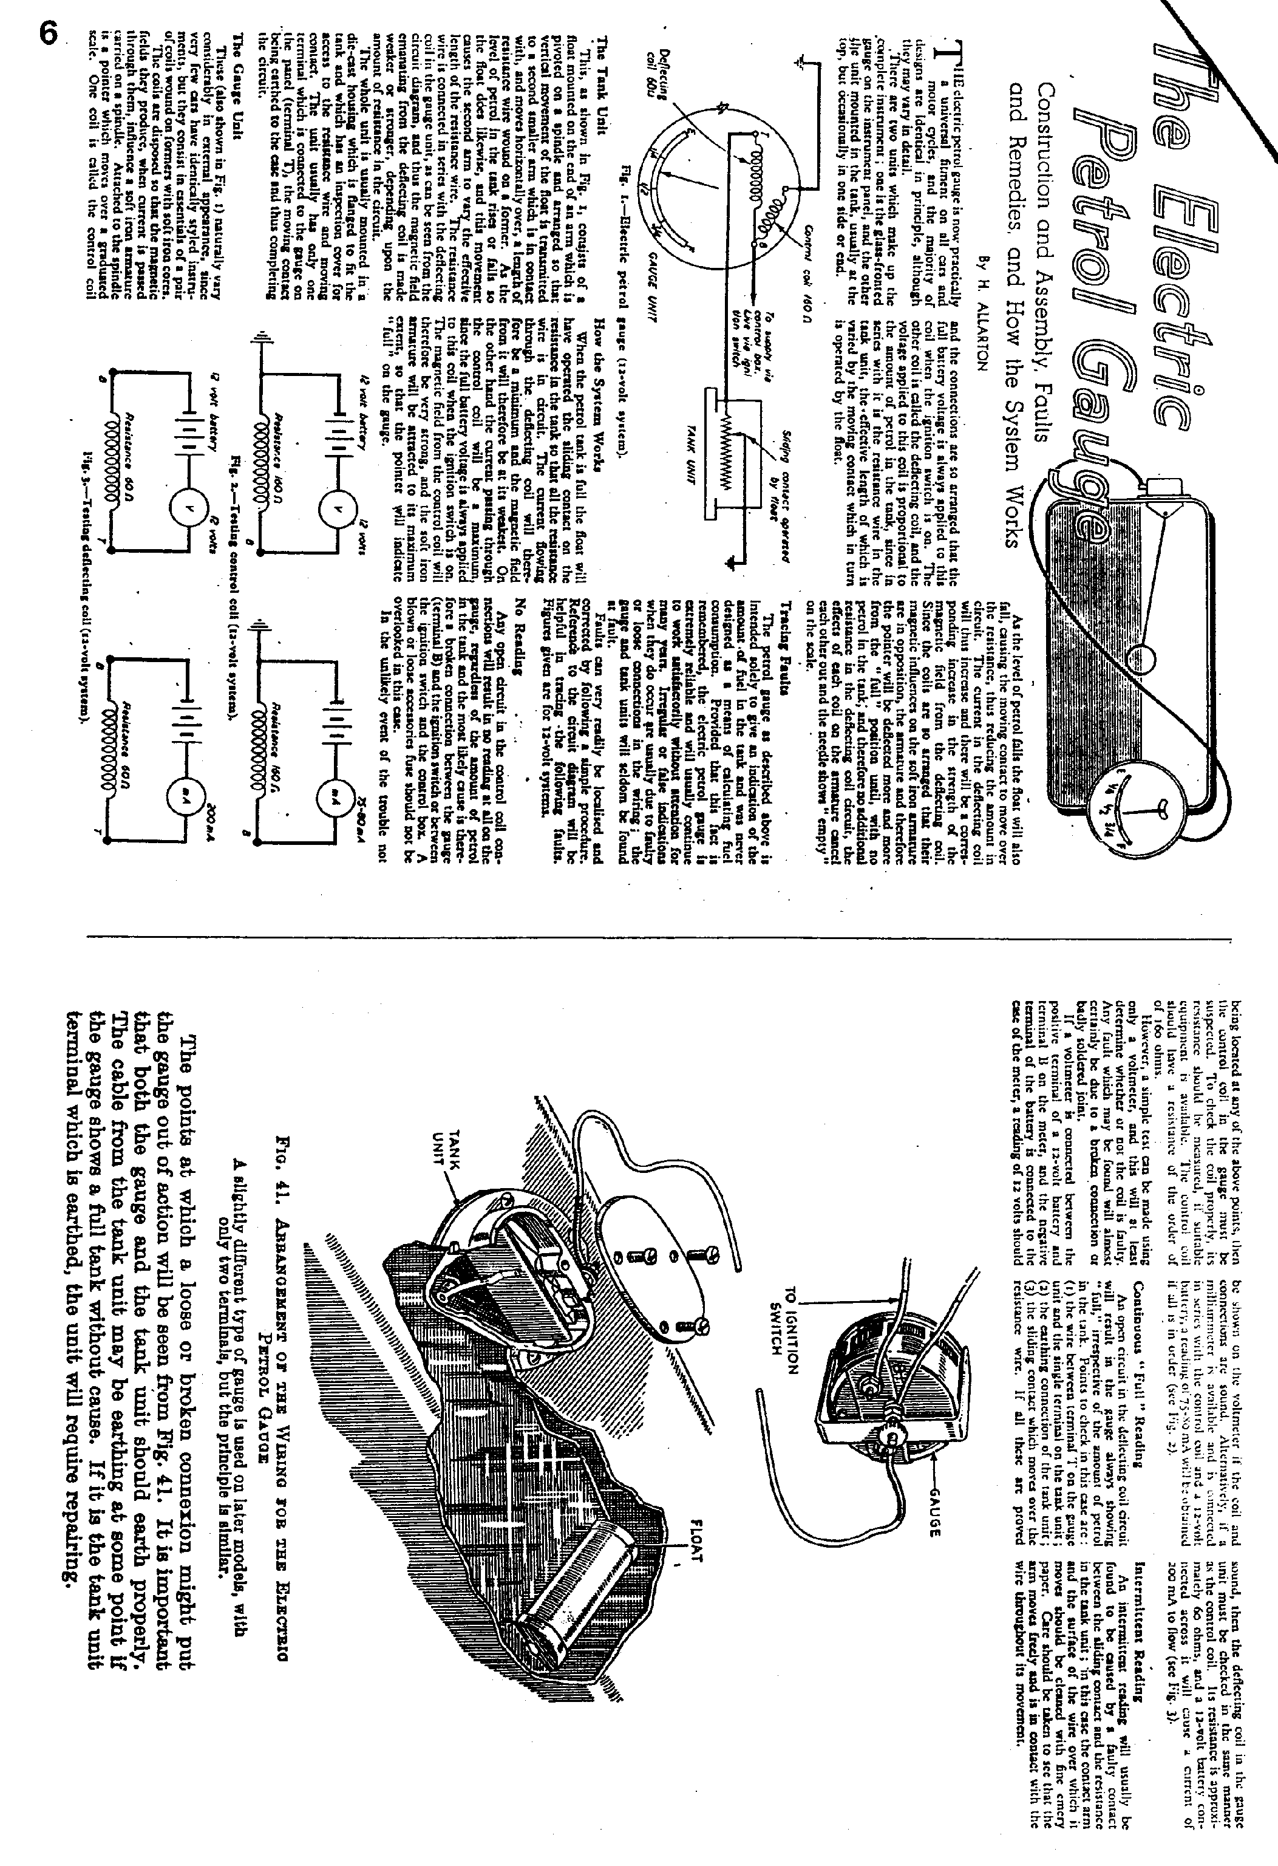
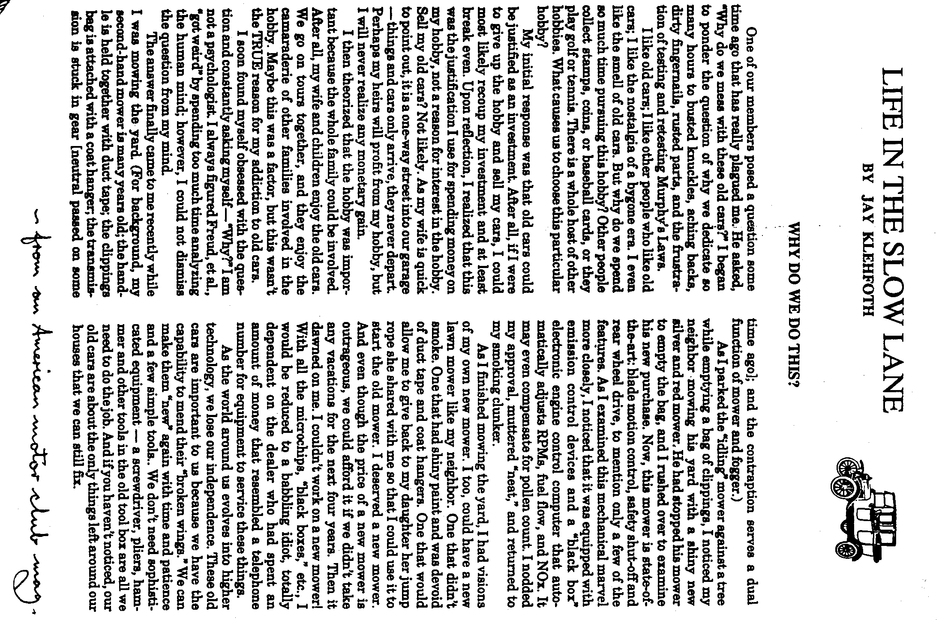
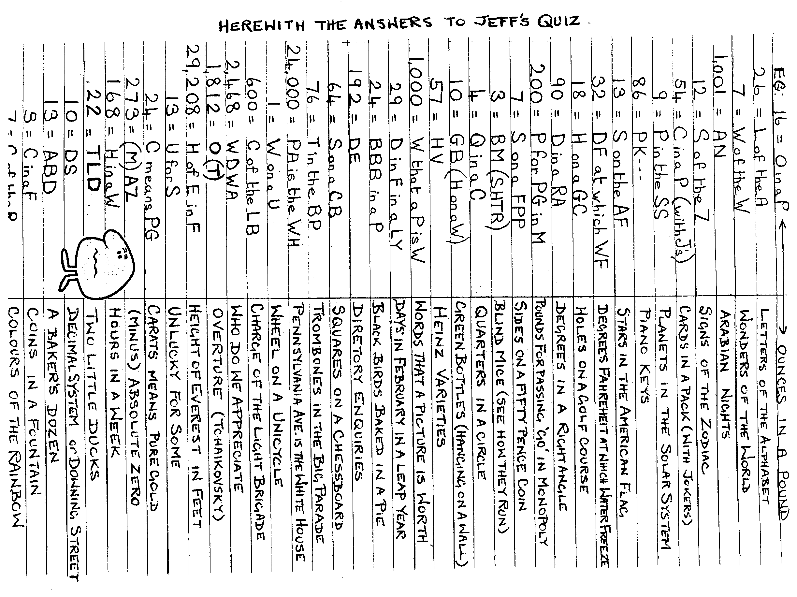

8
EVENTS
OCTOBER Thursday 17th October. CLUB NIGHT at The Elm Tree. 8.00 pm ANNUAL GENERAL MEETING. All Club Members urged to attend. Spares will be available.

Sunday 20th October. CLUB RUN. A Dorset Dawdle. Meet at the Safeway Car Park, Wimborne at 10.15 for 10,30 a.m.

Thursday 24th October. COMMITTEE MEETING at the Tyrrells Ford. 8.30 p.m.

NOVEMBER Thursday 7th November. '9 to Late' (for those who want to meet for a natter) at the Red Lion, Sturminster Marshall.

Saturday 16th November. Trip to Glastonbury floodlit carnival.
See September Newsletter for details.

Thursday 21st.November. CLUB NIGHT at the Elm Tree. 8.00 p.m. Auction Evening - dig out those goodies, folks.

Sunday 24th November. CLUB RUN. Details next month

Thursday 28th November. COMMITTEE MEETING at the Tyrrells Ford. 8.30 pm
And now for a history lesson. ...the Renaissance.
Martin Luther was nailed to the church door at Wittenburg for
selling papal indulgences. He died a horrible death, being excommunicated by a bull. Sir Francis Drake circumcised the world with a 100 foot clipper. Henry VIII found walking difficult because he had an abbess on his knee.

