EDITORIAL OCTOBER 1989

You will find only six pages this month instead of the usual eight. The reason for this is the shortage of material from Club Members. Last month's request fell on stony ground it seems. Please think if there is something that YOU could send in. Your Editor is urgently in need of articles, competitions, pictures, reminiscences, scandal, quizzes, comments, news items, letters - anything to keep the Newsletter interesting and varied. If you enjoy receiving the Newsletter help keep if alive.

It looks as if Richard and Margaret Cressey have organised a very interesting Run for us this month. They have had this in mind for us for some time, I know, and it's kind of them to offer us tea at their home to conclude what promises to be an unusual day. Let's have another good turn out:

Gary has details of the Skittles Evening within. Be sure to place your orders in good time. It does help.
John
SECRETARIAL Hi Gang,

Autumn has arrived again which is a reminder to me that it is AGM time.
Our October meeting is partly taken up with this and I do urge as many of you as possible to attend and put forward your point of view. Also if any Member would like to serve on the Committee, or if you know of someone who would, please let me or Bernard Cowley know as soon as possible before Club Night. I would also ask you to give some thought to who you will vote for for the Bob Burrows Clubman or woman of the Year Trophy, as this is also a feature of the October Club Night. This is presented to the person you think has done most for the Club in the last year. It can't be won in consecutive years.

Although the Rally season is just about at an end for 1989, it's good to note that not so many people take their Austins 'off the road' for the winter nowadays. Our Winter runs seem to get as many entries, if not more, than the summer ones. I suggest that the Concessionary Road Tax has helped, but it is good to see so many of you maintain interest all the year round.

As some Members will have noticed, there has been a change of management
to our new Club venue, The Dudsbury. Our new hosts made us very welcome last month and assured us that we will be welcome in the future. We have booked 'our bar' for the Club Christmas Dinner this year which is on the 15th December; see elsewhere in this Newsletter.

After all that waffle about the AGM, I now find that due to other commitments I cannot attend myself, so please accept my apologies now.

See you on the Run: _ Glyn
.
NOVEMBER NEWSLETTER - Contributions welcome (in fact begged for) by 29th October.
The Cerne Abbas Run Sunday. 24th September
This was a run Fran and I didn't want to miss, the last one before putting the Box away for Winter when the tax runs out at the end of September.
It was a misty start to the day but by the time we got to Wimborne Square, the sun was shining from a clear blue sky - a perfect day. After scurryings to the local loos we were off, eight Austin 7's (including 3 Chummies, fourteen humans and two dogs!
Paul, our leader (suitably identifiable by cap and scarf) took us along the busy A31 towards the Sturminster Marshall roundabout and just past the Botany Bay he turned right and took us down leafy lanes through Winterbornes Anderson, Kingston and Whitechurch. Then a steady uphill pull to the charming village of Milton Abbas with its line of thatched cottages on both aides of the village street.
Back towards Milborne St. Andrew we drove and then through more picturesque villages bathed in glorious September sunshine - Dewlish, Cheselbourne, Piddletrenthide and finally the doyen of them all and our luncheon venue, Cerne Abbas.
The Royal Oak was an excellent pub, we had the place to ourselves on arrival and were joined by Richard and Margaret Cressey and the girls. Excellent service and even reserved tables in a little area for Club members only. They must have known we were coming!
After lunch, a walk to the famous giant, I suppose to view at close quarters that immense anatomy: Alas his manhood has been fenced off so even the handful who made it to the top, saw nothing. You have to go down to the lay-by these days to be a voyeur but everyone seemed too warm and exhausted. So we just sat and chatted in the afternoon sun and then meandered back to our cars via the ice-cream shop.
It was a lovely day and a perfect run at the end of a glorious Summer. Thank you Paul and Emma for the organisation - it couldn't have been better.
Mervyn.
(Thanks Merv and also to Fran for typing this item.)

NEW MEMBERS, A warm welcome to R. Edbrook, R. Allen and S. Cotton who have recently joined the Club.
CONGRATULATIONS to Derek Whitter who, with some fellow pupils, won a national competition for schools 'local radio'. Derek is apparently the enthusiastic driving force behind his school's internal broadcasting station. Well done, Derek.
AND TO Bernard who won the speed trials in the Nippy at Blandford Camp during the recent RNLI Run.
THANKS TO Susan Moody who has again typed the Newsletter this month.
GOOD WISHES to Lawrence and Margaret who have completed their move to a new home at Dibden Purlieu.

-----------

You may recognise this month's cover picture. If you don't it's our Chairman's Ulster T.T. See the reference within to the R.N,L.I, run.

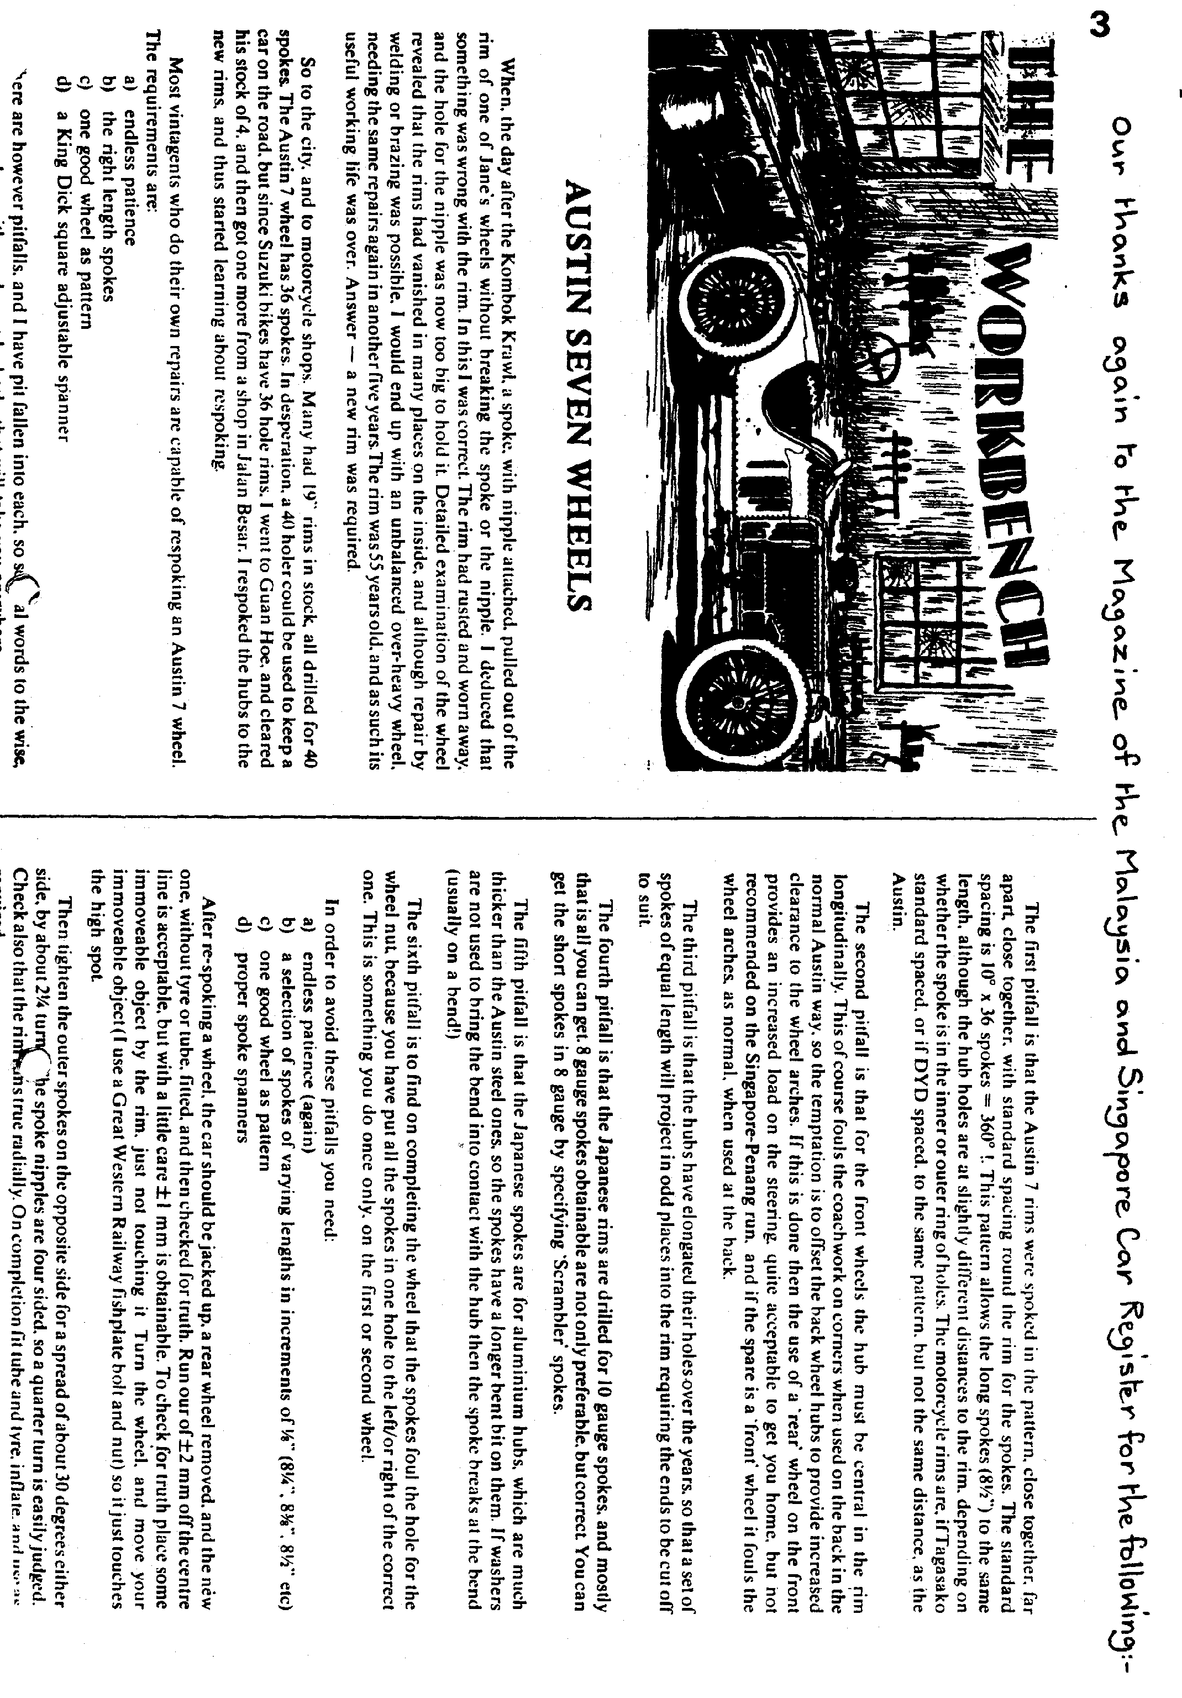

DA7C SWEATSHIRTS make ideal Christmas presents. Orders can be placed with Gary next Club Meeting as Pat will not be there.

MERELY MOTORING have produced a new catalogue. There may be items there to
solve your Christmas present problems. It's worth looking at. Your Editor has a copy or Roger and Rosemary Ballard (0722 23570) can supply one direct.
There is some talk at the moment about the possibility of an Easter Run to France or Guernsey. Early booking would be necessary. If you are interested in such a trip (in the A7 of course) contact any Committee Member.
ANNUAL SKITTLES EVENING
MONMOUTH ASH VERWOOD

SAT 25TH NOVEMBER - 7. 30PM
Well folks a slight change of venue this year, but nevertheless back to an old faithful!
Don't worry if you can't play, most of us have little idea, it's just a light-hearted knock about, a bite to eat, raffle and chat, and it's your Chairman's birthday Beer on you Bernie? .
Please complete the entry form below. -
Friends welcome;
Prices include food, alley hire and private bar facilities. Please return slip below by 18th November latest. Send if off now!
Gary
-
Please reserve me places on Saturday 25th November for the Annual
Skittles Bash. I enclose a cheque £ payable to 'Dorset Austin 7 Club'.

I require Ploughmans @ £2.50
Sausage & Chips @ £2.50
Chicken & Chips @ E3.25
l
Chilli & Bread @ £3.50
Scampi & Chips @ £4.25 `
Name
Address
..................... ......... .....................................
EVENTS
OCTOBER Thursday 19th October - CLUB NIGHT at The Dudsbury, 8.00 pm. ANNUAL GENERAL MEETING followed by a talk on 'The History of the Austin Seven' by Phil Whitter. - All Club Members urged to attend.
'Sunday 22nd October -:CLUB RUN. A visit to Rosie's Cider' nr. Wincanton where the Owner will give us 'a short tour.` Lunch at the Queen's Head, Milborne Port followed by a walk through Sherborne Castle Grounds during the 'Autumn Colours Week-end', (Free entry). Afternoon tea will be served at Old School House, Charlton Horethorne. Meet at Wimborne Square 10.00 for 10.15 am OR Sturminster Newton Mill at 11.00 am.
NOVEMBER, Thursday 2nd November -''9 to Late' - The Fairmile Hotel, Christchurch, (For those who want to meet for a natter). Thursday 16th November - CLUB NIGHT at The Dudsbury 8.00 pm.

AUCTION EVENING. Bring and by! 90% of sales to the vendor and 10% to the Club.
Sunday 19th November -CLUB RUN to Milton Abbas. Details in November Newsletter.
Saturday 25th November - ANNUAL SKITTLES EVENING 7.30 pm. Details within.
FOR YOUR DIARY - The Annual Christmas Dinner will be in 'our room' at The Dudsbury on Friday 15th December, Full details will be in the November Newsletter. , .

