EDITORIAL OCTOBER 1988

Beaulieu Autojumble seemed to live up to its reputation again this year. One thing was different - it was dry. Remember last year? Business seemed pretty brisk all round and I noticed some satisfied smiles on the faces of certain stallholders known to us all. As I found a copy of 'Coleman's Drive' at a sensible price I was happy too.
It seems that the chap to whom I sold the Chocbox was a bit of a dealer and that it was offered for sale on the second day. Let's hope that it will fall into the right kind of hands if and when it is sold on.
I see that Gary has been busy again on our behalf and has fixed one of our annual fun⁻evenings -,the Skittles. Next month's Newsletter will appear after the event, so be sure to return the slip to be found within this Newsletter!
Also bear in mind that the Club Auction will take place in November and put aside anything you wish to sell. You receive 90% of the selling price and the Club benefits by 10°b. Motoring and other items welcome and you've plenty of time to find something suitable for this - the 'Mike and Bernie Show' as it has become known. _
Keep waxing!
.
John
SECRETARIAL
Hi Gang. It's AGM time again; our Annual General Meeting will take place at The Elm Tree, Hightown on Thursday 20th October at around 8.30 pm. Do make a special effort to come, the official business does not generally take long, and it is your opportunity to speak your mind or make suggestions.
Pat and I, along with Bernard and Jackie took part in the RNLI Beaulieu to Weymouth Run on the 16th September. Pat and I thought that this was one of the best runs we have been on for a long time (other than Club runs, of course) what with the navigating and making sure you arrived at the time checks dead on time, and looking for special letter markings along the road. This made for a very interesting day out and there was also a timed speed section at Blandford Camp. We were given a super free lunch at Crichel House with coffee and a sweet, and at the afternoon time check we were given a punnet of strawberries - a super event which we certainly mean to enter next year.
Returning to the next Club meeting, October is also the month that members vote for the Clubman of the Year, that is the person that 'you think has done the most for the Club over the last twelve months. The Bob Burrows Cup is awarded, which is held for one year and cannot be won by the same person two years running. So give this some thought and let me have your nominations on Club Night.
Anyone with a desire to serve on the Committee next year should telephone me or any Committee Member preferably before Club Night.
Glyn
OCTOBER RUN _ The New Forest Conker Tournament Run will now take place
- on SUNDAY 30TH OCTOBER not Sunday 23rd October as notified last month.
THE SCENIC DORSET RUN - SUNDAY 18TH SEPTEMBER

What a great day weather-wise we had chosen for the Dorset Run, as nine A7s gathered at Wimborne Square, along with two canine friends 'Susie' and 'Jessie' better described as Little and Large.
We set off following Lawrence and Margaret, who had a super route in store for us, which was made all the more interesting by the typed notes provided with places and points of interest to note. Tiny hamlets and villages were passed, one so small it was without both a post office and a general store - sounds quite an inconvenient place to live! The scenery was beautiful, we drove down through Piddle Valley passing through Briantspuddle with its quaint thatched cottages and hamlet, I'm told erected by Sir Ernest Debenham. (Could that be the founder. of 'the' Debenhams?) On through Affpuddle whose claim to fame was a pre-war enamel telephone sign, plus a soon to be extinct red telephone box.
Must say the route increased in fascination and surprise mile by mile as the narrow tracks we drove through had to be seen to be believed. This was the first time I've known it possible to be able to pick blackberries from either side of the car - at the same time: Approaching-the coast we were greeted with superb panoramic views over Weymouth Bay - best view of all of course being the Smuggler's Inn, Osmington Mills, where we were to spend a very pleasant couple of hours. The landlord was obviously impressed with us, as he had us all line up for a photo-call in front of the pub before we left.
Following lunch we progressed to Ringstead with its magnificent views. Some of the more intrepid took to the hills to walk off any excess, while the rest reclined on blankets, faces up to the sun, mumbling a variety of excuses as to why it wasn't possible to join them!
The day must have had everything - lovely scenery, charming villages, quaint old churches, and most welcome of all - sunshine. Many thanks indeed from all of us to Lawrence and Margaret for organising a superb day.
Margaret Seymour.
0000000000000000000000
WORK AND PLAY (an echo of Easter Run to France)

On the occasion of our trade fair 'Semaine du Cuir', which is an annual event and takes place in Paris, it has long been our practice to try to tack on a day or so for us. This year we only managed the one day because of the lateness of the fair.. (It usually takes place end of August/beginning of September.) We very often spend 'our days' on the French coast and this year decided to spend time at Port-en-Bessin, a spot discovered during the Dorsets' trip to France earlier in the year. We happened to notice, at that time, what looked like a worthwhile hostelry - The Marine Hotel. And sure enough this proved to be the case. Typically French comfort, all facilities, jolly good breakfast, everything included for the two of us for FFR 170. The fantastic view-over the harbour was free. Now for the really good bit - the food. Gourmand standard - absolutely excellent - although in all fairness a cheaper meal could doubtless be had elsewhere, but certainly not a better one.

PS Having heard and read so much about it, whilst in Paris, we took the opportunity of making an all too quick visit to the new museum recently opened in the old building; of the Gare D'Orsay. An absolute MUST. We shall certainly spend more time there on our next visit. The nearest Metro station is SOLFERINO on line 12.
PPS Yes, most of the three days in Paris is very, very hard work. Paul Mainzer
3
Brian, Jill, Gordon and Lena have once again taken part in the 'Autumn Amble' organised by the North Hants and Thames Valley Sections of the Austin Seven owners' Club . The whole Run is from Reading to Bognor Regis, but can be joined along the route. Apart from the Run itself there's some travelling to do in order to join it. Brian clocked up 196 miles on the day and has just presented your Editor with Jill's account of the event and a stick of Bognor rock. He thinks I shall give the rock to my grandchildren. He is mistaken. Herewith Jill's account.

THE AUTUMN AMBLE - SUNDAY SEPTEMBER 25th 1988

The Radio 4 Weatherman was emphatic that we were in for torrential rain, so with that idea in mind we decided to pack the cagoules, umbrella and galoshes before we set out to join the Autumn Amble.
Despite the threatening clouds which followed us all the way to Bognor Regis we had not a drop of rain, even the 'current bun' was in evidence.
Rather than meet the main convoy at Graffham for lunch, as Lena and Gordon had planned to do, we motored on to Hindhead for the coffee break where we were greeted by over 120 cars and received our route cards and navigation sheets for the remainder of the journey. ,
It needed some nifty map reading to navigate through the beautiful and scenic highways and byways of Hampshire and Sussex. The Rolls Royce we were following was last seen heading back towards London; their pith-helmeted navigator
was adamant in his decision that he was going in the right direction.
After lunch and with Lena navigating we set out on the final part of our journey. It was interesting to drive past Goodwood House, the Goodwood Race Course and Prince Charles' old polo haunt before meeting up with the dual-carriageway which would take us into Bognor.
I would hate to spend a week in Bognor Regis and fortunately I didn't get to see Butlin's Holiday Camp, but the 21 hours I spent there was enough. However, this in no way reflects on the organisers of the Amble or the locals. I mean to say we were welcomed on to the seafront by the smiling Mayor and the unsmiling Carnival Queen. Even our goody bags contained a stick of Bognor rock.
Confession time - as the weather was cold and windy we spent the remainder of the afternoon chatting with other car owners and drinking tea in the Town Hall restaurant and missed the presentation of awards and cups.
At about six thirty we decided to make tracks for home and yes we would do it again next year.
Jill k+.

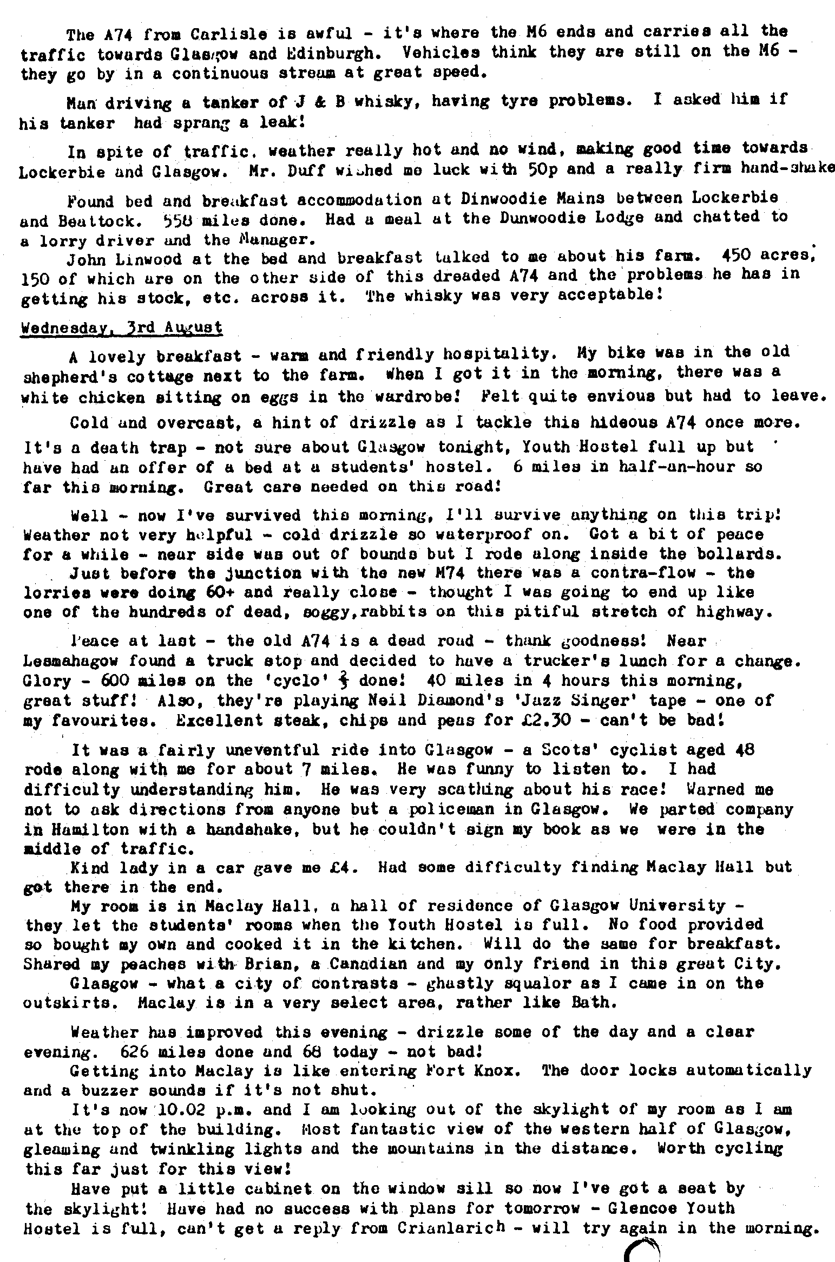
EVENTS
October Thursday 20th October - Club Night at the Elm Tree. 8.00 pm ANNUAL GENERAL MEETING. All members urged to attend.

Thursday 27th October - Committee Meeting at the Tyrrels Ford 8.30 pm.

Sun. 30th October - Club Run. The New Forest Conker Tournament Run. Meet at the Furlong Car Park, Ringwood 10.30 for 10.45 am.

NOVEMBER Thursday 3rd November '8 to Late' (for those who want to meet for a natter) at the Fairmile Hotel, Christchurch.

Friday 11th November - Skittles Evening. See below.
Thursday 17th November - Club Night at the Elm Tree.
AUCTION EVENING. Bring 'car stuff' or anything. 10% to club funds - the rest for yourself.

Sunday 20th November. Club Run. Details next month.
0
Thursday 24th November. Committee Meeting at the Tyrrels Ford 8.30 pm.
ADVANCE NOTICE - KEEP THIS DATE FREE! ,
The Annual Christmas Dinner will take place on Saturday 17th December at the Crooked Beams Restaurant, Iford, near Christchurch. Look out for details and application next month!!!
SKITTLES EVENING - FRIDAY 11th NOVEMBER - 8 PM

We have once again decided to play our annual light-hearted match at the Old Barn Farm Inn on the Ringwood to Three Legged Cross Road. Unfortunately all Saturday evenings are already booked, up to Christmas; but I'm sure Friday will still appeal to you! Please remember this is first and foremost a social evening out, you don't even have to play if you would rather not. In fact the inexperienced often do best. The more the merrier. Please return form to: Gary Munn by 4th November.
12 Shaftesbury Road
Poole BH15 2LT

