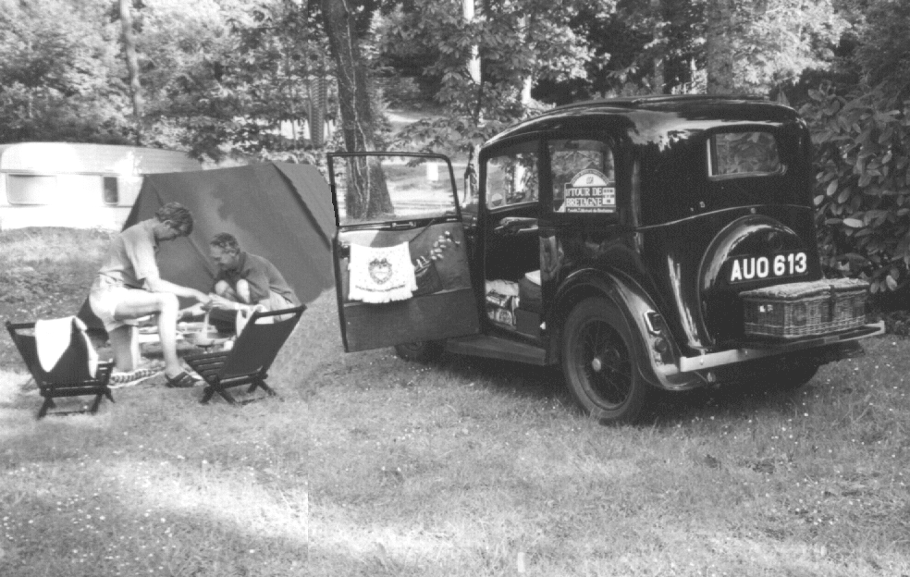
NEWSLETTER
November 1998

The motor for the Million
Built in the largest and most up-to-date Motor Works in the British Empire

Member of the A7 Clubs Associati

DORSET AUSTIN SEVEN CLUB

COMMITTEE MEMBERS 1998
CONTENTS

Club Contacts 1
Editorial 2
Secretarial 2
Club Run 3
Committee Business 9
The Way We Were 9
Here & There 10
Family News 10
AGM Update 10
Future Events 11

FEATURES
Pit Stop 4
Technical Torque 5
Edinburgh Trial 7

Chairman Bernard Cowley
27 Delph Road, Merley
Wimborne, Dorset, BH21 1RS (01202 887666)

Secretary Glyn Llewellyn
10 Woodvale Gardens
New Milton, Hants, BH25 5EE (01425 613080)

Treasurer Lawrence Rideal
12 Redwood Close, Dibden Purlieu,
Southampton, Hants, SO4 5SN (01703 207191)

Membership John Page
Secretary 74 Walcott Avenue
Christchurch, Dorset, BH23 2NG (01202 473207)

Spares Phil Whitter
Secretary 134 Northfield Road
Ringwood, Hants, BH24 1SY (01425 475558)

Events Gary Fatt
Secretary 98 Bear Cross Avenue, Bearwood
Bournemouth, Dorset, BH11 9NZ (01202 572621)

Newsletter Gary Munn
Distribution 12 Shaftesbury Road
Poole, Dorset, BH15 2LT (01202 683848)

General Pat Llewellyn
Committee 10 Woodvale Gardens
New Milton, Hants, BH25 5EE (01425 613080)

General Roger Ballard
Committee Kea House
Laverstock Pk.
Salisbury, Wilts, SP1 1QL (01722 323570)

General Mike Wragg
Assistance 67 Uplands Road, West Moors

CLUB NIGHTS
are held on the third Thursday of every month at The Tyrrell’s Ford Hotel, Avon (on the Ringwood/Christchurch Road)
B3347
& Raffles Ferndown, Dorset, (01202 895622)

Newsletter David Whetton
Editor 129 Lonnen Road,
Wimborne, Dorset (home: 01202 848743)
BH21 7AU (Fax: 01202 876661)
(Email: davidw@fernup.dorset.sch.uk)

Club Regalia Jackie Cowley (01202 887666)

This month's cover photograph features Richard & Marlies Bishop camping in Brittany earlier this year avec Le Sept. The Ruby door chain makes an excellent towel rail. See August Newsletter for the full story.

EDITORIAL

THANKS THANKS THANKS – to all the 36 contributors to last year’s Newsletters and the 15 Run Reporters. It is a pleasure to edit our magazine with such willing and productive members - if you haven’t had the pleasure yet then make this the year you put pen to paper to share some little Sevening experience with us. If you were at the AGM (and who wasn’t?) then you know that the Editor’s Trophy went to Gary & Suzie Fatt for their eloquent and erudite contributions over the year known as Poets’ Corner.

You need to read COMMITTEE BUSINESS carefully this month as it has announcements about XMAS CARDS, SPEAKERS and the CLUB XMAS DINNER. This month, PETER TRELIVING appears twice – once as Club Run organiser and again as TRIALS CORRESPONDENT. Also featured this month is part 2 of the BASIC GUIDE to LUBRICATION, an end-of-season tale of derring-do from the fast (and not-so-fast!) lane and a WORLD EXCLUSIVE from our own international roving reporter.

Now we are two – I’ve got an assistant editor!!! Peter (he must be madder than me) TREBILCO has taken on the role of whipper-up for articles and the ever-popular FAMILY NEWS. So if he appears to be lingering with intent – speak in whispers children.

Congrats to all the CUP WINNERS – a full list appears under Here & There. It’s great to be a member, ain’t it?

David.

Deadline for the next issue is 27/11/98 . Please send material to me by post, fax or E-mail or pass it over to the Editorial Team at Clubnight.

SECRETARIAL

Hi Gang

It was good to see so many members, both old and new at the AGM . The official business did not take very long and we were all well entertained by our Treasurer, Lawrence Rideal, who has a very clever and witty way of extracting more money in the form of subs from all of us. Dusty Whibley who has been our events “Man” for the past year has now resigned his position on the Committee. We thank him for all his efforts as events secretary and, earlier, as assistant spares secretary. His place on the committee has been taken by Gary Fatt. This is the only change to your committee this year and the rest of us were duly re-elected on block.

The regalia sale following the AGM was a great success. I couldn’t get near as Jackie

Cowley had a queue for most of the evening. I understand she has sold most of the stock so now has space for some new lines.
For the first time in 20 years or more I have not got an Austin 7 in my garage as Gary and Susie Fatt have bought the Fabric and the Tickford is still away having its hood done. Pat and I had to go in the MX5 to Pete Treliving's October treasure hunt , a really good run and a beautiful day too. Many thanks Pete and Judy.

Pat tells me the Christmas Dinner is booking up fast so if you want to come please don’t delay in sending in your order. We did forget to mention in the Xmas blurb that we are having The Buddies Duo once again to play and sing as last year.

See you Club Night.

Glyn
The Bulbarrow Run 25th.October 1998
It was a glorious morning as we set off on the run to Wimborne. Peter Treliving greeted us all – a good, but not enormous turnout of seven cars including one oriental sports type (Glyn & Pat) and we were presented with what looked like an intriguing run around our beautiful Dorset minor roads. Joy and I set off first in the box and were quickly on the best of minor roads looking for our clues. Happily there was plenty of time to enjoy the run without the chore of too many clues and some of the clues were very subtle. As an example: how many of you have ever noticed that the stag on the gate on the Blandford road just out of Wimborne has 5 legs. Odd indeed.

Because there were not many of us we avoided the usual follow my leader type of treasure hunt and as a result the run was an absolute delight. At lunch we stopped at the Fox at Anstey but the choice was limited on a Sunday and the prices were on the high side. Several of the group headed off in search of more choice and better value and Bernard & Jackie, Dusty & Jane and Richard & Margaret told us later that they had struck GOLD at the GREEN MAN!

After lunch we set off along BULBARROW revelling in the wonderful views and wondering if the life of the TINKER or GYPSY is as idyllic as it looked with a group encamped overlooking the view. Several of us missed one of the turns outside Wimborne, but we eventually made it to “Nightingales” which is Peter’s house at the end of a lane, in a wood, just close to nowhere, you know the place.

We were warmly welcomed in the still glorious sunshine with tea and cakes as promised. For the first time in a long time I spent the whole day out in the car in the sunshine with friends. It was perfect. Joy and I would like to congratulate Peter on a well chosen run and for the warm hospitality of the family extended to all of us, it really was a super day out.

Thank you Peter. George & Joy Mooney
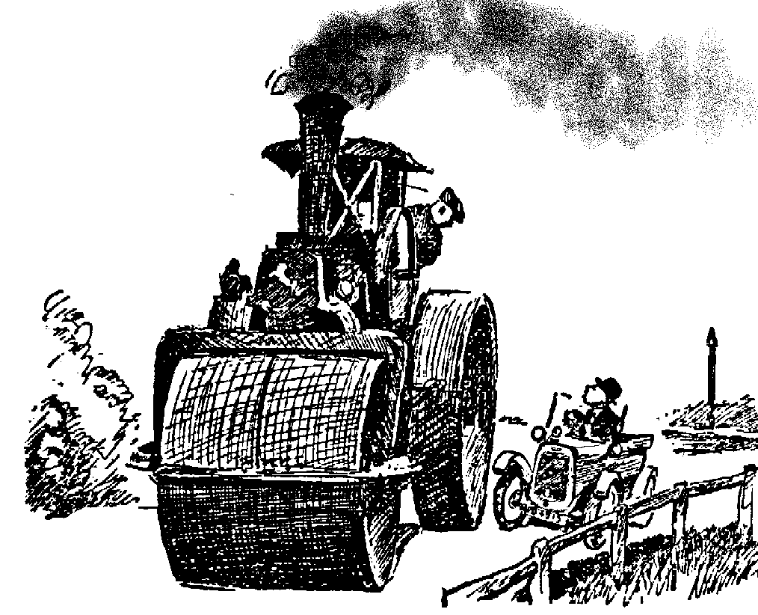
and many thanks for finding the time for the write-up George just before jetting-off to South Africa on business - Ed.
“THE WORLD TOUR” - Hello to DA7C
From Matthew Cheeseman;Regina,Canada

I’m having a great time – been to LA, Seattle, Victoria, Vancouver, Alaska, Anchorage & Fairbanks.
Vancouver from Alaska by car 2300 miles in 52 hours with a forced stop in Yukon because no petrol stations were open. It was a very backward area – an A7 would not be out of place!! Then on to Banff, Calgary & Edmonton, Saskatoon. Now I’m off to Winnipeg on the overnight bus and then on to Toronto for a week or two. Then it’ll be down to the lower 48 to see the sights. I can’t wait to get to South America. Matthew.
Bumptious Small Car Driver: “Now then you - Are you going to move to one side or do you want your front wheel knocked off ?”
From the internet
SHOOT-OUT

AT SILVERSTONE
PIT STOP

Saturday, October 17th - High noon at Silverstone with Chambers on 80 points from 6 wins and DA7C’s own Dorset Dave in the lead with 84 points but from 8 results. Therefore, if Chambers finishes in the top three he will win the Championship whatever Our Boy does. Practice started in drizzle, always an advantage for DD who has developed Shoe-maker-type tippy-toes resulting in third row on the grid for the Big Race - a full 7 seconds faster than Chambers! However, being at Silverstone went to Dave’s head and he entered for an earlier HIGH SPEED TRIAL against Lotus Elans, Aston Martins, Porsches, Cougar Jaguars, C-type Jags, TVRs and a Ford Cortina (!). Being a handicap race, proud Dave was on pole position in the very slot occupied by the Greats of the past – Hill (x2), Senna, Piquet, Prost, Lauda, Mansell (who?). It was said the grin could be seen all the way from Copse. Lights red – green and the echo of Murray Walker could be heard “THEY’RE OFF!!” – Copse flat out, Maggots, Becketts in third, watch the curbs on the exit, long uphill Club, change to fourth at 6000 rpm, brake hard for Brooklands where Damion went out on the gravel at the British GP, change down for Luffield and back to fourth over the Start/Finish line - Jaguars and Astons passing at 100 mph. GREAT STUFF. After six laps the Seven started to break away round Luffield, on the seventh it was a distinct four-wheel slide and by the eighth the inside rear started to spin, power fell away and the oil pressure dropped to zero. Pulling off round Copse, Dismal Dave soon saw the reason for all the slipping and sliding – oil everywhere including the rear wheels and the designer racing boots. Two hours to go before the Big Showdown. Off came the radiator, bonnet, sides and dynamo and the damage was evident - the copper oil pipe feeding the pressurised crank had split! But how to fix it? A local autojumble stall provided a small hacksaw and flaring tool (£10 rip-off) and with the skills of fellow enthusiast TONY THOMAS a good repair was effected. Everything back (with a quarter of the bolts) with support crew Sue having wiped off all the slippy stuff, refilled the radiator and sump and down to the start. But horrors – they’ve started – too late. What’s this? – a red flag – and a re-start. Hurrah! – a pitlane start is better than no race. Chambers watch out.

One lap and something’s seriously wrong. Only 4000 revs through Maggots and a ghastly haul up Club Straight. “Pit lane ”appears on the right and discretion takes over.

Outcome – Chambers wins leaving Dorset Dave second in class and 5th overall in the national championship. But what a season and what a grin to last all winter. Got a spare block anyone750

TROPHY CHAMPIONSHIP TABLE AFTER 10 ROUNDS – BEST OF 8 RESULTS
Points  best of  8 | Class | Driver | Mallory  22/3/98 | Lydden  25/4/98  2 rounds | Mallory  31/5/98 | Pembrey  18/7/98  2 rounds | Cadwell  16/8/98  2 rounds | Snettert’n  26/9/98 | S'stone  17/10/98
115 | D | Richard Reeve Lotus Mk.6 | 16 | 28 | 12 | 13 | 26 | 15 | 16
95 | D | Roger Rowe RWR Special | 12 | 0 | 16 | 29 | 24 | 13 | 1
93 | D | Roger Windley S/Ch Genie | 10 | 19 | 10 | 25 | 25 | 10 | 12
88 | A | Graham Chambers A7 | 1 | 26 | 13 | 26 | 13 | 1 | 10
84 | A | David Whetton A7 | 10 | 20 | 9 | 20 | 22 | 12 | 1
45 | A | Ed Bradley A7 | 16 |  |  |  |  | 16 | 13
31 | A | David Asplin A7 | 12 | 18 |  |  |  | 1
10 | A | Graham Goode A7 |  |  | 10

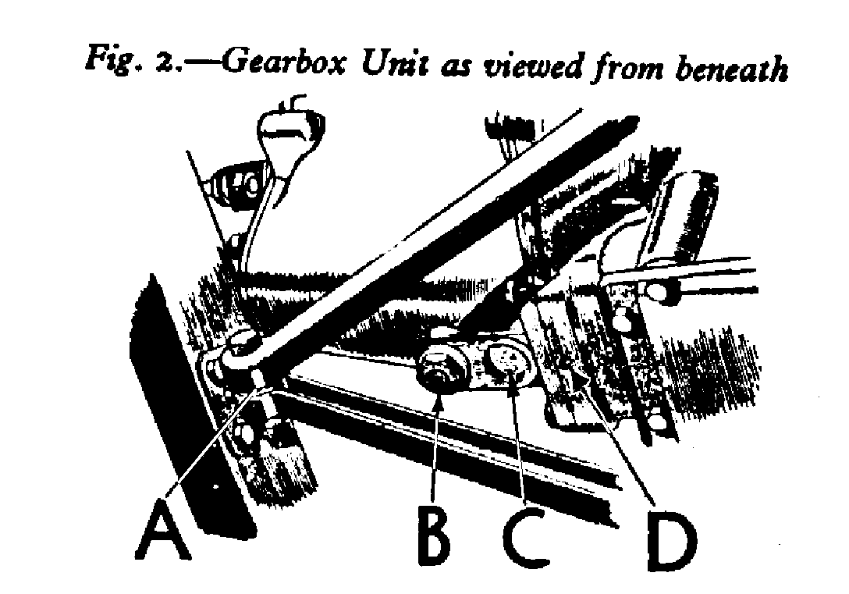

AUSTIN SEVEN
LUBRICATION
part 2

GEAR BOX
When your Austin Seven is new the gear box should be completely drained after the first 500 miles running. To do this remove the gear box drain plug (the position of which is shown in Fig. I) whilst oil is still warm after a run. This drain plug also holds the clutch pit drain hole cover in position as illustrated in Fig. 2, and when refitting the drain plug this must be replaced
“A” is the Radius Arm Anchorage; “B” the Gearbox Drain Plug; “C” the Clutch Pit Drain Hole Cover; and “D” the Drain Hole for releasing oil which might have gained access to the Clutch Housing.

After draining, about two-thirds of a pint of CASTROL XL is the maximum quantity required for complete replenishment of the gear box. The amount of oil in the gear box can be checked by inserting the engine dip-stick in the gear box filling orifice (Fig. z). The depth of oil should never be less than one inch or more than two and a half inches. It is advisable to check this every 1,000 miles and maintain at the maximum level by replenishing with CASTROL XL.

Changing the oil.
Every 5,000 miles after the first 500 repeat the draining process previously described and refill with
CASTROL XL.

Rear Axle.
The rear axle should be replenished every 1,000 miles with CASTROL "D" Gear Oil.
To do this, first remove the plug situated at the rear centre casing. Then screw the end of the grease gun adaptor into the hole, attach the barrel of the grease gun and force in lubricant. Do not inject too much at any one time, as oil is liable to reach the brake shoes and impair their efficiency.

Steering Gear.
In order to enjoy ease of steering and eliminate the possibility of "play" developing between the steering wheel and road wheels through wear, regular lubrication at all points of the steering gear is essential. The parts mentioned below can he located by reference to Fig. 4 and also the Oiling Chart at the end of this booklet.

Steering Gear Box.
Every 1,000 miles give a charge of Wakefield CASTROLEASE Medium with the grease gun at the nipple situated on top of the box. This will lubricate the worm and worm wheel bearings.

Steering Column.
Give hearing at top of the steering column a little oil from the oilcan every 250 miles.

Steering Side Tube.
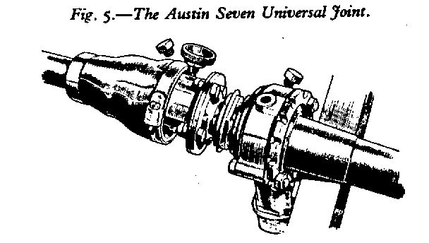
Every 250 miles the steering connections on this should be lubricated with CASTROL XL using an oilcan which injects the lubricant under pressure into the sockets.

Steering Swivel Pins and Cross, Tube.
Every 250 miles apply Wakefield CASTROLEASE Medium with the grease gun at the nipples provided (there are four of these in all).
This illustration shows Grease Gun Adaptor being attached to Universal Joint Housing preparatory to filling with grease. The filler plug for the Torque Tube forward end is also shown. On earlier chassis a grease nipple is fitted here.

Universal Joint.
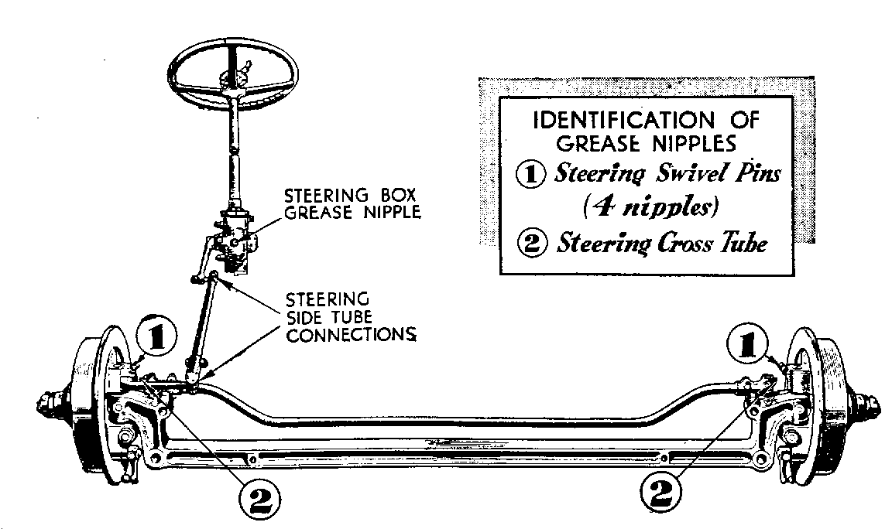
Every 250 miles fill the joint housing with CASTROL UNIJOYNT Grease. To reach this point move aside the small cover in the car floor board. Now move the car until the filling plug on joint housing is facing upwards. Remove the plug and apply lubricant with the grease gun (see Fig. 5). CASTROL UNIJOYT should always be used here. It is a non-separating grease specially prepared for high-speed metal joints. Do not neglect this point or rely on an inferior grease or unnecessary play will very soon be in evidence.

Just to the rear of the Universal Joint is another filling plug (or on the earlier model a grease nipple) for lubricating the forward end of the torque tube. Apply Wakefield CASTROLEASE Medium here, using the special adaptor if a filling plug is fitted.

continued next month with Wheels & Brakes
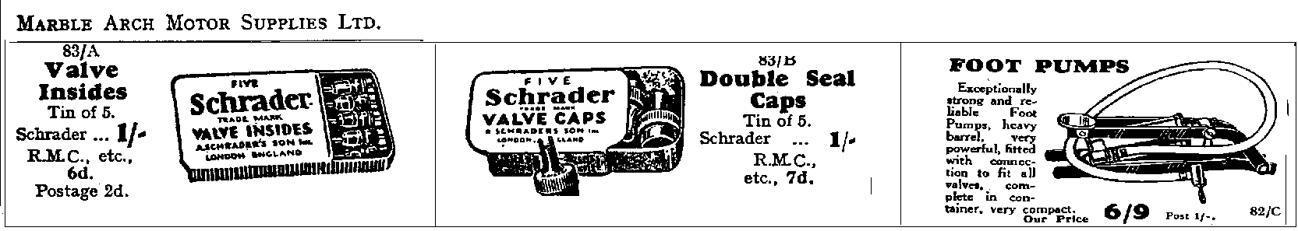
Club Disclaimer - The Dorset Austin Seven Club, the author, or the Editor, especially the Editor, cannot be held liable for any damage or injury caused as a result of following the advice or instructions in any article. Only attempt jobs you are confident you can do SAFELY.

The 1998 Edinburgh Trial

By Peter Treliving

Due to all the work that getting the Chummy through its first MOT in 8 years entailed, I suddenly woke up to the fact that the Edinburgh would be soon upon me and I had done nothing to the special since putting it away at the end of the winter season in April. Now although it was going OK at that time there were items that needed attention before subjecting the poor thing to another rigorous season. As there was never going to be enough time to do all the work I would like to carry out, there was nothing else for it but to book some precious holiday time. The first task was to get a new MOT. Brakes were relined, new wheels built, new tyres fitted, new track rod ends and even a re-furbished steering wheel installed. The MOT was secured on the Monday before the Friday of the trial. Now to sort and check the car out to make sure both it and me were in a fit state for the 400 miles of the Edinburgh. Eventually all appeared ready with all of Friday to spare, except where on earth had I put all my trialing gear? Oh dear! I am sure I meant to have washed some of this by now. Never mind the goodness will help to keep out the cold!!!

On Friday evening my passenger, Steve Potter, arrived and we set off with the Austin on the trailer to Strensham Services. Brian and Monica Gray had very kindly offered to let us leave our trailer and tow vehicle at their house. We met up with Tim and Anne Whellock, John Green and Ron Mackey in their Sevens and proceeded to drive the short distance to Strensham. Having cleared scrutineering we departed at our scheduled time of 23.55 to drive the first 70 or so miles to another scrutineering session at the Elf garage on the A5 outside Burton on Trent. A quick refuel and we were off again to find our first section, Agnes Meadow. On route we saw Steve’s brother Phil and his wife Christine coming the other way in their Dellow. After a quick chat we set off again to tackle Agnes Meadow, which I doubt caused anyone a serious problem. It was now off to the Salt Box at Hatton Cross for breakfast. Except, like most other competitors we were far too early and had to resort to sitting in a lay-bye for an hour before being able to sample the culinary delights of the Salt Box at 6 a.m. A route amendment was issued informing us of some route changes and that the event was being televised. What a time to remember about the unwashed state of some of my kit! Never mind it was too late now and in any case the toilets were already full with those wishing to put on a fresh face for the cameras!

An hour later we were on our way again to the second section, Clough wood. This was surprisingly dry and the only problem was having to stop on the way out behind Roger Bricknell whose car had expired with a flat battery due to a wire having fallen off the alternator. Son Thomas did the honours by pulling him out and he soon caught up with the rest of the field at Litton Slack. The sun had not reached Litton by the time we arrived and the surface was extremely greasy, causing many competitors to fail at the line. Our turn duly arrived, but we could not get enough grip and the car did not seem to be on full song. Three quarters up the hill was as far as we got and with heavy hearts we returned to the bottom of the section to watch the endeavours of the other Austins in our group. John had a similar result to us as did Tim and Anne in whose case failure was a distinct blessing. Having stopped Tim noticed a complete lack of oil pressure and on returning to the bottom discovered that the Austin had deposited most of the contents of it’s sump on the hill. Amazingly this was due to the oil filter coming loose, a fault that was easily rectified with the help of some oil donated by John Green. I decided that the special was running too retarded and advanced the ignition a few degrees. This appeared to correct the problem, but in the event was only hiding the true cause.

Swan Rake is a new section. Rough is not adequate to describe the surface, but I am sure my osteopath will appreciate its inclusion! We all climbed it successfully and amazingly all the cars were still in one piece. On now to Old Long Hill, except for us as en route there was a massive misfiring and we came to an unscheduled halt. Investigation showed that the skew gear on the end of the distributor had parted company with the shaft. Steve looked depressed, until I told him about the complete spare distributor behind his seat. Ten minutes later we were on our way again, but with a slight misfire and down on power. Another stop where condenser, points and plugs were changed and now the Seven was back on full song again. Was this reason we failed Litton? We shall never know, but it helps with the excuses! Old Long hill special test was carried out without incident and by the time we got to the Marquis of Granby we were back on scheduled time. I thought the holding control at the Marquis was very well run this year and after an hour stop we were off to Bamford Clough. Bamford is always one of the highlights of the Edinburgh and soon we were off again. More money for my osteopath! but what great fun being cheered on by all the spectators to the top of the hill. Brian Osborne and Martin Price sadly broke a spring on their MGB after clearing the section ends and had to retire.

On now to Hagside, with a stop and restart test. Hagside was in it’s usual rough state and unfortunately claimed one of our team of Austins. John Green had the very unfortunate luck to snap the drop arm on the steering box. This sent him off the track and into the fields and for some unknown reason he decided he was unable to continue, muttering something about not being able to steer. A pretty lame excuse if you ask me!

Great Hucklow was next and this will no doubt remain in many peoples mind for years to come. We waited our turn and watched several cars fail including one Escort, which got it’s diff stuck on a root at the start and despite the efforts of many strong arms required the assistance of the recovery vehicle to pull it free. Our turn duly arrived and we succeeded in getting off the line OK and in positioning ourselves in the restart box correctly. Knowing that we would now be faced with a sharp left-hand bend up a very steep, slippery, gradient with an adverse camber I decided a large amount of momentum was called for. We actually hit the bend going too fast and there followed several frantic seconds of flaying arms trying to get the car back on course (some of these arms were mine!). This proved successful and we found ourselves at the top with another clear. We ran back to watch Tim and Anne, who adopted a slightly different technique and whilst it was not quite as spectacular it did the trick.

On to Jacobs ladder and Deep Rake special test. Both were climbed without problem and our thanks must go to the villagers at the bottom of Jacobs ladder for their indulgence in having the trial pass through the centre of their community. Any inconvenience was minimised by having a holding control outside the village and a motorcycle escort to the start.

Putwell 1 and 2 were the last sections to be climbed, with a restart on Putwell 2 for all classes. What a view from the top and a fitting end to another fantastic Edinburgh trial. A final pump up of tyres and on to Buxton to sign off and have a beer and chat with friends at the Robin Hood. We claimed a silver medal as did Tim and Anne, having only failed Litton.

It was now time to find our hotel, have a meal and go to bed for the first time in 40 hours. We had been in the Austin for about 18 hours and both it and we needed a rest before the long drive home again the next day.

We thoroughly enjoyed our event and hope to be able to have another go at all these hills again in future Edinburghs. As always the organisation was fantastic and our grateful thanks must go to all the organisers and Marshals who devoted their time so generously for our enjoyment.

and many muddy thanks to you, Peter, for taking the trouble to share your madness with us - Ed.

COMMITTEE BUSINESS
This month we welcomed young Gary Fatt into the Committee ranks who will try to inject NEW LIFE into some of our ACTIVITIES. So if you’ve any new ideas especially SPEAKERS – see Gary. One idea he will be floating will be an INTER-CLUB QUIZ. Thanks also to BIDDY & GORDON who will represent us at the A7CA meetings at Gaydon. “SHOOTING STARS” are looking for our cars to use on FILM SETS (about £100 per day!!!) - form a queue behind Gary Munn (but there is a £15 registration fee unfortunately). The Xmas meal is coming along nicely with 52 BOOKINGS already so if you intend coming, contact Pat NOW. Glyn will be looking into 15% discount on RAC Services through their Club Membership Scheme. Again the Committee is recommending NO XMAS CARDS between Club Members and an alternative CHARITY BOX will be available at December Club Night and the Xmas Dinner. At 50p per card these days a fiver should do nicely for the MACMILLAN CANCER UNIT at Christchurch.

THE WAY WE WERE - a blast from the past

From the Club magazine for NOVEMBER 1977

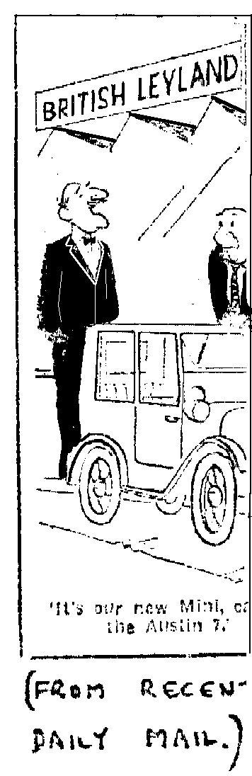
“At the AGM it was decided that Bernard was overloaded and I have taken over as NEWSLETTER EDITOR. Bernard continues as Secretary and his other job, CHAIRMAN, has been taken over by Derek Munn. Now don’t forget to get those subs to Lawrense - £2 + 75p if you want the Association Magazine. On the social side it was decided we would have an informal SKITTLES EVENING in January. This month’s meeting will be at the Nag’s Head, Ringwood and is a TABLE CONCOURSE. - Phil Whitter

agm report: 25 members attended and it was decided to join the A7CA at their next meeting in October. The Committee for the year will be:
Chairman Derek Munn
Secretary Bernard Cowley
Assistant Secretary John Page
Treasurer Lawrence Rideal
Events Secretaries Gary Munn & Peter Treliving
Newletter Editor Phil Whitter
Committee Members Glyn Llewellyn & Mike Wragg

INSURANCE: Now we are in the A7CA you can insure your A7 for £15 fully comp through Everest Insurance Services at Lloyds.
“It’s our new Mini – called the Austin 7”

SPARES:- 350x19” Avon tyres at £12 + 50p carriage.
Roof topping 60” wide at £4.50 per metre
Kit of parts to build A7 van(less doors) £85
WANTED:- by Willie McKenzie - a fan pulley, windscreen latch & headlight rim for his ’34 Box.


FOR SALE
NEW TYRES 400x17 now back in stock (imported) £35; tubes for above £5; Tyre and tube purchased together £38.50; set of 5 tyres and tubes £185. Could deliver to Club Night - Vince Leek 01985-847658 (day) 01985-216632 (eve)

1938 RUBY blue, MOT, regular use, recon engine £3500 ono Gary Fatt 01202-572621

1935 RUBY Maroon/black, fully restored, MOT/Taxed, £3750 Ron Sinden 01202-779590
CLUB FAMILY NEWS
A Swanage love story - RUSSELL TOPHAM has married EVE CREASEY (BA7C) They first met at the Club Rally last year and Russell proposed in the rain this year. Scott was the best man (who else?) and wedding cars included the Alvis, an MGA and a Seven.

Love on a Beach (and in a Beach Buggy) – KEITH WHITTER is marrying LEANNE in Mauritius. The whole family is going but weren’t allowed to take a Seven. Never mind, though – the Young Lovers take over the Whitter Ruby on return.

Talking of take-overs, we hear Dusty’s taken over Benson but whether this is for the duration of the wedding or longer is not clear.

Finders – keepers: Barry Goodman has found an original 1927 Chummy in a barn. The price isn’t being revealed but is in the region of a couple of pints of Scrumpy and a shiny new Biro.
Losers – weepers: The missing VIC STEELE CUP has been found and presented to last year’s winner (Roger Ballard) for 5 minutes. Nice touch Bernard.

AGM UPDATE
SUBS – up to £16, now due - cash or cheques (payable to DA7C) to John Page at Club Night or by post (see inside cover)

NEW COMMITTEE MEMBER – Gary Fatt (Events Organiser)

ASSISTANT EDITOR – Peter Tribilco

CUP WINNERS: LADIES’ CUP - Pat Llewellyn
BALLARD TROPHY - Dusty Whibley
VIC STEELE CUP - Peter Tribilco
BOB BURROWS TROPHY – David Whetton
EDITOR’S TROPHY - Gary & Suzie Fatt
oO CLUB DIARY Oo
NOVEMBER

Thursday 19th Nov. Club Night is AUCTION NIGHT. - Clean items only please, 10% of sales goes to Club Funds. Spares by prior arrangement only

Thursday 22nd. Nov. Glyn’s Club Run - 10.15 am for 10.30 off at RINGWOOD Market Car Park with an afternoon visit to the JET HERITAGE MUSEUM, Hurn.

XMAS CALENDAR
Thursday 3rd. Dec. 8-til-Late: The Angel Inn, Ringwood Road, Longham

Saturday 12th.Dec. Club Xmas Dinner - book urgently with Pat Llewellyn

Thursday 17th. Dec. Club Night – Noggin & Natter in the Bar

Sunday 20th. Dec. Club Run – Gary’s traditional pre-Xmas circular buzz. Meet QE school, Wimborne at 10.45 am for 11.00 off. Lunch back in Wimborne

January 1st Glyn & Pat’s infamous New Year’s Day Treasure Hunt. This year we will be meeting-up at the pub stop (The Vine, Ower) with members of the SOLENT A7C who will be on their Reg Pickett memorial run. There is an afternoon invitation to David & Bobby Burris’ - Sounds unmissable!! – Ed.
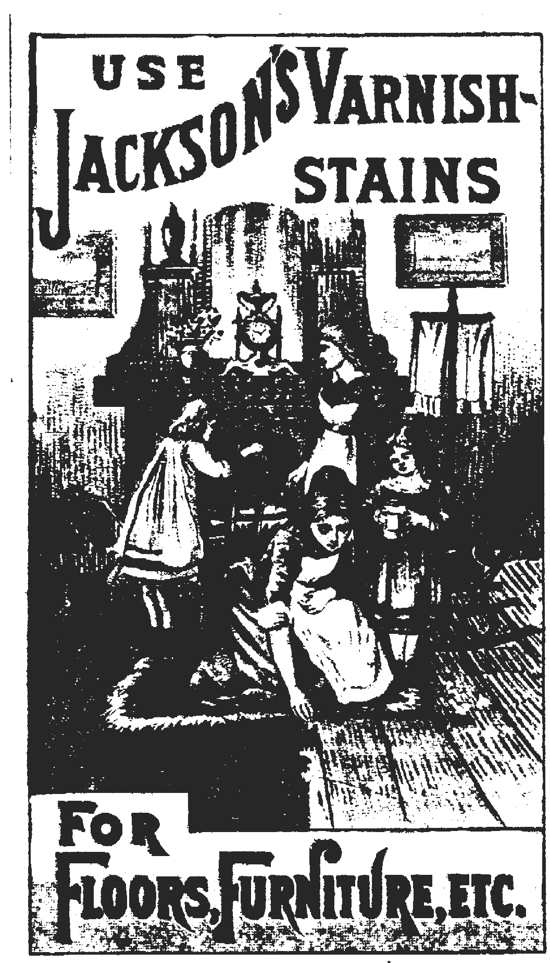

Happy Motoring

