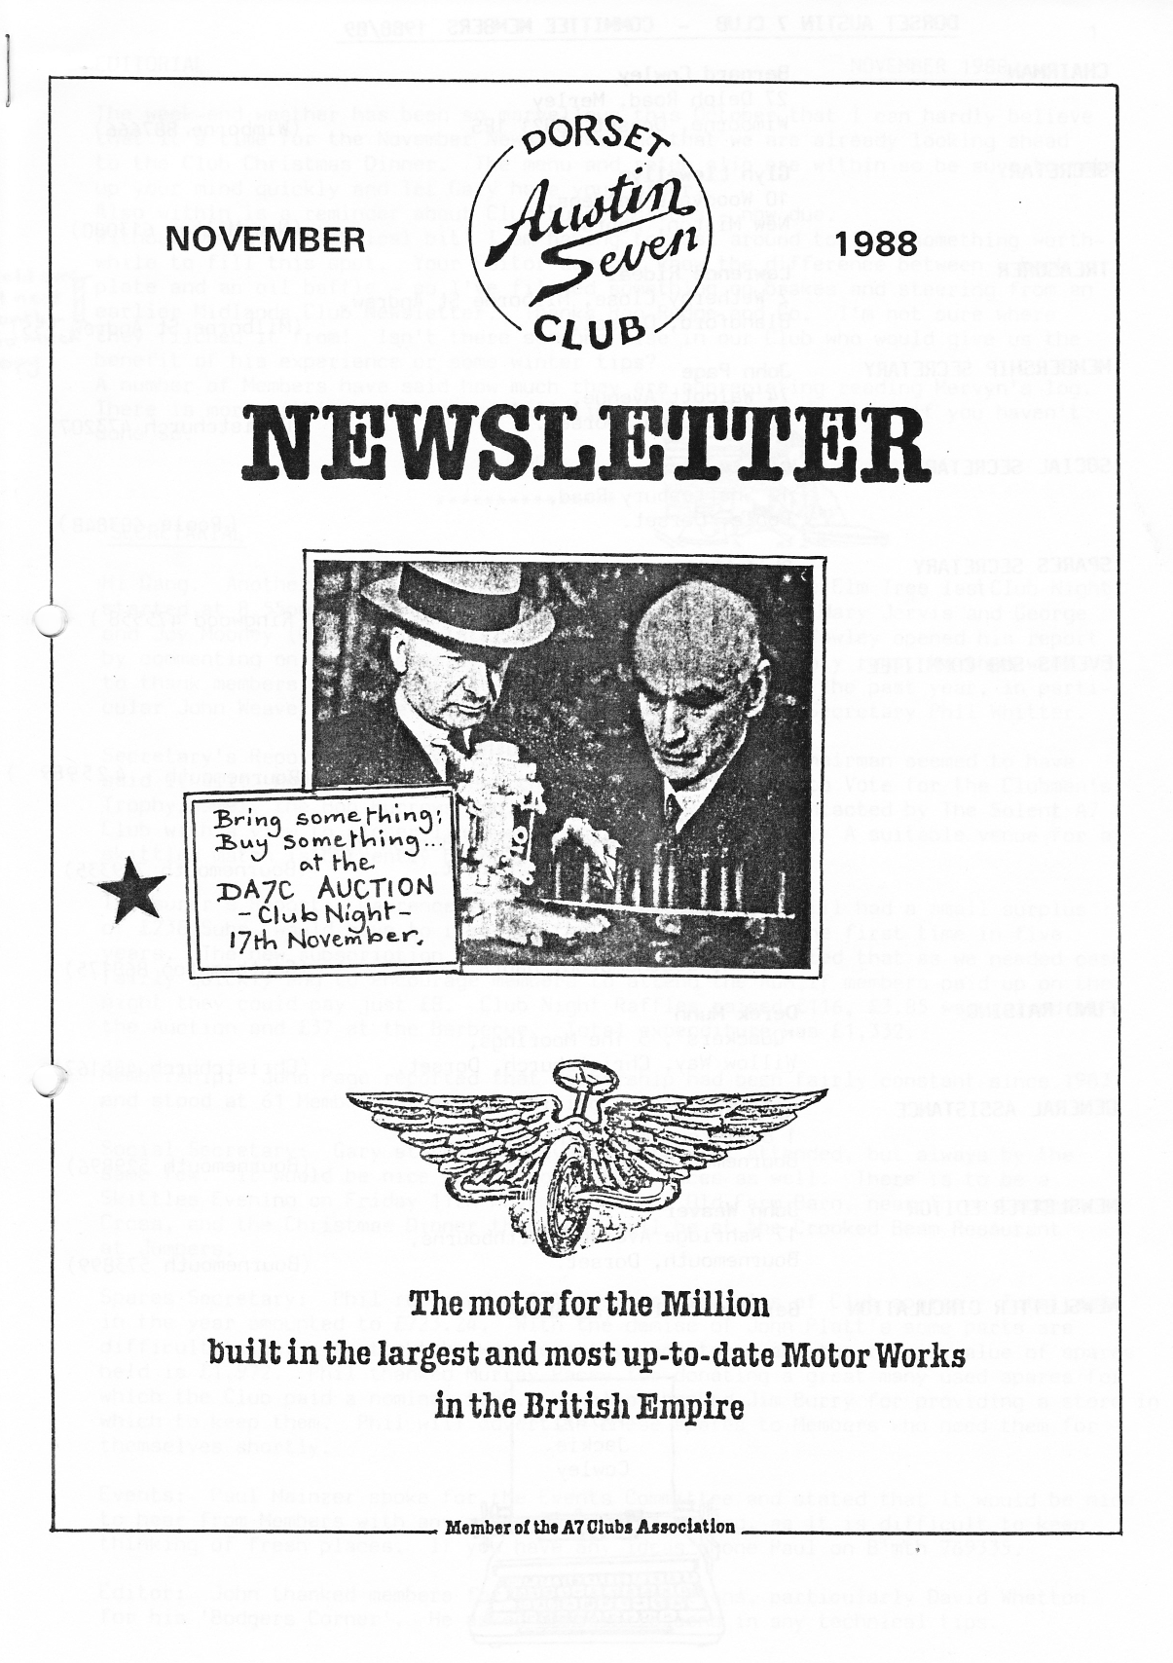
1
EDITORIAL NOVEMBER 1988

The week-end weather has been so marvellous this October that I can hardly believe that it's time for the November Newsletter and that we are already looking ahead
to the Club Christmas Dinner. The menu and return slip are within so be sure to make up your mind quickly and let Gary have your order.
Also within is a reminder about Club Subscriptions - now due.
Without David's 'technical bit' I am having to cast around to find something worthwhile to fill this spot. Your Editor doesn't know the difference between a back plate ⁻and an oil baffle - so I've filched something on brakes and steering from an
earlier Midlands Club Newsletter. Thanks Ron Rudge and Co. I'm not sure where they filched it from! Isn't there someone else in our Club who would give us the benefit of his experience or some winter tips?
A number of Members have said how much they are appreciating reading Mervyn's log. There is more within and there's still time to send him a donation if you haven't done so.
John "~=
SECRETARIAL
Hi Gang. Another AGM has come and gone; the meeting at the Elm Tree last Club Night started at 8.55pm. Apologies were received from David and Mary Jervis and George and Joy Mooney (who arrived later). Our Chairman Bernard Cowley opened his report by commenting on the success of our social events and monthly runs, he then went on to thank members of the Committee for their efforts during the past year, in particular John Weaver for the excellent Newsletter and Spares Secretary Phil Whitter.
Secretary's Report: I had very little to report, as the Chairman seemed to have said it all! However, I reminded the meeting of the need to Vote for the Clubman's Trophy, namely the Bob Burrows Cup, also that I had been contacted by The Solent A7 Club with a view to closer links on runs and social events. A suitable venue for a skittles match is currently being sought.
Treasurer's Report: Lawrence reported that, although we still had a small surplus
of £238, Subs. would have to rise for the coming year for the first time in five years. The new subscription is £8.50, however Lawrence stated that as we needed cash fairly quickly and to encourage members to attend the AGM, if members paid up on the night they could pay just £8. Club Night Raffles raised £116, £3.85 was raised at the Auction and £37 at the Barbecue. Total expenditure was £1,332.
Membership: John Page reported that membership had been fairly constant since 1983 and stood at 61 Members, the last joining in April 1988.
Social Secretary: Gary stated that events were well attended, but always by the same few. It would be nice to see some other faces as well. There is to be a Skittles Evening on Friday 11th November at the Old Farm Barn, near Three Legged Cross, and the Christmas Dinner this year will be at the Crooked Beam Restaurant at Jumpers.
Spares Secretary: Phil reported a 10°o increase in sales of Club spares., Total sold
in the year amounted to £723.24. With the demise of John Platt's some parts are difficult to get. A stocktake was recently undertaken and the retail value of spares held is £1,972. Phil thanked Murray Pacey for donating a great many used spares for which the Club paid a nominal £250. He also thanked Jim Burry for providing a store in which to keep them. Phil will advertise these spares to Members who need them for themselves shortly.
Events: Paul Mainzer spoke for the Events Committee and stated that it would be nice to hear from Members with any ideas for ª run or outing, as it is difficult to keep thinking of fresh places. If you have any ideas 'phone Paul on B'mth 769335.
Editor: John thanked members for their contributions, particularly David Whetton for his 'Badgers Corner'. He asked Members to send in any technical tips.
At this point the Committee stood down and Derek Munn took the Chair. With the exception of Richard Cressey the Committee were re-elected. George Mooney was nominated and elected to the Events sub-Committee.

Any Other Business: George Mooney mentioned that new members may not know what the Bob Burrows Trophy is all about and explained that Bob's wife gave the cup in his name as a memorial. Bob died of cancer about five years ago. ,

Derek Munn mentioned difficulties with the meat raffle and Alan Seymore kindly offered to supply the meat.

Lawrence mentioned that we still have some cast car badges. The meeting closed at 9.25pm.

The voting for the Bob Burrows Trophy followed and the Cup was won by Lawrence Rideal.
Any inaccuracies in this report are due entirely to the flow of Whitbread beer and no responsibility is accepted. See you Club Night.

Glyn

CLUB SUBSCRIPTIONS FOR 1988-89 ARE NOW DUE

The Club Membership subscription is currently £8.50, which covers all the family. Please let Lawrence have your sub. as soon as convenient. Cheques should be made payable to Dorset Austin 7 Club. What a bargain!
Newsletters cease after December if subscriptions are not renewed.
MERELY MOTORING. We hear from Roger and Rosemary Ballard that they hope to bring a selection of their interesting wares to the November Club Meeting. The Merely Motoring Christmas Catalogue, with great gift ideas will also be available. Those unable to attend the meeting can obtain a catalogue by writing to Merely Motoring, Kea House, Laverstock Park, Salisbury, Wilts SP1 1QJ Roger and Rosemary have kindly said that 10°0 of their takings at the Club Meeting will be donated to Club funds - as before.
I also hear from Roger that The Welding Institute (Southern Counties Branch) have arranged a Practical MIG Weldinq Evening at Eastleigh on 14th December. Admission to either of the two sessions, at 6.30 or 8.15pm is strictly by ticket, but a few places are likely to be available to interested Club Members who should apply to . Mr Eric Riggs, 31 Carisbrooke Avenue, Hillhead, nr Fareham, Hants P014 2PL, for tickets. For further details contact Roger Salisbury 23570
A few car badges are still available from Glyn at £5. As you will remember., these have been cast from old A7 crankcases. There are alternative lugs for fixing either to your A7 or to your modern' and badges can either be painted or polished. Don't miss out - they are unique and will not be made again.
There is some talk at the moment about the possibility of a visit (with A7s) to Jersey next Easter. If you are interested please contact Glyn who will have the latest news.

NEW FOREST CONKER TOURNAMENT RUN - 30th October
First we went... er, er.. "Gordon where did we go first?" (Coming to something when I can't remember where we went a few hours ago isn't it? Just retired in time if you ask me.) "Gord, this morning, after leaving Ringwood car park, where did we go?" (Me calling from the typeface, notice the affectionate "Gord." Usually works wonders..')
Slight shuffle of the Times, I know when not to pester! "Don't worry Cord I'll write down what I can remember and then you can put me right".
Now let me think. Right out of the car park, right again, through some traffic lights, then I remember thinking what a wonderful day it was to be out driving with the open top even if I was sitting on a pair of gloves to prevent chilblains in the nether regions. The road opened up; I felt like Toad, 'The car's the thing',. and all that jazz. Whee Hee! Ripley here we come.
Oh! but before that I do remember passing cars at that church outside Ripley and thinking that Bill Quayle had said we ought to be going to the synagogue else we'll be drummed out before long. (He's always trying to save all Gordy and me; keep it up Bill we need it.) Then I remember the sun was shining so much that Bob's shiny Ruby limousine dazzled me as we went round that sharp bend; you remember. (Excuse the way I write I think I'm talking to G.), when we met that tractor towing the big brown inquisitive cow in a mesh cage. Dear old chap his face positively lit up seeing all the T s he even insisted on pulling into the verge to let us pass. Mind. you when John got out to carefully count us, all present and correct like, his face went a bit glum, sort of saying, "Now come on you wealthy layabouts, we farmers have work to do on a Sunday". Still he was all gooey eyed as we bounced away.
Where then? Did we go to Sopley, Ringwood again, Bransgore? Well, nearly
I think, and er.. er.. well I know there was one name on the sign post I'd never heard of; can't remember what it was. (Never heard of Bagnum?) You know how it is, eyes on the one in front, dodge the potholes, horses, kids, eyes out for the one behind. Just a minute while I look it up... Sorry we don't have a fine detailed map of the area.. I know it was a lovely leafy lane all orange and yellow (It was Castle Hill - Ed.) I do know we went round Burley 2 or 3 times, in an out of people's drives, lanes, criss-crossing our tracks, each time saying, "Didn't know this existed, or who'd have thought this led to here?".
We used to play a game like that when I was a kid, called 'In and out the dusky bluebells'. Only this was more in and out of leafy lanes and forest paths Actually the first posh drive we turned in I thought, "By Jove, John's got some posh friends out here; he's taking us into morning coffee!" Until we all turned tail of course, wrong track!
In and out, round and about we even passed straight by the Elm Tree
pub without a mere suggestion of a stop, out over the A31 passing those forest weekenders. "Oh! George do look at all those dear little cars!", past the cyclists, head down, and those in Burley Street - sort of yuppies with their mountain bikes strapped behind the car. Looking for a Mountain I suppose. Funny things folks get up to on a Sunday these days, don't they? But, as I was saying, John, all this time smiling away, totally happy. Well he would be wouldn't he all that lovely sunshine a lovely wife and knowing what he had in store for us.
Eureka! The Alice Lisle! Zip, zip, zip, all lined up. Yes the cars as well as drinks and grub. John still smiling as he got ribbed about the mulberry bush and how to make a twenty mile run out of a five mile one. Actually I had to agree with his view that we do have some very enjoyable lanes to ride in, very close at hand and do not have to go miles and miles to enjoy a run.
By the by, one or two others joined up here, some to stay the course, others just to say, "Hi!" Nice how club members do that isn't it? If we kept up with things a bit more we could do that you know. (Talking to myself, sorry.)
Now where was I? Oh yes, trying to remember where we went, well if
you sort of take the map and scribble a path from Ringwood to the Alice Lisle which would take a row of Austin 7's about two and three quarters of an hour to do you'd find that you would have to travel along every minute lane and path not ,to say the odd garden drive, you would know the names of all the tiny hamlets we passed through, the order being irrelevant. It was just lovely, the sun glinting through the oaks all the world out enjoying themselves, just lovely.

And then the ultimate -
Out of the pub, no messing, straightaway to Cadman's Pond somewhere at the back of beyond, past the High Corner pub turn.
Zip, zip, zip, cars lined up, inmates out, excitingly encircling our hero John and the box of Conkers and even more excitingly the handful of individually strung conkers. Yippee! childhood returns.
Much ribbing ensues as John explains how he thinks we should run the
TOURNAMENT
Hey! hey! two girls in the final... cor that's a turn up for the books.. blimey Cynthia, you can't half hit! John P, I bet you have to be careful don't you? Come on Biddy, I reckon your conker's on its way out.. eight, nine, ten hits in a row... Hurray! Marvellous Cynthia! Well done! She's the Austin 7 Conkers Champ for 1988... You'll have to buy her a box of chocs, John... Well done!
Mar-vellous day. Thanks John. We haven't enjoyed ourselves so much for years. You and your beloved must have put a lot of hard slog to have found all those conkers, string and most of all a delightful unpredictable route. Many thanks.
Sorry this isn't so much of an account as a jumble, but somehow I'm not really sure where exactly we went, except the places I've mentioned, and that it took most of the day. The sun shone and we all had a super time and well that's the Dorset Club for you isn't it? Happy, friendly and full of fun. See you at the skittles.
What? Where are they? How do you get there? Well it depends whether you want to go as the crow flies or the Weaver way.
.
Biddy - ^{U}
SPARES NEWS

Recent 'additions to stock:
Oil strainer gauze Fan pulley bushes
Engine mounting rubber sets 26-29 gearbox seal and gasket set
All sizes starting handle springs 29-32 gearbox seal and gasket set
Sidedraught float bowl bolts Steering box oil seals (early and late)
Sidedraught progression jets Steering box cover gaskets
slow running jets _ Steering_-box_-thrust button shims
Throttle spindle bushes Headlamp nuts
Rear spring U bolts Front hub nuts
Front and rear S/A bolts
Please note there will be no spares at the Auction in November unless requested beforehand.

Regards, Phil.
FOR SALE: 1937 Austin Ruby Special. Contact Roger Nunn 4a Christchurch 474420
FOR SALE: An A30 and A35. Telephone Rosemary Hawkins, Gosport 580888 for details.
EVENTS -

NOVEMBER Thursday 17th November - Club Night at the Elm Tree. 8.00pm AUCTION EVENING Bring and buy! 90% of sales to the vendor 10% to the Club.

Sunday 20th November - Club Run to the Lymington area. Meet at the Furlong Car Park at 10.45 for 11 am.

Thursday 24th November - Committee Meeting at the Tyrrells Ford 8.30pm.

DECEMBER Thursday 1st December -'8' to Late' (for those who want to meet for a natter) at The Riverside Inn,Tuckton Bridge.

Sunday 11th December -(Earlier than usual this month) - Club Run to the Purbecks. Meet at 11 for 11.15am at Wimborne Square.

Thursday 15th December - Club Night at the Elm Tree. 8.00pm , Noggin and Natter.'
•
Saturday 17th December.;- ANNUAL CHRISTMAS DINNER
.
Thursday 22nd December - Committee. Meeting at the Tyrrells Ford 2.30pm.

