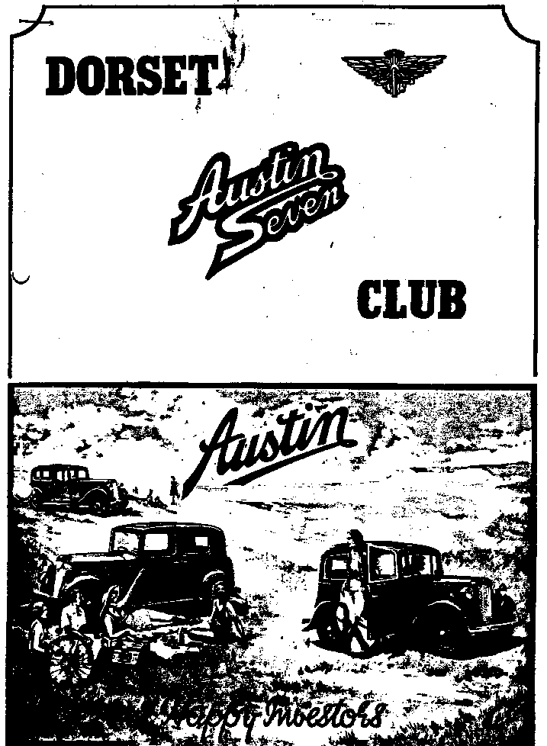

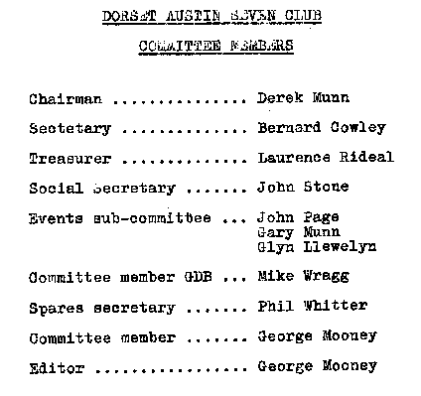
DORSET AUSTIN SEVEN CLUB NEWSLETTER NOVEMBER 1981

EDITORIAL
Hello everybody, here I am sitting down to write my first newsletter editorial and to try to get to grips with preparing my first newsletter, Cor!
Firstly, on behalf of all the membership I want to thank Glyn and Pat Llewelyn for the excellent newsletter that we have been receiving during the last two years and for the very considerable effort that has been put into their production. To explain to those readers who were not at this weeks AGM, Glyn Llewelyn has stepped down from the post of newsletter editor and yours truly was voted in. So for a while you are going to get my style of writing. I just hope it’s OK for you.
Secondly, just a reminder, it is your newsletter and it is your news and views that we are interested in so please let me have your input in the way of articles or letters unless you want to get just my musings and opinions. I need your help and rely upon you. OK! enough of that.
Did any of you see ‘Wheels’ on the TV on the subject of energy saving cars? It is amazing cars are heading for 80+ MPH. Before long you know we are going to be accused of driving gas-guzzling Austin 7s. Wow!
Looking out of the window from the bedroom this morning, I realized that the Chestnut true was becoming quite bare. The little schoolboys have stopped collecting conkers now and we have leaves all over the floor. It seems no time since the first leaves were showing. You watch, anytime now it will be Christmas ads. on the tele and Father Christmas in the shops. Doesn't time fly.
The November Club night relies heavily on your participation, so dig out those A7 slides and photos and bring them along. Winter evenings and slide shows go well together.
AGMs are usually dry affairs but despite the formal business, our AGM evening was a great success with considerable support, some members travelling quite a long way.
Finally, don't forget to put on your thinking cap before club night so that you will know what parts you need to buy from Phil Whitter. It will be so much more convenient for you to be able to get your parts on club night. If you buy a few small parts at a time, you will have them when you need them and you won’t notice the cost the same as when you have to buy in a hurry.
There was a recent TV programme that I was disappointed to miss, called Collectors World and much of the programmed was about Barry Clarks Austin collection. Anybody get it on video? See you club night if you can make it.
Yours in oil,
George
THREE MONTH CALENDAR
19th November. Clubnight Slide and Photo Evening. Nags Head, Ringwood. Bring your A7 slides/photos. The success of the evening depends on you.
22nd November. Sunday Club Run to Weymouth (Ideal for our Wareham members!). Leave Wimborne Square 10.30 am sharp
26th November Thursday Committee meeting at The Tyrell’s Ford, Avon, 8.30 pm
17th December Clubnight Christmas Noggin & Natter, funny hats and crackers optional!
20th December Sunday Club Run to the High Corner Inn. Depart from Ringwood cattle market car park at 11 am sharp. Just a short run to the very popular Inn at Linwood.
21st December Monday Committee meeting at The Tyrell’s Ford, Avon, 8.30 pm
1st. January Friday Club run to Calshot. Leave Cat & Fiddle at Hinton Admiral 11am sharp (on A35 near Christchurch)..
16th January Saturday Skittles Evening at a The Langton Arms Tarrant Monkton, nr. Blandford.
21st January Thursday Club night at the Nags Head. Brush up on your Austin general knowledge for a bit of fun.
23rd January Saturday Solent 10th anniversary party, Beaulieu.
24th January Sunday Club Run to Shaftesbury. Leave Wimborne Square 11am sharp.
28th January Thursdsy Committee meeting at The Tyrell’s Ford, Avon, 8.30 pm

Will other club secretaries please note:
Visitors to DA7C club runs are always welcome so come along if you can. Tell your members.

SALES & WANTS
WANTED: Steering. wheel in good condition to fit 1936 Pearl/Ruby. Please contact with price/wants Margaret Cressey, Old School House, Charlton Horethorne, nr. Sherborne, Dorset.
FOR SALE Morris Series E green/black needs a little work for MOT seen recently by club member and quite tidy. Ring Mr. Thomas, Bournemouth 39754.
NEW MILTON TYRE CO. have a supply of 4.25 x 17 Pirelli tyres better size for your Ruby than 4.50 x 17 £30 + VAT each.
350 x 19 Avon tyres also in stock at £22 + VAT each.
Phone No. New Milton 613647, ask for Mr. Bates junior.

MEMBERSHIP MATTERS
No new members this month. (Correction - Late Item).
Subs were revised it the AGM and a majority vote ln favour of a small increase was cast. Annual subscription now to become £5.00 per annum. For those members wanting copies of the quarterly A7CA magazine the subscription becomes £7.00 per annum inclusive.
We hope you will be pleased to have a list of club members, one is enclosed.

ALLIANCE RUN Sunday 18th. October
You will have seen the run to HMS Dolphin and the Alliance advertised with a 10 am sharp departure, guess who was late! Me.
We got away at 10.15 am and what a lovely morning - bright but fresh, an ideal October day for a run out.
There was a very good turn out, we had nine cars including five Rubys, two Boxes, one superb flat nose Morris Cowley and one Japanese light bulb, (Mazda). We surprised ourselves and got to Gosport too early! It took us about an hour and a quarter for the trip so we all has chance to go to the beach at Gosport until opening time.
Our party ran to 28 people including 11 children plus Sherlock (Holmes the dog of course).
We left the car park to go to a local hostelry called the Inn By The Sea but we were held up by, guess who - right first time, it wasn't my day. I lost Peter!
At the Inn, we had the use of a rather musty garden pavilion/shed for the children, full of coin machines and with a pool table. I don't think they noticed the must. The landlord kindly put a heater in to make it more comfortable. The food was good and was good value.
Before we left the pub a local arrived in a really very smart Series E Morris Post Office telephones van in correct livery and in very nice order. It came out of service in 1965 but had been built in the late 40s. The sight of it took Phil Whitter and John Page right back to those good old, bad old days. (They both work for the PO!)
HMS Dolphin was a short run which nearly finished with us all in the dock! We were misdirected by the Navy man on duty.
The Alliance was one of the last of the wartime subs to come out of service. It was built for service in the Pacific but hostilities ended before it could get there! So it never went.
The submarine is completely out of the water on two massive concrete plinths. The whole visit, including the museum, is really well worthwhile. If you missed the trip go on your own someday. Incidentally, you missed a bargain. We got about 30p reduction because of some hard-nosed bargaining by Glyn and John Stone and because there were 28 of us.
Of interest to the ladies will be the fact that the problems of getting this large 1200 ton submarine out of the water, so the concrete plinths could be built below it, were solved by a young lady engineer working for Wimpy.
It's a bit of a performance getting from the Alliance to the museum. You must go in the minibus and the driver doesn’t seem very organized, so our party seemed to get split up for a long spell.
They hope to get the very first Holland class submarine up from the bed of the sea and bring it to Gosport for exhibition during the next year or so. That will be a must for a visit.
The day held fine for us all and we enjoyed a pleasant run home together as far as Southampton where we split up and went our separate ways. A good day out enjoyed by all.
George & Joy
AUSTIN SEVEN CLUBS ASSOCIATION MEETING

At the request of the club, I attended the Assoc. meeting at Great Hasely on 11th October 1981. This is a review of the day’s proceedings.
The minutes of' the previous meeting were reviewed.
Matters arising: 1) The A7CA magazine index issue will not appear in 1981 due to pressure of work. Index of 1st 10 years issues should now be in 1982A issue.
2) A gentleman named Aldi Halabi 750 MC, is working on a new chassis register.
3) Entry forms for the 1982 events i.e.:- John O’Groats - Lands End. Run and Longbridge Rally will go out with 1982A magazine issue.
4) Vegetarian meals will be available at the Longbridge formal Jubilee dinner.
5) Dates for the John O’Groats - Lands End Run are Sat. April to Wed. 14th April.
Secretary’s report
We have been approached by a company connected with Car Club publications for information on club activities. The information is considered to be more than should be given and. therefore it will not be. given.
Classic Vehicle Hire Co. may advertise in the A7CA mag. They are interested in hiring certain classic cars for films, events etc. The Assoc. know a certain amount only about them and the f act that they are to advertise in the mag does not imply endorsement of this company. We have been approached by a number of reputable companies who may advertise in the magazine.
A certain company in Swindon have been doing poor work on magneto rebuilds. Two new sources are being investigated. More details later when fuller information available.
NB The secretary urges you all to re-read your magazine on the subject of insurance and EVEREST and to please take note of the new insurance recommendations, it is in your own best interest.
Treasuries Report
The association is in a satisfactory financial situation but the cost of magazine production will increase around 10% for 1982.
Editors Report
In the Jubilee year 1982 there will be 4 issues unlike 1972 when there were only 3. The Jubilee issue will probably be 1982D but it will be difficult to get all the Longbridge rally information available in time to produce the 1982D issue as Jubilee issue due to lead times involved. At worst, the Jubilee issue will be 1985A but every effort will be to have it ready in the Jubilee year.
For some time now we have been seeing a ‘Cars We Own’ feature. A new feature is planned ‘Cars We Find’ showing them as we find them. These two features may run together replacing ‘Personalities’ as people are now fighting shy of this one.
Bristol club representatives offered a well-deserted vote of thanks to the Editor for the continued high standard of the magazine.
Registrar
There are around 8000 chassis on the existing computer record. As mentioned earlier, its meet toned a new register is being worked upon.
Archivist
We have been offered 3 volumes of Gunner Pope's scrap books for £600. They are to be viewed before any decision is made re refusal or purchase. Robin Reid of Dante has found a photo for a poster and has offered to write the story of the Dante for the magazine.
Breakdown Register
This will continue unchanged. NB my address is wrong! I no longer live in Salop.
Fabric Register
The register is now in the capable hands of Wally Dew, 42 Adelaide Road, Chichester, West Sussex. Ch. 783938. He awaits your calls.
Spares
John Barlow now has new oil buttons available, both patterns. I have seen them and they are excellent. Price £23 each plus postage and packing.
Calendar
Bernard Griffiths urgently needs club input re event dates. Please send as soon as ⁻possible. An interesting local event is on 23rd January 10th Anniversary of formation of Solent A7 Club. There is to be a party at Beaulieu. More details later.
The 750 MC National A7 Rally may be moved away from Beaulieu. They are having difficulties with the management at Beaulieu, possible alternatives are available in this area.
Any other business
There is a continued fear that the DVLC Swansea may clear unused old numbers out of the system after 3 years and not accept claims to numbers held on old log books. You have heard of this one before. It is still possible that we will see X reg. Austin 7's if we do not put up a fight. Incidentally, I saw an M reg. A7 Ruby at Beaulieu National Rally this year!
Write as often as you can to Mr. Bailey at DVLC Swansea, your MP, the Transport Minister and make your views known, if you care.
It seems that you can currently still tax your Austin 7 for £50 per annum on the basis that it is a 7hp car. Get in touch with your local transport dept. and get them to delete 747cc from your owner document and insert 7hp. Show them your old log book to back up the point. It is worth a try to save £20.
For those people taking part in the end to end run arrangements have been made to camp at 3rd off normal rates at the end of the run at the St. Merrion Camp site. A list of guest houses will also be made available to entrants.
Sponsorship for the Jubilee events may be forthcoming for the assoc. to help with costs. Likely sponsors will be TSB and Unipart.
Date of next meeting, 10th January.
*****
Latest copy date for December newsletter, articles/sales/wants etc. 3rd December in the hands of the Editor. Articles received after that date may appear in the following issue.
******
Congratulations to Gary Munn on his 21st Birthday which he celebrated on the 6th November.
CLUB SPARES
The following spares (unless previously sold) available from Phil Whitter on Club night or on Ringwood 5558 by arrangement.
All felt oil seals King pin sets early & late
All gaskets Lock washers
All studs and stepped studs Manifold nuts & studs
Brake cables Oil pump springs
Brake cams Prop shaft universal joints
Brake cam bushes Radiator hoses
Brake drum screws Rim tapes 17”
Clutch linings Rear spring pins & bushes
Clutch mousetrap springs Rad. caps (Ruby)
Clutch comp. springs Spring shackle bushes
Core plugs large & small Spark plugs
Shock absorber rubbers & washers Shaft keys
Distributor caps (late) Engine mounting rubbers
Exhaust flange nuts & bolts Track rod kits
Distributor points (Ruby type) Valves
Dynamo brushes Valve guides
Fly wheel keys & nuts Valve springs
Fan belts early & late (original & nylon)
Spares Report
Recent additions to spares include everlasting nylon fan belts, carburettor spindles and bushes, to recondition your clapped carb., and clutch linings. I have a few copies of John Platts catalogue for those of you that have not received one through the post. The services he offers are very ambitious, let's hope he will make a success of this venture.
Special Offers This Month
Nylon Everlasting Fan Belts coil/mag £1 each
Split Collet Valves (believed, but not guaranteed to be exhaust quality) £1.50 each (normally £2.20)
LJ 1¼ Bearings for Wheel Hubs
diff. ball races 23-28
1st motion shaft 3 speed box
normally £6.30 each ………………………………………………………..£3/£5 pair
Secondhand Snares
Late Ruby cut outs £5 each
Sweat Shirts
I have just received our order for £105 worth of sweat shirts. This is a heavy money commitment for our club. Please collect and pay for your order on club night or by arrangement. The club has some stock of various colours and sizes if you have not ordered.
Important Note Because of the time lapse between paying the bill and getting the money in, .all future orders for sweat shirts will have to be sent or handed to me with a cheque made out to Dorset Austin Seven Club, please. Adult sizes £4.75 Child sizes £3.50.
Phil Whitter, 134 Northfield Road, Poulner, Ringwood, Hants. Phone. Ringwood 5558
OBITUARY
It is with great regret that I have to announce the death of Bob Burrows on Friday 30th October after a long illness. I am sure that we will miss him both for his character and his ever-friendly advice to any of us who were in trouble with our cars. We all offer our deepest⁻ sympathy to his wife, Barbara and family and also to Ted Carr-Jones his friend of very long standing.
Derek Munn
***********
Late Item
Welcome to new member Mr. Ian Vose of 1 North Crescent, Millborne Port, nr. Sherborne, who has a 1936 Ruby recently acquired.

