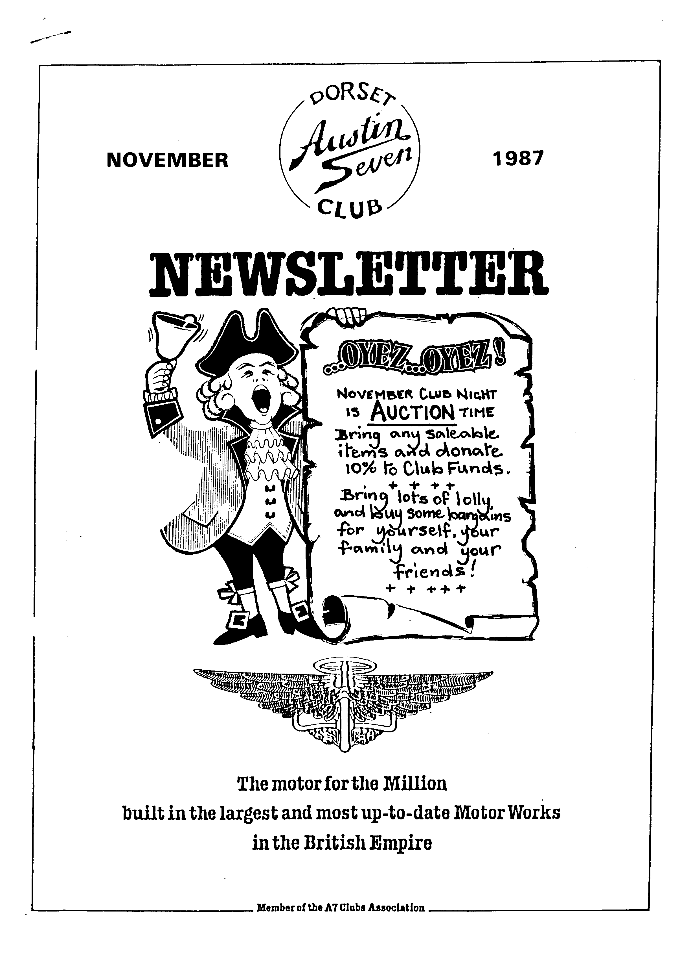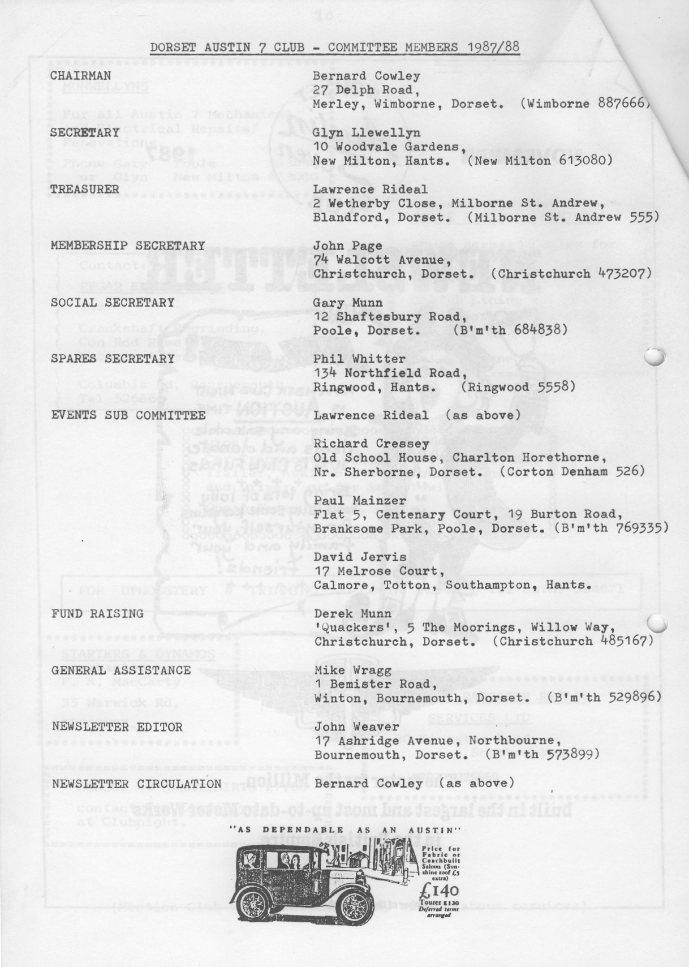

EDITORIAL

For me it was a memorable AGM this year. To carry off the Bob Burrows
trophy and a pound of Tesco sausages is something few have done. I am absolutely delighted with the award which came as a complete surprise. There are others just as deserving, as I well know but my thanks to those whose votes gave me the honour. In fact I enjoy putting the Newsletter together and for such a pleasant company it is a pleasure.

Gay and I joined the Club in August '85 and so did not know Bob Burrows. As there must be other members in that position I have questioned some founder members and discovered that Bob was a keen club member who sadly died some five or six years ago. Bob's wife kindly presented the Club with an attractive cup in his memory which is inscribed 'The Bob Burrows Austin Seven Trophy'. The Club Committee decided that the cup should be presented annually to the 'Clubman of the Year' and it certainly ensures that Bob is not forgotten.

This month's main feature concerns Austin Marine Engines, one of which was a Seven. I remember how, at one of our earliest meetings at the Elm Tree, Vic Steele produced part of the gearbox of such an engine to set us guessing. There was a good deal of curiosity at the time as not many had seen a Thetis or a Triton, although some knew about them. All you need to know is within. It's motoring afloat time, folks! Look out for the Wiring Diagram for the 1930/31 A7, plus Test Data in next month's Newsletter.
DECEMBER NEWSLETTER
Your contributions welcome.
Please submit by 28th November
- Christmas is coming!
As the November Club Night
is an Auction Evening
spares will not be displayed and available in the usual way, but Phil has kindly said that he will try to meet any orders made prior to the day.
SECRETARIAL
Hi Gang!
I am sorry that there was no Secretarial last month, the reason being that Pat and I were on holiday, I should have done it before we left, but there.
I did discover whilst on holiday that navigating a narrow boat is not dissimilar to driving an Austin Seven, they take awhile to get going, are not very fast, they weave about all over the place, and take a lot of stopping. By and large a real home from home.
Last month's meeting included the AGM once again which passed very smoothly. We heard from Bernard, our Chairman, that it had been another successful year, although events had been a little disappointing due to our not having an Events Secretary. Lawrence, our Treasurer was also in optimistic mood and reported that the Club was in a strong financial position and that for the umpteenth year subscriptions would not need to rise. Phil Whitter reported record sales for the Spares scheme. Sales were £655.76 and purchases £520.34. The total value of the spares is estimated at approximately £1500. Phil stated that due to pressure of work he had not had time to do a complete stock take of the Spares.
Social Secretary Gary Munn reported that Social Events were reasonably attended He said it would be nice to see a few 'new' faces at events. The one non-event of the year was the 50s & 60s Evening which had been a nightmare to him - we were lucky not to make a large monetary loss.j
ohn Page reported that Membership remains much the same each year, peaking at about 70 member,.

As Secretary I thanked my fellow committee members for their efforts, in particular John Weaver who took over as Editor in March after Brian Hooper had to resign, due to pressure of work.

I also reported that the first consignment of car badges were in the process of being cast.

The Committee then resigned and was re-elected on a show of hands. Two
new Committee Members were elected to organise events, these being Paul Mainzer and David Jervis. Well done lads, don't forget Whitbread pubs are best and they must take dogs and children! Mervyn Frampton proposed a vote of thanks to the Committee for its work over the last year. The meeting was closed at 9.30pm, the Clubman's Trophy was then put to the vote and was won by John Weaver for his tremendous effort with the Newsletter, well done that man. (Aw, shucks! Ed.)

Unfortunately the Club Run last month 'The Wiltshire Wander' had to be abandoned because of the Hurricane which had brought down quite a number of trees across our route. However, Phil said he would organise it again for November.

Well that's all from me this month, hope to see you Club Night.

BEAULIEU - WEYMOUTH RNLI RALLY

My intentions were good, they always are, and I really did mean to try and meet John's deadline for the October issue, but you all know how it sometimes is. Excuses. Excuses.

It would seem by the report of the Shaftesbury run that there is a darker and more perverse side to this gathering. Or maybe it's just Brian. At any rate, whilst the thigh gazing was taking place on the Saxon Hill Top, your Chairman and I were endeavouring to maintain the good name of the 'Dorsets' on the Beaulieu - Weymouth RNLI Rally, which took place on the same Sunday.

It was very well organized, especially so, bearing in mind it was the first time they had undertaken to organize a rally and although there were no cars of outstanding interest, apart from the Stanley Steam car that is, the meeting was well attended. The spread, which had been laid on at Crichel House, for the lunchtime break, was superb and itself well worth the entry fee. In the afternoon the weather deteriorated, but notwithstanding Bernard won the Speed Trial held at Tarrant Rushton Airfield. How he has got the nerve to make Jackie and Daniel stand in a tropical rainstorm just to lighten the car is beyond belief. Although I must admit that when I asked Emma or rather suggested to her that she might like to join them, I got an answer which would have made the habituees of the St Pauli district of Hamburg blush!

All in all a very worthwhile day out. Perhaps next year a few more of us might go along. You won't be disappointed.

Paul.

Thanks, Jackie, for much typing this month on that snazzy new typewriter. Ed.
SPARES REPORT

Pistons and rings are currently difficult to obtain and Dave Phillips tells me that he is not now expecting delivery from Taiwan until January '88. Talking of Taiwan, Howard Annett is expecting a new delivery of 'Rickshaw' tyres with 350 x 19 at £20 each and 400 x 17 at £30 each. Inner tubes will be £4 each.

John Barlow is producing cross shaft bushes in all sizes and I currently have these in stock. I have got two copies left of the new revised 'Austin Seven Bodies' poster from Phil Baildon at £3.50 each and four copies of the classic 'Chummy In The Lane' picture at £1.50 each (just right for Christmas!)

Recently I visited Seven Workshop and spent over £300. on replacement and additional spares. This represents an extra injection from club funds of £115 but this is the first additional purchase for over a year. As a result of this we now have good stocks of distributor caps, brake cables, cross shaft bushes and springs, brake rope guides, copper asbestos high and low compression head gaskets, hub felts, sump gauze, alloy shock absorber links and many other items including small things like keyed shock absorber washers and brake drum screws.

For those of you with VHS video I have purchased a copy of 'Miles Ahead' from the Austin Seven Film Library which features ten black and white sound films about Austins including some super film of the works in the thirties. This will be available for a nominal hire fee following its preview at a future club night.

Changing the subject I am very aware that I sometimes keep people waiting for spares at club night and if this happens please accept my apologies but I am unable to serve everyone at once and not always in the right order. It is not easy running a 'one man band' to keep everybody happy all at the same time so I hope you will understand if you have to wait a few minutes for the items you need.

Lastly, does anyone have a new oil jet that can he copied or do we have a retired engineer (or a working one!) who is prepared to make a batch of these badly needed items? They have never been seen again since John Platts produced them back in 1983 and are a badly needed item for our members (and even other clubs if you have the production capacity!).

' Yours sparingly, „
_ Phil.

MOTORING AFLOAT
By " Propeller"
ALL power-driven boats, large or small, new or secondhand, have this in common they must have a dependable engine. A breakdown on the road is irritating enough, but a breakdown at sea can be much more serious. So the engine question must be studied well, and a few words here about power units will not be out of place.
The chief differences between a car engine and a marine petrol engine are in the cooling and in the reverse gear. Instead of a radiator the marine engine has a pump which sucks water from the sea, passes it round the circulation system and ejects it overboard. The pump has to be of the self-priming variety and not so particular regarding its diet that it gets upset by a few grains of sand in the water. It should be furnished with some device for controlling the amount of heat which it removes from the engine.
Not only must the cylinders be cooled but the exhaust manifold as well. Otherwise, lacking the blast of cold air which cools the exterior of the engine when in a car, it might become red hot and cause a fire. It is a good practice, also, to provide some means for cooling the lubricating oil. Usually, after doing all this good work, the water is passed into the exhaust pipe to assist in silencing and to prevent the pipe from getting too hot for comfort.
There is no need for a change-speed gearbox in a boat, but a reverse gear is an essential and, since this is the only form of brake aboard, it must be capable of changing from ahead to astern instantly and without complaining if it is used a trifle unfeelingly in moments of anxiety (such as when under-estimating one's speed on entering
a lock). This mechanism has, therefore, to be of rather special design.
There are, of course, other features particular to marine engines but this article will be devoted to those points for which the prospective owner should look when making a choice.
If silence is desirable in a car, it is twice as much so in a boat, especially in a cabin cruiser where a small compartment may be shared with the engine for many hours at a stretch. In these circumstances the difference between a noisy and a quiet power "nit can be the difference between discomfort and pleasure.
Exercise is, we know, beneficial to health, but we don't all like the same forms of it. 1, personally, dislike taking it by swinging an awkward handle in an attempt to start a reluctant engine. If you share this distaste, pay heed to the starting properties of your unit. Even those engines fitted with electric starters should have a starting handle so mounted that it can be swung without damaging knuckles against a bulkhead or the boat's bottom.
In these enlightened days engines do not require much tinkering but they all require a little attention and adjustment at some time or other. In cars they can be reached from above, from each side and from below, but in boats they are not always so fortunately situated. It is an advantage, therefore, for such things as tappets, water pump greasers, the contact breaker and distributor, to be arranged where they are easily accessible. In the same way it is essential to be able to drain the crankcase oil without having to lift the engine from its bed.
Such accessories as petrol tanks, instruments and controls should be designed for their job and thought should be given to their location. Tanks should be easy to fill and should be furnished with a drain cock for removing water and dirt, while the disposal of the controls and the instruments so that they are under the helms-man's hand and eye respectively is a point to which enough attention is not always given.
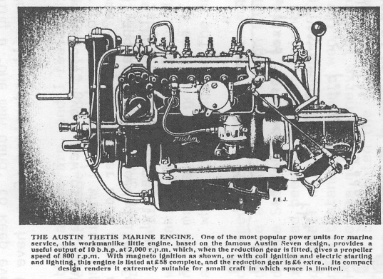
Engines are so often placed where they are out of sight and out of mind, and they are nowadays such uncomplaining creatures, that there is a temptation to leave the;,, too severely alone. Remember, then, that a little care and an occasional clean round is never wasted. It increases one's pride of possession for one thing, and enhances the value of the boat in the secondhand market for another, in this latter connection I might add that a boat with a marine engine built by a well-known firm commands a better market than one with an obscure make, or one that has been built for a car and adapted for
marine use.
⁻⁻⁻g-⁻⁻- line length, the faster a ship
How much power is required to drive a boat? Well, to say that this depends on the boat's size and speed is to make a rather obvious remark ; but the phrase, "It is impossible to lay down a fixed rule on this point"--one that I have seen too often in print-evades the issue.
Let me therefore quote a few examples, just to give a rough idea. A sixteen-foot dinghy needs about seven horse-power ; a twenty-two-foot river launch needs about the same ; an estuary launch of twenty-two feet in length should have between ten and twenty horse-power. Coming to cruisers, seven horse-power would be right for a boat of from eighteen to twenty-two foot, while about ten horse-power will he wanted for a twenty-six-footer. A thirty-foot cruiser needs around twenty horse-power, preferably in the form of two engines driving separate screws, a system which has advantages both in respect of manoeuvrability and immunity from complete breakdown. It is interesting to note that speed is not directly proportional to power. If a cruiser does seven knots with 20 b.h.p., she will not do fourteen knots with 40 b.h.p. For every hull there is a speed at which she can be driven comfortably and economically ; going above this speed requires an increase of power out of all proportion to the results gained. Generally speaking, the greater the waterline length, the faster a ship may be propelled.
Sports and games can be divided into two classes : those in which the new¬comer requires a course of instruction before begin¬ning to enjoy himself and those at which he can enjoy himself from the word "go." Motor boating falls into the second category. Providing he is content to begin in a modest way, there is nothing to prevent the tyro from learning as he goes. Handling a boat in a non-tidal river is simple enough to anyone who can drive a car, and a knowledge of seamanship is unnecessary. In tidal waters there is, of course, more to learn, such as the behaviour of the tide and the location of mudbanks. In the course of a few week-ends the novice will have picked tip enough knowledge of elementary seamanship and navigation to take his boat a little further afield than the immediate neighbourhood of his home port. Bit by bit lie will acquire more and more knowledge of weather, tides, charts, knots and the hundred, and one things that are so interesting that he cannot help
but learn about them, until he finds himself skilled and confident enough to take his ship for a prolonged holiday cruise. Of books dealing with all matters of interest to the motor boat owner there are scores ; to mention but two, "The Motor Boat Manual" and "Motor Cruising," by K. Marillier Miller, will be found very useful and instructive.
So long as he does not attempt anything too ambitious before having acquired a little experience, nobody need be deterred by lack of knowledge from taking to the sea for pleasure. Nearly anyone can find among his circle of acquaintances a keen amateur mariner only too willing to ship as crew and give a little help and guidance.
The question of expense is a less alarming one than might be supposed, for the reason that boating can be as cheap or as costly as one cares to make it. This feature of being able to cut one's suit to fit one's cloth is one which allows yachting in various degrees to be enjoyed by all, from artisans to millionaires.
In the same way that costs for a motor tour of the British Isles can vary according to the tastes and means of the participants, so is it with the costs of running a motor boat for a season. Junes will leave all painting and maintenance jobs to the local boat-yard while Smith takes a delight in doing as much as possible with his own hands. Junes will have a paid hand aboard while Smith scorns such an idea. Jones's tastes run to caviare and a well-stocked wine-locker, while Smith enjoys the more primitive type of picnic meal. And so on from clothes to clubs. Each will be enjoying himself in his own way though expenses
differ widely. Some
idea of the amounts involved may be gathered from one or two average instances of different types of boat, each assumed to 'be bought new and well maintained, the figures including interest on capital, depreciation (taken on an average over ten years), insurance, repairs, painting, storage, fuel and oil.
Take first a river launch costing be. tween £200 and £250. If she is used for only 200 hours in the year the cost works Out at under five shillings per hour of
use. If the average number of people aboard
be four, then the figure of less than one shilling
and threepence per person per hour is a very
cheap rate at which to entertain one's friends.
A sixteen-foot motor dinghy used for the same
number of hours on an estuary would cost even
less ; somewhere about three shillings and sixpence per hour of use.
With motor cruisers it is obvious that the figures must vary very much with the size, the extent of cruising and the cost of laying up, which varies in different districts. But four fellows I knew, who shared a000 cruiser of 28 ft. length, found that E25 each covered their costs (including interest and depreciation). The boat was in commission from the middle of April to the end of September and they used it three week-ends out of four as well as for a fortnight's summer holiday. They found it compared well with what they would otherwise have spent on hotels and cinemas. There is one expense one does not have with a boat-there is no road tax to pay.
In the same way that motor boating can be made as cheap or as expensive as one chooses, so can one make it as safe or as dangerous as one chooses. In the quest for amusement and adventure there is no need to run the risk of being drowned in a gale or of running onto an
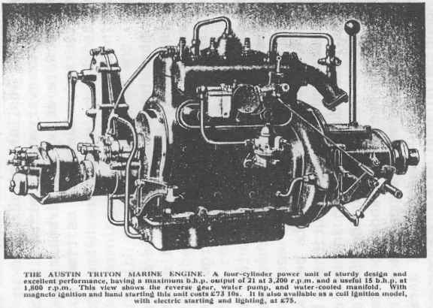
uncharted rock. Just use the same care and common sense as is called for in crossing the street. In fact, accidents to pleasure boats are so rare that when one occurs it is always sure of a prominent place in the daily Press.
But this is no reason for neglecting precautions.

All boats used at sea should carry fire extinguishers and some sort of life-saving equipment. I have had a fire at sea, but it was not caused by the engine or its fuel. It was due to an unsecured cooking stove taking a header onto the floor. This small outbreak was skilfully dealt with by my companion, who extinguished it with a potful of tea ("I did not like to use the 'Pyrene,' unnecessarily " he said, "because my hands were dirty! ") I have also been a "man overboard," but it was not due to the dirty weather through which we had come. It was when we were safely moored in a harbour and was due to my neglecting to look in the direction in which I was walking. Such trivial happenings show that one should always be prepared. A good sailor takes a pride in the efficiency of his precautions against disaster.
The most important precaution is tidyness, a virtue of ten times more value afloat than ashore.
If, in your own home, you were so untidy as to leave your sea boots on the piano, a spare tin of petrol in a chair and a coil of rope on the hearthrug, it would not matter seriously (I don't mean that your wife might not demur, but that you would not, as a direct result of such carelessness, fall into the bath and be drowned). Afloat, however, it is dangerous to leave gear lying about in the wrong place. Besides, nothing responds better to orderliness than a boat. So be tidy, not only with things, but with your actions.
There is some excellent advice on this score given in Ecclesiasticus, which applies to the handling of boats, guns, fishing rods, ropes and particularly boat-hooks :"Whatever thou take in hand, remember the end and thou shalt never do amiss." And that, I think, forms a fitting conclusion to a mariner's words of advice.
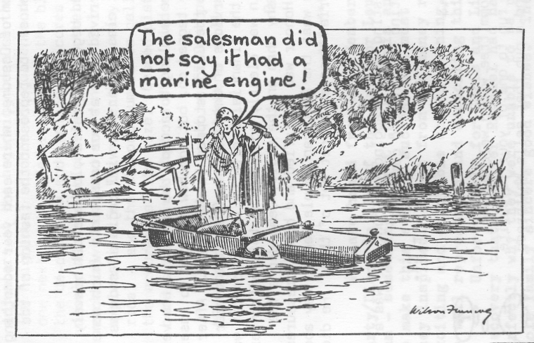

BATH - An extra run - Sunday 4th October

Seven A7s, joined on the way by one 'modern', (the driver stated that he was trying it out with an A7 engine) made very good time on the outward run, arriving at The George, Bathampton around noon, as planned. It was soon clear what a popular lunchtime spot this was, as folk crowded in from all quarters; but there seemed to be room for everyone either inside or outside in a very pleasant setting. As we were among the first arrivals we did not have to wait long before we were served, which left us time to wander along the canal bank before the 'Longbridge sound' was heard again as we covered the few remaining miles to Bath itself.

Dropping down on the A36 afforded a striking view of the elegant city, much enhanced by the Autumn sunshine. Fortunately Brian and Jill are familiar with Bath's one way system (or so it proved in the end!) and they. lead us into the Royal Victoria Park where we parked prettily and without charge.

As the majority had favoured a quided walk rather than a bus tour we ambled off, securing ice-creams as we went, to meet our Guide outside the - or was it? We all found her in the end and were delighted to find that she was a member of the Bristol A7 Club, ensuring instant rapport. She proved to be a very knowledgeable lady and for well over two hours led us throughout the city, pointing out a great deal that was of interest and describing in particular the ascent and decline of Bathas the out-of-town centre of London Society in Georgian times. We traced the footsteps of Jane Austen who, it seems, didn't much like the goings on, and those of Beau Nash around whom much of the frivolity and mannered behaviour centred - until he expired at a ripish old age in the house of 'the lady next door' with whom he had become exceedingly well acquainted over the years.

We learnt something of architects and architecture, hot springs and cold shoulders and we saw the National Museum of Costume, where each year something, apparently quite unrepresentative, is chosen to represent the fashion of the
, day.

By then some DA7C feet and legs had begun to protest, but we all bravely pressed on together until we finally arrived back at our cars, into which some climbed with evident relief. (Keep fit classes for all will begin as soon as this year's alcohol has been absorbed.)

During the tour not many of us were willing to accept the company of a very well-heeled looking couple who not only tagged on, but somehow managed to insert themselves in prime position every time the Guide stopped to discourse. After all, the rest of us had paid for the services of this Guide! One club member - a fiscal genius in whose hands rests the financial health of the 'Dorsets' was more disturbed than some - his adrenelin was clearly coursing at this effrontery. However, our leader for the day, not a shy chap on the whole, demanded a fee from the interlopers - and he got it! Honour was satisfied and blood pressures returned to normal. I'm just wondering what the American couple had to say about those damned Limeys and just how much Brian managed to get out of them. He didn't ever tell us.

Thanks Brian and John P. for suggesting and arranging the run. It was a success - another enjoyable and interesting day in good company. - Ed.
Have you and idea for a run? Your committee would welcome any suggestions, or an offer to lead a run to one of your favourite haunts. It is not essential to find a pub that sells Whitbread bitter - let's broaden his taste.
BODGERS CORNER
THE OPAL SAGA - PART II "THE MOURNING AFTER"

When all about you seems lost and the end of the world is looming up fast
get the strength of the Club around you. Within 24 hours of Black Sunday I was fixed up with a wallet full of telephone numbers, all thanks to Club members with 'contacts', and by the next weekend pistons and liners were ordered, Regar Engineering on stand-by and no less than two bottom ends in the garage. The first job was to clear the decks and construct a large working surface in the garage and lots of shelf space for bits. After a week of reading and re-reading the Companion, Saturday morning was put aside for taking out the engine. I chose the "full method" with gear-box attached and it all came out, single handed, in three hours. Unexpected hold-ups included the clutch pedal having a grooved shank so that the holding bolt has to be removed completely like a king-pin bolt, the rear engine mountings being normal bolts but almost totally encased in the chassis and the accelerator rod being in the way at the most inconvenient moment. However, in all other respects the account in the Companion is dead-on, even down to the little present of sludge waiting in the nose-cone. For first-timers like myself, the pleasure of working on a bench cannot be fully imagined. By tea-time, head, block and crank-case were all separated and all knuckles were still intact. Saturday evening was spent on the tenth reading in preparation for the great Sunday strip! What I wasn't prepared for was the immovable studs - hundreds of them and each one welded into place. Suprisingly the solution was simple, but it took me a long time to find it, namely Stillsons. Only three were a total right-off, but none of them sheared off. Mystery number two, which was revealed to me over 100 decibels of disco music was how to get out the tappet guides. In the end I modified what I thought was bellowed at me and was able to knock them out (downwards) by using an old valve bearing onto an 8 mm bolt and brass washer down their centres. This had the advantage for the semi-skilled operator with a big hammer of preventing any possible damage to the valve seating or alloy valve guide whilst providing a straight blow to the tappet guide. One hint here - undo all the tappet adjusters at the beginning because the only thing stopping each tappet turning is its neighbour, so once one guide is removed it is impossible to slacken off the .one next to it. Before sending the block off to be bored, it seems prudent to do the de-coke now and replace all cores rather than be hammering hell out of a nicely machined block later. On the face of the block I was surprised to find each valve numbered and a number 2 in a diamond stamped beside each bore. The explanation for the numbering is easy - the block on its own is perfectly symmetrical - and the stamped number is called the "grade" of the bore, referring to the accuracy of its size. Graded pistons are then fitted to match the exact bore size. I see that is still used as in the Cortina engine.

Even if there isn't sufficient public demand, part III, entitled "Stripping off your Bottom-end" will appear next month. Perhaps. (Yes. please. Ed.)

Dave Whetton
We have heard from Club Members Chris and Linda Smith that their Party/Disco in aid of the Fund for Leukemia Research raised a magnificent sum - something over Z1,200. Chris and Linda worked hard over a long time to make this event a success and must feel very pleased with the response they inspired. Apart from the money raised a huge gathering enjoyed an exciting and enjoyable social evening. It was good to see the 'Dorsets' so well represented and supporting this excellent cause.
Unfortunately for Chris and Linda the event coincided with the discovery that daughter Rachael had had a setback. We all understood perfectly why they were unable to be present at the Party and send the whole family sincere good wishes. They are in our thoughts.

ALL SUBSCRIPTIONS FOR 1987-88 ARE NOW DUE

The Club Membership subscription remains at £7.50, which covers all the
family. Please let Lawrence have your subscription as soon as convenient. Cheques should be made out to Dorset Austin 7 Club. Newsletters cease after December if subscriptions are not renewed.
1
EMMA IS DISGUSTED... .that Bath's hot spring water goes to waste. She knows a radiator or two in Guernsey that could use it.

HIDDEN TALENTS... .keep emerging. Did you see Glyn and Pat's Rock 'n Roll at the Avon Country Club - and Phil's dynamic gyrations? Wow!

WHAT ABOUT .... the non-voting honorary member in the crumpled overcoat at the AGM? Are all Shar Peis as well behaved?

SOME MEMBERS.... found the Southampton East Street Car Park Autojumble
useful. David J. is pleased with a vacuum wiper he acquired.
r.,
BACK IN TIME .... and no crash helmets for Bernard and Jackie as they
explored Corfu on a motor scooter!

DID A FOUNDER MEMBER..., recently present his wife with a Citroen 2CV to prove the comfort of an A7?
EVENTS NOVEMBER

Saturday 14th Nov. Club Skittles Evening - The Old Barn Farm Inn - 7.30 p.m.

Thursday 19th Nov. Club Night at the Elm Tree at 8 p.m. - AUCTION EVENING. Bring along anything saleable - motoring or otherwise.
10% to Club Funds. Buy your presents here : Your unwanted items needed.

Sunday 22nd Nov. Club Run. 'A Wiltshire Wander' - transferred from October
because of the chaos after the storm. Meet at the ` Furlong Car Park, Ringwood at 10.15 a.m.. for 10.30.
(See page 3 for more details)
Thursday 26th Nov. Committee Meeting - 8.30 p.m.. at the Tyrrells Ford.
DECEMBER
Thursday 17th Dec. Club Night. Noggin and Natter at the Elm Tree - 8 p.m..

Friday 18th Dec. Club Christmas Dinner at the Manor Arms, Burton. (See within
WANTED 19" WHEELS EITHER AUSTIN CENTRES OR CHROME CENTRES ALSO FLOOR STARTER COVER PLATE AND CENTRE SWITCH PANEL BOTH 30/31.
Bernard Cowley Wimborne 887666

FOR SALE 0/S FRONT DOOR FOR 30/31 SWB SALOON

WANTED BODY PARTS '33 SALOON CONTACT: R. F. Saunders Colyton (Devon) 52888
ANNUAL CHRISTMAS DINNER
MANOR ARMS, BURTON - FRIDAY 18th DECEMBER 7.30 for 8 pm
After the tremendous success of last year's Dinner, your Committee has decided to re-book the Manor Arms, Burton. It represents fantastic value for money and even includes a free glass of wine! The cost is £8 a head.
The menu remains unchanged and all dishes can be highly recommended!
Please complete and return the slip showing your starter and main course selection with your cheque, before 12th December; but remember numbers must be limited to 35!
For those who didn't attend last year the Manor Arms is on Salisbury Road, which is the turn off the Christchurch Bypass under the footbridge travelling from Christchurch.
Remember Friday 18th December - 7.30 pm. Book now! Donations of Raffle Prizes most welcome.
Return application to: Gary Munn, 12 Shaftesbury Road, Poole BH15 2LT
Please reserve me places for the Christmas Dinner. I enclose
cheque payable to the Dorset Austin 7 Club.
STARTER Choose from:- Soup
Prawn Cocktail
Fruit Juice Pate
Egg Mayonnaise
MAIN COURSE Choose from:- Roast Turkey
Roast Beef
Plaice
All the trimmings included, followed by a sweet selection and free glass of wine! Name
Address
..............................
Tel:
Menu subject to change by the Management
