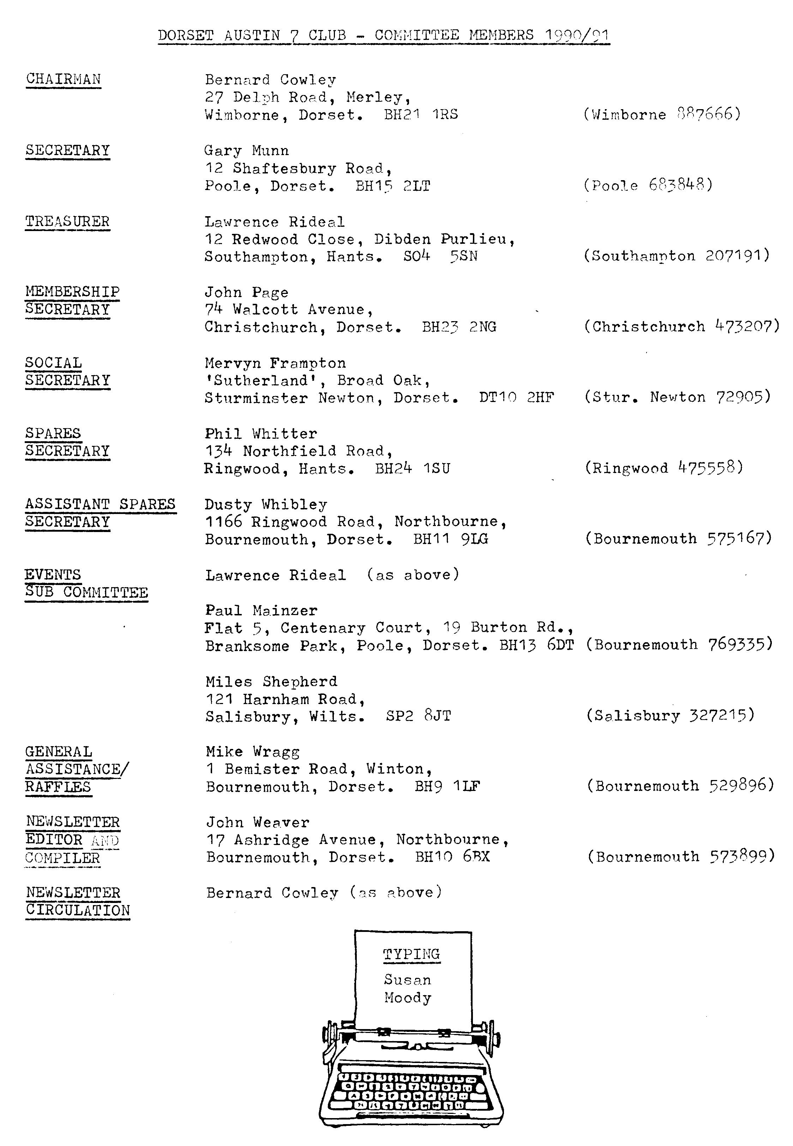
I
EDITORIAL MAY 1991

Last month we heard just in time for the Newsletter to carry the news, that the Whincroft Hotel had closed for refurbishment.

It seems that the merry round of pub face-lifting and departing landlords is continuing. However, it's an ill wind etc. because as a result we have booked again at the Elm Tree and have been able to book the barn for the next three months. There is a possibility that we could continue to meet there after that time. Club Meetings took place at the Elm Tree for a number of years and it was a generally popular meeting place. There has also been a change of management there.

It is intended to ask Club Members for their opinion at the May meeting.

For newer Members, older Members who have forgotten and the generally inebriated, the Elm Tree is at HIGHTOWN, RINGWOOD. Ring a Committee Member if you need directions.

Phil is expecting to have spares available at the May meeting, together with posters, books and (car) body drawings that he and Miles brought back from the recent Austin Seven Clubs' Association Meeting.
John
SECRETARIAL
Well Folks,

I always feel that after the Daffodil Run, the summer's events really start, so it's all ahead of us. Make the most of the events offered by both ourselves and other organisations, some of the do's in particular are a must.

On the subject of the Daffodil Run, Glyn had the misfortune to blow a cylinder head core plug. These can blow out with no previous warning and believe it or not out of half a dozen A7s that passed, not one driver carried a spare. Worth bearing in mind, I feel. They only cost a few pence and of course are available from Phil.

I believe Phil has invested in some reflective spare wheel covers, so enquiries to him if interested.

Some of us have now received details from Ken Cooke of the 750 MC Eurotour '92 to mark the 70th birthday of the A7 (August 15th - 30th). Seven European countries are to be visited in fourteen days. Hotels or campsites can be pre-booked and of course there will be a back-up vehicle. Sounds like a smashing do for the more adventurous, see a Committee Member if interested, as soon as possible.

It's a shame we have lost our room at the Whincroft, because despite its scruffiness, Club turn-out has gone from strength to strength. We'll see what the renovations bring, but I think we will lose it.

My Ruby is progressing well, engine in and today T-Cut - what a lovely job, isn't it?:

See you soon, Gary
THE OLD TOWN POOLE WALK RUN WITH AFTERNOON TEA AT SUE AND MIKE TOPHAM'S SUNDAY 28TH APRIL 1991

"Frilly Knickers" leading the way, 12 Austin 7's left Safeways car park on a fresh but sunny morning. Driving through Wimborne towards Shapwick we passed the lovely "Vine Cottage", followed by the more familiar "Vine Inn"! Just about here a huge crowd of Bassett hounds were gathered what a sight they were - it seems they were on their club run as well. The beautiful old church at Kingston Lacey came into view here and close by was a lovely picnic spot which we've ear-marked for a future Sunday. On, west of Badbury Rings, just the countryside, us, and the sheep. The Red Lion was just about here as well, scene of our recent skittles evening. We passed St Mary's church at Lytchett Matravers where Fran tells me that she and Merv were married there - altogether now, aahh..
Thanks to John's precision planning we arrived bang on schedule at the New Inn at Oakdale for lunch which proved to be a super venue. The place had been completely refurbished in the old farm style, with the addition of original items such as a pitch fork, scythe and traps which gave the place an old farm atmosphere. At a quarter to two we were well on our way to Poole Quay, where parking facilities fit for a king awaited us. In true James Bond style a huge door was slowly raised and our convoy was escorted in. Our guide was soon on the scene and I'll attempt to give you a few snippets of information as far as the old brain can remember.
Following our guide in true tourist style he pointed out a nearby building which apparently the top half used to be the old town hall, but the lower part which held more interest, was in fact used as the local prison. A plaque was erected here to the effect that John Wesley the Methodist was involved in some way - this must be the vaguest explanation yet! An unfortunate aspect of the prison being here apparently was that Poole being tidal, the prison was regularly flooded twice a week - ah well, what can you expect for free bed and board. Poole it seems boasts three Guildhalls, the first one being the United Reformed Church built in 1777. The first Sunday School was started here and it also served as an ordinary school as well where the children could learn to read and write, there being no free education in those days. Our guide pointed out many of the genuine old buildings - and the not so genuine. Our tour was completed at the Customs and Excise building on the Quay, where our guide proceeded to relate a cheerful story when several chaps were involved in a tea stealing incident, which resulted in them being hung, drawn and quartered - what a price to pay for a cup of tea!
By now we're more than ready for our tea at Sue & Mike's where we were
warmly welcomed, even glasses of wine awaited us. What a lovely spread Sue had prepared and it didn't take us long to be tucking into the delicious goodies. In fact the occasion turned into a birthday tea party when John presented Mike with a plaque bestowing Sue & Mike with the honourable title of Host and Hostess of the Year - and so say all of us. With our grateful appreciation to Sue & Mike for inviting us to their home and thanks also to John & Gay, for such a well organised trip.
Margaret and Alan.

FURTHER TO THE ABOVE. During the walk in Poole Gary was asked how many pubs he thought there were in the town. Not only was he ashamed to say
he didn't know, but immediately felt it was his duty to find out! He has since reckoned that there are 27 pubs and bars open to the public. With amazing self-sacrifice he and a friend have (a) decided to visit them all (b) give them a star rating and (c) discover if there are any others he hasn't thought of. It shouldn't take more than a week. We await his findings with interest. The 'Munnstars' ?
WORTH MATRAVERS VILLAGE FETE

Those who went to their calendars and diaries to note this event will have noticed that the date given did not make sense.

PLEASE NOTE: This event will be on SATURDAY, 27th JULY not June as notified. That does make sense and it will also make sense if you are able to support the fete as mentioned in the April Newsletter.

DA7C BLANDFORD CAMP DRIVING TESTS

This popular event which includes the May Club Run (i.e. Wimborne to Blandford) will take place as notified on Sunday, 26th May.

A good deal of pre-planning and effort on the day goes into this. Glyn has again kindly agreed to assemble and transport the equipment needed, including a large barbecue. He and others will be busy at Blandford at 9 a.m.

Apart from this it becomes very arduous for two or three people to supervise and record all the events throughout the afternoon. Therefore, when the Club arrives Members will be asked to volunteer to oversee different events. In this way, we hope it will be an enjoyable day for everyone and leave no one exhausted. Please help make the day a success.

Bring your own picnic and, if possible, your own small barbecue, for this will ease the pressure on the main barbecue. Water will be available for dousing.

Meet at the Safeway Car Park, Wimborne at 10•15 for 10•30 a.m.

We are again grateful to the Military for making this venue available. It's perfect for the occasion.

W.V.P.C. MOTORCADE is a two-day event this year, again at Braemore House, on 1st and 2nd June. However, the first day (Saturday) consists of a Road Run and Driving Tests, whilst on Sunday there will be the usual static display of vehicles and trade stalls.

As a Club the DA7C will be involving it-self with the usual Sunday event only, and we shall again have a pitch provided for DA7C cars. If you wish to be there on the Club pitch, please give your name to David Whetton next Club
Night. David is organising the Club entry and will be glad to have a provisional idea of how many are interested in taking part.
We have just received the details and entry form for the Lymington Vintage Show to be held at Buckland Manor Farm, Sway Road, Lymington on 13th and 14th July. This is the week-end that Gay and I enjoyed so much last year. Club Member, Jeff Savage will again be organising the display of motorcycles, as well as taking his A7. Entry forms etc, can be obtained from Dennis and Joan Knight, 96 Gosport Street, Lymington, SO41 9EH and should be returned by 13th June.
WE HEAR that the last A7 Clubs' Association Magazine (the little grey one)
that we received had the wrong cover. It is not Publication No. 1991C, but Publication No. 1991B. If you want to keep the record straight transfer
the covers when 1991C is eventually received (Presumably calling itself 1991B).
AUSTIN 7 BEGINNINGS - 9 - A story of Austin folk. Lawrence Rideal.

A young banking lad of `twenty two/twenty three-ish' who parts with the vastly enormous sum of around £500 to buy a 1933 Box reg. JT 106 just has to have had a burning passion for Austin Sevens for many a long year. Especially when we golden oldies can remember how much of a very presentable house this princely sum would have bought.
So what is Lawrence's story? More, what was he doing phoning one John Page, from wildest parts of Llanberis Pass?
Well .... it all began at Sunday school, or rather afterwards when the Sunday School teacher gave children lifts home in his chocolate coloured Box Saloon with its mysterious yellowy, orangy windows. Young Lawrence, way back, in Rye, Sussex in 1955, became totally mesmerized, thinking it to be a far more enjoyable car than his Grandfathers' Vauxhall.
Lawrence wanted such a car. Sadly, one shilling and sixpence pocket money, even in those dim and distant days would not purchase an Austin.
(THINKS..., did this deprivation stimulate Lawrence to become a banker?) I digress, sorry! However, being heavily into Meccano, Lawrence wrote to Meccano Company in Liverpool, asking them to please bring out interesting cars like Austin Sevens. They politely thanked him for the suggestion, saying that they would give it thought. (What a pity that Lawrence wasn't in a position to go into production himself, and who knows, his suggestion might well have been the forerunner of the present production line in the series of model Vintage Vehicles!)
In fact Lawrence also wanted at that time THE Megga big Meccano set which every boy enthusiast dreamed of and which no self respecting father would afford. No worry, for now Lawrence has an Austin Seven which he fondly sees as the next size up from the Megga Meccano Set. A creative thinker what?
Meanwhile back to the story: Lawrence about to buy his first car, was told by parents that he should buy a 'proper car' i.e. not a Seven! Dutifully he purchased, and still has, his 1959 Morris 1,000 (one previous owner). (Determination will out, and in 1972 THE Box was purchased in Dorset where it had lived since 1933. He then joined the Wessex vehicle Preservation Club, met up with the gang of four/five, Bernard etc. Austin Seven owners and yes they started THE CLUB. Being a banker he slotted right into his present role on the Committee and has done his creative Mathematics (I jest, sorry), ever since.
Snowdonia, I hear you say, what's that all about? Lawrence proudly on his Grand Tour of Wales heard the 'Sound of Music’ most alarming coming from the car engine. To the nearest telephone box, parking, car engine almost inside, he phoned John, stretched the phone wire to get the receiver as near to the musical engine as possible and pleaded 'John, what do you think of this?' Before you all begin to do likewise, it was of course not possible to diagnose in this way. (The manifold screws had come loose, air was being sucked in, whistling like mad as it did so.)
Apart from all this excitement, Lawrence, being very proud of his beautiful car, went to many events, with the crowning glory of having his hand shaken by no less than Lord Bath when he won Longleat!
Lawrence, his Box and his Morris cannot be parted; though perhaps not so his Seven Special.
Finally, a confession: his first car was illegitimate!! Yes, yes! He and a friend, with Seven pounds each, bought a 1946 Ford Anglia, hadn't money for insurance and tax and yes, you've guessed it, they ran it just like that!.

Thank you Lawrence for sharing your story, though the last bit is not quite what we would have expected of you!!
B.B. April, 199£.

CORRESPONDENCE

Newsy letters are always welcome and it was nice to hear from John and Diana Savage this month. They have been Club Members for about a year and although not often able to attend Club functions they feel that the Newsletter is keeping them in touch. John reports that he is making slow but steady progress on his 1931 RN and that the series on tracing electrical faults was useful. Perhaps we shall see more of them when their commitments lessen and we look forward to the day when the RN can join us on a Run.

Letters from Club Members are always welcome.

Although there's no report on the famous Daffodil Run, Jill Toalster has written to say how much it was enjoyed again this year. Jill and Brian seem to make this Run one of their annual 'specials', as do a number of Club Members.

She says that Club Member Jane Symonds received the shield for the longest distance travelled and not only that, but Jill has sent a picture by
Katie Goblin (5 11/12 years - 6 in May) showing the trophy. Having tea with the Mayor and Mayoress in the Pier Approach Showbar was very exciting for
Katie for she was asked to present a bouquet of flowers to the Mayoress. Apparently she did this with 'a very elegant curtsey'. Well done, Katie! Katie's picture of the occasion is shown below - pity we can't reproduce it in colour. It's always good to have something like this from one of the youngsters.
THIS MONTH'S COVER PICTURE is of Glyn and Pat in their famous Tickford departing into the setting sun on a recent Run.

THE SOLICITOR DEALING WITH THE LATE Vic Steele's affairs has been able to give the Club two cups that Vic had won in Germany. Your Committee has decided that one of these will be awarded annually for the Club Member covering the most A7 mileage in the year and the other will be a Ladies Cup. Further discussion will take place on how the latter will be awarded.

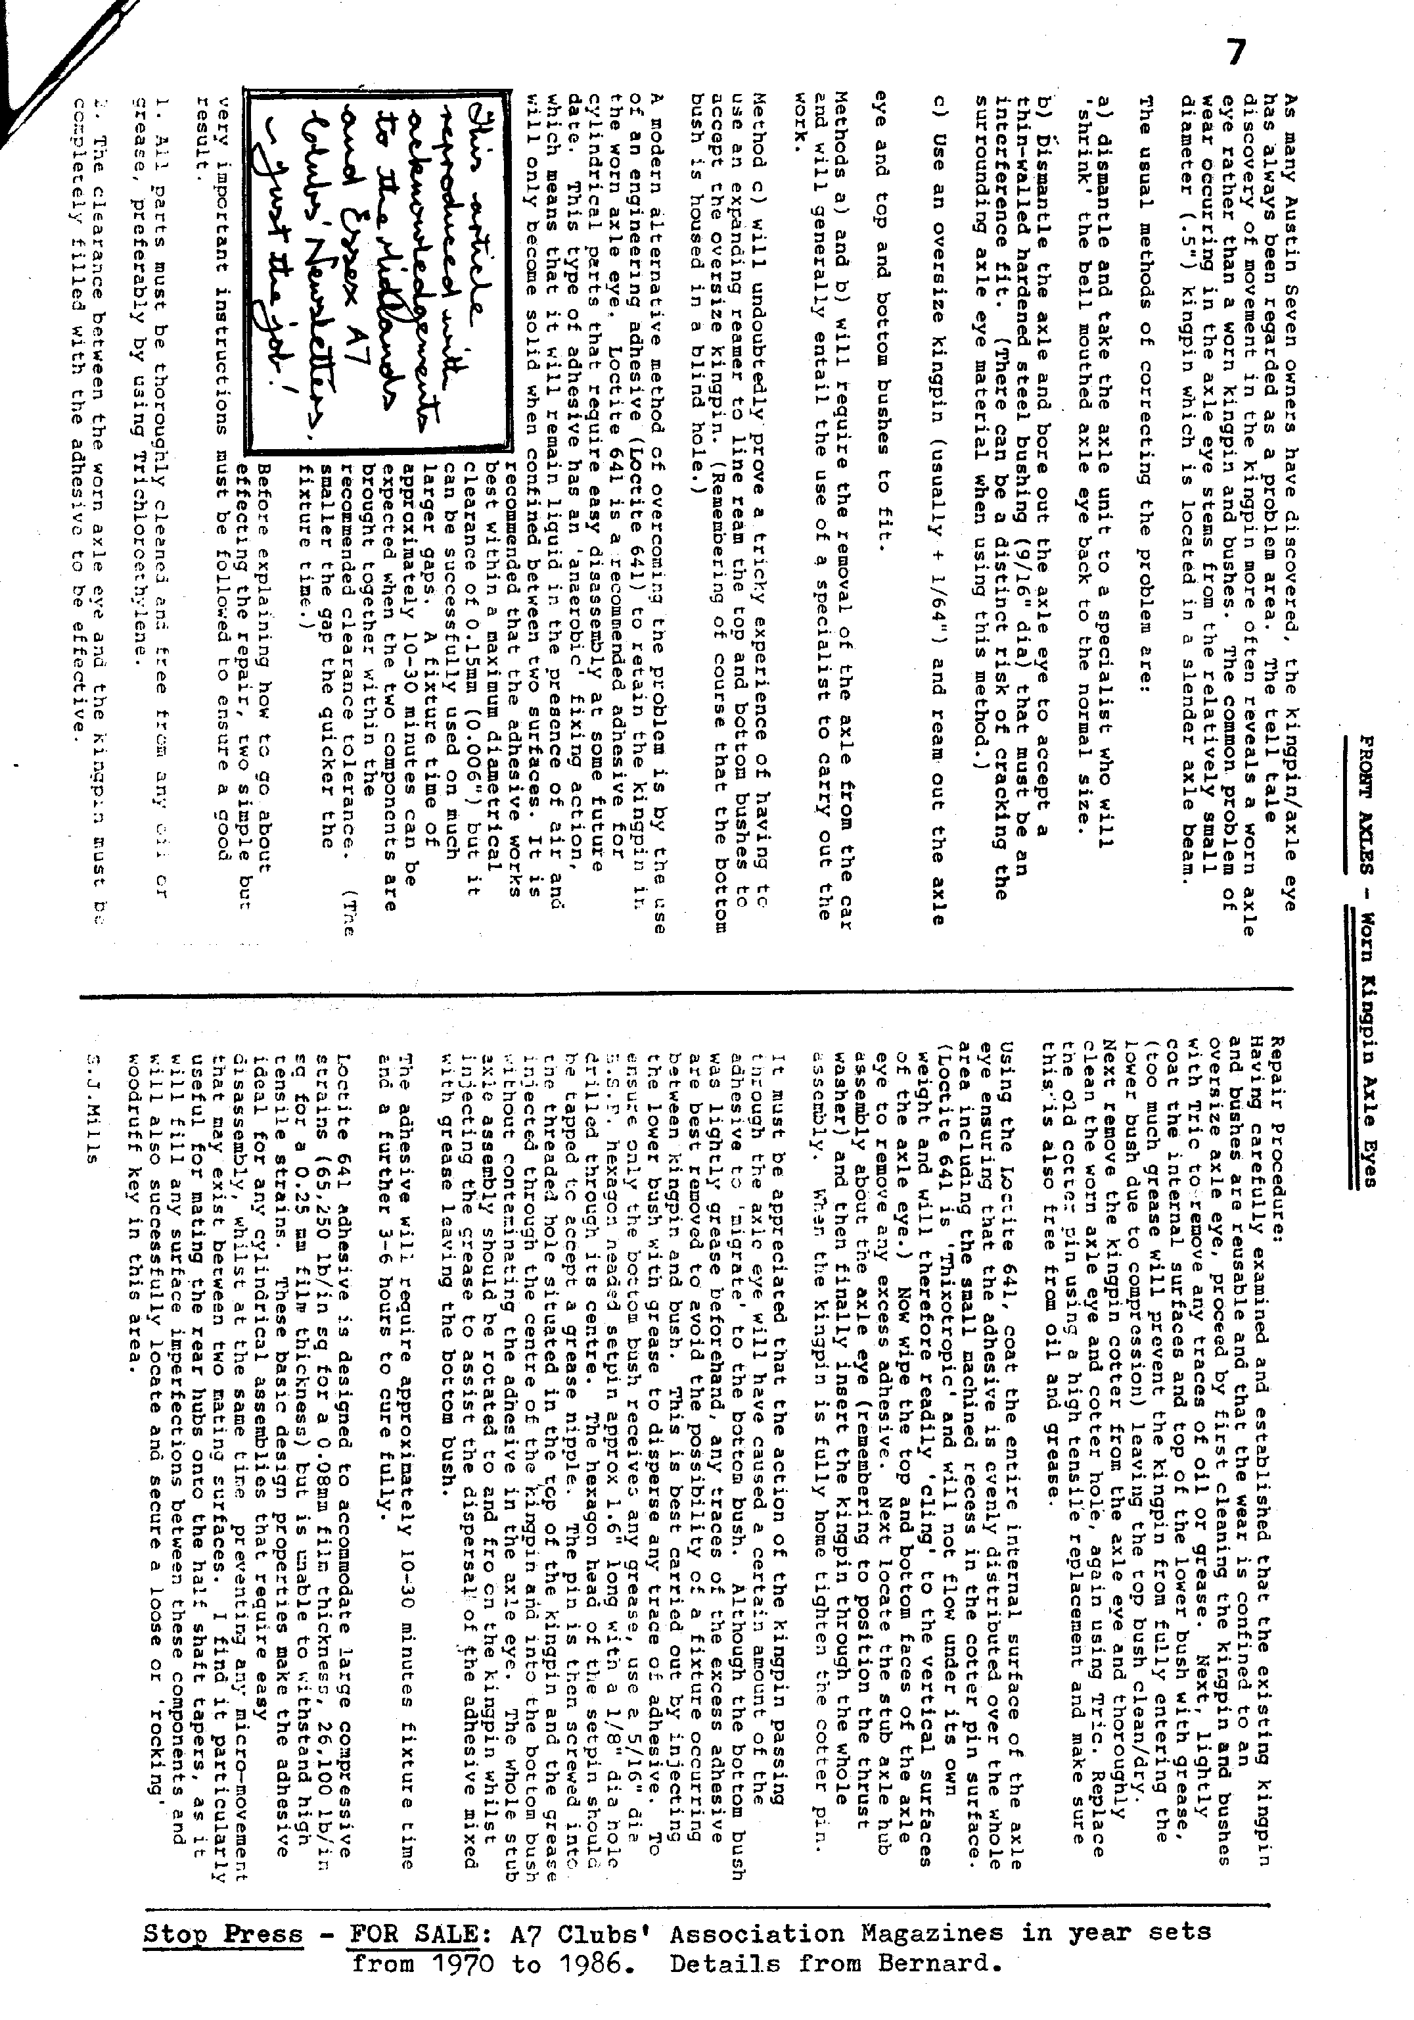
EVENTS

MAY Thursday 2nd May. '9 to Late' (for those who want to meet for a natter) at the Langton Arms, Tarrant Monkton.

Thursday 16th May. CLUB NIGHT - AT THE ELM TREE, HIGHTOWN, RINGWOOD - 8.00 p.m. Noggin and Natter. Some Members were sorry no-t to see all the photographs in March so bring your photographs again if you would like to do so. Discussion re future Club meeting-place will also take place. Spares available.

Thursday 23rd May. COMMITTEE MEETING at the Tyrrells Ford. 8.30 p.m.

Sunday 26th May. CLUB RUN AND DA7C DRIVING TESTS, BLANDFORD CAMP. Meet at the Safeway Car Park, Wimborne at 10.15 for 10.30 a.m. See further details within.

JUNE Thursday 6th June. '9 to Late' (for those who want to meet for a natter) at the Old Barn Farm Inn - on the Ashley Heath to Three Legged Cross road.

Thursday 20th June. CLUB NIGHT- See June Newsletter.
STOP PRESS: Biddy says, "S.O.S. from Brockenhurst Firemen. No A7s booked in yet for 9th June. Contact Jeff (0590) 23551 re entry."

