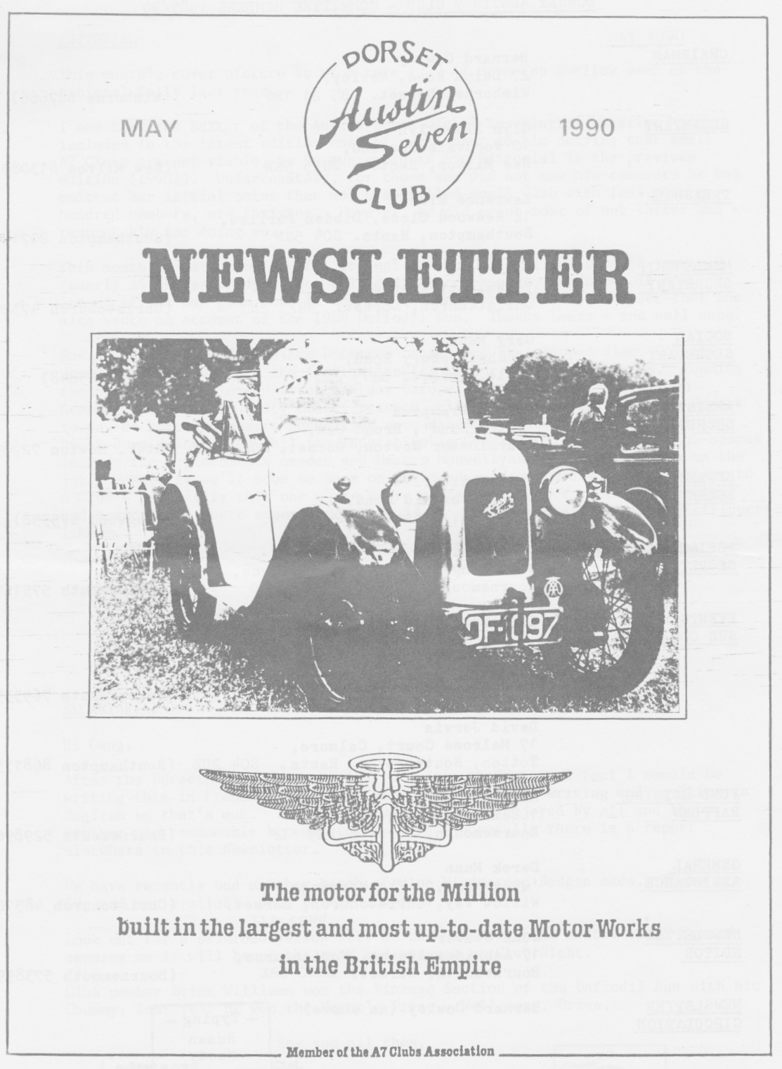
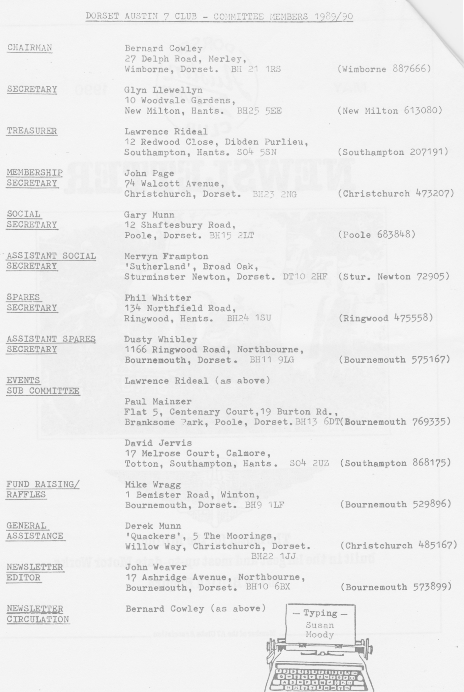
EDITORIAL MAY 1990

This month's cover picture is of a rare 1929 A7 Open-Top Swallow seen at the National Rally last year.

I see that the Editor of the Austin Seven Clubs' Association Magazine has included in the latest edition most of our letter to him denying that small A7 Clubs are not viable, as he suggested in his Editorial in the previous edition (1990A). Unfortunately, for those who did not see his comments he has omitted our initial point that we, a so-called small Club with less than a hundred members, are thriving. However, he did print most of our letter and we respect him for doing so.

This month we have a delightful account of the Daffodil Run from 13 year old (nearly 14) Leesa Bridge. Not only did she compose it, but typed it too. A lot of effort has gone into it to excellent effect. You may remember that she also wrote an account of the 1988 Daffodil Run. Thanks Leesa - and well done!

Having missed Club Runs since December because of the slipped disc, Gay and I were looking forward to the April Wiltshire Wander. It wasn't to be. Running the Box around to loosen it up the day before, I had to stop smartly on hearing a sudden and nasty clank, scrunch, clink, clink, clink. My son Stuart towed me home and Messrs Munwellyns soon diagnosed a crown wheel and pinion break-down. Thanks to Phil the Indefatigable Goodies Collector, the Club spares include the replacements needed and Messrs Munwellyns have kindly taken on the job. Hopefully we'll soon be back on the road. It certainly pays to belong to a Club - especially this one where spare parts have been so keenly collected and hoarded and where experienced help is so willingly available to cog-strippers like me.
Keep your axle oiled, John.

SECRETARIAL Hi Gang,

After the Dorsets' recent excursion to France at Easter, I feel I should be writing this in French, however, I have enough trouble writing and spelling in English so that's out. The holiday was very much enjoyed by all and the weather was reasonable between the showers. Hopefully there is a report elsewhere in this Newsletter.

We have recently had another batch of Club Windscreen Badges made. These are 50p and are available from Bernard Cowley.

Look out for a primrose yellow Ruby at the Dudsbury next month. Jeff Savage assures me it will be on the road and present on Club Night.

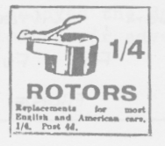
Club member Brian Williams won the Vintage Section of the Daffodil Run with his Chummy; last year he won the Mayor's Prize. Well done, Brian.
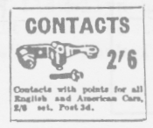
See you all then, Glyn.

The Mother' s Day West Dorset Run Sunday 25th March 1990

Brian has refused to help me with this write-up owing to circumstances beyond his control (he's waxing Emma's twiddly bits) which is rotten because on the day of the run I had forgotten to wear my spectacles and therefore failed to notice the names of the beautiful villages we passed through after leaving Wimborne.
But I did notice the breathtaking scenery and I did hear Cynthia mention that the Primrose Run would be an apt name for this day out. I agree, never have I seen so many clusters, of this pretty yellow flower, adorning the hedgerows.
We stopped at West Bexington for lunch, and although the pub's name escapes me, it was pleasant and the grub as good.
With lunch over, some members of our eight strong convoy (Joy, George, Glyn, Pat, Gary and Susie) made tracks for home.
The hardcore decided to hit Weymouth. Once there, but worried about incurring a £20 fine, we commissioned Marion (Ben wasn't watching) to chat up a young (good looking) policeman and obtain permission for us to park on the prom. With this done, and having said farewell to Bernard, we wandered off in search of ice creams for Rosie and Emily Cressey who said they would surely starve to death if they didn't have one.
Despite the sunshine, there was a freezing wind blowing so while we huddled together for warmth and watched the girls eat their ices, John Page helped cheer us up with some hearty jokes.
After saying our Good-Byes to one another, we left Weymouth and started to wend our ways home. As Dusty thought the Sandbanks Ferry would be busy we decided to follow him on his 'quick route back' to Bournemouth.
This involved being threatened by a pedestrian for using a non-access road and driving under a by-pass using a narrow footpath obstructed with bollards and overhanging a river.
Unharmed, but nervous wrecks, we ended up in Joe's Cafe at Blandford Forum for a calming fag and cuppa.
Thank-you Dusty and Jane, for an exciting day out and for nominating me to do this write up.
P.S. A very special thank you to Scott for my Mother's Day Strawberry Pavlova. (It was delicious).
Jill

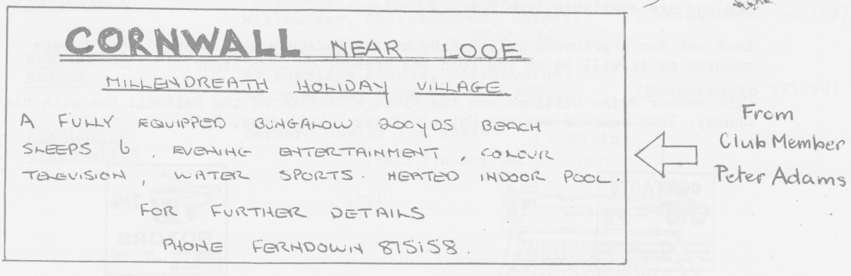
THE DAFFODIL RUN

At 4.45 a.m. I quickly found my jeans and club sweater, then went out for my breakfast. Today's the Daffodil Run. At 5.15 a.m. I went to the car to put the petrol on for Dad. We were ready, whilst Mum was last as usual. Finally we set off for the Hampshire Centre car park to meet up with Brian and Jill, Mr. Steel, Mr. Whetton and Rachel, Marion and Ben, Frank, Jan and Katie. Brian and Jill turned up in 1930 costumes, very traditional. Marion was wearing a straw boater trimmed with 'daffs' for the occasion.
We left the car park with Brian and Jill leading the way and Frank, Jan and Katie bringing up the rear. The time was 5.15 a.m. We made good progress and when we reached Salisbury I looked at my watch. It was 6.20 a.m. Personally I don't like seeing this time of day, especially on Sundays. Looking on the bright side (ha! Ha!) we did see lots of little bunnies at the side of the road.
We were going well and making good time, almost at 'Seven Stars', when David
(Mr. Whetton) flashed his lights for us to stop. We pulled over and David told us that Rachel had noticed our left-hand back wheel was loose. In fact the wheelnut came off in Dad's hand as he tried to see to it. Well spotted Rachel. This was no laughing matter as it was the wheel I was sat above and it could have been nasty.
A few minutes later, at 8.24 a.m., we arrived at 'Seven Stars' safe and well. We signed in and were given our plaques and some real daffodils. (Last year we had to make do with artificial ones.) Then we had a well-deserved cup of coffee, which was cold. Whilst at 'Seven Stars' we saw Mr and Mrs Mooney and Bernard (Mr. Cowley) and Danny.
We left 'Seven Stars' at 8.57 a.m., arranging to meet at the petrol station, and then we were on our way. On the way to Stockbridge, our first venue, we saw lots of little lambs and sheep jumping and playing around. There were lots of pheasants and even more rabbits. We even spotted a headless one, the hedgehog's 'flatmate' perhaps? We finally reached Stockbridge at about 10.55 a.m. The whole village had been invaded with old cars of all shapes and sizes. I met up with my cousin and she showed me round Stockbridge and I caught up with the latest news.
About an hour later we left for lunch. The weather was warming up by now
and we went through Rhinefield Ornamental Drive. Not a deer in sight. Several old cars joined us on the way. It must be because we had such a good navigator. 'Well done', Jill. After quite a while we reached 'The Plough' where we had a well deserved lunch stop as we were famished. After we had eaten our picnic and drunk a nice cup of tea, Katie and I made a visit to the pub's play area and had a few jumps on the trampoline and a quick go on the swings. We saw several of our club members at 'The Plough'.
We left 'The Plough' at 2.25 p.m. to head for Bournemouth. We got onto the Christchurch bypass and thought we were doing well, doing about 35-40 m.p.h., when we were left standing by some boy racers in a bright red Ulster Replica, namely Bernard and Danny Cowley, doing about 60 m.p.h. We know our friends. The next time we saw them was at Bournemouth. Never mind, we carried on chugging along quite happily.
We approached Boscombe Pier at about 3.05 p.m., where we could relax for a little while. At Bournemouth it was good to see Mr. and Mrs. Purdy, Geoff and Kathy. We were parked behind Brian and Jill who kept us entertained with their old fangled music machine. It was very nice really, Brian. Not far from us were the boy racers and the red Ulster. Then at 4.30 p.m., we went to the Pavilion car park for the prize giving. After that we had tea with the Mayor. All too quickly it came to an end and we had to go home, but what a great day we had. Leesa Bridge

There's no report yet on the Wiltshire Wander, the later than usual May Run, but Pat Llewellyn has written to say how much she had enjoyed the day and that It was nice to see that the 'Dorsets' have not lost their adventurous spirit." We look forward to an account of events.

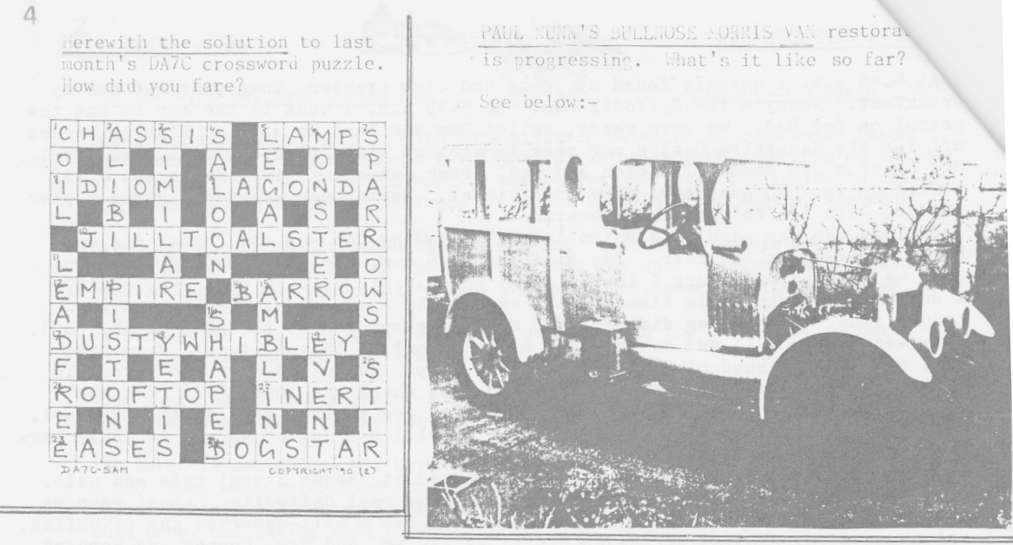
FURTHER INFORMATION is available on the POWERPLUS catalytic converter that we featured last month. Following our wonderful example, the 'Daily Mail' have since published the following. As you will see their item also gives prices.
Bob Stanley is also still available for consultation and can describe the size, fitting etc. - in return for liquid refreshment.

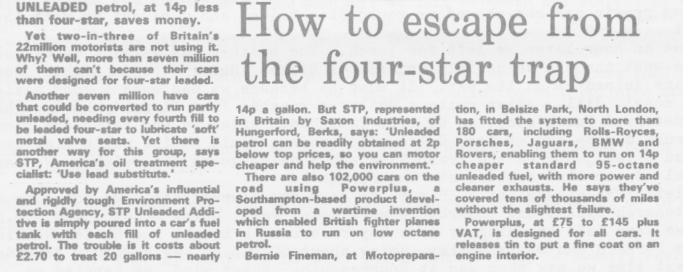

FOR SALE 1935 (March) RUBY. In mint condition. Blue in colour. New MOT. £5,000 o.n.o.
Ring Mark Young(DA7C Member) at Home (0202)874637 or at Work (0202) 861313 for further details.

SEEKING TO INSURE his newly completed Box Saloon, Leonard Moody discovered that Beacon Insurance have moved.

The new address is:- Library House, New Road 1 Brentwood
Essex CM14 4GD Tel: 0277 20011

New Club Members: A warm welcome to A. Taxis and D.Higson

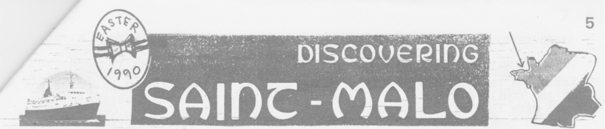
THE DA7C EASTER RUN 1990
We set off in fair weather for Portsmouth with four Sevens in convoy, Glyn and Gary were together plus John and Cynthia, Paul and Emma and ourselves in the 1935 Pearl Cabriolet 'Amy’, arriving in good time to board the 'Duchesse Anne'. After sorting out our sleeping accommodation we all suitably refreshed ourselves in the bar. Next morning (or was it the Crack of Dawn?) we all had coffee and croissants then made a scramble back to the car deck and in a very short time all disembarked in St. Malo, on a dry, windy morning. As it was rather early we decided to take a walk round the ramparts of the city which date back to the 12th Century. On one side there are beautiful views over the sea and the Emerald Coastline, with three islets Grand Bé, Petit Bé and Cézembre. On the other side were views of the Old Town and the port. After all this vigorous exercise Paul decided he wanted a PROPER breakfast. We all agreed and found a little cafe in the Old Town. After that we set off on the Rennes road to our hotel which was only ten minutes from the city centre, close to the hypermarket and shopping complex.
The Hotel Ibis proved to be warm and comfortable and the food excellent. However, as we were a bit early then to check in we all decided to go to Dinan for lunch. The scenery along the River Rance was beautiful. We found parking space close by the port and walked up the cobbled streets to admire the wood-fronted houses. Unfortunately the weather then took a turn for the worse and we were caught in the heavy rainwater pouring off the old guttering and running down the cobblestones - so we beat a hasty retreat into the nearest crêperie. The crêpes were absolutely delicious, but rather delicately constructed for A7 appetites, so we all ended up with several savoury and sweet crêpes each. This threw Madame into a state of confusion over our bill and filled the cafe with blue smoke. Leaving the cafe we made it back to the cars through the pouring rain. By some miracle they all started without problems and it was off to the Hotel Ibis for hot baths, a rest and our first pleasant evening in the bar and restaurant.
The next day we visited Dinard, St. Lunaire, St. Briac-sur-Mer and St. Cast making a stop near St. Lunaire. We walked out to the cross on the rocky outcrop, losing our hats in the high wind, to watch the sea crashing in on the rocks. In St. Cast we found a warm, sunny spot to break out the vino, bread, cheese and pate. Then the more athletic members climbed to the top of the cliff. You can see why the coast is called Emerald as the sea is all shades from aquamarine to deep green. In the afternoon we went on to Dinard briefly, promising to return the next day. On our return to the hotel we found a letter awaiting us from our illustrious DA7C Newsletter Editor describing some wildly imagined French property for sale. This we read in the evening in the bar and had a good chuckle. Thanks John, we are glad our accommodation didn't turn out like those you described!
The next morning Cynthia suggested a run to Mont Dol, a local high point topped with a windmill. It was a challenge to the A7s to make it up the hill, during which Mike forgot we were supposed to be going up on the right until reminded by Glyn tooting away behind us! If anyone had come down I think they would have pushed us all the way back to St. Malo, but luckily we all made the top safely.
There was a bit of a parking problem when we returned to Dinard in the afternoon - Glyn ended up parked across a zebra. We walked along the cliff walk to the centre to look in the shops at the local lace, jewellery and galettes (flat cakes) and then, to Gary's delight, we spotted a dazzling blue and white sign - WHITBREAD Needless to say the next few hours were spent
refreshing the parts that lager and French wines can't reach!

DISCOVERING ST MALO CONTINUED
Our last day we spent in Dinan and St. Malo sightseeing and shopping.
Lunch was the best yet, in a tiny café. We were coaxed in by the son
of the family and seated in a tiny room, but given the most enormous tasty meal with lots of service and washed down with the local brew. Our last evening came too quickly and all decided on an early start in order to visit the supermarket for the last time before boarding the Duchesse Anne for our return voyage. With all cars suitably loaded with local wine and cheese we reluctantly took our leave.
After a good crossing we arrived in Portsmouth for a rather wet run back to Wimborne. That is after steering majestically past the Green customs with smiles and waves. Little did they guess what can be crammed into a little A7!

Thanks to all for the great company and organisation. It was a Happy Easter
Sue and Mike Topham

THE MUCH TRAVELLED veteran Vic Steel - he of the twinkling eyes, the Opal and the Triumph Tiger 90 - had some very artistically addressed envelopes at the last Club Meeting which he has received from a Polish friend. He kindly had them photo-copied so that we could show them in the Newsletter. We can't show the colours, but here is a sample:

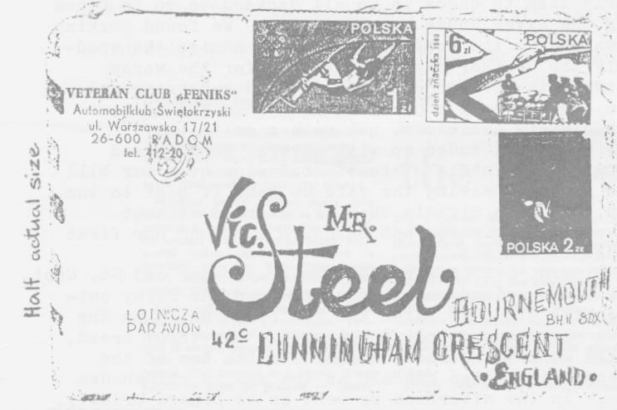
Also, below, is the solution
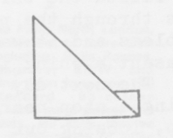
to Jeff bridges three dimension, puzzle. The missing side view for the toolmaker is shown.

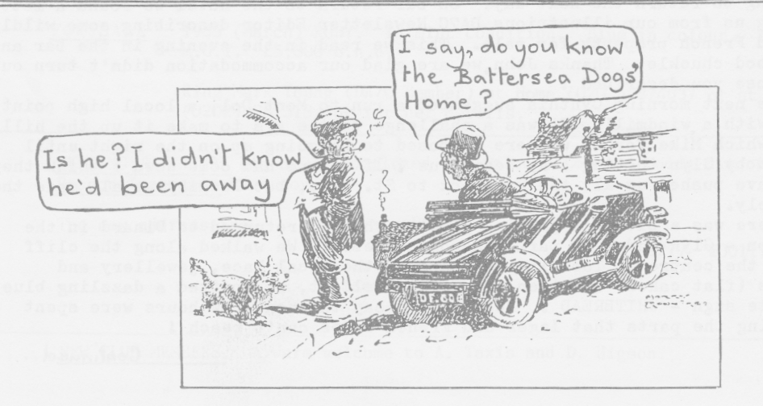
Bodgers' Corner: "An Opal with a dash of Ruby"

For those of you familiar with the racy lines of DUO 803's dashboard, there is no need to describe the reversing light switch, windscreen washer plunger, fog light switch and temperature gauge all neatly laid out in a mathematical straight line on a beautiful piece of flat steel and set off by St. Christopher. About a year ago I was able to acquire a Ruby dashboard from a well-known squirrel and with two weeks to go before the Daffodil Run I thought it was about time to re-set the instruments in their more conventional (and boring) cluster. Horror of horrors - an initial inspection revealed that the Opal dash is different from the Ruby dash (see diagram) and welded in place since, not having a roof, the Opal dash needs to be used for strength. I had hoped that the Ruby dash could be put over the remaining bits of the Opal dash like a mask, but no such luck - the contours are not compatible. So I was left with a nasty dilemma, whether or not to cut the Ruby dash along the curved profile and screw it in place or to try to cut out the Opal dash completely.
The answer is of course clear to all true Bodgers - cut up the Ruby dash and hope no-one notices! In fact, just like the wife, it worked very well with a little beating and so, encouraged, I set about making a glove compartment from a nice piece of plastic-coated aluminium gleaned from a skip on the Ferndown Industrial Estate. One point in writing this informative article is to inform any glove-compartmentless Bodgers out there that I now have a secondhand template that can be borrowed for the usual (liquid) fee. The other point is to share a well-known fact with other people like me who do not get to know these well-known facts - the glasses on the front of the instruments unscrew and the horrid little green bits inside just brush out. Oh, one other hint - paint the dashboard after trying to fit it in place, not before. Must go, I'm now working on a head-up display since all the instruments are now cleverly hidden behind the steering wheel. David Whetton
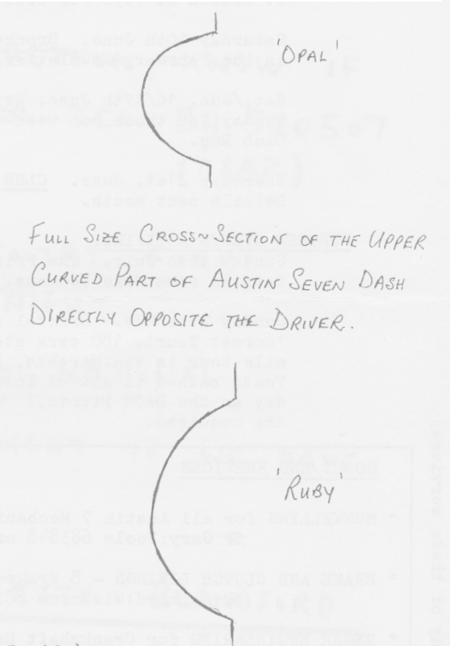


EVENTS

MAY Thursday 17th May. CLUB NIGHT. A short Evening Run to The Dudsbury. Meet at Safeways Car Park, Wimborne (opposite the Allendale Centre) at 7.30 p.m. Those not participating in the Run meet those who are at The Dudsbury at 8.30 p.m.

Sunday 20th May. ST. EDWARD'S SCHOOL AUTOFAYRE. For details see the March Newsletter.

Sunday 27th May. THE DA7C PICNIC, BARBECUE-AND DRIVING TESTS at THE OLD PARADE GROUND, BLANDFORD CAMP. Meet at Wimborne Square at 11 a.m. Bring your own picnic for a fun, family day out. BARBECUE AVAILABLE ON WHICH TO COOK YOUR OWN.

JUNE Thursday 7th June. 8 T0 LATE. Meet at The Cat and Fiddle/Harvester at Hinton at 7.30 for 8.00 p.m. for a short Run and Treasure Hunt.

Saturday 10th June. Brockenhurst Country Fayre. See the mention in the February Newsletter.

Sat./Sun. 16/17th June. Bristol A7 Club Spye Park Rally. Main events Sunday for those not week-ending. This replaces the usual monthly Club Run.

Thursday 21st. June. CLUB NIGHT: A CLUB CONCOURS at The Dudsbury. Details next month.

FURTHER EVENTS NOTIFIED.
Sunday 15th July. The Friends of Upton Country Park Summer Fayre. Details from Mike Yeomans. (0202) 696224.

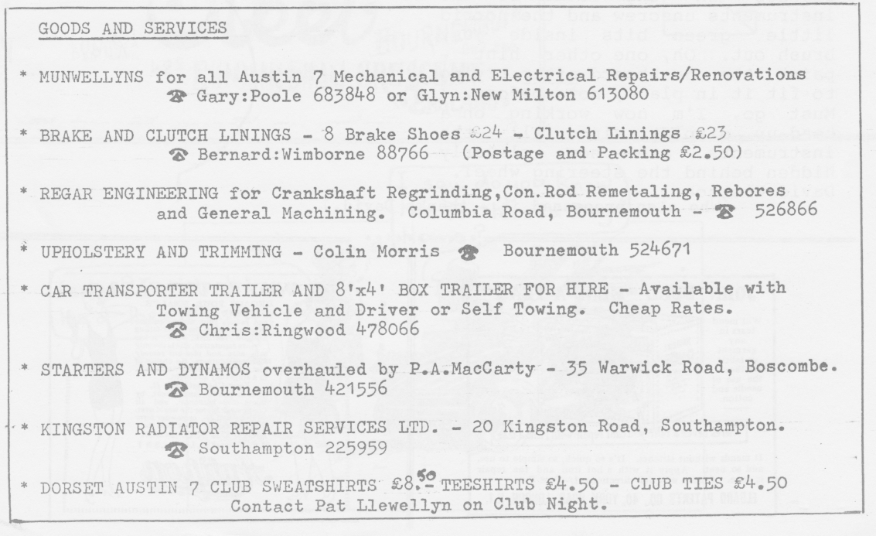
Sunday 27th May. Bristol and Midlands A7 Clubs are supporting a 'Dorset Tour'. 180 cars start from Weymouth from 9.00 a.m. The 90 mile tour is via Wareham, Blandford, Sherborne and back to Weymouth. Funds raised in aid of Telethon and Save The Children. (The same day as the DA7C Picnic.) Contact Lawrence Rideal if further details are required.
