EDITORIAL MARCH 1990

It is encouraging to have received two very interesting items this month from Club Members who are first-time contributors. Dave Tanner's tips are very useful and Jeff Bridge has an unusual story of restoration to tell.

See also the solution to last month's Crossword Puzzle, a new Wordsearch Puzzle and other items of interest.

This month's cover picture is of FK 5382 in Lacock Village during last year's Spye Park Rally. ,
Do I detect a whiff of Spring in the air? Let's hope that it will lead on to another glorious Summer like last year's. Rain or shine, however, there will be plenty to interest 'heptaphils' in the coming months.

Keep your revs up!
John
I think that everyone enjoyed the 'feely bag' evening organised
by Paul on Club Night. I must admit a good many things completely baffled me, and how the winner Bob Stanley worked out that the spanner in one of the bags was 17/64 is a mystery to me!
A very sad occurrence last month was the death of comparatively new Member Robin Allan. Our sympathies go to his wife and family. In his short membership Robin joined us on several Runs, the last being to H.M.S. Alliance at Gosport, a Run that he seemed to enjoy.
The '50s and 60s Evening' was very well attended with 44 people enjoying the music, many in period costume, Teddy Boys, Flower People, Hippies etc. The dancing went on until 12.30 a.m, and even then some were reluctant to leave.! `
John Weaver received a letter from Members Bill and Norma Quayle agreeing with his comments in the last Newsletter concerning the comments made in the-Association Magazine editorial (1990A). Bill and Norma who have been Members for many years said, "Our spares section is second to none and social events are an on going commitment. We are further blessed with real expertise to keep our friends on the road, knowledge willingly shared for the benefit of all" Sentiments uttered by many more of the happy band of 'Dorsets'.
As will be seen elsewhere in this Newsletter we have received an invitation to attend the Silver Jubilee celebrations of the Bristol A7 Club at 'The Lamb' at Iron Acton over the May bank holiday. Several of us have taken up the offer. If you wish to go contact Dusty Whibley on Bournemouth
575167.
See you Club Night.
Glyn.
THE SUB RUN SUNDAY 21ST JANUARY 1990
Ten cars left the Cat and Fiddle car park in the rain, a steady drizzle. Good to see some of our newer members braving the elements and joining in the winter runs. '
The route took us via Romsey and skirted Winchester along some very quiet country lanes would be very picturesque on a sunny day. We shared the roads with a few horses and riders and some very wet looking cyclists.
It was "be polite to Austins Sunday", on more than one occasion the modern motorist gave way to our convoy with a cheery wave when they had right of way.
Our route took us along the coast at Lee-On-Solent, and looking even wetter and colder than the cyclists were numerous wind surfers and water scooterists, the latter falling into the water as frequently as the wind surfers.
The rain had stopped when we arrived at the Swordfish Pub for lunch. There was plenty of room for us all and the food was good (well mine was), and so was the coffee, cannot speak for the beer but it seemed to be going down all right.
At the appointed time we set off on the short run to the submarine museum.
We had a conducted tour onboard the submarine Alliance. Very little in the way of home comforts on board. The mattresses were as hard as a board and the galley was supposed to accommodate 2 cooks to cater for a crew of 65. They must have worked in shifts as it would have been impossible to get 2 men weighing over 72 stone in that small space. I will never complain about my small kitchen again.
The Subs carried 14 torpedoes at a cost of £1 million per torpedo, a bit expensive if you missed the target.
We also went on board the Holland 1, this submarine was designed by an Irish man who hoped to use them to sink the British Fleet. Holland 1 was built in 1905, but sank without loss of life whilst being towed to a scrap yard in 1913 off the Eddystone Lighthouse.
In 1982 Holland was raised and taken to Gosport to become part of the museum. It is a smaller vessel than Alliance with even fewer home comforts. I didn't notice a separate galley and even the heads were not partitioned off, with just one loo parked to one side. The engine was a 4 cylinder petrol with a top speed of 7.4 knots on the surface. The Sub could only dive to a depth of 100 feet. They were very brave men to go down to 10 feet in the Holland, never mind 100 feet.
The tour complete we just managed to buy a cup of coffee each before the cafe shut for tea.
Refreshed we set out for home. We had not been going long when the rain started, but heavier than in the morning.
Four cars managed to lose sight of the rest of the convoy, it's the old problem of various sets of changing traffic lights in town.
So the strays were led out of Portsmouth and through Southampton and Lyndhurst by Bob in the blue Ruby.
Hope all the rest got home safe and nearly dry.
Thank you David for a well organised run, and if you had told me before the end of the visit that I was down to do the write up I would have paid more attention and perhaps made a note or two.
Joy Mooney. (Who kindly typed her report.)

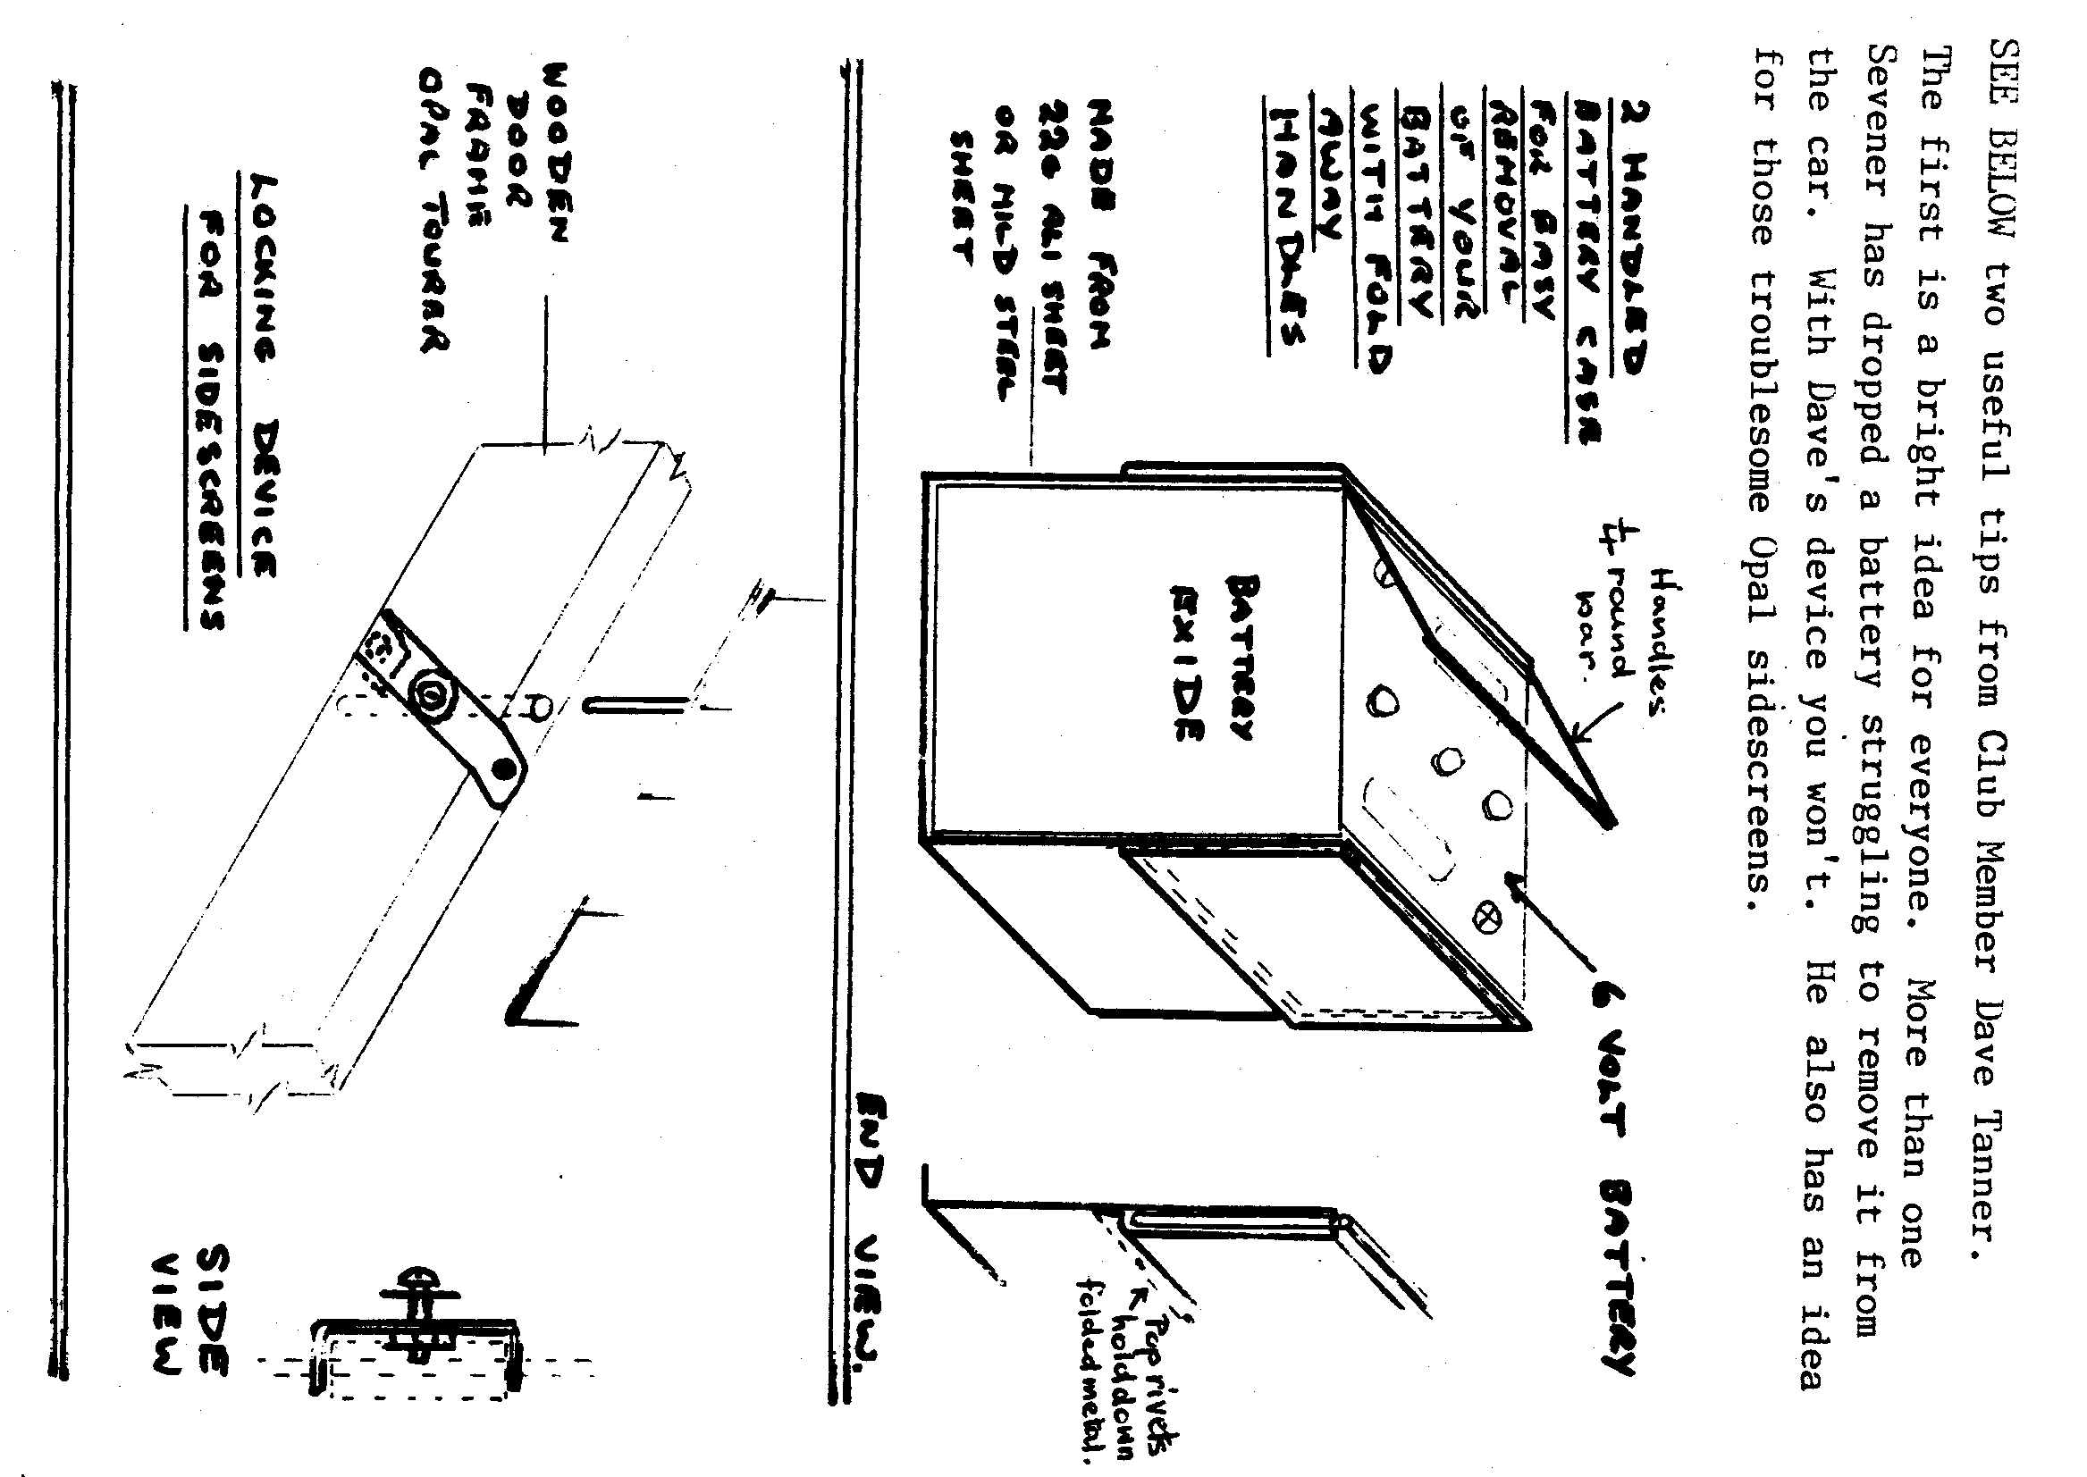
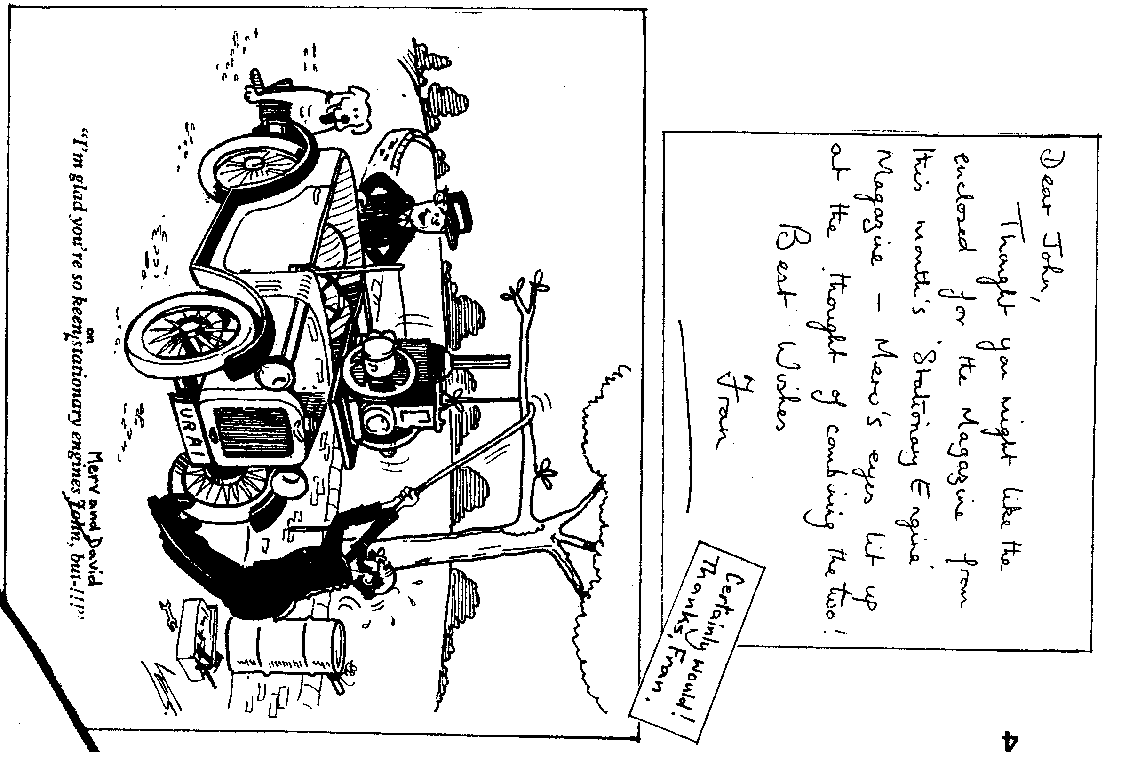

THE WHITSBURY nee DOWNTON RUN. Sunday 18th February
We were last there in August 1989, but the Cartwheel in Whitsbury is one of those pubs where it doesn't matter how often you go, it always seems to be so worth while.
This was actually Gary's delayed run to Downton-- and still we didn't make it but who cares, there is always a next time and anyway there is good chance we end up at the Cartwheel! The weather was very kind to us and although the turnout not overwhelming, the run itself was a delight, but what a sorry sight the Forest makes, but again strangely enough, only in parts. It would appear that nearly all the lanes and byeways are now cleared of fallen trees and once more open to traffic, but by the look of the havoc caused by the recent storms it will be many a moon before all traces of the very extensive damage are finally removed.
Our little convoy of six arrived at said hostelry only to find Rt. Hon. Editor and Gay quietly sitting there and, of course, in the best seats. Well, these modern car drivers. However, after a really good meal and a small sample or two of the liquid offerings and our usual natter to put the world to rights Emma & I made for home. The more adventurous went on to a Zoo or was it a Park or perhaps a Garden Centre, anyhow somewhere or other of doubtless interest.
As usual, all great fun and many thanks Gary .
PAUL. (Thanks, Paul, and for the typing.)

It was with dismay and sadness that we heard that Club Member Robin Allen died on Sunday 11th February. Robin was only recently an active member and was certainly enjoying his involvement and particularly driving his Chummy on Club Runs.

Following his last Run to Gosport on 21st January he wrote a report that reflected his pleasure. I hope that we will be able to include his report at a later date.
CHRIS and LINDA Smith said how grateful they were for the 'relief operation' following the gale damage to their house. They would like to thank Club Members involved and Phil and Hilary in particular. It may be some time before full order is restored, but that initial help was particularly welcome.
CONGRATULATIONS to David Whetton who has had his first book published. Not entitled, 'My Adventures With The Opal', unfortunately. It's a GCSE Maths textbook.
ALL GOOD WISHES to Sue Whetton who is making a good recovery following a major operation.
SORRY TO HEAR that Roger Nunn was injured in the course of duty and trust that he hasn't had to forsake driving.
NICK PLACE reports that he is now the proud owner of a rare AAK Austin Seven Tourer. He says there are only seven of these in the country.
DUSTY tells us that the building of the two Ulsters is going ahead steadily.
QUIZ NIGHT Now identified are the couple who with George and Joy Mooney
ended up joint winners. They are Kevin and Marion Wisset, Again, well done!

CLUB SWEATSHIRTS Please note that there is a small rise in price, to £8.50, for these desirable items. They're still very good value.

-
All In A Day's Work

A few months ago I had the good fortune to be seconded to maintenance. While I was there I got to know the part-time gardener, his name being Frank Rhodes. He worked as a fitter before he retired, now he works just one day a week.
One day he came in and said he had thought of me in the week. As he had been digging the garden at his new bungalow he had dug up an old temperature gauge. He thought it came from a Bedford, but it was no good, all rusted up, and he had thrown it on the rubbish heap. I said I-would have liked to have seen it.
The following week in came Frank with this rusty, dirty mass which had once been a temperature gauge. After all the jokes, "You know it will match in with the rest of your car", I put it in a bucket of Rydelime which we had used to descale the boilers in the canteen.
The next day I took out the gauge, all the rust and scale had gone.With a soak in release oil I got all the screws out of the glass bezel, did more washing out and when I put all the bits back together again 'Bedford' became 'Wilmot-Breeden'. The words COOL, NORMAL, BOIL and CALORIMETER were also there, but faded.
Now it was my turn to brew the tea, so with the kettle boiling in went the probe of the calorimeter. Over went the needle to BOIL and under the tap back went the needle to COOL. It was working!
I stripped it all out again then after a lick of paint and a hole cut in an old petrol tin cap (it has the same thread as the radiator) the job was done.
The next week the Seven went to work with the gauge on show. Frank was 'over the moon' when he saw it and with the bottle of Bell's whisky, as a thank you. It really made his day. Mind you I didn't volunteer to dig the rest of the garden to find the remainder of the car.

Jeff Bridge.

ST EDWARD'S SCHOOL AUTO FAYRE. Several Club Members showed their Sevens at this event last year and have said what a good 'do' it was. You may remember that Mike and Sue Topham were prizewinners.
Also from last year's event we have a picture of Frank Joblin's Ruby and Katie.
This year we have decided to enter as a Club and entry will be FREE. Various classes of vehicles will be displayed including motor cycles, vans and lorries and buses.
Details of this year's event are shown below. If you would like to enter please contact Gary before the end of April.
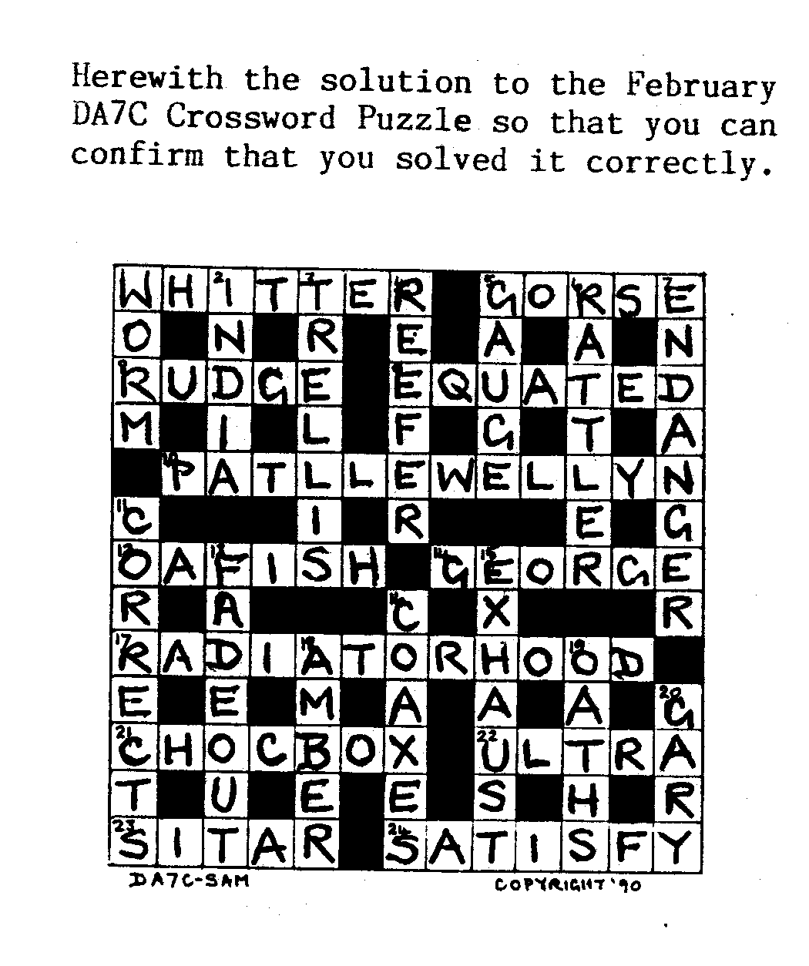
No Crossword this month, but another Wordsearch Puzzle.

Hidden within are 30 'car words' to circle. To save you becoming too wild-eyed the 30 words are listed here, but can you also find word no. 31 which is not listed?
Remember - words may be horizontal, vertical or diagonal and some are written backwards. Have a rest from the telly, folks, and enjoy this headache instead.
BRISTOL AUSTIN SEVEN CLUB 25TH ANNIVERSARY
An invitation has been extended to the Dorset brethren to attend the Bristol's 25th celebrations which is to be held over the Bank Holiday weekend of 5/6th and 7th May.

Camping facilities will be laid on in the grounds of the early 17th century 'Lamb Inn' at Iron Acton, 10 miles north of Bristol. 'Limited bed and breakfast is also available at around £12.50 per night.

Included in the weekend programme will be a barn dance, in the village hall, which is approximately 100 yards from the 'Lamb Inn', dancing to the sounds of the 'Electric Lobsters' and the 'Pigsty Hill Orchestra'. Refreshment supplied by 'Smiles Brewery', admission will be charged £4 per head in advance, or £5 on the night.

An Austin Seven tour of Bristol with possibly a visit to the SS Great Britain on the Saturday. A Treasure Hunt is on the cards for Sunday, and for Monday, a trip to the May Day celebrations at one of the surrounding villages.

I am sure this event is not to be missed and if the Bristol Club's Spye Park Rally is anything to judge by this weekend should be a winner.

Dusty.

If you are interested in taking part in this weekend, let Dusty know - in the near future.

STOP PRESS Further information received from Dusty r
Ian Dunford, of Bristol Austin Seven Club, will be sending entry forms
for the event. These can be obtained from Dusty. 575167. B. and B, is available at the Lamb Inn for £15 each per night -
Telephone 0454 22265 or at the Rangeworthy Court Hotel - Tel. 0454 22347 - where a double room costs €50 per night. (!)

A camping site is also available for tents and campers.

EVENTS
MARCH Thursday 15th March. CLUB NIGHT at The Dudsbury. 8.00 p.m. 'Noggin and Natter'. Spares will be available.
Thursday 22nd March. COMMITTEE MEETING at the Tyrrell's Ford 8.30 p.m.

SUNDAY 25TH MARCH. CLUB RUN . A WEST DORSET RUN. MEET AT WIMBORNE SQUARE AT 9.45 FOR 10.00 A.M. NOTE! This month's Run is a week later than usual - not the date notified in the February Newsletter.
APRIL Thursday 5th April. '9 to Late' at The Woolpack, Sopley. (For those who want to meet for a natter.)

Thursday 19th April. CLUB NIGHT at The Dudsbury. 8.00 p.m. A 'What's My Thingy?’ Evening. Please try to bring along an unusual object for Club Members to identify. It can be something motoring or something else.

Thursday 26th April. COMMITTEE MEETING at the Tyrrells, Ford
8.30 pm .
Sunday 29th April. CLUB RUN. (Again a week later than usual.) Details next month.

NEW CLUB MEMBERS Welcome to J.Savage, Robin and Jane Symonds and Kevin and Marion Wisset. Don't be afraid to let yourselves be known at Club Meetings, folks.

CORRESPONDENCE Thanks to Bill Quayle for a witty letter prompted by last month's Editorial. Bill had some very kind things to say about
the Committee and the Club in general and has vowed to be a 'born again' Member. He is also a fan of the Brockenhurst Country Fayre, mentioned last month, and which he thoroughly enjoyed last year. Bill states
that at his age he doesn't 'buy green bananas any more'! I've a feeling that he would be safe to buy them for a long time yet.

