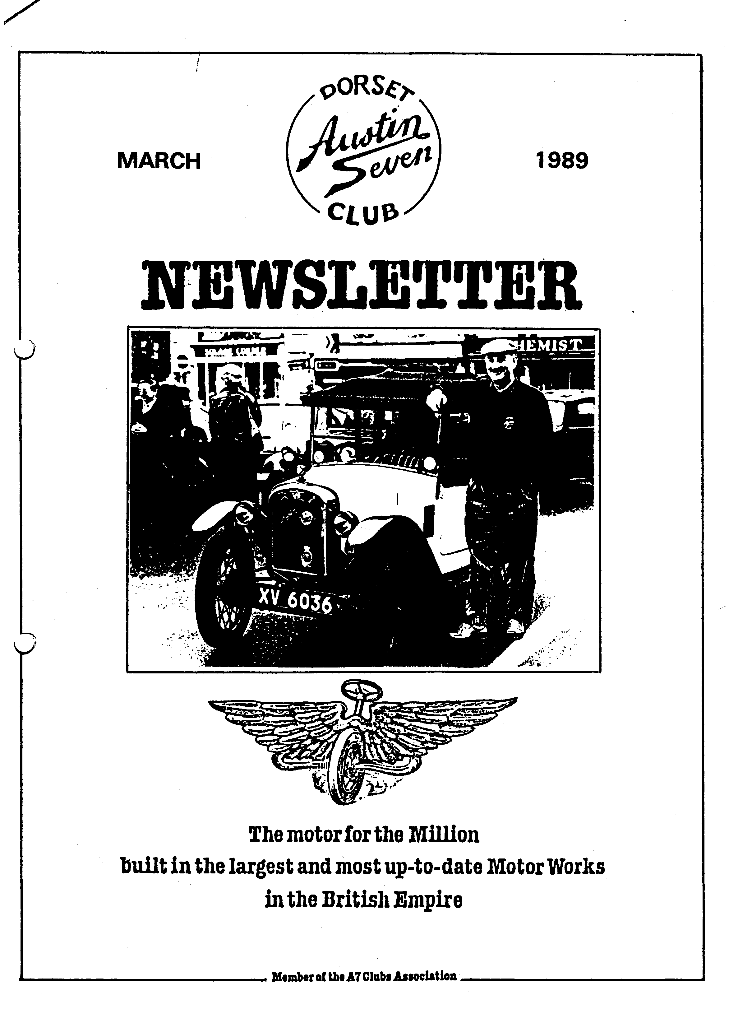
EDITORIAL
MARCH 1989

There was just one response to my appeal in the February Newsletter for comments, tips etc.. Gary's account of his Magneto/Coil conversion is the sort of thing we need. The sharing of experience, particularly in technical matters, should be one thing that justifies our Club's existence. It would be good to hear from others as I'm sure that many of us are more ignorant of particular technical matters than it would seem. Your contribution is still needed.
Petrol is very much in the news at the moment. I was pleased to learn that the Subaru could take unleaded without conversion and am on my second 'trial' tankful. Performance seems to have improved, but I'm not sure yet that I'm getting the same mileage as with leaded petrol. However, I was dismayed to discover that there was no longer any 2 star petrol for the A7 at either of my two local garages. Both now offer only 4 star or unleaded. I found some 2 star in the end, but have since been told that the A7 will run on unleaded as, "After all when it was made there wasn't any leaded petrol." Could anyone clarify the petrol situation? What is your opinion?
Munwellyns seem to be having a busy time lately. For people like me it is very comforting that there is such experience and know-how in the Club. Their cheerful and modest approach is also appreciated. I for one am never left feeling that my technical ignorance makes me into a lesser form of life. Thanks chaps.
Finally, every good wish to those who are taking part in the Easter Run to Jersey, Gay and I are not going on this one, but are kindly prepared to purchase any spare duty-frees after the event! Have a great time - and a Happy Easter to all.
John
APRIL NEWSLETTER,- Your contributions welcome - by 30th March, or earlier if possible because of Easter.
SECRETARIAL
Hi Gang. It was a pity that we did not have the Barn Bar last Club Night as it was a little cramped in the bar for our Photo Evening. It seems to happen a little too regularly lately, I think we shall have to have words with the Manager.
The Piddle with Paul Run turned out to be somewhat 'different'. Munwellyn's were kept very busy for most of the day (what heroes) and the run ended with a disaster as you will read elsewhere in this newsletter.
I have received a letter from the Austin Seven Clubs' Association concerning the future of Lickey Grange, the former home of Lord Austin. The owners have put in plans to demolish the building to make way for re-development, which would be very sad to say the least. The Austin Seven Clubs' Association have called an Extraordinary General Meeting on March 12th which I shall be attending. I'll let you know what happens next month.
The entry forms for the Daffodil run are out and I have one or two if you see me Club Night; also Motorcade at Braemore. If you would like to be a part of our Club entry let Bernard Cowley know as soon as possible.
See you Club Night.
_ Glyn

THE PIDDLE WITH PAUL RUN SUNDAY FEBRUARY 19th

As we assembled in Wimborne Square, I thought this was one of the best turnouts I had seen. There were ten A7s of various models and colourings, Paul's newly completed Chummy coming under close scrutiny. Len Moody, a Club Member still restoring an A7 saloon also joined us to have a look at the various styles of upholstery. The weather was quite passable, considering it was February, good is probably a better description.
It was about that time that I offered to do the write-up but bear with me if it seems to be dramatic or repetitive. Augmented by friends of Biddy and Gordon in a modern, the lengthy procession led by Paul prepared to leave the Square. By the time those who managed to reach Stone Lane took stock, it was apparent that we were a remnant of the original cavalcade. Word eventually reached us that Lawrence had a problem but was being assisted by some of our capable enthusiasts and they would soon all be with us.
That proved correct and off we went again. We sailed past Badbury Rings and reached the edge of Blandford where we were joined by Richard, Margaret and the girls, but as we tried to pull away Lawrence found he could not and Paul's Chummy, which was by now en route, emitted three very loud bangs and thick black puffs of smoke.
Those of us who had started stopped and those who had not started at all did not bother. Some crew members were experiencing calls from nature here, as was the case at the stops that followed. We either came upon stationary evacuated A7s or met them coming back!!
The problem had now been diagnosed. The Chummy's distributor gears had slipped and Lawrence's fuel pump had packed up. A temporary distributor was installed and Lawrence was once more functioning so off we went - as far as Wareham Forest. This stop was helpful to the ladies while the original distributor was repaired and refitted and as it had become necessary to install Lawrence with a replacement pump.
Gary then took the Chummy on a trial run (complete with Emma) and soon came back announcing that all was now well, but I wasn't too sure about Emma and I really am doing my best to convey the overall picture. I think I've combined two stops into one somewhere but never mind!
The countryside was very picturesque, we saw quite a lot of it and acquired souvenirs on our shoes.
It was decided to leave Lawrence and his fan club while Paul and his followers continued to Plush. John and I were in this group. We had one more stop when a simple adjustment was made to the Chummy, it having jibbed at a hill, and arrived at the Brace of Pheasants via Ibberton, Woolland, Mappowder, Droop and Folly, the latter very aptly named.
Our arrival attracted much attention because it was very busy but we behaved as nonchalantly as possible whilst trying to find our way to the 'alternative facilities' offered by all pubs. The rear column arrived at that time and, united, we had a belated lunch.
Some folk left before the main party and shortly afterwards the rest of us set off for home. At various stages the party divided into smaller groups until John and I were the last of three travelling along the A31 to Sturminster Marshall roundabout. At that Junction with the A350, our progress was sabotaged by an MG that had just overtaken us, crossing our exit from right to left and stopping so abruptly that we went into the back of it!! It transpired that he should have been turning left into the A350 but why he stopped dead we don't know, nor did he it appeared and what is more, he said, he had had that happen to him twice within the last few days!! Not surprising I thought.
He rushed through the formalities and fled saying his car was not suitable for passengers - beyond his companion in the front seat - so he couldn't take us to a 'phone or etc..
As we wondered what to do, our car being undrivable, a knight in shining armour appeared on the roundabout; well it was Bob actually in his Ruby. He had come back to see what had happened to us. Help was at hand.
Initially Bob and I went home to pick up the Subaru but by the time we reached John again he had realised the car was untowable. He then drove the Subaru into Sturminster Marshall to arrange for National Breakdown to collect FK. They could do so within the hour.
Bob and I returned home and John arrived quite quickly with a hairy companion and a huge trailer with our poor little A7. Our very grateful thanks to Bob.
A thorough post mortem has now been held and I've been told not to worry, we can soon straighten the axle and track rod, repair the radiator, knock out the etc.. etc.. but there sits Frilly Knickers in a twist with a pathetic paw in the air waiting for the assessor before we can do anything!!
Thanks for the run Paul. We did admire the Chummy, it is attractive and we know what effort it involved.

Gay.
Under present arrangements the envelopes used to send out the Newsletters are addressed by hand. This is a time-consuming monthly chore which we would like to overcome. Is there a Club Member with a computer who could make us some address labels ? We will gladly pay for materials. If you can help, or know of an alternative way of producing labels for your Newsletters, please contact our Chairman, Bernard.
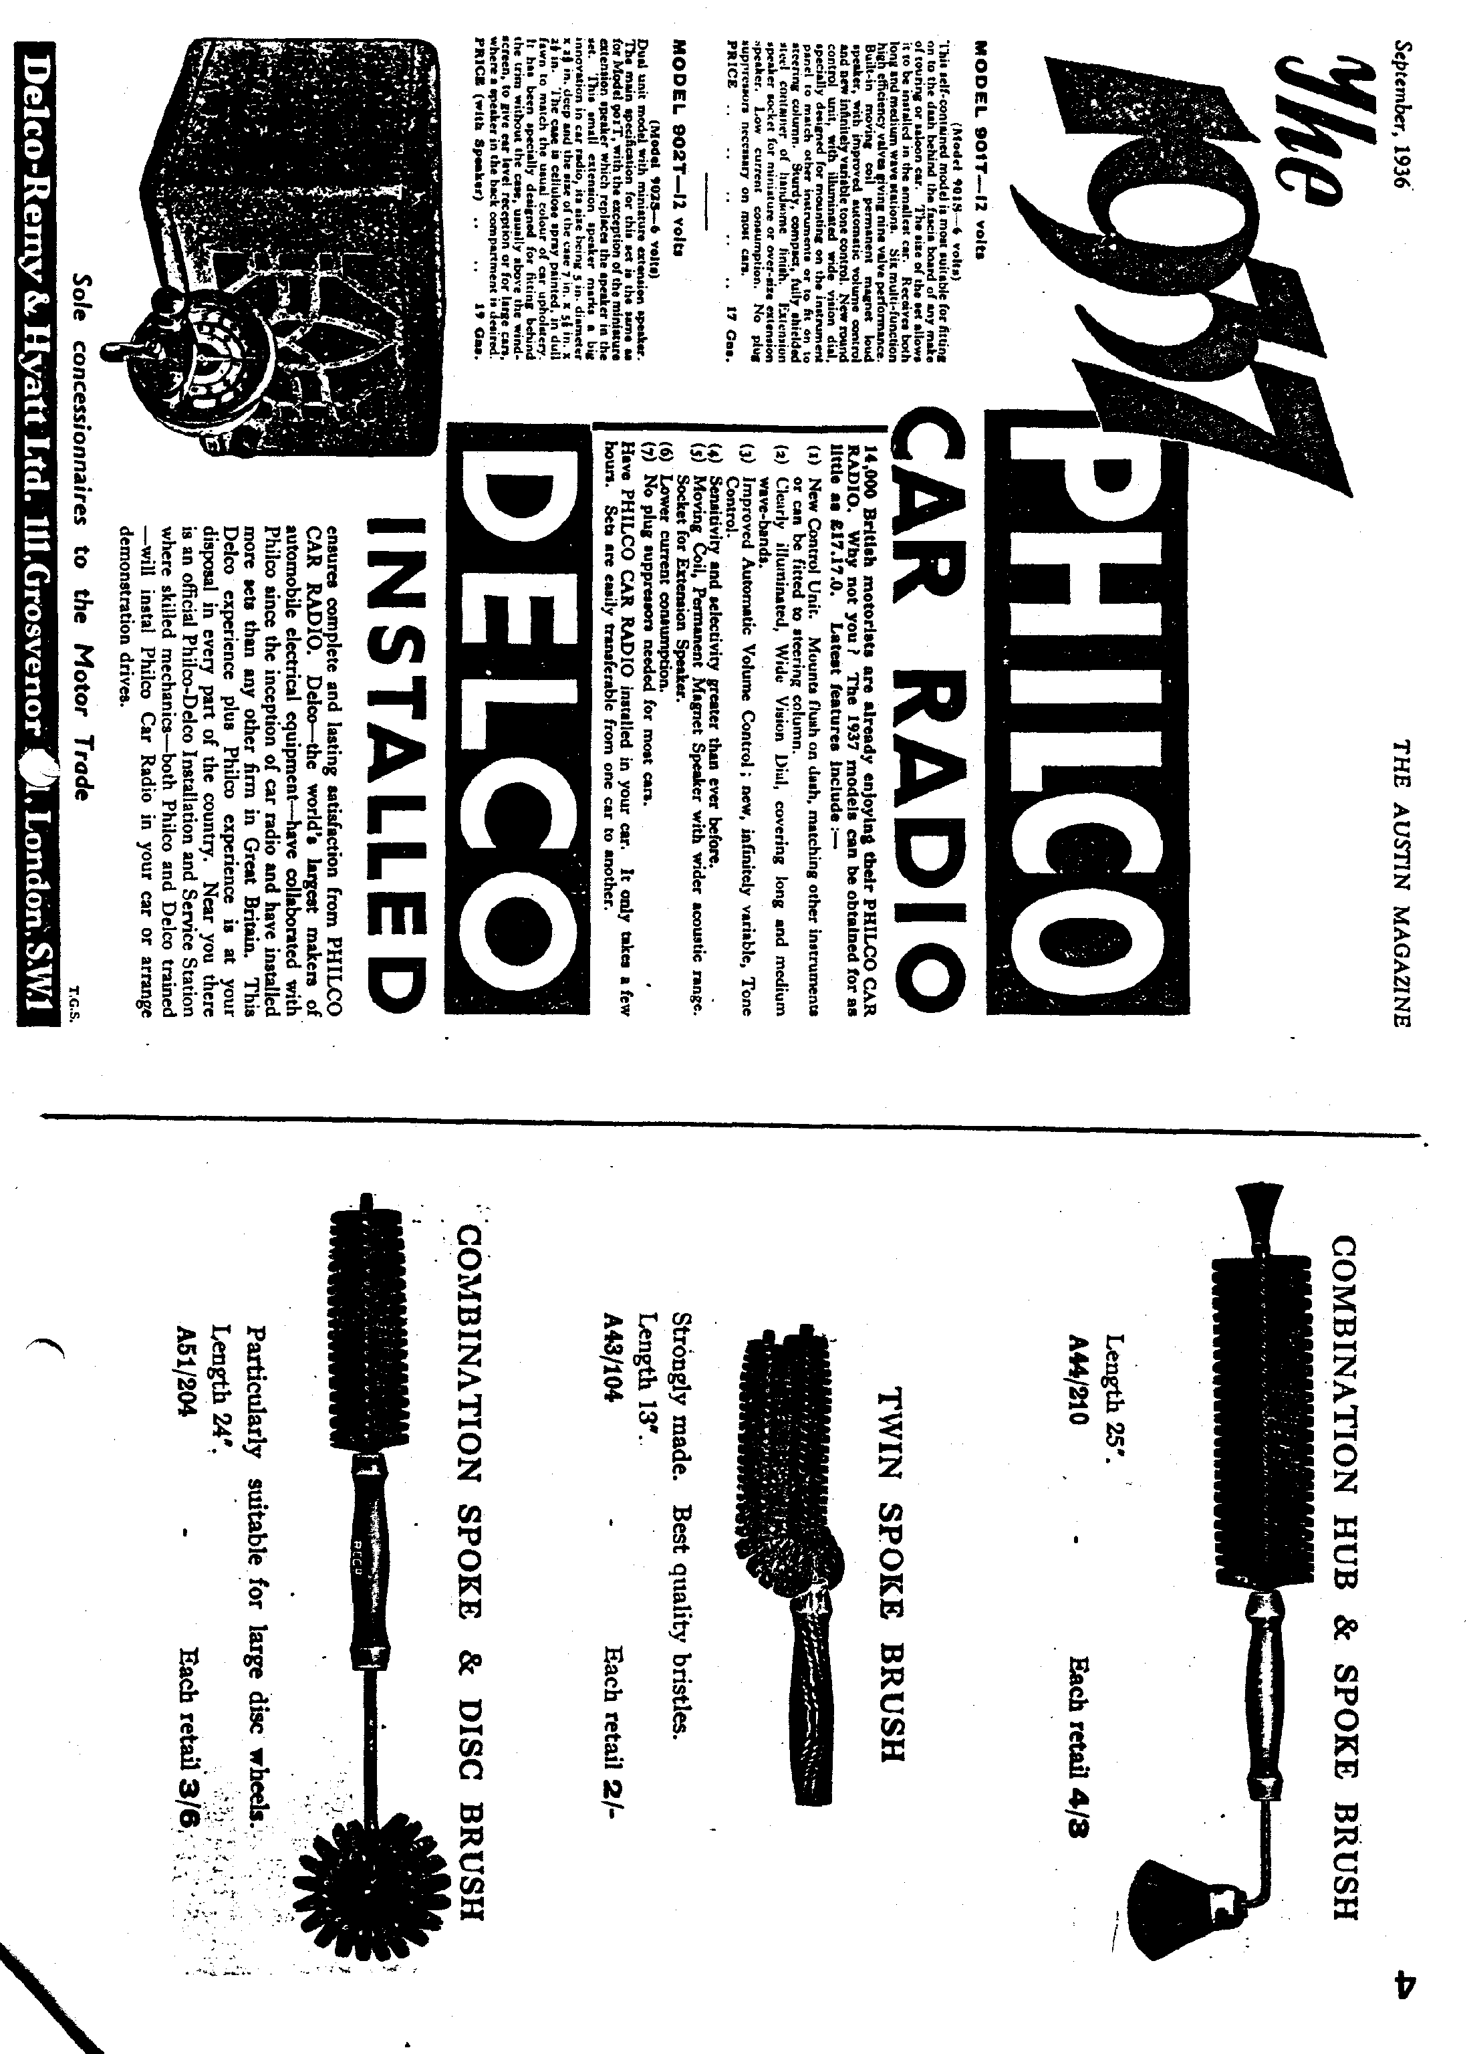
THE ULTIMATE MAGNETO/COIL CONVERSION

Attention all those owners of Magneto engined cars, who like myself pray each outing that the dreaded device won't give up the ghost miles from home. I speak from experience having had to tow my Chummy some 100 miles home in the middle of the night, with the prospect of starting a new job the very next morning!! I have since converted my Blicc Mag to coil ignition, using the existing contact point gear, with, I must admit, a good deal of success. The problem is, of course, when points wear out they are almost impossible to obtain.

Mr Kirby Robotham of 58 Arch Street, Rugeley, Staffs - 0889 584758 has come up
with the ultimate reliable answer. Using the existing Magneto and hiding a coil and magic box under the dash, he has ingeniously converted the unit to electronic ignition, which not only should give almost a lifetime of trouble-free motoring but uses only milliamps to power the ignition, so conserving the battery. Prices start at around £150 for the basic conversion. The modification has transformed the smoothness of idle of my car, and the ease to which it revs to the top of the range. The unit produces a high tension spark of some 40,000 volts, so enabling one to open the plug gaps up to 30 thou. to enhance more efficient engine operation.

I know the purists out there will be throwing up their arms in horror but believe
me with the experience I have had with so called re-built Magnetos this 'Mod' is the answer to my dreams. If you are interested give the chap a ring he really is very helpful.
Gary
FOR SALE
Rolling Chassis, more or less complete, with engine and old log book

Bowdenex Brake conversion set
Hydraulic Brake kit, back plates and master cylinder etc. 2 off 16" Wheels - shrouded variety, chrome centres Set Military Wheels for late 32 Mil Tourer (4.00 x 17)

Independent Front Suspension hits, choice of either LMB or Bowdenex, both with springs.

Various Go Faster manifolds, both inlet and exhaust.

Several Zenith Downdraught 26VM and 30VM carburetors '

offers or swap for "lag engine parts Tel Miles Shepherd Salisbury {0;22) 2r2105
WANTED
For Ruby - Bumpers and irons, front seats, headlamps.
Glyn Llewellyn 4a New Milton 613080

FROM ONE EXTREME TO THE OTHER (continued)
Friday was spent looking around Thurso where we met some
very hospitable members of the Caithness Vintage-Car Club and had
a look at all the local shops. I bought some molyslip gear oil and this was poured over the timing gears to protect them when the crank drifted backwards. On the war back to John 0'sroats,we explored the coast and had a look' at the most Northern lighthouse . When we arrived
- back at the farm the oil was changed again and soon after this Keith and Pete arrived in Keith's Chummy having had a good run up from Ower.
In the evening we all went up to the John 0'Groate Hotel where
a good time was spent talking Austins with the varied and large gathering of enthusiasts, We were particularly amused by the exploits of Geoff Walker and his resultant physical disasters,

After breakfast on Saturday we, made our way to the start but only after I had rescued our rotor arm from the evil clutches of the Roach who was intent on getting me wound up:

For some of the starters the event was more like an assault
on Everest - there were trailers and support cars all over the place and it must have cost them a fortune. Keith and Pete. were to be first away with the oldest car: and. Willie and I managed to be ninth in the line.
• At mid-day Viscount Thurso waved off Keith and Pete to a cheer from the large crowd gathered and nine minutes later we were off as well. The first stage was to Inverness and we had a good time dicing with Chummies up some of the hills and in some cases the superiority of the three speed box became apparent. We eventually passed Keith and Pete when they stopped for petrol and as we approached Inverness our average was already nearly 40mph. •• .

On the other side of Inverness Keith and Pete suddenly appeared from nowhere and there was some friendly bantering for the next law miles. Eventually on the long drawn out hills we pulled away from the Chummy and we found ourselves out in front but not for long. Just north of Inverness we ran out of petrol going up hill but were fortunate to have a reserve in our Jerry can.

Soon after this we were overtaken by Terry McGrath and Geoff Walker in their 65 Sports and shortly after by Vince Leek going very fast in his Ulster. About a hundred miles further on we were surprised to catch up with Terry and Geoff again but they must have seen us in the mirror because they suddenly took off and the next time we saw them was at Lands End. . . ,".
I carried on. driving to Carlisle and then Willie took over for the marathon drive through the night to Exeter. We kept the speedo
hovering at around 50mph and we still had 5mph in reserve. The only incident was when at one stage Willie 'flashed a lorry and the ignition key fell out: I was frantically looking through twenty keys on the floor of the austin while we drifted downhill at 50mph - on sidelights!
Herewith the second part of Phil's account of his A7 Run from Lands End to John 0'Groats at Easter 1982.
Later in the night we were overtaken by Andy Storer in his much modified 65 Sports and in fact Andy eventually got the fastest time of 18 hrs. 10 mins.

As we pushed further south we could see our average getting better and better until when eventually we reached Exeter we knew we had beaten the previous record time and if we could do the last 130 miles to Lands End in 3 hrs. we could even get under 20 hrs.

Willie was glad to got into the passenger seat for his nondrive down from Carlisle and I took over for the last stretch to Lands End. The Ruby was driven harder and faster than ever before in its life at times reaching 65mph downhill but a combination of the hilly terrain and our heavily laden car meant we eventually reached Lands End 20 hrs. 11 mina after we left John O'Groats. We
,reached welcomed by Terry McGrath and Andy Storer and a bottle of. 'sponsorship' Highland Whisky was passed round by Terry. •
At the time we felt somewhat disgruntled at the apparent lack of organisation at the finish but realised. later that it did not officially open until 9 am and in fact Terry McGrath and Geoff Walker had been 'signed in' soon after 6 am by an Indian gentleman • exercising his dog:

We thought it would be a good idea to drive back the ten miles to Penzance to buy some Pomagne to celebrate our arrival, but it was not until we arrived that we realised it was Sunday morning and you can't buy anything until mid-day; Making do with an ice lolly we had not gone far down the road back to Lands End when the starter switch caught fire: (this is a major hazard if you use your car a lot as muck and oil accumulates around the contact until it goes short circuit) We carried out our first roadside repair in 2000 miles and continued back to Lands End to find that no other cars had yet arrived.
At 10.30 Keith and Pete arrived in the Chummy having driven all the way with the hood down and not only did the, have the fastest Chummy but also the fastest oldest car. After a good welcome from our families who had arrived by now and were surprised to see us,we made our way back to the caravans at }Perranporth for a well earned rest. .

In conclusion, it was all great fun and Willie put up with my company very well during the trip. We were pleased to have done such a good time in a totally standard car and in fact can claim a new record for a saloon as we were beaten by a Pearl Cabriolet with the later more powerful engine doing a fantastic time of 18 hrs. 55 mins.

The trip raised nearly ;10(i0 for local charities and Willie and I were pleased to be able to present Poole PHAB club with cheques for £370 towards their new bus many thanks to all of you who supported us.
Phil Whitter

PS The Ruby is still being driven with a broken front bearing flange 30,000 miles later.

EVENT 7
MARCH

Thursday 16th March - CLUB NIGHT at the Elm Tree 8.00 pm. This is Quiz Night.
Sunday 19th March - CLUB RUN to the Sparkford Motor Museum, nr. Yeovil. Meet at Wimborne Square at 10.15 for 10.30am or Sturminster Newton Mill at 11.15am.
Thursday 23rd - Tuesday 28th March - CLUB EASTER RUN TO JERSEY. Thursday 30th March - COMMITTEE MEETING at the Tyrrells Ford - 8.30 pm. APRIL
Thursday 6th April '8 to Late' (for those who want to meet for a natter) at The Tavern, New Milton.
Thursday 20th April- CLUB NIGHT. Meet at the Elm Tree at 8.00 pm for a short Evening Run.
Sunday 23rd April - A St George's Day Run. Details next month. Thursday 27th April - Committee Meeting at the Tyrrells Ford - 8.30 pm. WIDER EVENTS
Details from Secretary, Editor or as shown.
16th April The Daffodil Run
7th May - Bournemouth and Poole Preservation Club Road Run '89 in conjunction with the Bournemouth '40's' Festival.
4th June - WVPC Motorcade '89 at Braemore House $M 072 56334
11th June Vintage Vehicle and County Fayre Brockenhurst Park p 0590 23175
15th/16th July Eastleigh Vintage Machinery Preservation Society (Animals and Mechanicals) at Marwell Zoo. OR 0705 479026
Just time to thank Gary for arranging another joyful Barn Dance. It was a great success - more next month.

