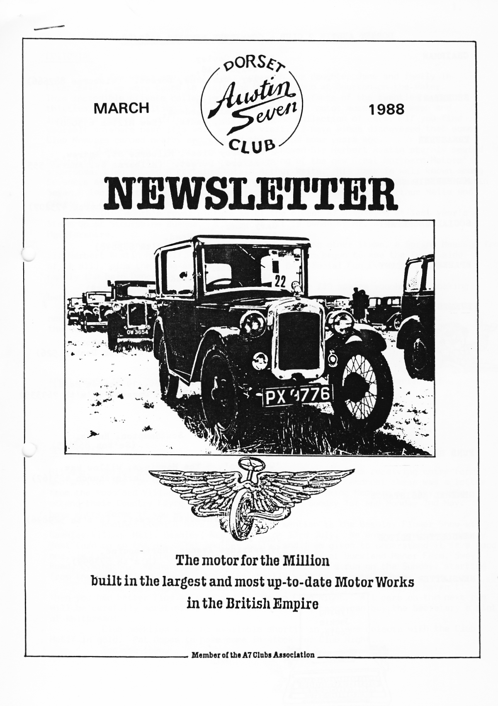
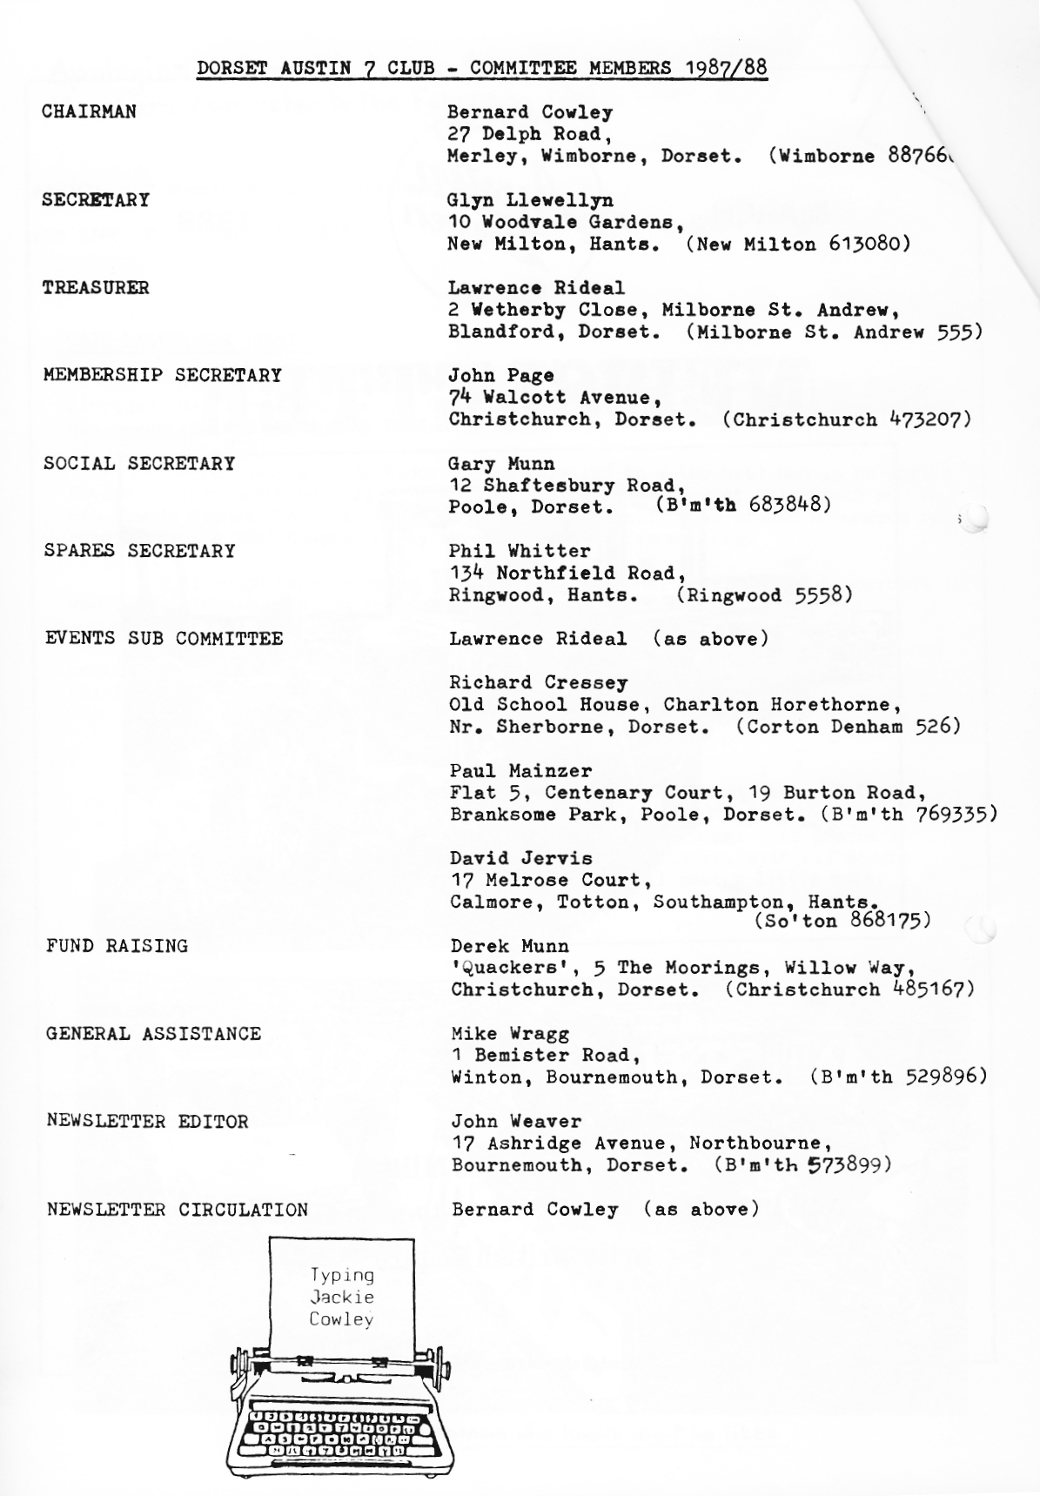

EDITORIAL

A few weeks ago, whilst staying with our daughter Jane and family in Cirencester, we were taken to visit the Motor Museum at Bourton-on-the-Water. This incredible private collection of cars and artefacts of the twenties and thirties is most exciting. It's the best 'natural' motor museum I've seen and includes a number of different Sevens among the collection of cars. If you find yourself anywhere near it's well worth a visit. I have since discovered that some Club Members camped nearby and visited the museum some years ago.
Last month's cover picture, which showed Sir Herbert Austin sternly seated behind those monster microphones at the opening of the new Great Northern Motors' showrooms, also showed a certain Captain Arthur Waite. His name is well known among Seveners as a pioneer of motor racing in the twenties - behind the wheel of an Austin Seven. Included this month is a brief account of the exploits of Arthur Waite and others on the Brooklands track.
This month's cover picture is of the oldest A7 displayed at last year's Steam Up at Stourpaine Bushes. A 1929 car, it is owned by Mr. A Meadows of Hertforshire.
As Spring is in the air we also have, among other items, a Spring Message from Sir Herbert Austin himself, more from David (who has begun to see the funny side of it all), plus the long-awaited news of the DA7C Social Fun Event of the Year, namely the Barn Dance, from Gary.
Ensure your inclusion in the draw for the £10 spares voucher by booking before 31st March. It makes sense and costs no more for the opportunity.
Please also, as Gary says, bring your friends and relations. We urgently need the bodies and they will certainly enjoy the evening. Give 'em a treat - - they deserve
John
APRIL NEWSLETTER - Your contributions welcome - by 30th March, or earlier if possible because of the Easter Run.
SECRETARIAL

Hi Gang. Spring must be just around the corner, because I am receiving entry forms and invitations for Members to attend various functions. Amongst these was a letter from the Woodford Village Hall Management Committee asking Members if they would attend their Country Fayre which is to be held on Sunday 1st and Monday 2nd May. I have entry forms if you would like to go.
Another event I have been asked to mention is the Bashley Flower Show at Bashley Village Hall, Bashley, New Milton, on 23rd July. No entry form is necessary just turn up on the day. Yet another rally, and I am given to understand it is a good one, is Lymington Vintage Show on the 9th & 10th July at Buckland Manor Farm, Sway Road, Lymington. We have been invited to take part in a run on the Sunday, starting from the Rally field, again I have (or shortly will have) entry forms.
Have you bought and fitted your Club car badge vet? What, you haven't!
Then you had better find a fiver and see me on Club Night. All cars on the next run will be carefully scrutinised and any one without a badge can buy the Secretary a pint of Whitbread!
Club neckties will be available shortly in various colours with the Club Motif in gold. Pat hopes to have some in stock for Club Night. See you then.
Glyn
THE WEST DORSET WANDER - Sunday 21st February

It seems a very long time ago since we saw wintery weather, and this, particular Sunday was yet another glorious day, rather like an early Spring morning
We set off expectantly for Wimborne Square and were certainly not to t, disappointed.
When we arrived at Wimborne there were already a lot of people ready and waiting. The first impression I got was the very strong presence of Rubies. When we first joined the club, all those years ago it seemed it was all Rubies then it seemed to be all Box saloons, then there was the Specials phase, now it is clear Rubies are on the way back!
We didn't have to wait long before we moved off, just as well as the local Bobby was rather less than happy about the improper parking!
There was indeed a very fine turnout with four Rubies, four Box saloons and Bernard's Chummy, plus the delightful Jo in her Morgan, Mike Wragg in a bargain Rover 2.3 and Mervyn Frampton in his Russian Cadillac (Lada).
Paul and Emma were in charge and they set off at a brisk pace towards Blandford.
It was not long before we left the main roads and Paul pulled over to ensure we were all still together. I was grateful, I had to spend a penny, those damn pills!
We weaved many a trouble-free mile from then through absolutely delightful countryside until Paul's car expired! His ignition lead fell out! Thank heavens. I was off yet again to spend another one.
Paul was soon on the move and we headed across behind the tank ranges of Bovington heading all the time towards Weymouth. We never saw any tanks though.
We eventually arrived at the lunch stop which was the Elm Tree Inn, Langton
Herring.
Seems the place has a new owner and he/she has certainly created an excellent and very different menu. The food is brilliant and very good value.
Strangely though I didn't notice whose beer! Editor? (Search me. I was too busy drinking it, too. Ed.)
The pub is run by Anthony and Karen. You can contact them on the phone number 871257.
I enjoyed the Hot n' Spicey Beef Casserole, Joy had the meat pie - both really good. Paul and Emma had Prawn sandwiches with so many prawns and T_ noticed quite a few struggling with huge Ploughmans' lunches; large and very interesting portions.
For those who missed the run I am sure everybody would recommend you to
this fine old fashioned Country Inn when you are exploring the Chesil Beach area. Richard and Margaret Cressey turned up at the lunch stop with Emily and Rosie swelling our numbers. Joy and I had a long talk with Emily, really great fun.
Paul was busy during the lunch break making French holiday final arrangements
and Mike Wragg was keeping everybody cheerful with his happy laughter.
After lunch we all walked down to the stretch of water behind Chesil Beach
the Fleet; on a very pleasant and sunny afternoon; down a quiet track.
As we had friends coming to call Joy and I left before the main party and
enjoyed a pleasant run home via Weymouth and Wareham.
There can't be many clubs around the country that get such support for club runs. Long may the Dorset Club continue.
Congratulations Paul and Emma for organising a pleasant run and thanks. That's it until the next time.
George and Joy
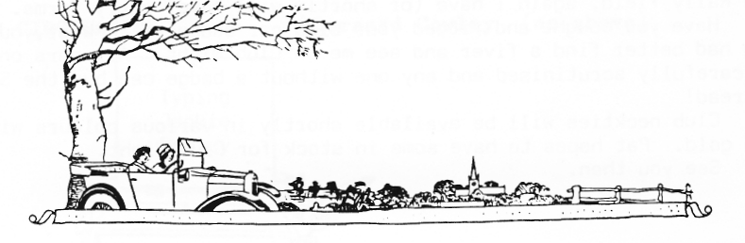

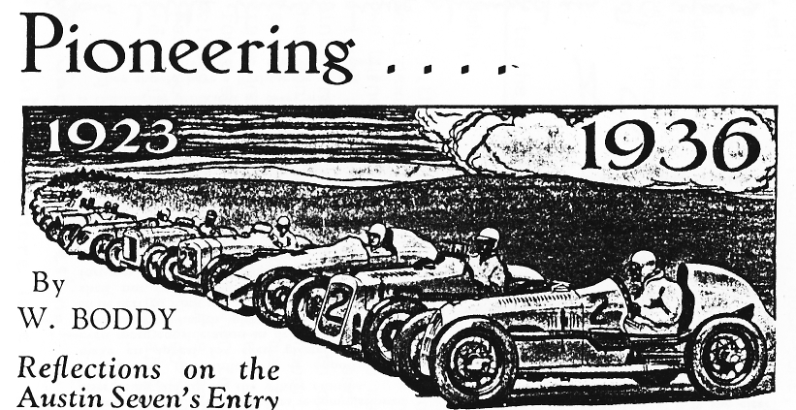
TODAY, with the Austin Seven an established fact, the wonderful little white, single-seater Austin lapping the "mountain" circuit at Brooklands to the tune of over 70 m.p.h. skilfully piloted by Driscoll, or devouring the railway straight at speeds of over 80 m.p.h., we are apt to forget that even the Seven was once unknown. Its amazing achievements may seem rather commonplace when they become a regular occurrence, and thus it is worth while to recall the first appearance of the Seven in the racing world and how it performed in comparison with the present competition models.
It is interesting to discover that as early as Easter, 1923, the Austin Seven figured amongst the race-winners. In what then must have seemed an absurdly tiny racing car, Capt. Arthur Waite headed the long list of subsequent Austin victories by winning his race at the Brooklands Easter Meeting of 1923. His average speed was 59 m.p.h.
The performance created a considerable stir, and amongst the people who were more than temporarily impressed was E. C. Gordon-England, at the time walking with sticks as a result of' a gliding accident. Shortly afterwards he commenced his long and noteworthy run of successes by taking Class Records at nearly 80 m.p.h., including the coveted "hour" at 73 m.p.h. In the 1923 two hundred mile race England entered
the little Austin, which was up against the 1,100 c.c. cars, as no 750 c.c. division was recognised at that time. The performance in that race was really magnificent, the Baby running through non-stop to second place in the class, averaging nearly 77 m.p.h. for the whole distance.
For 1924 the Junior Car Club recognised the 750 c.c. class in the two hundred mile race, and the general esteem of the Austin Seven a year after its entry into racing is revealed by the fact that no fewer than nine of these cars were entered.
They had no rivals, and the winner again proved to be England, this time at 75.61 m.p.h. The lower speed is accounted for by the loss of one con-rod and piston towards the end, but even so, it surpassed that of every 1,100 c.c. car with the exception of the class-winning Salmson ! Incidentally, England, himself no lightweight, carried a passenger throughout, and although his car was not specially streamlined, one lap was done at 80.33 m.p.h.
In 1925 a supercharged edition of the Seven appeared at Brooklands, which car was capable of well over 90 m.p.h. and was successful in capturing many records at around 85 m.p.h. That year Gordon England once again won the two hundred mile race, proving that the Austin was equally at home over the semi-road circuit as it had been previously round the outer circuit only.
It was in this 1925 event that Capt. Waite
ran a beautifully streamlined Seven, bored out to 776 c.c. to place it in the 1,100 c.c. section.
To continue this history would fill many pages ere we came to the stirring period when 100 m.p.h. first came within the possibilities of the baby car, achieved by Leon Cushman at Brooklands during August, 1931.
But the purpose of this article is merely to • remind you of those very early days of baby car history, when the Austin Seven entered, untried, into the stern field of competition, and did incredibly well right from the start.
Few people expected a purely utility car - the world's smallest - to be much use in serious racing. Yet with the sole addition of two carburettors and a special camshaft, the Baby Austin happily averaged over 76 m.p.h. for 200 miles on its, first appearance in a classic contest.
In conclusion, ignoring the classic contests altogether, it is instructive to note the best winning average speeds recorded year by year by Austin Seven cars, in the ordinary Brookland short handicap events that constitute the private owner's playground.
,, 'The very first victory of all was gained at 59 m.p.h. in 1923.
was victorious in a 75 m.p.h. L..
?7.79 m.p.h. Spencer gained his c_ m.p.h. in 1926, while in 19f17 Boyd Carpenter, popular little car averaged 73.38 m.p.h. in win. the August 90 m.p.h. Long Handicap Race.
The first Brooklands win at over 80 m.p.h. was registered in 1928 by G. Hendy, whose Austin won a 75 m.p.h. Short Handicap at 80.20 m.p.h.
The 1929 President's Gold Plate event went to
- pero's famous B.C. Austin Special "Mrs. Jo-Jo," at 8A70 m.p.h., and a "mountain" contest was won by Capt. Waite at 62.87 m.p.h.
The speed of over 83 m.p.h. achieved by the winning Austin in the 1930 five hundred mile race, driven by S. C. H. Davis and the Earl of March was truly remarkable.
The 1931 Relay Race went to the Austin Team at nearly 82 m.p.h. and, .reverting to short handicap, A. B. Gilbert that year won a Club Sports Contest in a sports model at 85.57 m.p.h. lap speed.
By 1932 lap speeds of over 90 m.p.h. were fairly common, and in winning a race at the Easter Meeting Driscoll lapped at 102.48 m.p.h.
And last season various Austin Sevens were lapping the difficult "mountain" circuit at from one to seven or eight m.p.h. faster than Gordon England and Capt. Waite were winning straight away races in 1923. Truly a great marque.
During 1924 Gordon England won a race at 75} m.p.h. and in the following year R. E. Hall
.
DON'T LET IT BE 'IF ONLY '
?f you haven't bought one of the new, unique Club car badges it isn't too late.
Glyn still has a number for sale at £5 each. What other
A7 club has badges made from old A7 crankcases?
Rumour has it that these may soon become collectors' items, as the word has gone round. It would he a pity if we let them go to those outside the DA7C before all members had one.
Don't miss your chance!

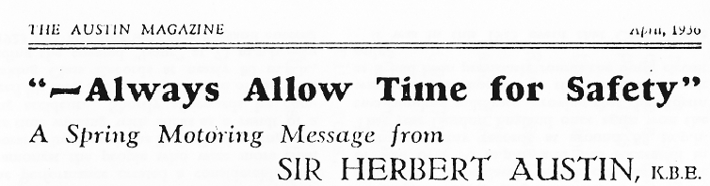
DURING March, when the new motor licensing quarter began, 300,000 more motor vehicles took to the roads of Great Britain.
Of these, if we are to judge from last ),car's figures, nearly 50,000 are new vehicles licensed for the first time, of which it is safe to assume that an appreciable percentage is in the hands of new drivers. 'Fire others are vehicles re-commissioned after being laid up for the -inter months.
Following this influx, it is opportune to make an appeal for even greater care and even more consideration in driving, so that the advantages in health, pleasure and convenience to be derived from sprint; and summer road travel shill not have offset against them the misfortunes of injury and death.
During the past year accident figures have steadily declined, and the total number of road deaths in 1935 was the lowest for seven years, even though in that time the number of motor vehicle,, if, use had almost doubled.
lire 300,000 additional drivers who are on the roads this spring must share the responsibility of maintaining this improvement.
This they can do by ensuring tint their driving is thoroughly proficient in every way.
They should have n lively Sense of the mechanical forces involved in speed or change of direction and the possible consequences of collision. -they should maintain their vehicles In proper adjustment so that they respond with certainty to every movement of control. They should allow ample time for all journeys, long or short. They should scale down the optimistic mileage schedules or high average speed ambitions which encourage risks. They should pass ,,lower vehicles or enter road junctions or crossroads only when the certainty of safety exists. In short, they should always allow time for safety.
When considered in terms of road mileage covered, motoring is safer to-day than it has ever been, and the roads of this country will be even safer when the Government sees fit to spend more of each year's motor taxation receipts on improving our road system. At the moment these receipts amount to over 70 million pounds, but for the next five years we are promised an expenditure from these receipts of only fourteen millions annually on new toads and improvements, and for the time being most of the unsuitable surfaces, awkward corners and poor lighting with which we are all familiar, will probably remain.
But while there are accidents, it is the clear duty of every motorist, undeterred by these omissions, to exert every endeavour to reduce their number.
In his New Year appeal, broadcast on January 3rd last, the Minister of Transport said, "Not in regulations and mechanical devices lies the real salvation, but in personal care and restraint."
May we take this as a promise of no further restrictions on motoring, and as an intimation that for the future all road users are to be put (,r:, their honour in this matter of road safety? Knowing that they will readily respond, I wish all car owners safe and therefore pleasant travel during the spring and summer motoring season that lies ahead. //
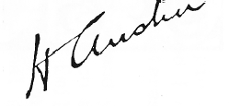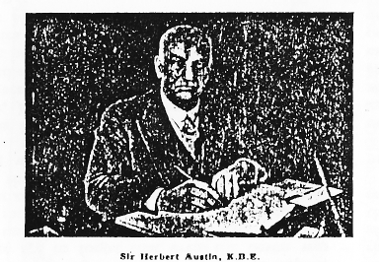

OILS SURVEY - 18.2.88

Thank you to 22 Members who revealed their choice of oil at the February Club Night.
It was interesting to see the wide range of brands and SAE. For engine and gearbox Morris's oils were most popular with SAEs varying from 20 to 50; but with SAE 40 being the majority choice. All but four Members questioned chose SAE 140 for the rear axle.

Hope this will he useful Jeff; and also of general interest.

BODGER'S CORNER - The Jigsaw

Some of the oldest Club Members might dimly remember that this article was started back in September when yours truly, without a care in the world, took all of his engine to bits. Seven months later, a tentative peek into the forgotten garage revealed a 5000-piece jigsaw of thingamajigs, whatsits and funny roundish bits and no picture to go on. I had carefully put all the sump nuts in one box, the head studs in another and so on, and it was all perfectly clear which was which. Then. The moral of this tale is 'Don't leave it too long or the brain goes soft.'
Two hints for those who haven't yet used Regar Engineering - any job takes as long as it takes you to lose your patience; and you have to pay CASH. This may not be a problem for most, but at 4.30pm on a wet Friday afternoon it was a problem for me. Every cash point in Moordown and Winton was empty of course and it wasn't long before I started to do my. John Cleese imitation.
The next morning, all relaxed and ready for anything I turned to the Green Bible and looked up 'Engine re-assembly' (p.126). I quote, 'There is little or
nothing to say about engine reassembly...and I propose to say nothing about it at all.' A great help! So the rest of Saturday morning was spent writing down how to take an engine to pieces backwards. To save others this tiresome task, here is what is meant when the manuals say 'replacement is just the foregoing in reverse.'
Firstly, match big-ends to crank journals to check for clearances. On the crankcase; replace oil pressure relief valve, oil pump, camshaft, centre bearing and front bearing retaining bolts, crankshaft, rear roller race, outer race and housing, oil thrower, front races, retaining plate, small timing wheel, starting dog and locking washer, camshaft timing wheel, flywheel, clutch. On the block: replace valve guides, tappets, grind-in valves, attach little ends to pistons, with the block up-side-down push pistons down into bores, turn block over on top of crankcase dropping conrods down into bores, turn block over on top of crankcase dropping conrods down onto crank, attach bottom halves of big ends, tighten block holding-down bolts, fit valve springs and adjust tappets, replace valve chest cover, fit cylinder head manifold, starter, dynamo, nose-cone, pulley and gearbox and replace in car. Put back all those bits dangling around, the floor, radiator and bonnet. Total time equals seven months and seven days.
Next month (yes I'm milking this for all its worth), secrets revealed will include how to get the outer rear main out of its housing, why big ends stick when they're the right size and how to tell which way round the con rods go. Exciting stuff, I know, but you're just going to have to wait.
David Whetton
Letter to the Editor Dear John,

With reference to our West Dorset Wander, I read an interesting fact in our local newspaper a few weeks ago. On the main road from Wimborne to Bere Regis where we turned off to Bloxworth you may have noticed that the signpost was red.
I have lived around here for years and always wondered why that particular signpost was painted red - well, according to our Wimborne newspaper it dates back to the time when convicts were being transported to Australia. These poor unfortunates were kept at Dorchester and then marched to Portsmouth but their guards were illiterate and unable to read milestones so they had to place this red post along their route so that they knew when to stop for the night. This snippet of information was included in an article about a nearby pub the ex General Allenby (a real dump) which has recently been refurbished and re-named The Botany Bay, presumably as a belated tribute to those original Aussies!!

Jackie

Your Committee have been considering the fact that at present Club Events are bunched towards the end of the month. As there are good reasons for this, it has been decided to have an informal EXTRA meeting on the first Thursday of each month.
This will be at a different venue each month and is simply to provide an opportunity for Club Members who wish to do so to keep
in contact. There will be NO PROGRAMME, NO SPARES and NO RUNS and members are not 'expected' to turn up. However, anyone feeling like a natter is welcome.
The first of the '8 to Late' meetings will be on Thursday 7th April at the Langton Arms, Tarrant Monkton. Time? It's up to you entirely.
EVENTS

MARCH Saturday 12th March - Skittles Evening with the New Forest Morgan Club at the Old Farm Barn Inn - 7.30pm. See January Newsletter.

Thursday 17th March - Club Night at the Elm Tree 8.00pm 'Noggin and Natter'

Sunday 20th March - Club Run to the Royal Victoria Country Park, Netley -
ex military hospital and now a museum. Meet at The Cat and Fiddle, Hinton Admiral at 10.15 for 10.30am, or at the Asda Car Park, Totton at approx. 11.30am.

Thursday 24th March - Committee Meeting at the Tyre's Ford 8.30pm.

APRIL Thursday 31st March - Tuesday 5th April - Club Easter Run to Bayeux, France via Portsmouth and Le Havre.

Thursday 7th April - '8 to Late', Langton Arms, Tarrant Monkton. (See within).

Thursday 21st April - Club Night at the Elm Tree 8.00pm. A talk on Victorian bicycles by Roger Street.
WIDER EVENTS

17th April - Bean Car Club Daffodil Run from Maidenhead. Entry Fee £6. Further details from Brian Toalster T Bournemouth 514818.

Sunday/Monday 1st/2nd May - Woodford Country Fayre. Details from S.Kerley, Wishford Road, Middle Woodford, Salisbury, SP4 6NG ( M.W.320), or entry forms from Glyn.

5th June - W.V.P.C. Motorcade '88, Braemore House, nr. Fordingbridge. Details from Mrs. J. McPherson, a 072 56334.

18th June - Spye Park Rally. Details, Glyn Llewellyn, V New Milton 613080, or at Club Night.

9th & 10th July - Lymington Vintage Show (See Secretarial). 23rd July - Bashley Flower Show (See Secretarial).

1st. 2nd. 3rd. & 4th September-20th Great Dorset Steam Fair. Stourpaine Bushes, nr. Blandford. For car entries contact Mr. Dave Lovering W B'mth 572504.

_L THIS TALK of oil Bernard topped-up the Chummy's rear axle - only
- to have the Chummy spray it back in spectacular fashion!

CHUMMY HOODS are in the pipeline at last for Gary and Paul.

HERE'S A CHANCE we'll have an Opal on the French run. Glyn's hoping to complete his project with an MOT test this month.

THE INTRODUCTION OF the 30 mph speed limit was on 12th March 1935.

Well folks, at last, we have been able to finalise arrangements! We have a new Band 'The Diggory Venn' which is much recommended, and a new venue - The Quarterjack Suite of the Allendale Centre, Wimborne. This is on the one way road opposite the Dormers and next to Antiquatat. Those of you who may have attended functions there will appreciate its quality. There will be a Ploughman's Supper included in the price of £5 and bar facilities. Once again, after the overwhelming success of last year's fancy dress, we have decided to leave the option of fancy dress open to you all; but remember there will be a prize for the best costume!

All your friends are most welcome - the more the merrier - so get 'phoning round! As a special incentive for early bookings Phil has kindly agreed to donate a free £10 spares voucher, which will be raffled among those Club Members who have
their money to me before the end of March. So don't delay, get signing those cheques!
BOOK NOW! BOOK NOW! BOOK NOW! BOOK NOW! BOOK NOW! BOOK NOW!
lease return booking form to me, Gary Munn, 12 Shaftesbury Road, Poole, Dorset BH15 2LJ by 30th April at the latest.
Booking form DA7C Annual Barn Dance, 7.30pm Saturday 7th May 1988 Allendale Centre, Wimborne. £5 per head

Name
Address
.................................... Phone:
Please reserve me places, including a ploughman's supper, for the
Barn Dance. I enclose cheque E payable to Dorset Austin 7 Club.

Signed

WANTED 19" Wheels and 28/31 Steering Wheel.
FOR SALE C.F.3 Cut-out - a15 Bernard Wimborne 887666
DA7C EASTER RUN 1989??
Did you know that the DA7C has an American Club Member in Lake Worth, Florida? He is Peter Masson who keeps in touch with the Club through Bernard and has recently sent his subscription for 1988.
Peter owns a 29/30 Wydor Saloon (similar to a top hat) and is an active Sevener. This month he will be involving his car in a show at Palm Beach and in his town's Pioneer Days celebration, where they usually have around a hundred cars ranging from a 1901 Nuestad Perry through to later fire engines.
Although Peter expects to attend the National Meet at Fort Lauderdale it won't be in the Austin, as that would be too far to drive.
All the best, Peter, when you read this, and we hope that the DA7C can continue to help keep your wheels turning. Drive carefully - especially as you're driving on the wrong side of the road!
As the Secretary has mentioned, Dorset Austin 7 Club ties are in the pipeline. These will be in various one-colours and bearing the Club badge - at approx £4 + VAT. The veteran designer version, with oil stains and built-in feeler-guage will cost a little more.
