Lord Herbert Austin, 1st Baron Austin
8 November 1866 – 23 May 1941
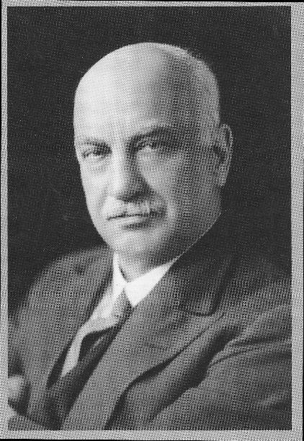
As this month sees the 150th anniversary of Herbert Austin’s birth, we thought new members may like to read a summary of his varied and fascinating life
The son of a farmer, he was born in Little Missenden, Buckinghamshire in 1866 but the family moved to Wentworth Woodhouse, near Rotherham, Yorkshire in 1870 when his father was appointed farm bailiff. Herbert Austin first went to the village school, later continuing his education at Rotherham Grammar School.
In 1884 at the age of 18 he emigrated to Australia with an uncle who lived in Melbourne but had recently returned to England on a family visit. He started work with his uncle who was the works manager at a general engineering firm, Mephan Ferguson, in North Melbourne. Two years later he joined Alex Cowan & Sons, a Scottish paper business which had an agency for printing equipment and Crossley gas engines. Later he worked for the Langlands Foundry Company Limited in Yarra Bank, Melbourne, which made locomotive boilers, wheels and gold mining equipment.
To develop his drawing skills Austin attended Hotham School of Art in North Melbourne outside working hours. During this time, he submitted a design for a swing bridge over the Yarra River at Spencer Street, Melbourne, for a competition organised by the Government of Victoria, but did not win.
In December 1887, Austin took up his new appointment as manager of an engineering workshop owned by Richard Pickup Park, who was developing a new sheep-shearing machine for Frederick York Wolseley. On the strength of this new managership, he married Helen Dron in Melbourne on 26 December 1887. They were to have two daughters, Irene (born in 1891, later Mrs. Waite) and Zeta (later to become Mrs Lambert). Their only son, Vernon James Austin, was killed in action in World War I in France on 26 January 1915.
After Austin spent three months improving the sheep-shearing machine, he was asked to join The Wolseley Sheep Shearing Machine Company in Sydney. Shortly after joining, he was sent to a sheep station at Avoca, Victoria to study the machines in use. Austin patented, in his own name, the improvements he made to the sheep-shearing machines and later sold the patents to the Wolseley Sheep Shearing Machine Company in exchange for shares.
Frederick Wolseley wound up the Sydney-registered company in 1889 and transferred ownership of the business to a new company registered in London and difficulties with suppliers persuaded the Wolseley board to move assembly to England in 1893. Frederick Wolseley and Herbert Austin left John Howard in charge of the Australian operation and returned to England in November 1893. Austin set up a factory in Broad Street, Birmingham and Fredrick Wolseley resigned from the company in 1894. The Broad Street factory was not large enough, so Austin bought a bigger one in Aston, Birmingham. As shearing machinery sales were highly seasonal, during slack periods in the year they built bicycles.
Looking for other products to even out the workload, Herbert Austin became interested in motor cars and built two different types of three-wheelers in his own time. A version of one of these was taken up by the Wolseley Sheep Shearing Machine Company and listed for sale in 1900, but the Wolseley board could see no profitable future for a motor industry. In 1901 Vickers bought Wolseley's car interests, taking Austin too, and naming the new business Wolseley Tool & Motor Company setting it up in Adderley Park, Birmingham. Herbert Austin retained his interest and ties with The Wolseley Sheep Shearing Machine Company and he was chairman of their board from 1911 to 1933, when he retired not long before his death.
In 1905, still under an unexpired 5-year contract, Austin resigned from the Wolseley Tool & Motor Company, taking some of the senior staff with him. His brother Harry also joined him in this new venture, having worked with him at Wolseley in Birmingham. Austin raised capital of £37,000 [£3.3 million today!] and embarked on a search for a factory that could accommodate his idea for a new car manufacturer. He took over an old print works, still outside Birmingham, in Longbridge.
Austin was producing 17 different models by 1908. During the First World War Austin produced munitions and built Austin Village in Turves Green for his workers.
The car business was difficult after World War I; the Austin company was threatened with bankruptcy in 1921 and a receiver was appointed. The "Baby Austin" was launched in 1922 and offered for sale at £225 [£8750 today], putting it within the budget of customers who had never previously owned a car. Its output reached 25,000 annually by 1925. In 1931, the Austin 12/6 was introduced, followed by the Austin 12/4 in 1933.
From 1918 to 1924, Austin served as Conservative Member of Parliament (MP) for Birmingham King's Norton but never made a speech in the House of Commons. In 1936 he was created Baron Austin, of Longbridge. In 1937 he received a Doctor of Laws (LL.D.) from the University of Birmingham.
Lord Austin died from a heart attack and a bout of pneumonia on 23rd May 1941. As his only son Vernon had been killed in action in France in 1915 the peerage became extinct on his death. He is buried with his wife Helen, Lady Austin, in the Holy Trinity Church in the Lickey Hills, near his former home at Lickey Grange and the factory at Longbridge.

From The Automotor Journal, November 4, 1905 Page 1366:
Mr H Austin, who has been for so long associated with the Wolseley Tool and Motor Car Co. of Adderley Park, Birmingham, advises us that he is leaving the Company, and is starting works on his own account situated at Longbridge, near Birmingham, where he will manufacture vehicles which are to be known as the ‘’Austin’’ Cars. At first Mr Austin will turn out two sizes of tourist cars viz., a 15-20 hp and a 25-30 hp. both of which models will embody the best approved principles in design, and Mr Austin proposes to use only the highest grade of materials in their manufacture. Moderation is to govern the selling price, and Mr Austin hopes to make the car of his name a household word for reliability and good service. Captain Frank Kayser is associated with Mr Austin in the new undertaking and he will be assisted by a specially-selected staff, several of whom have been connected with him in the past. The works are of considerable extent, covering several acres, and are thoroughly suitable for the construction of automobiles of all types. Mr Austin hopes to have his first 25-30 hp car on the road by the 1st of December and to commence deliveries by the end of March 1906. Mr Austin sends us, in a tabulated form, an extremely interesting record gained by the cars which have been turned out by the Wolseley Company during his direction of that Company. This list bristles with gold and silver medals in all the leading reliability and consumption trials, exhibitions etc whilst in the speed events and hill-climbing contests, the number of winners makes a formidable show, these triumphs being in addition to the selection by the A.C.G.B.I. of the Wolseley racers in 1904 and 1905 for the Gordon Bennett Race.
David Whetton

