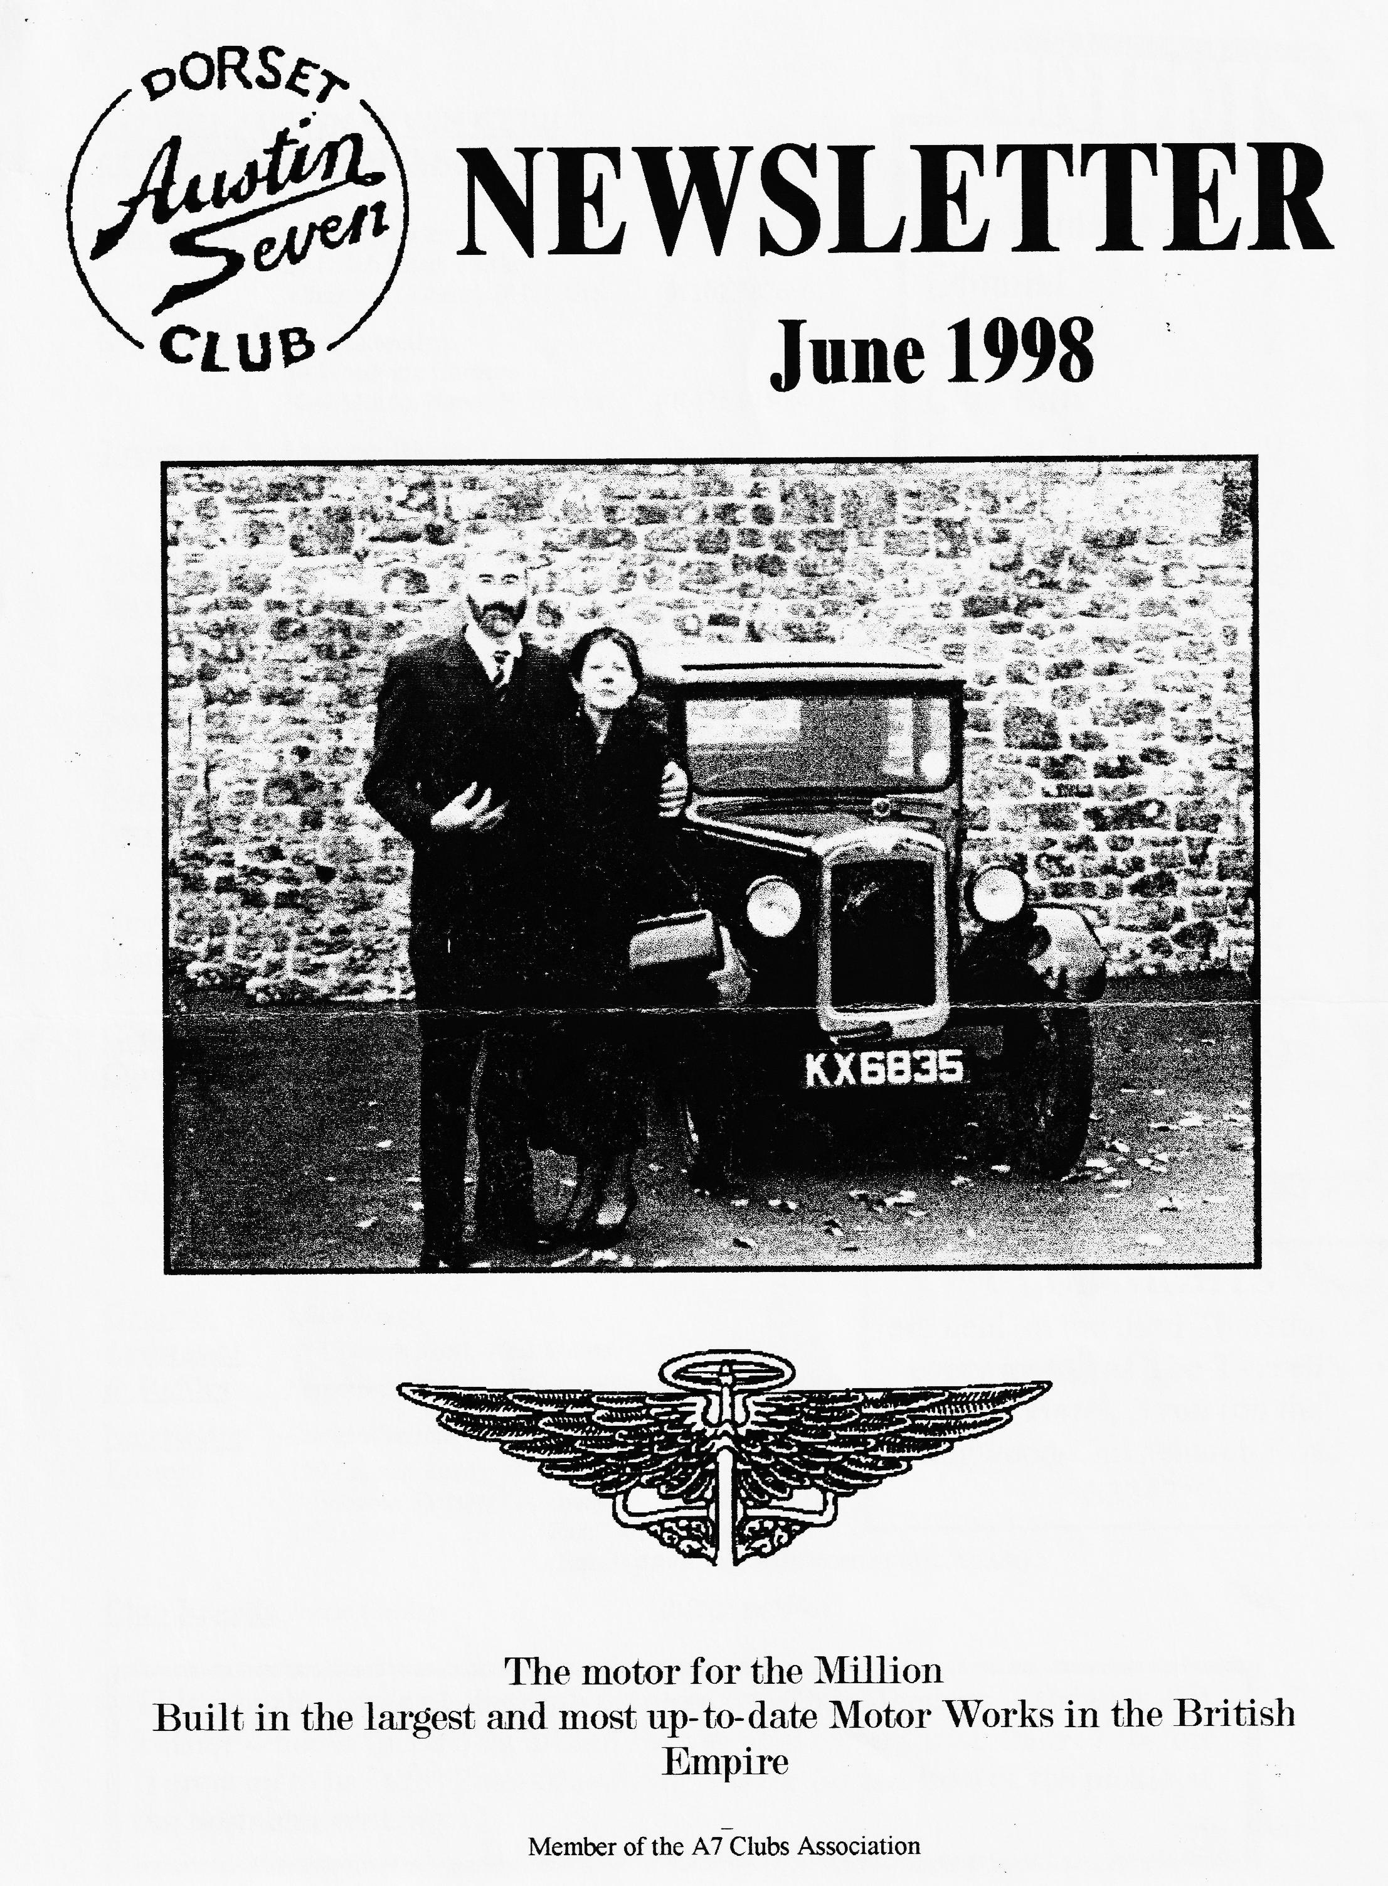

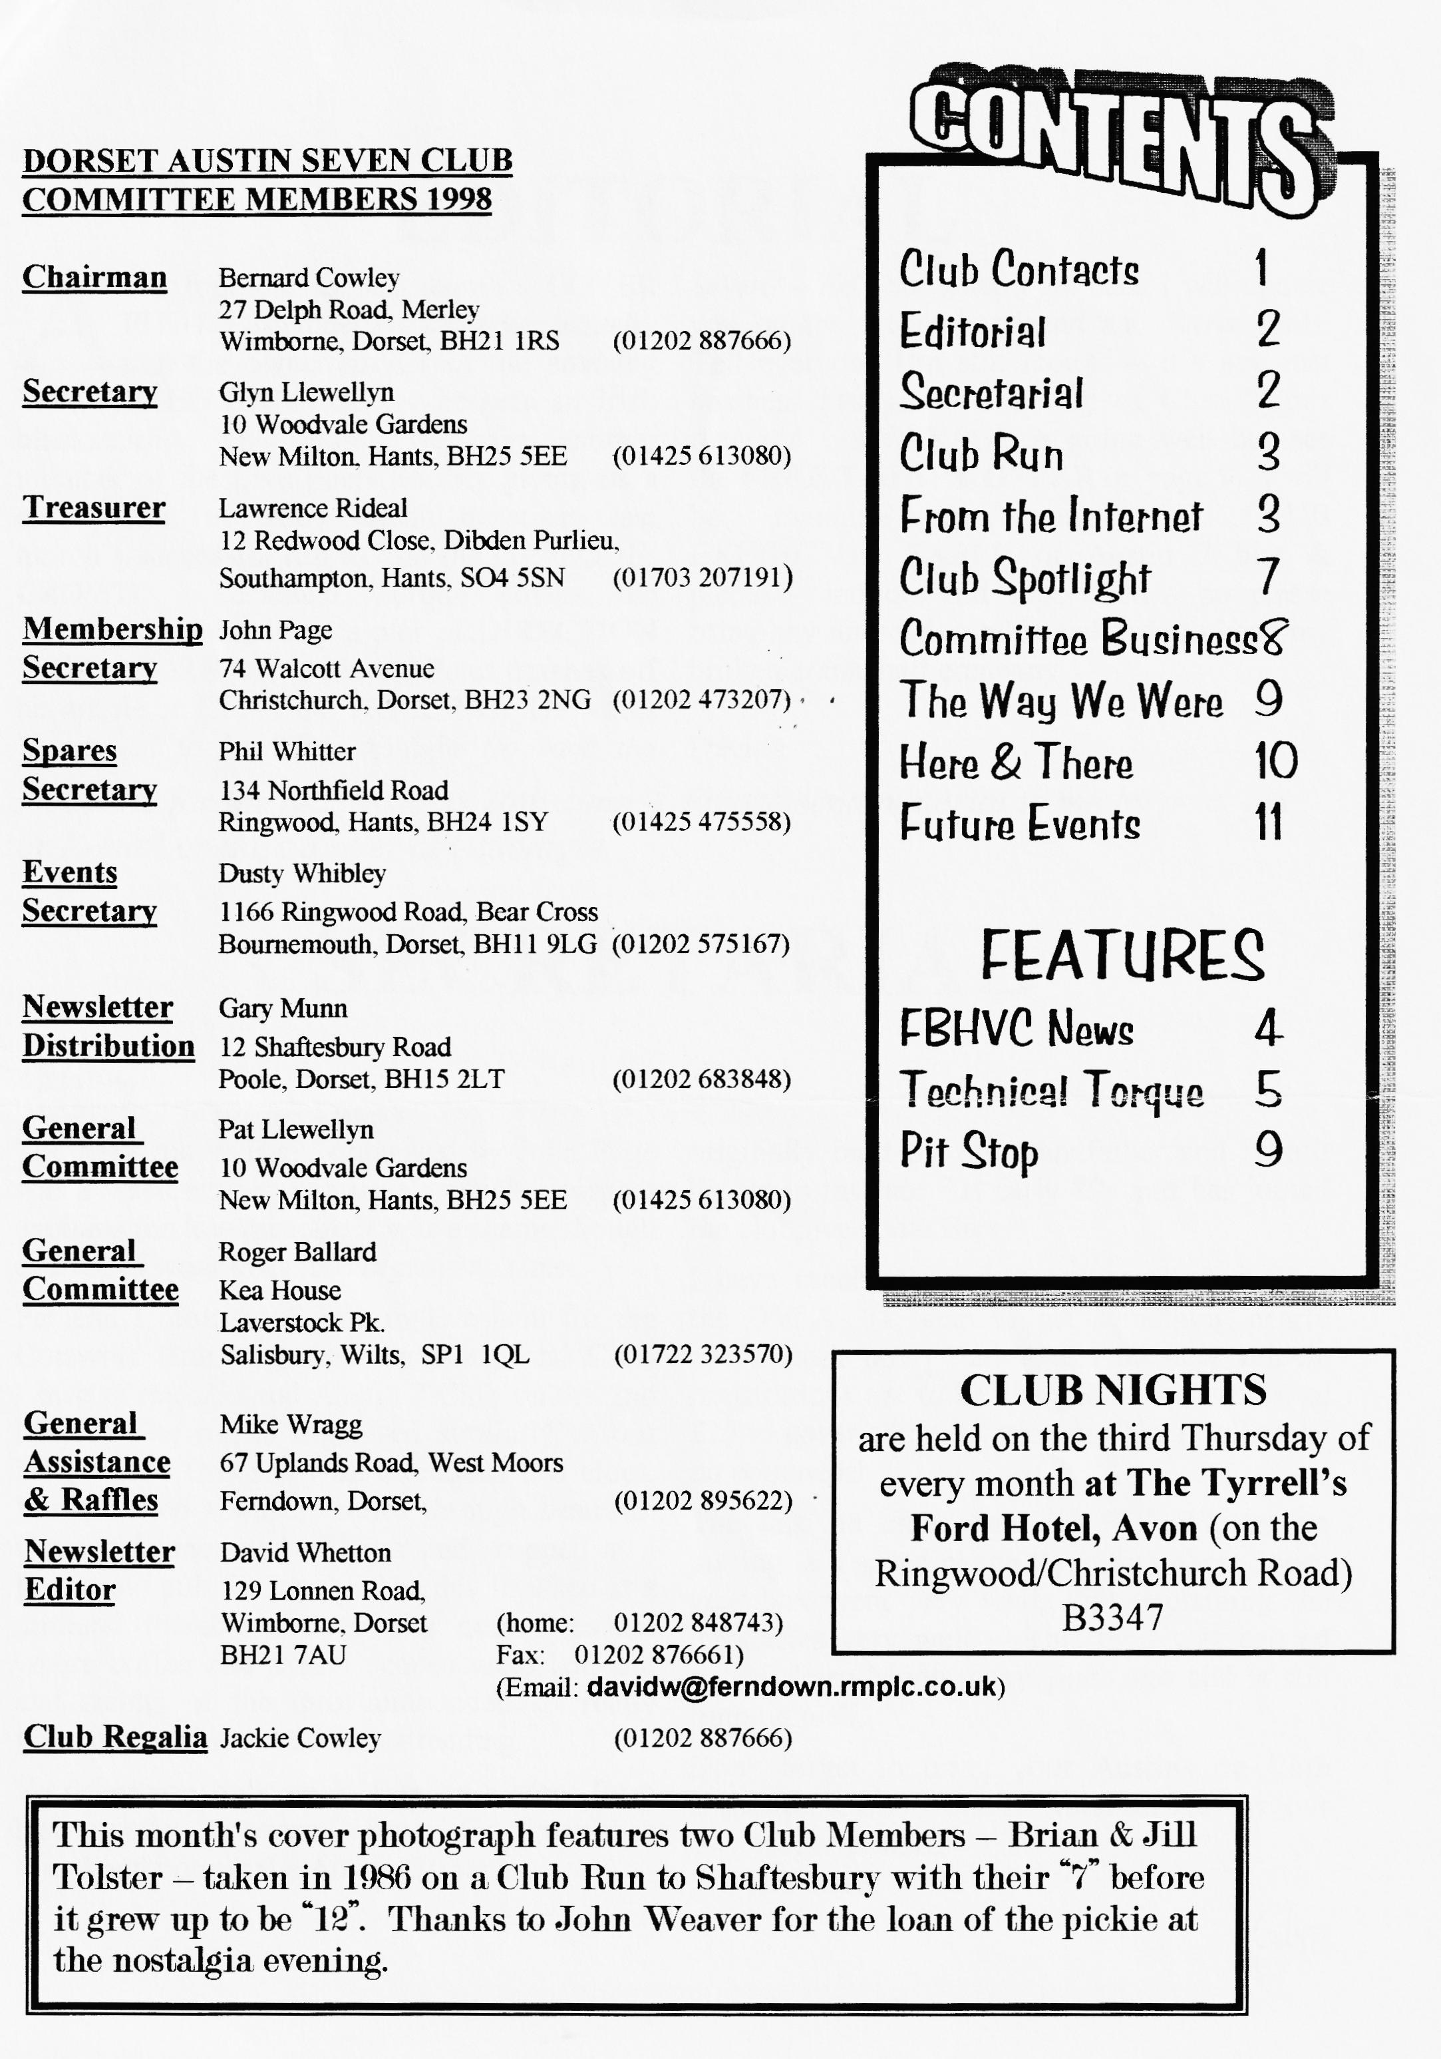

EDITORIAL
A
s a footnote to last month's COVER PHOTO, Member Brian Parker actually met the owner/builder of the amazing MOTORISED BICYCLE - he was an Irish blacksmith. This month we have another member of the Live Poets Society giving us a contribution to enjoy which describes last month's successful run to join the DAFFODIL CROWD. Technical Torque covers the mystery of maintaining a pair of DIRECTION INDICATORS that work and Peter finishes off his article on CLASSIC TRIALING. He writes "I am off to Le Mans tonight (to race the
Seven? — Ed.) but when I get back, I will update you on the recent Lands End and Kyrie trials. Tell everyone I'm still around — it's just that business has got in the way of Club Nights recently". SWANAGE is going well but see the FREE T-SHIRT OFFER on page 9. I will be manning (person-ing?) a CLUB EXHIBITION TABLE of Austin 7 bits & pieces — indoors and supervised — so please bring any interesting odds and ends to keep my broken crankshaft company.
David
Please send material to me by post, fax
Deadline for the next issue is 26th June . or E-mail or pass it over at Clubnight.
SECRETARIAL

HI GANG
The May run to Bath, organised by John Page was a week earlier than usual, which I suspect explains the low turnout. It was a shame though as a lot of work goes into organising runs.
Pat and I took the Fabric to Evesham for the Cotswold Run, organised by Andy and Chris Lowe of the Midland Austin 7 Club on the 2nd May. The run is organised similarly to our New Year's Day run with directions and clues. We travelled about 85 miles through beautiful Cotswold lanes and villages and stopped at a lovely old pub for lunch. The day finished at a midland member's camp site near Evesham where coffee and cream scones were laid out and results of the quiz announced. A really good day out, about 16 cars attending.
To bring you right up to date on a story from last month’s secretarial, Barry Goodman has found and bought the Austin 7 Special
originally built by his grandfather and rebuilt by me in the late 70s early 80s and has joined the club, welcome Barry.
I have received another communication from the DVLA (I seem to get something nearly every week now) stating that all new vehicle registrations are to be charged a one-off fee of £25 to cover administration costs! I will make no comment!
The talk on club night by Phil Whitter on putting a 4-speed clutch thrust in a three-speed gear box went very well, Phil explaining the intricacies very well. This mod was carried out by Gary Munn many years ago and is still running well.
Don't forget to bring your Austins on Club night for a free exhaust emission test by our own Roger Ballard.
See you there.

GLYN
Swayed we from Tiptoe, Ringwood bound O'er gorsey heath and horsy land,
With cloud and rain and sun around, Seeking rainbow, none to hand.
In Ringwood park, what delight!
Austin Sevens hove into sight.

Ten thousand saw we at a glance?
I tell a lie -t'were barely.... six! Bernard leading the merry dance,
The route for 'one' was quite a fix, Beside the ford and up THAT hill 'STUCK'! half way up - oh! what a thrill!

That was to come..., off we set,
Pewits, donkeys, hikers, and birch. Storms around, ( WE didn't get wet!).
For Bernard, a dry road did search.
To Stockbridge town he set our course O'er sleeping humps, through golden gorse.

Our cars all varied - AUO 613
From Exeter Dick Marlies left at dawn.
Paul's Pearl Cabriolet, good to see Bernard leading, on this wet morn,
Jackie his help, then Julian Wild,
Pat & Glyn, thus these Austin filed.

.En route flowers galore we saw-
Bluebells, Cowslips and yellow rape.
Mottisfont, Houghton, Broughton we tore
Wee Austins bright caused 'cyclists- gape'.
To Stockbridge soon we came, perchance
Daffodil cars there at a glance.

Admiring many and various
Bern gathered as all by babbling brook.
Route? - just slightly precarious.
T'ards Frogham direction we took
Blissford hill: nearly a cropper
One Pearl got stuck, good and proper!

Hefty lunch at Foresters Arms,
Ben, Jeff there for noggin / natter,
Food and drink soon worked their charms,
Filled the pub with laughter and chatter.
Thanks B. and J, your keenness and relish,
Filled our hearts: 'A day to cherish'!.
Biddy & Gordon (there in HIS Pearl!!)
Editor's postscript:
Wordsworth's ode to the Austin 7:
O'er rough and smooth she trips along and never looks behind
And sings a solitary song That whistles in the wind
and many thanks to two new bards - Ed

I am in the process of building an A7 Chummy from a pile of bits and a second-hand replica body. But I have run into a problem with the bonnet I have, being too wide for both the scuttle and rad shell. The body appears to be a 1927 AD type. Was this built with different width scuttles or is the bonnet from a different model?
From PETE BISHOP [bishop@autox.team.net] any comments to the Editor who will pass it on

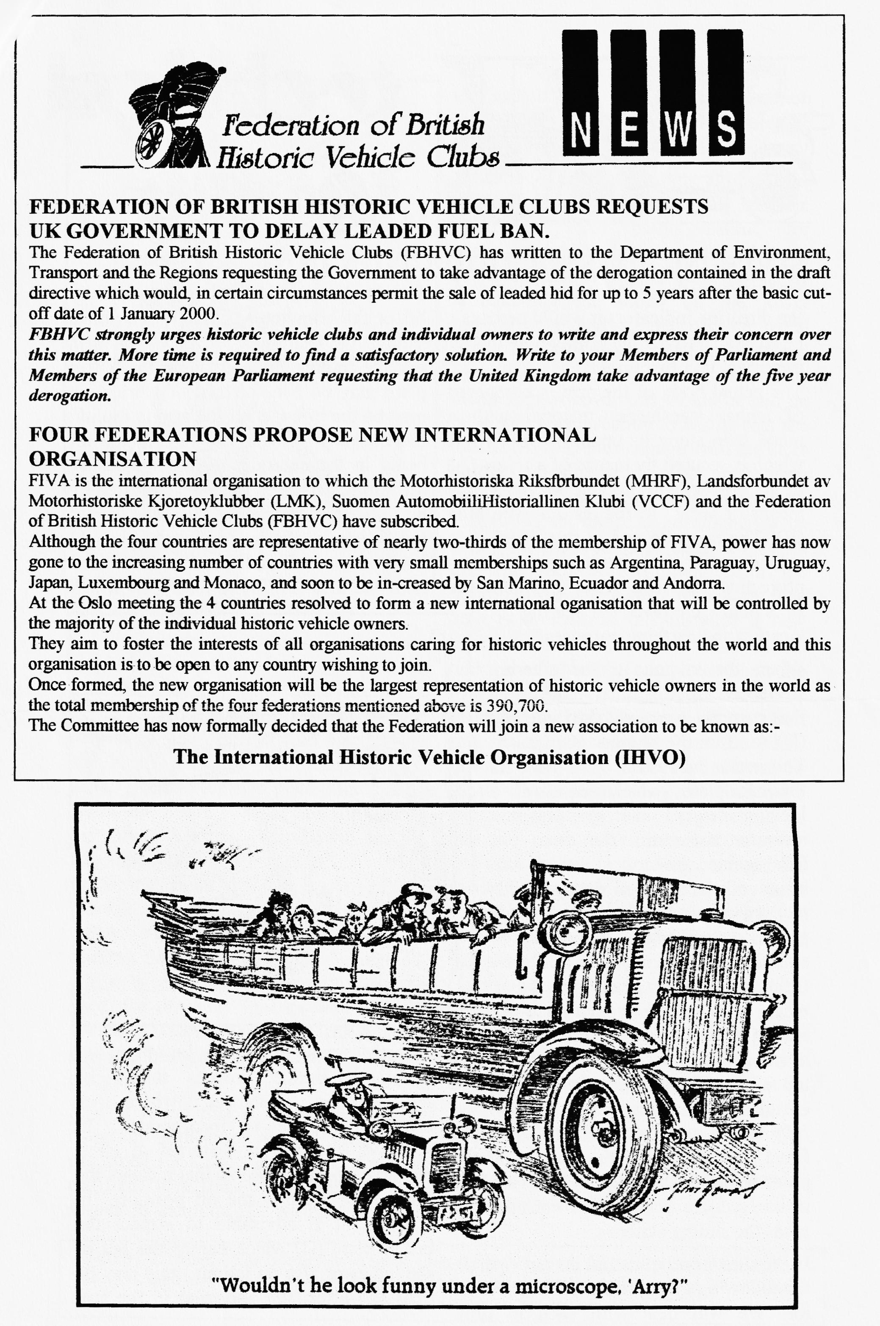

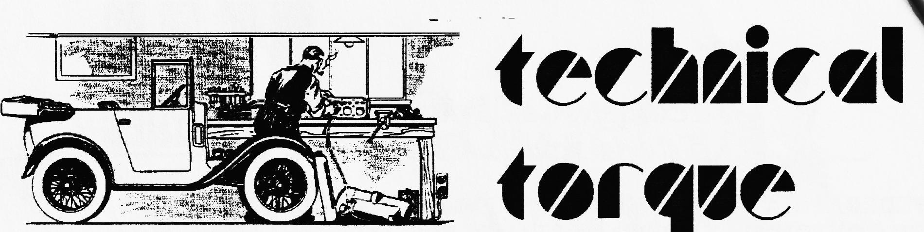
SERVICING HINTS FOR DIRECTION INDICATORS

BEFORE dealing with the servicing of the direction indicators it would perhaps be advisable to outline briefly how this important unit functions.
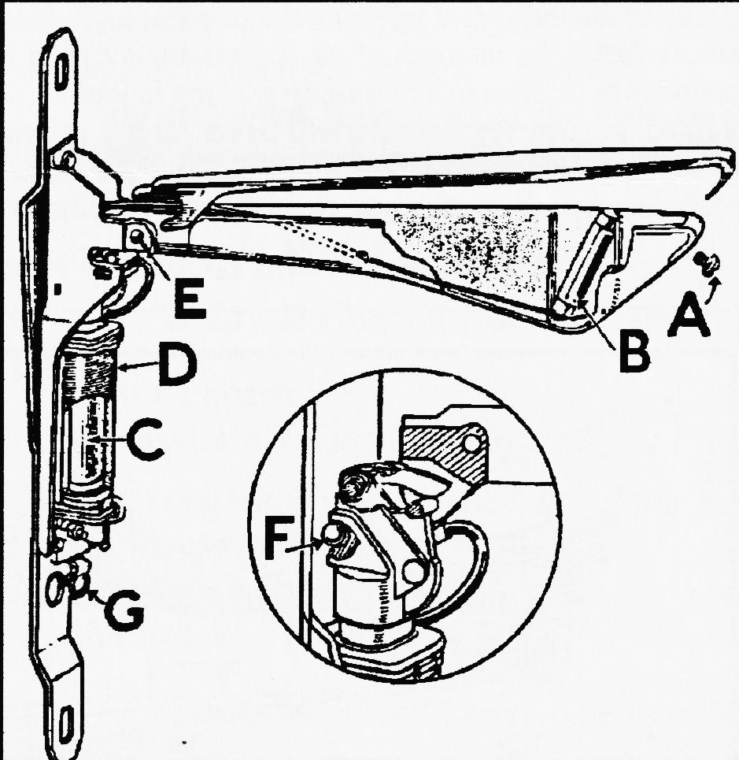
The actual body of the arm is composed of amber translucent material with a metal strip along its upper or front edge, which is secured by means of a screw (A) in its lower portion and serving as a means of access to the festoon type bulb (B). The opposite end of this metal strip extends over the pivoting pin (thereby protecting the feed wire) and into the slots below the pivot pin bearing for location and earthing purposes.
When the switch in the steering wheel centre is turned to either side, the current energises the solenoid (D) to draw the plunger (C) into it. This action moves the catch-pin over the cam-plate (which serves as a locking device) and the direction indicator rises until the catch pin falls against the stop or lug on the inside of the plunger casing. With the switch returned to the off position, the weight of the arm is sufficient to lower it into its flush-fitting position in the body pillar where it is locked by the catch-pin sliding over the cam plate locking
device. A light spring fitted between the top of the plunger and the lifting plate ensures that the arm will return to the fully closed position. A ball-bearing (F) fitted into the top of the plunger at the point where it slides up and down when in use reduces friction and considerably eases the sliding action.
If the direction indicators do not operate the following symptoms should be looked for. We will deal with each in turn.
Should the direction indicators not fully lift or fall completely home, three points should be examined, namely, the arm may be fouling the bodywork, the buffer plate may be bent or lack of lubrication may be the offender. If the arm is fouling the bodywork it may he due to its not being in the central position or because the arm when raised has been distorted by hitting some obstruction. If the former reason applies the securing screws should be slackened off and the unit centralised until the aim lifts quite freely, in which
case the screws may then be tightened again, A similar process should be repeated in instances where an escutcheon plate is incorporated. If, however, the arm is distorted at all it should be gently eased so that it clears the body sides when in the off position. In addition, it is advisable to inspect the buffer plate (G) which damps the fall of the indicator arm on falling - this may be bent and affect the operation of the arm

by preventing its fully closing.

If the direction indicator arms are sluggish in operation, lack of lubrication may be indicated and there are three points which need attention in this respect. A few drops of thin machine oil should be added to the catch-pin (H) which rides on the cam plate immediately below the inside edge of the arm and to the pivot bearing (as shown in the
accompanying illustration). The
remaining point is the inside of the bracket where the plunger ball is in contact and where a slight smear of high melting point grease should be applied, On no account should ordinary grease be used, for this may find its way into the solenoid when warm, and result in a sticking plunger - this should be kept quite dry.
If it is found that a fuse is blown the direction indicator wiring should he examined for a short circuit and the fault rectified; if a loose or broken wire is suspected examine the wiring from fuse
to switch and switch to direction indicators. All connections should be tightened up, or re-soldered if necessary.
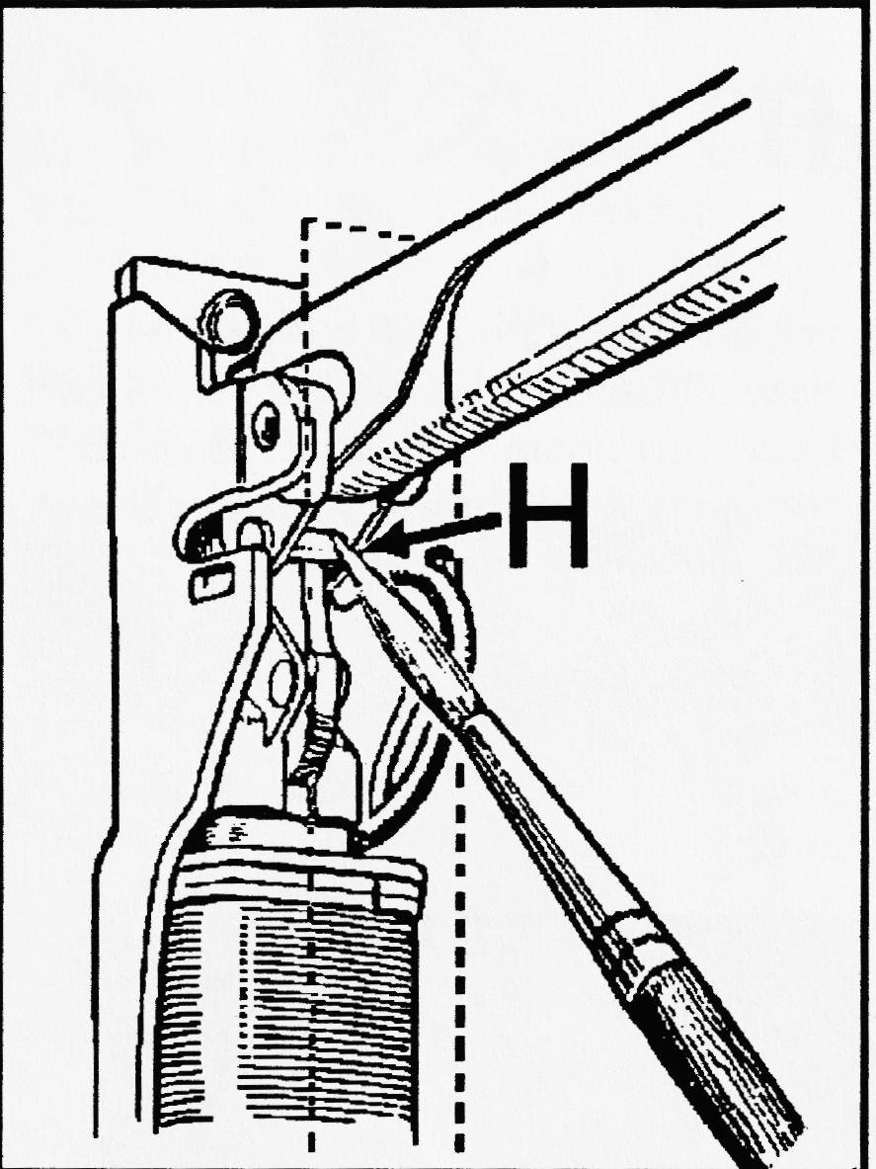
When the bulb does not light although the indicator arm may lift to its full position, there are three points calling for examination. The bulb may have blown, in which case it should be removed by withdrawing the screw on the lower outside edge and sliding off the metal strip. The bulb may then he replaced, and care should be exercised in replacing the metal strip or cover. It should be slid on in an upwards direction to ensure that the locating side pieces engage with the slots on the underside of the pivot pin bearing (see E) for these points serve as an earth return. If the bulb is not found to be faulty but the trouble persists, it may be that the feed wire running from the bottom of the solenoid to the festoon type bulb is broken. In this instance a new feed wire must be fitted. This entails removal of the unit complete. Then the solenoid and mounting plate should be separated by removing the nut and bolt and shakeproof washer from the back. The solenoid may then be lifted away to allow of replacement of the feed wire which runs along the casing behind it. The bulb must make contact at its upper end with the metal strip or cover and the spring beneath the bulb holder may need opening out a little if such contact is not being made. It is also advisable to ensure that the point of contact on the cover is clean and free from rust. When the direction indicators are finished in black enamel the ends of the cover which locate at the pivot end should be quite clean and free from any enamel or this may find its way into the solenoid and cause a stiffening of the plunger action.
From The Austin Service Journal, Oct 1939.

CLUB SPOTLIGHT

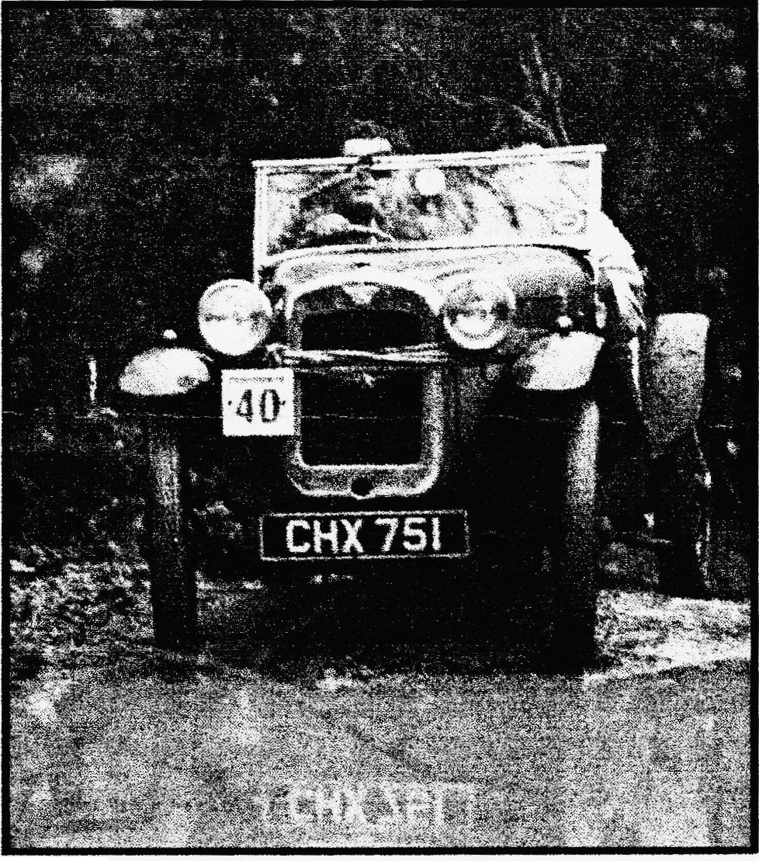
CLASSIC TRIALING PART 2- The Car
My car is based on a 1935 Ruby Chassis on to which has been grafted a sports special body manufactured by Keith Roach. The car has no doors with step over entry to maximise body strength .For the same reason the chassis has been partially boxed. Other than a windscreen the car has no additional weather protection so if it rains or snows life gets a bit tough!! Ground clearance is obviously very important and for this reason Ruby spring settings have been utilised and the car fitted with 18 or 19 inch wheels . Tyre selection is critical and whilst off road varieties are not permitted it is advisable to choose the tread pattern with some considerable care. To have any chance of climbing observed sections satisfactorily rear tyres have to be deflated to pressures where the driver feels that not too much power will be sapped from the engine and where tyre damage will be kept to a minimum. Depending on the section I run tyre pressures as low as 4 p.s.i..
For this reason, the tyres are clamped to the rims using security bolts. Twin spares are carried in case of multiple punctures and to provide extra ballast at the rear where it matters.
The engine runs a Phoenix pressurised crank with Renault 4 pistons and rods. I have gas flowed the block and utilised large inlet
valves. Carburation is by way of a
semi-downdraft S.U. An electric Facit fuel pump is used to ensure an ample supply of fuel to the S.U. This is essential when on full chat in first gear for extensive periods on observed sections. This lump is connected to a 4-speed crash box to give a good low ratio first gear. Final drive is by way of a late Ruby back axle using standard Ruby crown wheel and pinion ratios. The late Ruby axle provides larger halfshafts and therefore increased strength . Stopping power is provided by hydraulics borrowed from a Morris Minor. The Minor also provided the drive mechanism for the windscreen wipers
Twelve-volt electrics have replaced the standard six volt system using a magic box supplied by Dave Lynsey. I can thoroughly recommend this modification and anyone who would like more information on my
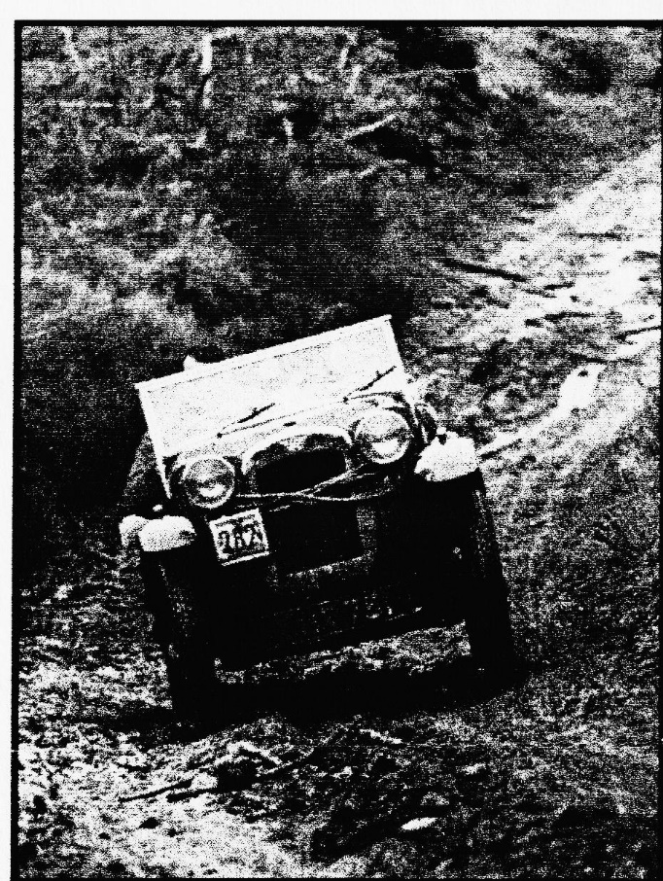
experiences with this conversion is free to contact me. Reversing and high intensity rear lights have been fitted in the interest of safety. A fire extinguisher sits under the passengers’ legs ( Always show consideration for your passenger!!).
Final touches are the provision or plates at front and rear to which competition numbers can be fixed and the provision of a strong rope which can be attached to a winch or towing
vehicle in case we have to be extracted from a section.
I hope this article has provided a small insight into a form of motor sport which is extremely friendly and fantastic value for money. There are of course times when it is raining, freezing cold, dark, and you are on a remote hill somewhere trying to fix a misfire when you wonder why you are doing this. Luckily those times with proper preparation are few and far between and in more than ten years I have only had to retire the car twice - once because of a broken king piu and I now carry a spare, and once because of a cracked head. I still don't and neither do have any intention of carrying a spare!!
Is it dangerous? Not normally and serious accidents are very rare. The worst I have done is to put the car on its side a couple of times, but the marshals and spectators are always willing to help put it shiny side up again such is the friendly nature of the sport. Just ask Scott!!!!
David Treliving
and thanks very much for sha, with us, David. David is gob" to date with his adventures so follow his progress. - Ed.

COMMITTEE BUSINESS
We have renewed our membership of the FBHVC ( see page 4 for details of its reorganisation). Last month we weren't sent enough A7CA magazines (the dark grey ones)and if this affected you, many apologies. Glyn is sorting it out. Swanage organisation is going very well — 163 entries so far but only 35 A7s — entries accepted at Club Night. Marshals are to wear distinctive T-shirts (see p.10 for details). Phil represented the Club at the funeral of Reg Pickett, a long-term Solent member respected throughout the A7 world. He was an apprentice engineer at the Austin factory and rebuilt, among many, many A7s, Bloody Mary. He was still working on his beloved A7 right up to the end at a creditable 83. Condolences to his wife and family.

THE WAY WE WERE - a blast from the past
From the Club magazine for JUNE 1977
The weekend at Swanage is still possibly going ahead. It is on the 18/19th June - contact John Page for details.
FORTHCOMING EVENTS
25th June - Ferndown Jubilee Rally
2nd July - Beaulieu Barbeque, Ower (Solent A7C)
3rd July - Beaulieu 750MC Rally
10th July - Breamore Rally
23/24 July - Netly Marsh Steam Rally
21st Aug - Bristol A7C Longleat Rally
21st Aug - Air Show Canford Magna (we are organising
the Vintage & Classic Car Display)
There was then the first technical article —RENEWING AXLE BEVELS & CROWN WHEELS from the Austin Service Bulletin for March 1931. Plus ca change - Ed

3 WHEELS ON MY WAGGON

B
ut NOT the A7 I'm glad to say. We had a brilliant day at the return to MALLORY PARK on 31/5/98. The 7 was flying, knocking 3 seconds off the lap time of only two months before. I even overtook a Cooper Mk.5 and a WEV 750!! Max revs peaked at 5850 (— 85 mph) and there's more to come. This was probably due to having the two front wheels rebuilt and re-spoked through the good offices of JEFF BRIDGE. Unfortunately, on paper, third place was recorded due to the return of
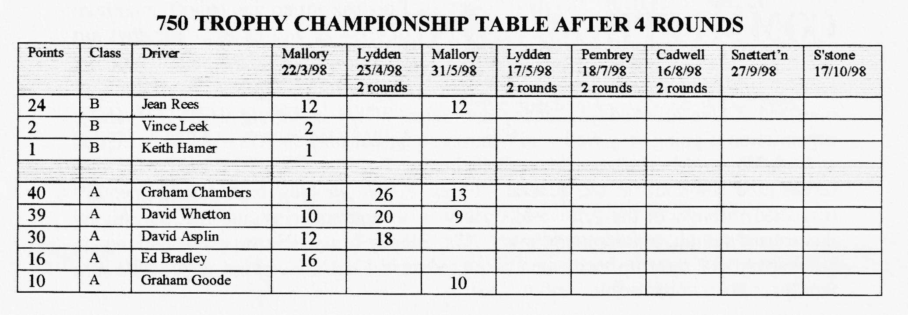
Graham Goode, last year's champion and Graham Chambers also having one of his best days yet. The fun came to a sudden stop (literally!) as a wheel came off the trailer on the homeward-bound M40. Thanks go to the Police and a Very, Very Nice Man who brought the 7 + trailer home at midnight and woke up all the neighbours. However, no-one was hurt or booked(!) Does anyone know how to re-build an ex-mini hub and bearings? Please tel. the Editor
David Whetton.

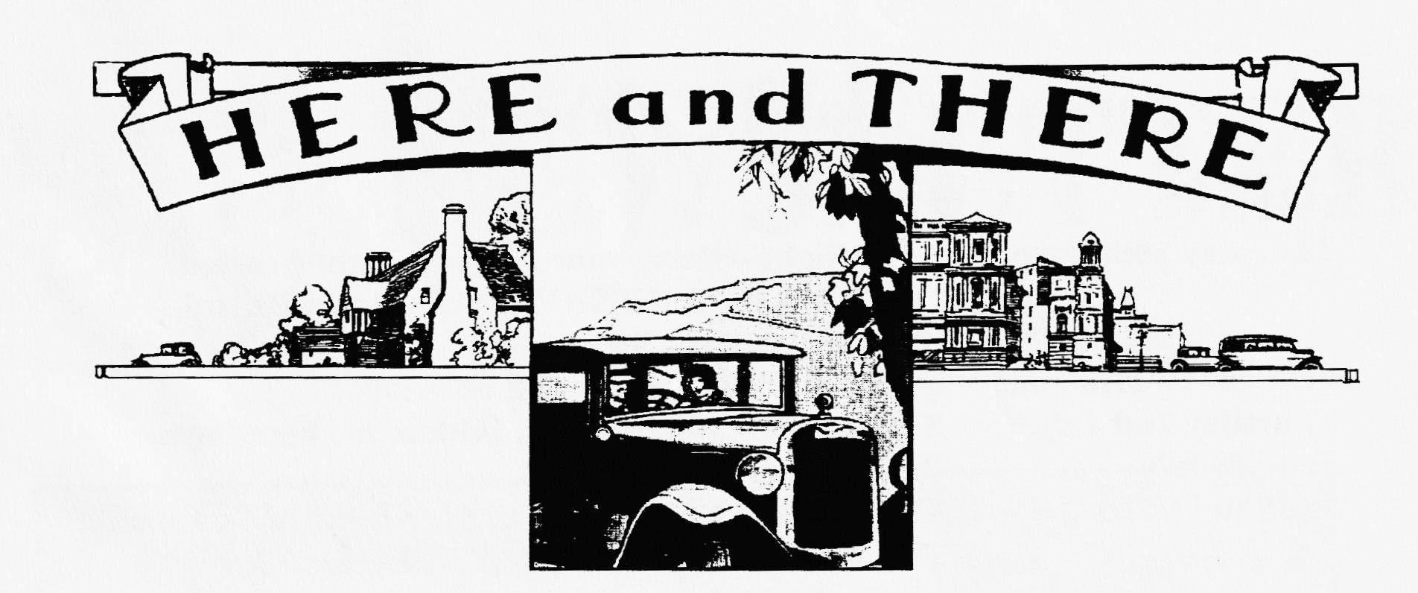
NEW MEMBER
Welcome to BARRY GOODMAN who comes from Ashley with a 1933 Austin 7 SPORTS SPECIAL. Look forward to seeing it at Club Night (Oh, and Barry too of course!)
FOR SALE
1933 TYPE "65" Cherry red with black wings. Very well sorted car in daily use for the last 12 years. Correct engine with rev-counter, 12-volt electrics, 17" wheels. Not concourse but very sound car. Offers to member TONY HAILES (01305-260007)
1937 Austin 7 RUBY maroon/black, 2-bearing, "fairly nice nick" but worn pinion bearing. Selling due to illness hence only £2,400. TED TUCKER (01823-480876)
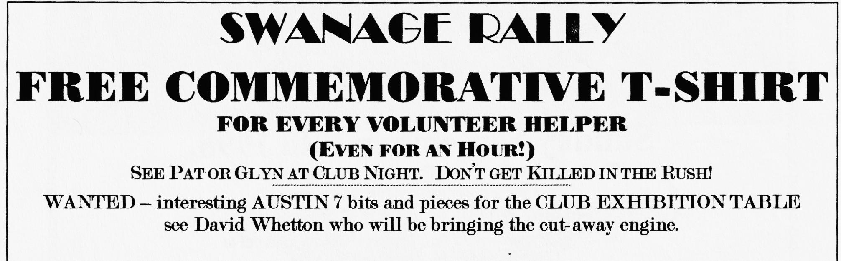
CLUB FAMILY NEWS
We hear that MARION TRIMBY and MARGARET RIDDEAL have both had unplanned stays in hospital and we all wish them well and a speedy return to the Austin fold.
It was good to see OLD MAN WEAVER sipping a glass of his favourite medicine at last month's Club Night and looking a picture of rude health.
Congratulations to JOHN HARRIS who has been appointed Vice President of the 750 MC

oo CLUB DIARY oo
June
Thursday 18th June Club Ni_{g}ht — Bring your A7 for a Light-hearted EXHAUST EMISSION test By Roger Ballard. Prize for the greenest Seven
Fri/Sun 19/21th June Spye Park rally (in lieu of Club Run)
Thursday 2nd July 8 'tit Late OLD THATCH, Uddens nr. Ferndown.
Sun 5th July 750 Club Beaulieu Rally
Sat/Sun 11/12th July CLUB RALLY at Swanage. See ad. re free T-shirt offer.
VOLUNTEER ORGANISERS NEEDED FOR '99
00FUTURE EVENTS 00
Thursday 16th July Club Ni_{g}ht — Noggin & Natter plus spares.
Sunday 19th July Club Run — BERNARD'S ANNUAL KITE RUN & PICNIC to Cranbourne Chase.
Friday 24th July Evening Run - details later
Sat/Sun 1/2nd Aug VSCC Prescott Hill Climb - details from Dusty
Sat/Sun 8/9th Aug Yeovil Festival of Transport £4 vehicle entry – details from Dusty
Sunday 9th August Luccombe RNLI Country Fair nr. Milton Abbas- free entry in aid of RNLI - Details from Dusty

