EDITORIAL JULY/AUGUST 1991
As reported last month there will be no Newsletter in August this year, so make the most of this edition folks, till September!
Gay and I missed the June Run. It appears to have been an unforgettable experience for those concerned that will go down in the annals of the DA7C. Sue Topham's official report is within plus a 'survival special' from David Whetton. Biddy continues her spotlighting and there's further gossip.
The Summer (when it comes) holds further adventures in store, especially for those off to the Continent in Sevens to tour seven countries in fifteen days. We certainly hope for a report on this in the Autumn.
Meanwhile continue to enjoy your A7 and the good fellowship it engenders. We may not be the biggest Club, but we must be the friendliest as a rueful other-club member recently remarked.
Keep smiling - it can't rain for ever.
John

SECRETARIAL
Well Folks,
Holiday's over. I thought the weather in Greece was only mediocre, but it was positively tropical compared with here! Last Sunday's Club Run or should I say swim, was very interesting, including a visit to a Friary - no, not the chip-type. They appear to do some very good work, but doubtless you-will hear more within.

Spye Park Rally has been and gone. The weather wasn't much better for that, but we all managed to keep reasonably dry in various hostelries! A good weekend, as usual.

I understand the driving tests were a great success, but once again dogged by poor weather. When will it end; surely in time for the annual beach barbecue next month!

Well no sooner had I got my 'new' Ruby on the road, that no less than the ex-Manager of the Bank of England wanted to purchase it. Good luck to him, he used to own one at college, and seemed as pleased as Punch with his new acquisition. He jumped straight into it and drove back to North Yorkshire - without problems I trust.

We seem to be maintaining good turn-outs back at the Elm Tree, and I must say Hon. landlord seems-quite affable. Long may this continue.
Cheers, Gary

THE WAY OUT-WET-WEST RUN 23rd June 1991

Eleven cars arrived on a very wet morning to meet Merv and Fran, Gary arriving bravely with his top down at Safeways Car Park although this was hastily rectified. Our run began from Sturminster Mill through the leafy lanes of Fifehead St. Quinton, Hazelbury Bryan and Stoke Wake which, if you used a very vivid imagination, would look beautiful on a hot Sunday June day.
However, as we splashed our way along flooded, muddy lanes it proved once again that the invincible A7s and their drivers can survive all the elements; trying not to think of the clean-up job on returning home!

Passing through Hazelbury Bryan, with its pretty church and cottages with names like Honey Bloom Cottage, we continued on through Mapowder and Brockhampton, pausing briefly for one of our number to leap a five bar gate and add a little more water to the pouring rain! At Narn Farm we took a right turn to climb through farm tracks. Little did we know what Merv had planned for us! We squeezed one by one past a Ford coming the other way with about an inch to spare. Bouncing and sinking up muddy ruts we went, the cars tipping and shaking (Bernie's spirit level gauge must have been going mad) stopping half way. Here Phil got out to check on us all - his face grim and determined looking down the track willing us all up the hill.

We finally reached the road with a sigh of relief, but only for a hundred yards or so for then we took a left turn marked '1 in 7' up another farm track, passing through forestry with water cascading down. This track looked as though it was used in 1800. Freezing to death, Merv, just for a change, decided to take us through a lake. As we descended the track disappeared into muddy water 2ft deep. The '1 in 7' hill was a deeply rutted mud slide with the water waiting at the bottom. I said to Mike, "Oh my God!" and just put my hands over my eyes. Mike in his usual manner said, "Shut up and keep writing". I was writing this whilst travelling - or trying to. Mike drove on manoeuvring the car round the highest ruts through the water and out into the lane which seemed like the motorway after what we'd been through. Every car made it; a real credit to cars and drivers. Then we climbed up through low cloud and rain up Batcombe Hill and finally to Evershot for a welcome hot lunch at the Acorn Inn where a room had been kept for us.

All suitably refreshed we set of for a visit to Hilfield Friary, one of several friaries of the Society of St. Francis, a religious community in the Church of England. We were met there by Friar Graham who kindly gave us a tour of the chapel, showing us the bronze representation of the Crucifixion by the Italian Sculptor Enzo Plazotta and the Icon of Our Lady. As the weather was so wet, we could not do a tour of the grounds, but Friar Graham spent a long time answering our questions about the Order and explaining about the work carried out by the Friars in caring for the mentally ill and homing the homeless. Between 5 and 11 people spend the night as wayfarers seeking refuge and help. It was a most interesting visit. We finally departed around 4•30 pm for our drive home.

On behalf of all, thanks to Merv and Fran for all the planning and organising of the Run - a real test of Stamina!

Sue and Mike Topham.

NOT THE WAY-OUT-WEST RUN REPORT

A personal reflection on a day out with God and Nature by David Whetton.

"And gentlemen in England, now abed, Shall think themselves accursed they were not there!" Or, as Max Boyce would have said! "WE WERE THERE BOY-O!!"

Over hill, down dale and through the floods went the intrepid eleven. This is what Austin Sevens were built for. Thank God no-one had brought the modern. No nancy tarmac for these boys. Three-and-a-half inch tyres scrabbling for a grip on near-vertical hill climbs, wives bouncing on the back axles, the waters of heaven above and hell below meeting in one continuous wall. At one stage I had to open the door to let the water out. Place names dimly glimpsed through the spume over whitened knuckles read from a Hardy novel - Droop, Mappowder, Horsey Knapp, Melbury Bubb, Dogwell Farm and Gore Hill. The procession, straight from Ice Station Zebra, was only briefly diverted into the ditch by a lone member of the local 4x4 Ford Escort rallycross team known by the message across his windscreen as KEVINMURIEL gazing enviously at the grit and determination of the little band of plucky heroes for whom hedges, ruts, ditches and banks held no fears.

The combination of cold and rain ensured the Acorn at Evershott was a welcome sight and the Le Mans style hundred yard dash to the loos was a fitting end to the morning's rallying. But this was to be only a brief respite in a day full of surprises. Who could have expected the sight of a fully furnished Friar Tuck complete in brown habit and hood waiting for us in the pouring rain at Hilfield Friary? Imagine, a little later, the band of happy Austin Seven travellers sitting down with Brother Bernard debating Chastity, Poverty, Obedience and The Meaning of Life. - Way out, man.

For me the day finished off in true surrealistic style listening to opera at the Winter Gardens. But even 0 Sole Mio and the World Cup Song couldn't dim the memories of one of life's milestones. PAX BONUM brethren.
HOW IT WORKS

THE DIFFERENTIAL GEAR

When a car is turning a corner the inside driving wheel rotates more slowly than the outside one. If both are to drive the car he engine must turn one wheel faster than the other. The differential gear provides for this.
Fig. 1 explains the principle. Two shafts, A and B, are each free to rotate, but are coupled by the cross bar C pivoted on the lever D which is pivoted at E. The ends of bar C engage with the forked ends of the levers G and H fixed to shafts A and B respectively.
If we pull D, cross bar C will pull G and H equally. If we hold A and pull D, one end of C will be held by levee G and it will turn on its bearing F and its either end will push lever H round towards us. This gives us differential motion as between shafts A and B, but we one which could not continue for a whole revolution.

If we substitute for forks G and H, and the cross bar C, bevel wheels, as in Fig. 2, and pull shaft D round it will pull all round together. But if we hold G and pull the wheels C round by shaft D they will rotate on their bearings on shaft D and will turn wheel H at twice the speed at which 0 is pulled round. If we retard G and pulled wheels C around we shall accelerate H in the same ratio.
So we can drive G and H round at different rates while either is retarded, as is the case when one or other of the car's wheels is turning a corner.
Fig. 3 shows in diagram the usual arrangement of the differential gear. The same reference letters refer to the same elements. The bevel wheels C.C are carried around the axles by the cage J in which they are mounted, and this cage is driven by the engine through the medium of the crown wheel K fixed to the cage and the bevel pinion L driven by the transmission.

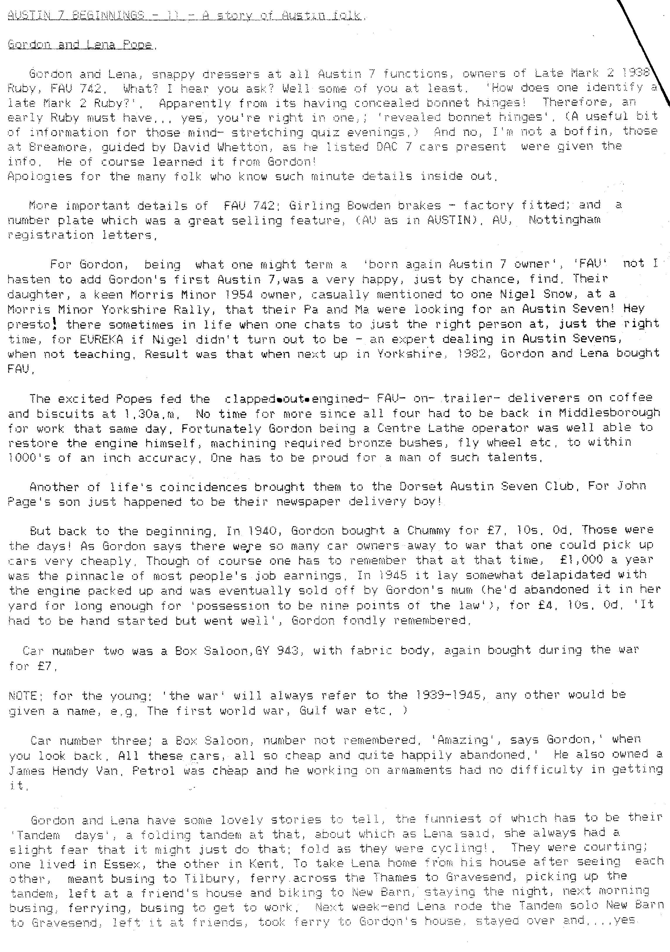
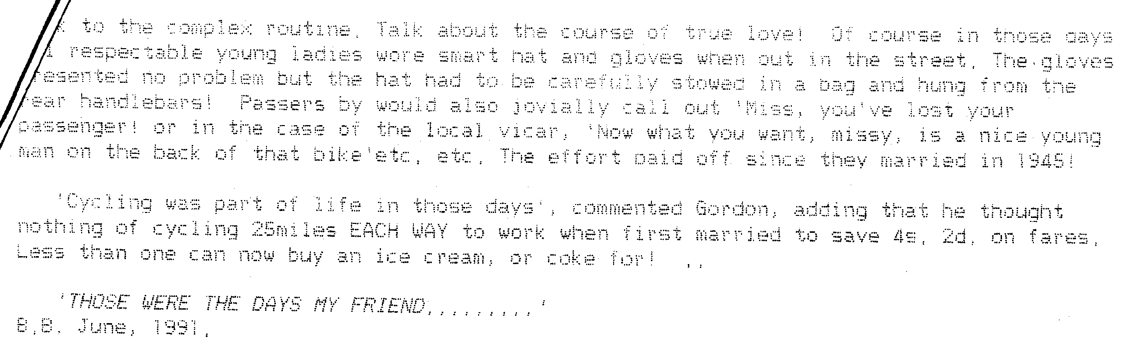
CONGRATULATIONS to John Powell on the outstanding restoration of an RN Saloon that he took to bits in 1965 and the main parts of which he buried. The car made its reappearance at the Brockenhurst Rally and is a credit to John. A fuller account of this will appear in the September Newsletter, for John and Margaret have already been targetted by Biddy.

CONGRATULATIONS to Miles Shepherd who won the individual driving test in his Chummy at the Spye Park Rally and to the Dorsets who won the team test.

The Rally was very well supported by the DA7C. Other winners, for their cars-were Jeff Bridge (WP 220), Merv Frampton (AJH 64) and George Mooney (FN8590 - the new Cambridge).

Those who stayed over the week-end had an interesting Run on the Saturday morning to the flight of locks on the Kennet and Avon Canal near Devizes. To see 24 locks so close together on a steep slope is an amazing sight. Walking up the slope we discovered that the canal rises 234 feet in a distance of 2 miles. It wouldn't pay to be in a hurry on this stretch of the canal. It's the longest flight of double-gated locks in Britain.
EXHAUST EMISSIONS. From 1st November 1991-the M.O.T, check on modern cars will include a test of exhaust emissions.

According to the Pre-War Austin Seven Club Newsletter, all vehicles (including A7s) will be checked to discover if there is excessive smoke. It is understood, however, that carbon monoxide levels will not be required to be reduced below the manufacturer's specification for all vehicles. The Department of Transport stresses that the standards it has set are minimum. It seems that older cars-will not be wiped off the road provided that engines are efficient.

THANKS to Mike Topham for supplying the following list of charges seen in a garage.
FAULT (Customer's report) CHARGE
A ping-ping-ping £ 25
A plunk-plunk-plunk £ 50
A thud-klunk-thud £ 90
A clang-thud-klank £175
- If puzzled check with Munwellyns.

NEW MEMBER Welcome to Graham Stansfield of Parkstone.

BERNIE AND JACKIE are grandparents again. Congratulations to them and to Rebecca and Darren on the birth of Nathanial.

BRISTOL A7 CLUB will be having their 'Dorset Dawdle' on the week-end of 14th and 15th September and have invited the DA7C to a skittles match at Bere Regis on the Saturday evening. Phil will have more details nearer the time.

LOOK OUT FOR key ring fobs with an 'impression' of Herbert Austin among Phil's spares next time, they are on view. You may like one. !

EVENTS

JULY Thursday 18th July. CLUB NIGHT at the Elm Tree. 8.00 p.m.
Noggin and Natter PLUS a short Run, for those wishing to participate, from and back to the Elm Tree, leaving at 8.30 p.m. Club room available throughout for those not wishing to go on a Run.

Sunday 21st July. CLUB RUN. The 'Mottisfont Meander'. Meet at Ringwood Furlong Car Park at 10.15 for 10.30 a.m.

Thursday 25th July. COMMITTEE MEETING at the Tyrrells Ford. 8,30 p.m.

Saturday 27th July. Worth Matravers Village Fete. Cars requested for
2 p.m.

AUGUST Thursday 1st August. '9 to Late' (for those who want to meet for a natter) at the Fox and Hounds, Hampreston.

Thursday 15th August. CLUB NIGHT at the Elm Tree. 8.00 p.m. Meet at the Elm Tree for a Mystery Evening Run.

Sunday 18th August. CLUB RUN. DA7C FIFTEENTH ANNIVERSARY RUN AND TREASURE HUNT. Meet at the Viewpoint, Constitution Hill at 10.15 for 10.30 a.m.

Thursday 22nd August. COMMITTEE MEETING at the Tyrrells Ford. 8.30 p.m

SEPTEMBER Thursday 5th September. '9 to Late' (for those who want to meet for a natter) at the White Hart, Longham.

Thursday 19th September. CLUB NIGHT.

