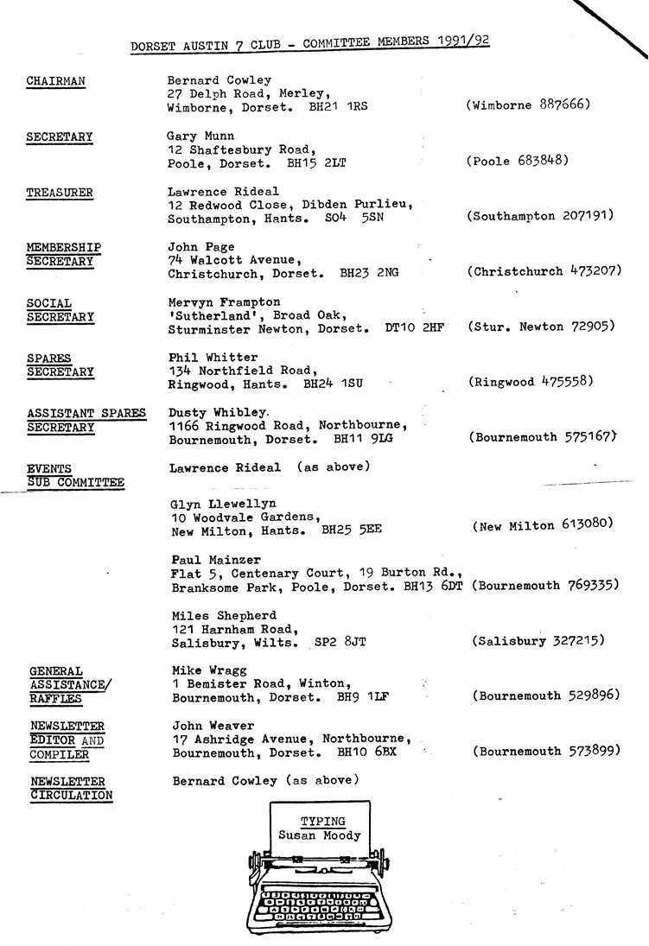
EDITORIAL January 1992

I wonder if in January 1993 we shall still be talking about recession and its effects. Certainly as we go into 1992 those in the motor trade are feeling the effects of the doldrums. Private vendors are also finding it difficult to sell cars of any kind, but A7s seem to be keeping their prices pretty well, although clearly buyers are finding it more difficult to commit themselves to the expenditure. The rise in values has been pretty heady in the last few years. It looks as though we shall be at least marking time for a while.
However, as far as the DA7C is concerned spirits are high. The latter events of '91 lived up to the standards we enjoyed throughout the year and Club events for '92 look promising. See within an opportunity for Club Members to contribute towards those events. Also, if you haven't yet returned our Social Secretary's questionnaire please do so on Club Night.
See you then, John

SECRETARIAL
Well Folks,
Christmas and New Year over, I reckon you all ought to get down into the garage and burn off some of that Christmas Pud!
What a turn out for the New Year's Day Run, there must have been 25 cars!
A pleasant treasure hunt was organised by Glyn followed by a very gentle drink-up at the Three Bells near New Milton, and then back home to bed to get over the previous evening's excesses!
A bit late for this Christmas, but a technical tip worth bearing in mind for next. Your spare Austin 7 flywheel makes an excellent base for that small to medium sized Christmas tree!
I have just made a start on a Special, having spent last Sunday degreasing and rubbing down the chassis components. The idea is to have it ready for the Eurotour in August, but at the moment there is a daunting number of hours work ahead of me, especially as I have decided to try and build my own body. I have most parts now, but does anyone have a period looking windscreen frame for sale, preferably one that folds down? If not I'll have to try to make one up.
Don't forget the Skittles Evening on Saturday, 25th January. An entry form was in last month's Newsletter. It's not an expensive evening out and usually goes well. You don't have to be able to play - one thing's for sure, I can't.
See you Club Night, should be good,
Gary

FEBRUARY NEWSLETTER - Items welcome by 31st January.
The Purbeck Run 22nd December
Four cars and drivers met at the viewpoint just before Christmas - no doubt it was a busy day for most people so the numbers were down. However, there were Phil Coulter and John Forshaw (Curator of Breamore Museum) in his Ruby, Brian and Jill Toalster in their '31 Box, Mike and Sue Topham in the Pearl complete with Christmas Tree and flashing lights and ourselves in the Chummy. We warned Phil to take his sea-sick pills as we were going on the Sandbanks Ferry - luckily it wasn't too rough!
We took the back lanes from Studland to Corfe and then a few more (muddy) back lanes in the direction of Swanage.
As we came to Herston, a steam engine had stopped to let another pass, so we all waved and had a photo call.
A very pleasant lunch hour was spent at The Scott Arms (one of my favourite pubs) and saying Good Bye to Phil and Brian we went for a short walk to Swyre Head. The view from there is excellent, with St Aldhelms Head one way and the Kimmeridge coast the other.
As it was almost the shortest day, we then made our way home.
Bernard
(who also arranged the Run)

w
A report on the New Year's Day Run will appear in the February Newsletter. l

AUSTIN SEVEN BEGINNINGS
Gordon & Biddy Brown
£25 only to spare and wanting a 'run-about` for self and two small kids. What on earth can you get for that? Well the year was 1961. Even then it was asking a bit much especially as that princely sum was to include insurance, Tax etc. to get going on the road.
'Have you thought about a pre war A7?'
'Don't know them, what do they look like?'
One was promptly brought round for viewing. Bright Blue, well not bright blue, more a faded deep blue, only with my enormous excitement of seeing THE CAR wobble down the road and even more wobble into the drive, the colour at that moment was ultra bright blue-eyed, effervescent blue. I'll never forget that moment! I just stood and chuckled with tingling excitement. Could £25 really buy such a ‘unique' car. At that time there certainly were not many of these lovely specimens on the road. I mean the avant garde thing was to be 'modernising' and throwing anything out that was more than a `breath' old! Multicoloured G-Plan furniture; three Plaster Ducks on walls (snobbishly rejected then, now collectors' items); brightly painted walls; mini skirts; sugar around 4½d (old money) for a two pound bag ….all the rage. As for cars! Mini Cooper if anyone was anyone. Not for me, I just could not believe that I had never seen or been aware of an A7 before nor more importantly that I could actually own such a unique car for £25, I HAD TO HAVE IT'. Not only did it happen but the seller was only too pleased to part with it for f20! I even believe in those days it was the thing to give back a 10 shilling note to the purchaser as 'luck money'.
A friendly, amused insurance friend arranged the cheapest 3rd party insurance, a tax disk was bought and I was on the road for I believe around either £8 or £12.
WHEE HEE!, did I not Kangaroo around Chertsey with two very excited kids bouncing in the back? Did the unusable, poorly nailed-on sunshine roof bounce and clatter? Did the indicators pop out? Yes they did. Did it have a self starter? No it did not. It had one clanking crank handle held in 'swing prevention' position by a roughly cut off piece of sturdy inner-tubing. Did it have a petrol gauge? .... NO. NO. NO. I had a piece of specially bent thick gauge wire which when masterfully waggled into the tank would indicate whether or not I needed to buy yet another half gallon, a 1s 4½d worth of very expensive petrol, or even worse for my trips all the way to London, a full whole gallon at 2s. 9d. My, weren't the drawers and pockets searched on those days in an effort to round up the pennies! And of course I was constantly embarrassed when sitting in proud ownership asking for the oil to be checked and being asked 'which side?' bonnet to be lifted, invariably pointing to the wrong side. No worry though; the garage man (never in that area, a woman), smiled indulgently, shook his head with total understanding as he let me gently down with a 'HA HA, wrong side!'
Did I do any refurbishing? BUT of course. I bought one whole tin of Blue paint for 7s. 6d, and did a hand repaint job on it, and had some left over for touching up. One 'new-to-me' tyre was purloined from the local rubbish tip, where in those days most of these cars were abandoned to R.I.P.
YOIKS! what tremendous fun that car provided. BUMPY was its more than appropriate name given by young newly talking son John when he declared; 'it a bumpy car'.
It delivered kids to parties, took us to Bentalls for our monthly outing, London to Harrods sales or to see Father Christmas where one year not being able to park at the rear of the store the doorman not only got the chauffeurs of the nearest half dozen Rolls Royces to budge up a little but then proceeded to get them to physically LIFT Bumpy into the minute parking spot (Refer to an earlier Newsletter for the embarrassing details). I once accidentally poured paraffin into refill! No damage; it wouldn't start, was siphoned off, petrolled, started, spewed volumes of black smoke as its only protest. Finally rather a two edged sword I've often thought was that it helped me to build up a highly successful 'Avon is Calling' business in the area (YOU'LL KNOW HER BY THE LITTLE BRIGHT BLUE OLD FASHIONED CAR'), to such an extent that I had after eighteen months enough money to buy a second hand Mini Cooper. I desperately wanted to have both but hadn't enough garage space and of course the £30 which I got for Bumpy put the newer car on the road! Even all these years later I feel really mean for letting such a dear car go and not only that but all its papers and yes even I cannot remember its Registration Number, I can only tell you that it was a Blue, 1934 RUBY, with unique features as above AND those of unlockable doors and instant 'fall down' windows, except the rear which were the 'push out type'; OH! and of course the inevitable holed floor for washing off shoes and legs on wet roads. NO, my little Grandson, they didn't have MOTs in those days!
BUMPY was mourned for many a long year, and still is. However, in 1981, Gordon and I were taken to our first old car rally in a rather classy MODEL T FORD newly imported from the States. There the ashy glow of the A7 love affair, exploded. There were rows and rows of gleaming A7s in such immaculate condition. Where had I been all these years not to have
known that such exciting things were going on? Gordon equally delighted as he nostalgically remembered his boyhood trips to Cornwall in their Ford 8. Life had gone full circle! we decided then and there to seek out a RUBY.
Monday morning, the staff notice board at school read 'wanted an Austin 7 Ruby'; put there in frustrated desperation of not knowing where to find one. Imagine my amazement when one of the staff said 'There's a chap in our road who has a lot of old cars, I'm not sure what they are but he might be able to help you'. Guess who it was...YES, no other that our dear friend Glyn Llewellyn. One telephone call to the always enthusiastic Glyn revealed the SHERBORNE number of Richard Cressey who was selling 1937 Ruby FDH 275 which had stood for a whole year without being started but whose shelter of a green house had blown away in winter gales. By chance we were in Bristol and called round to 'view'. It started! It was ours! M.O.T. booked in Hordle and off we sped the following Friday night to collect same. Gordon bravely drove, I had kittens following behind on two counts! One that the police might stop us since I could not believe that Gordon's innocent reply of 'we're just taking it for it's M.O.T. 90 miles away would be accepted and two that he would never get home safely. I mean there were so many blind corners for him to lurch and judder round that even I was leaning over to help him compensate!
But home we got. Actually washed and polished it, and got it through its M.O.T. and promptly joined the club, then meeting at Dormers in Wimborne, and have had fun in it ever since. Mind you our first long haul drive was to the 1982 Longbridge Birmingham Rally. The compression was negative to say the least and the run took something like 8 hours' driving with good friends Bill and Norma Quayle patiently trying to drive slow enough to stay behind us up all the long haul hills. On return journey we, panting for sustenance, pulled into the only tat cafe open along the whole route at Swindon? or Marlborough? with John and Janet Stone and their two small children and the Quayles. My! were we stiff for a good week after. You may not think it but much has been done to the Ruby! a new sunshine roof fitted, roof lining renewed, new engine, re-spray by George Mooney, much, much mechanical work by Munwellyns and the odd clean and polish! (I did say odd!) Used daily for many years as a school car. Filled to the brim with balloons in a fund raising events etc. etc. Its proudest run so far has to be as the wedding car of son John and his pretty bride Marion! It still has its original upholstery and now its own jointly shared garage with....!!..
OPAL, my own dear treasured 1935 OPAL; a total self-indulgent present to myself after retiring from some 29 years teaching. Again a fortunate chat with Gary that I was looking for a 'pretty little soft topped car' led to my being first in line when Glyn was selling. As many of you know it is on the runs as often as I can make them. Also it has done two Michael Sedgewick runs from Beaulieu. On both of these I have had my dear friend Joan Lawrence from Vancouver Island as navigator (Bob Lawrence doing likewise for Gordon), when in the first we were third car and first women's team home and in the second, second car home! Morning run; sadly the afternoon runs were not so successful! HA!
'Enough, Enough.I hear you say. And so in Panto Rhyme - I'll say 'Goodbye!'.
A Happy successful A7 Motoring 1992 to you all.
THANKS BIDDY - about time
B.B. Jan. 1992.
CLUB RUNS. Most Club Members with an A7 on the road enjoy the monthly Club Runs which are organised by individual committee members. The usual thing is to choose an interesting place to visit, work out a suitable back-road route and find a pub (for lunch and refreshment) arriving there at midday. The lunch break can be followed by a visit, a walk or whatever.

Your Committee now invites Club Members to organise a Run in the coming months. If you have a suggestion and could plan such a Run, your Committee would be pleased to hear from you.

CLUB CHRISTMAS DINNER 1991
Who'd be Social Secretary? When Merv called at the Manor Arms just before the event to confirm the booking he found that the place was in the hands of the Receivers, the Landlord had departed and there was no record of the booking!
Merv kept his nerve, the temporary Managers agreed to carry out the arrangements and not only that, Merv must have used his persistent charm to good effect, for the meal was probably the best we've had. Portions were enormous. it was hot and tasty and the service was swift. The inclusive wine flowed freely too. It was great and so was the company.

The Club Committee and Members are pleased to record their thanks to Mervyn for the efforts he made to make the occasion such a success.

AS YOU WILL SEE from the list of forthcoming events, Mervyn will be laying on one of his renowned quizzes for the February Club Night.

Arrangements will be similar to last year's, but with teams of six instead of four and you will be asked to arrange your own teams on the night. There will be prizes for the winning team so get boned up on Music, Sport, Entertainment, Nature, Current Affairs and the Austin Seven.

NOTE! There will be a prompt start at 8.00 pm.

FOR SALE
AUSTIN 7 RUBY. Maroon, recent rebore, respray, headlinings etc. Very tidy. New MOT and tax. Drive away £3,995 o.n.o.

Contact Glyn (0425) 613080 or Gary (0202) 683848.

FOR SALE
Rolling Long Wheelbase Chassis and Special Body (New), no engine and gearbox - £750.

SERVICES
1. Your own brake shoes relined, soft or woven linings - £30 for 8.
2. Steering wheels re-covered.
3. Front axles lowered.
Apply - Bernard Cowley.

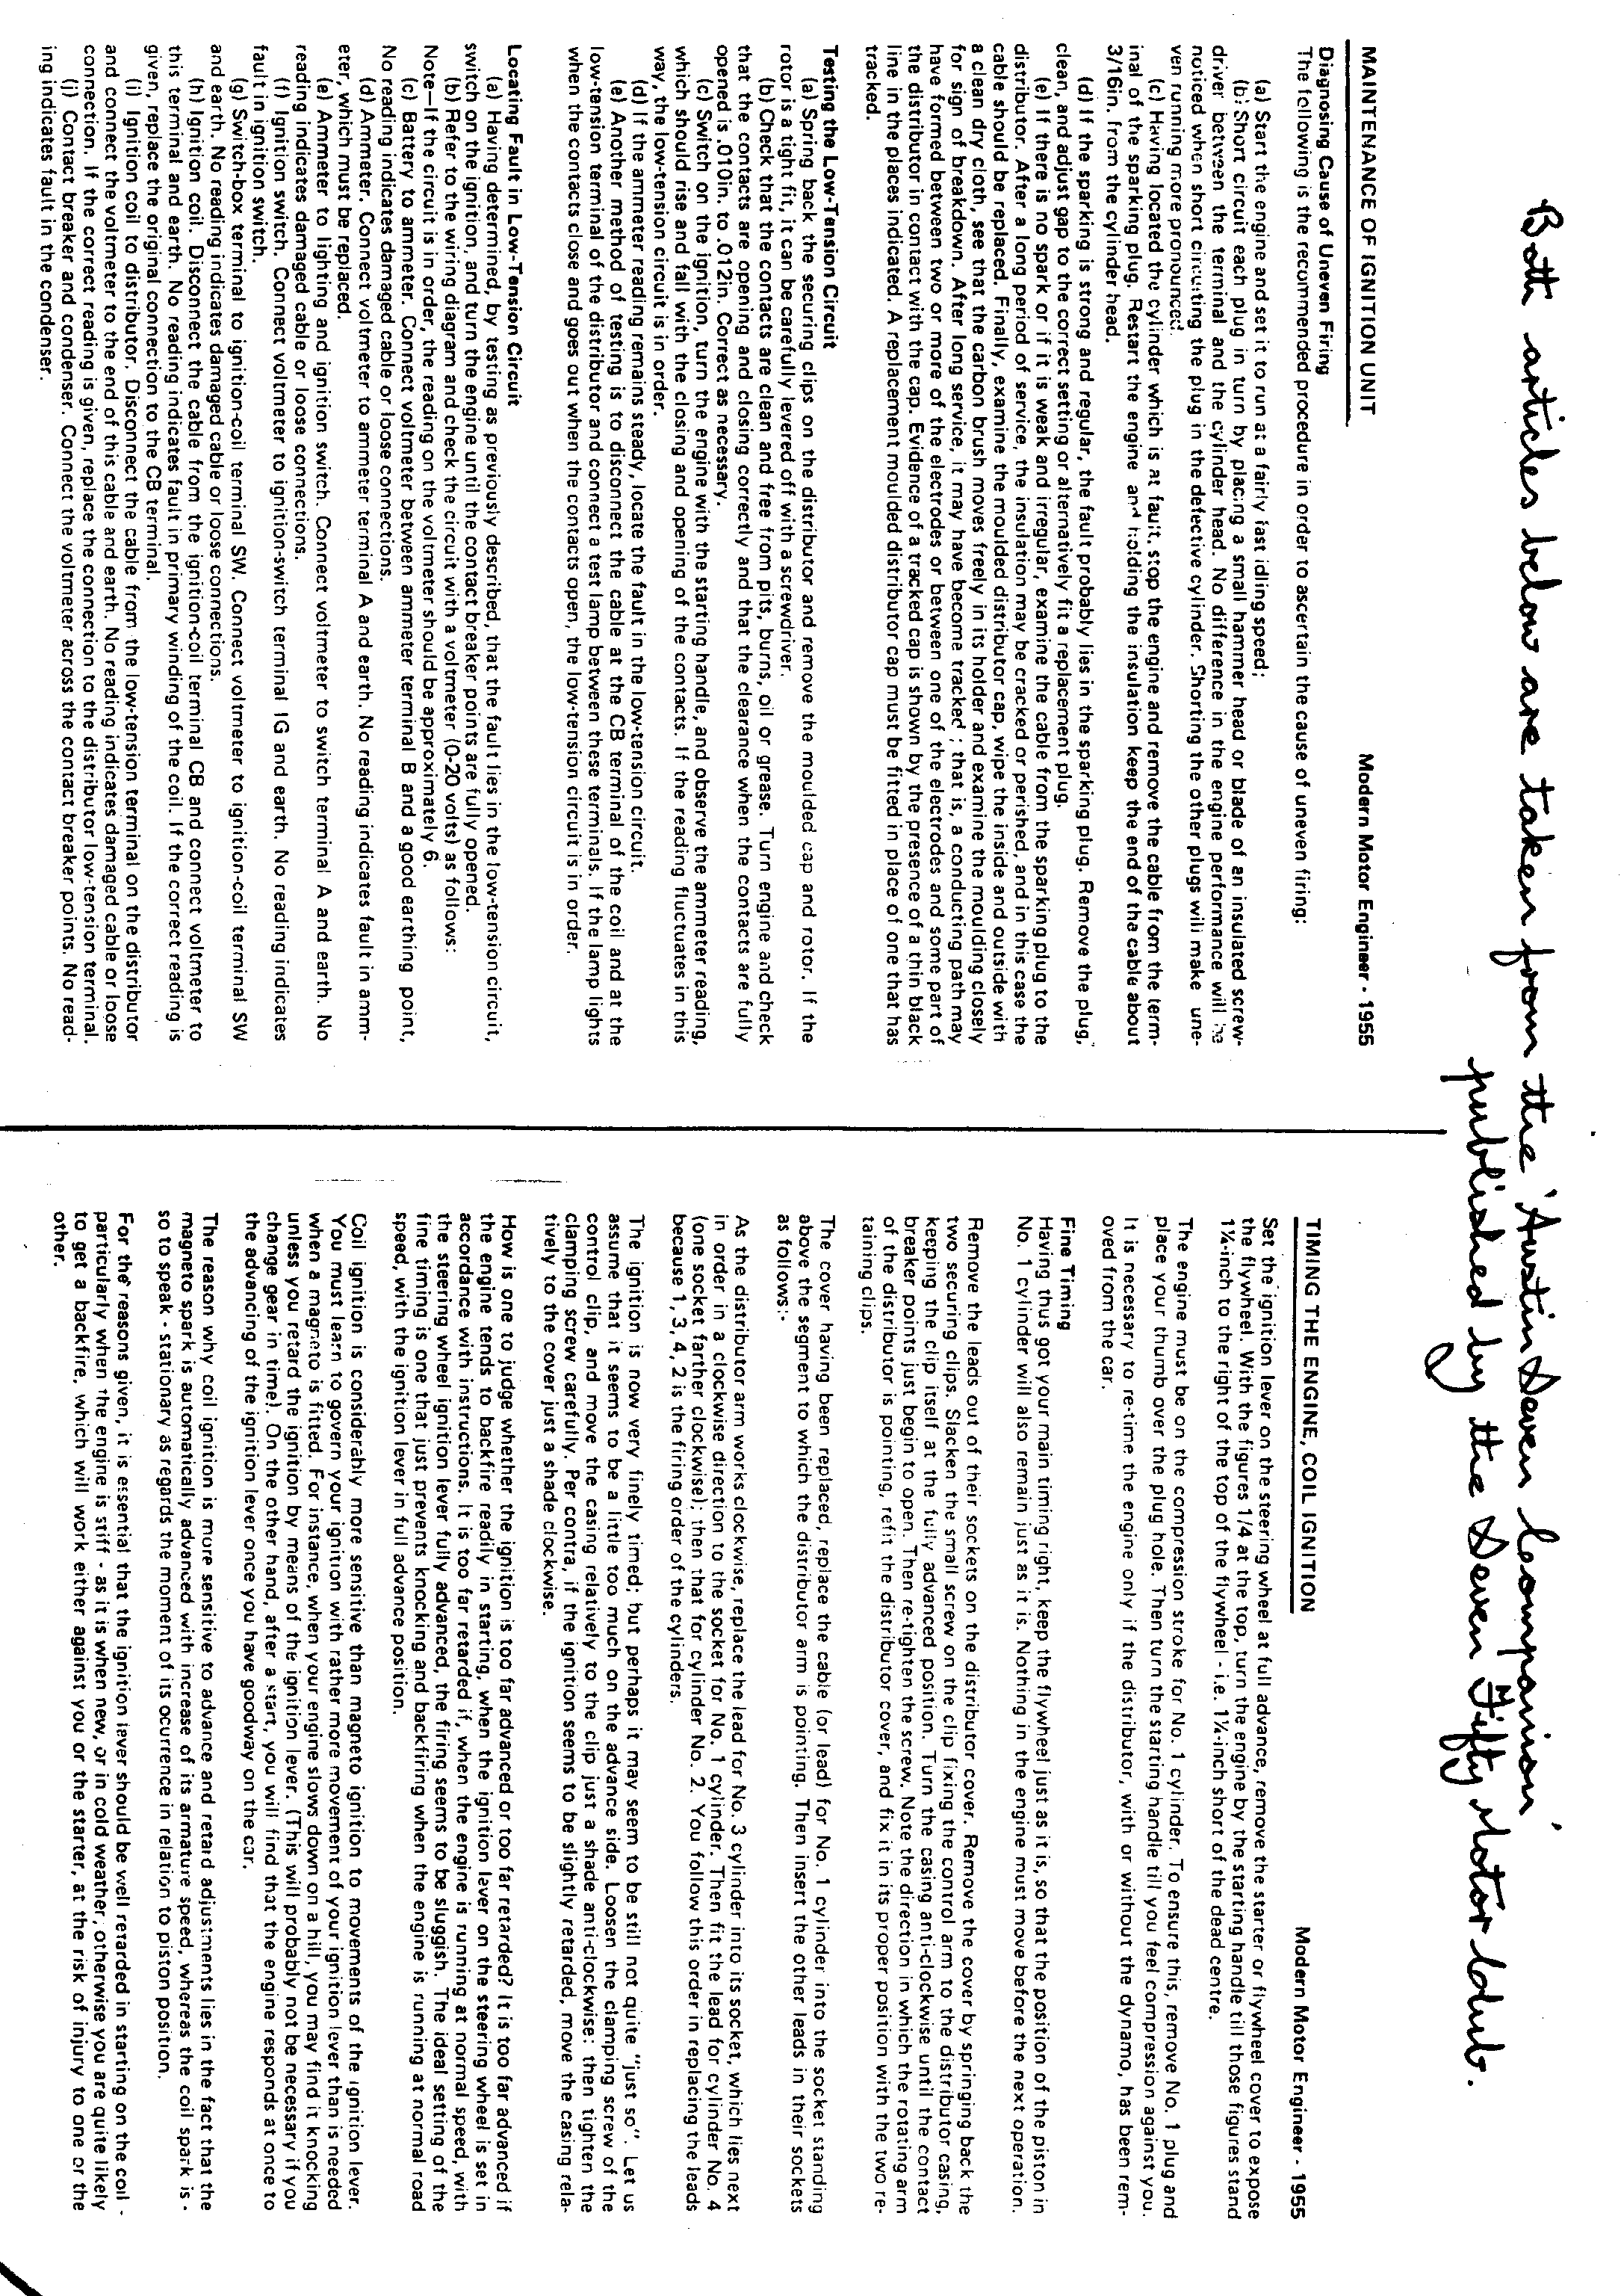
EVENTS

JANUARY
Thursday 16th January. CLUB NIGHT at the Elm Tree. 8.00 p.m.
Phil Whitter will be sharing his experience and giving a talk
on the pitfalls of rebuilding your A7 engine.

Sunday 19th January. CLUB RUN. A Run to the Woodfords. Meet at the Furlong Car Park, Ringwood at 10.15 for 10,30 a.m.

Thursday 23rd January. COMMITTEE MEETING, at the Tyrrells Ford 8.30 p.m.

Saturday 25th January. SKITTLES EVENING at the Old Farm Barn Inn, Three Legged Cross. First ball away at 8.00 p.m.

FEBRUARY
Thursday 6th February. '9 to Late' (for those who want to meet for a natter) at the New Queen, Avon Village.

Thursday 20th February. CLUB NIGHT at the Elm Tree. 8.00 p.m. QUIZ NIGHT. See within for further details.

Sunday 23rd February. CLUB RUN. See the February Newsletter for details.

Thursday 27th February. COMMITTEE MEETING at the Tyrrells Ford 8.30 p.m.

SPECIAL NOTICE On Saturday 1st February 1992 the Solent Austin Seven Club ' is celebrating its 20th Anniversary with a buffet, bar and films at The Brabazon, Beaulieu Motor Museum at 7.30 for 8.00 p.m. Any DA7C Member is invited to attend on this occasion. The cost is L10 per head and bookings can be made by ringing Mike Tye on Southampton (0703) 454235 as soon as possible. A couple of your Committee are likely to be there, check with Bernard or Glyn if interested.

