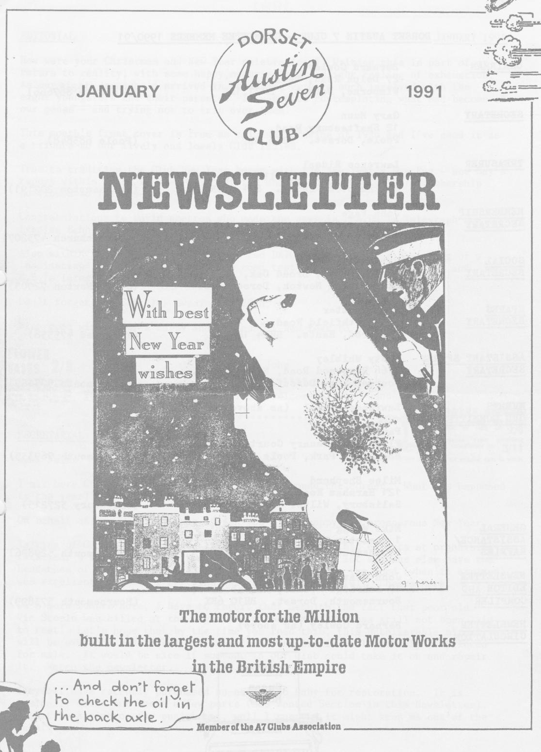
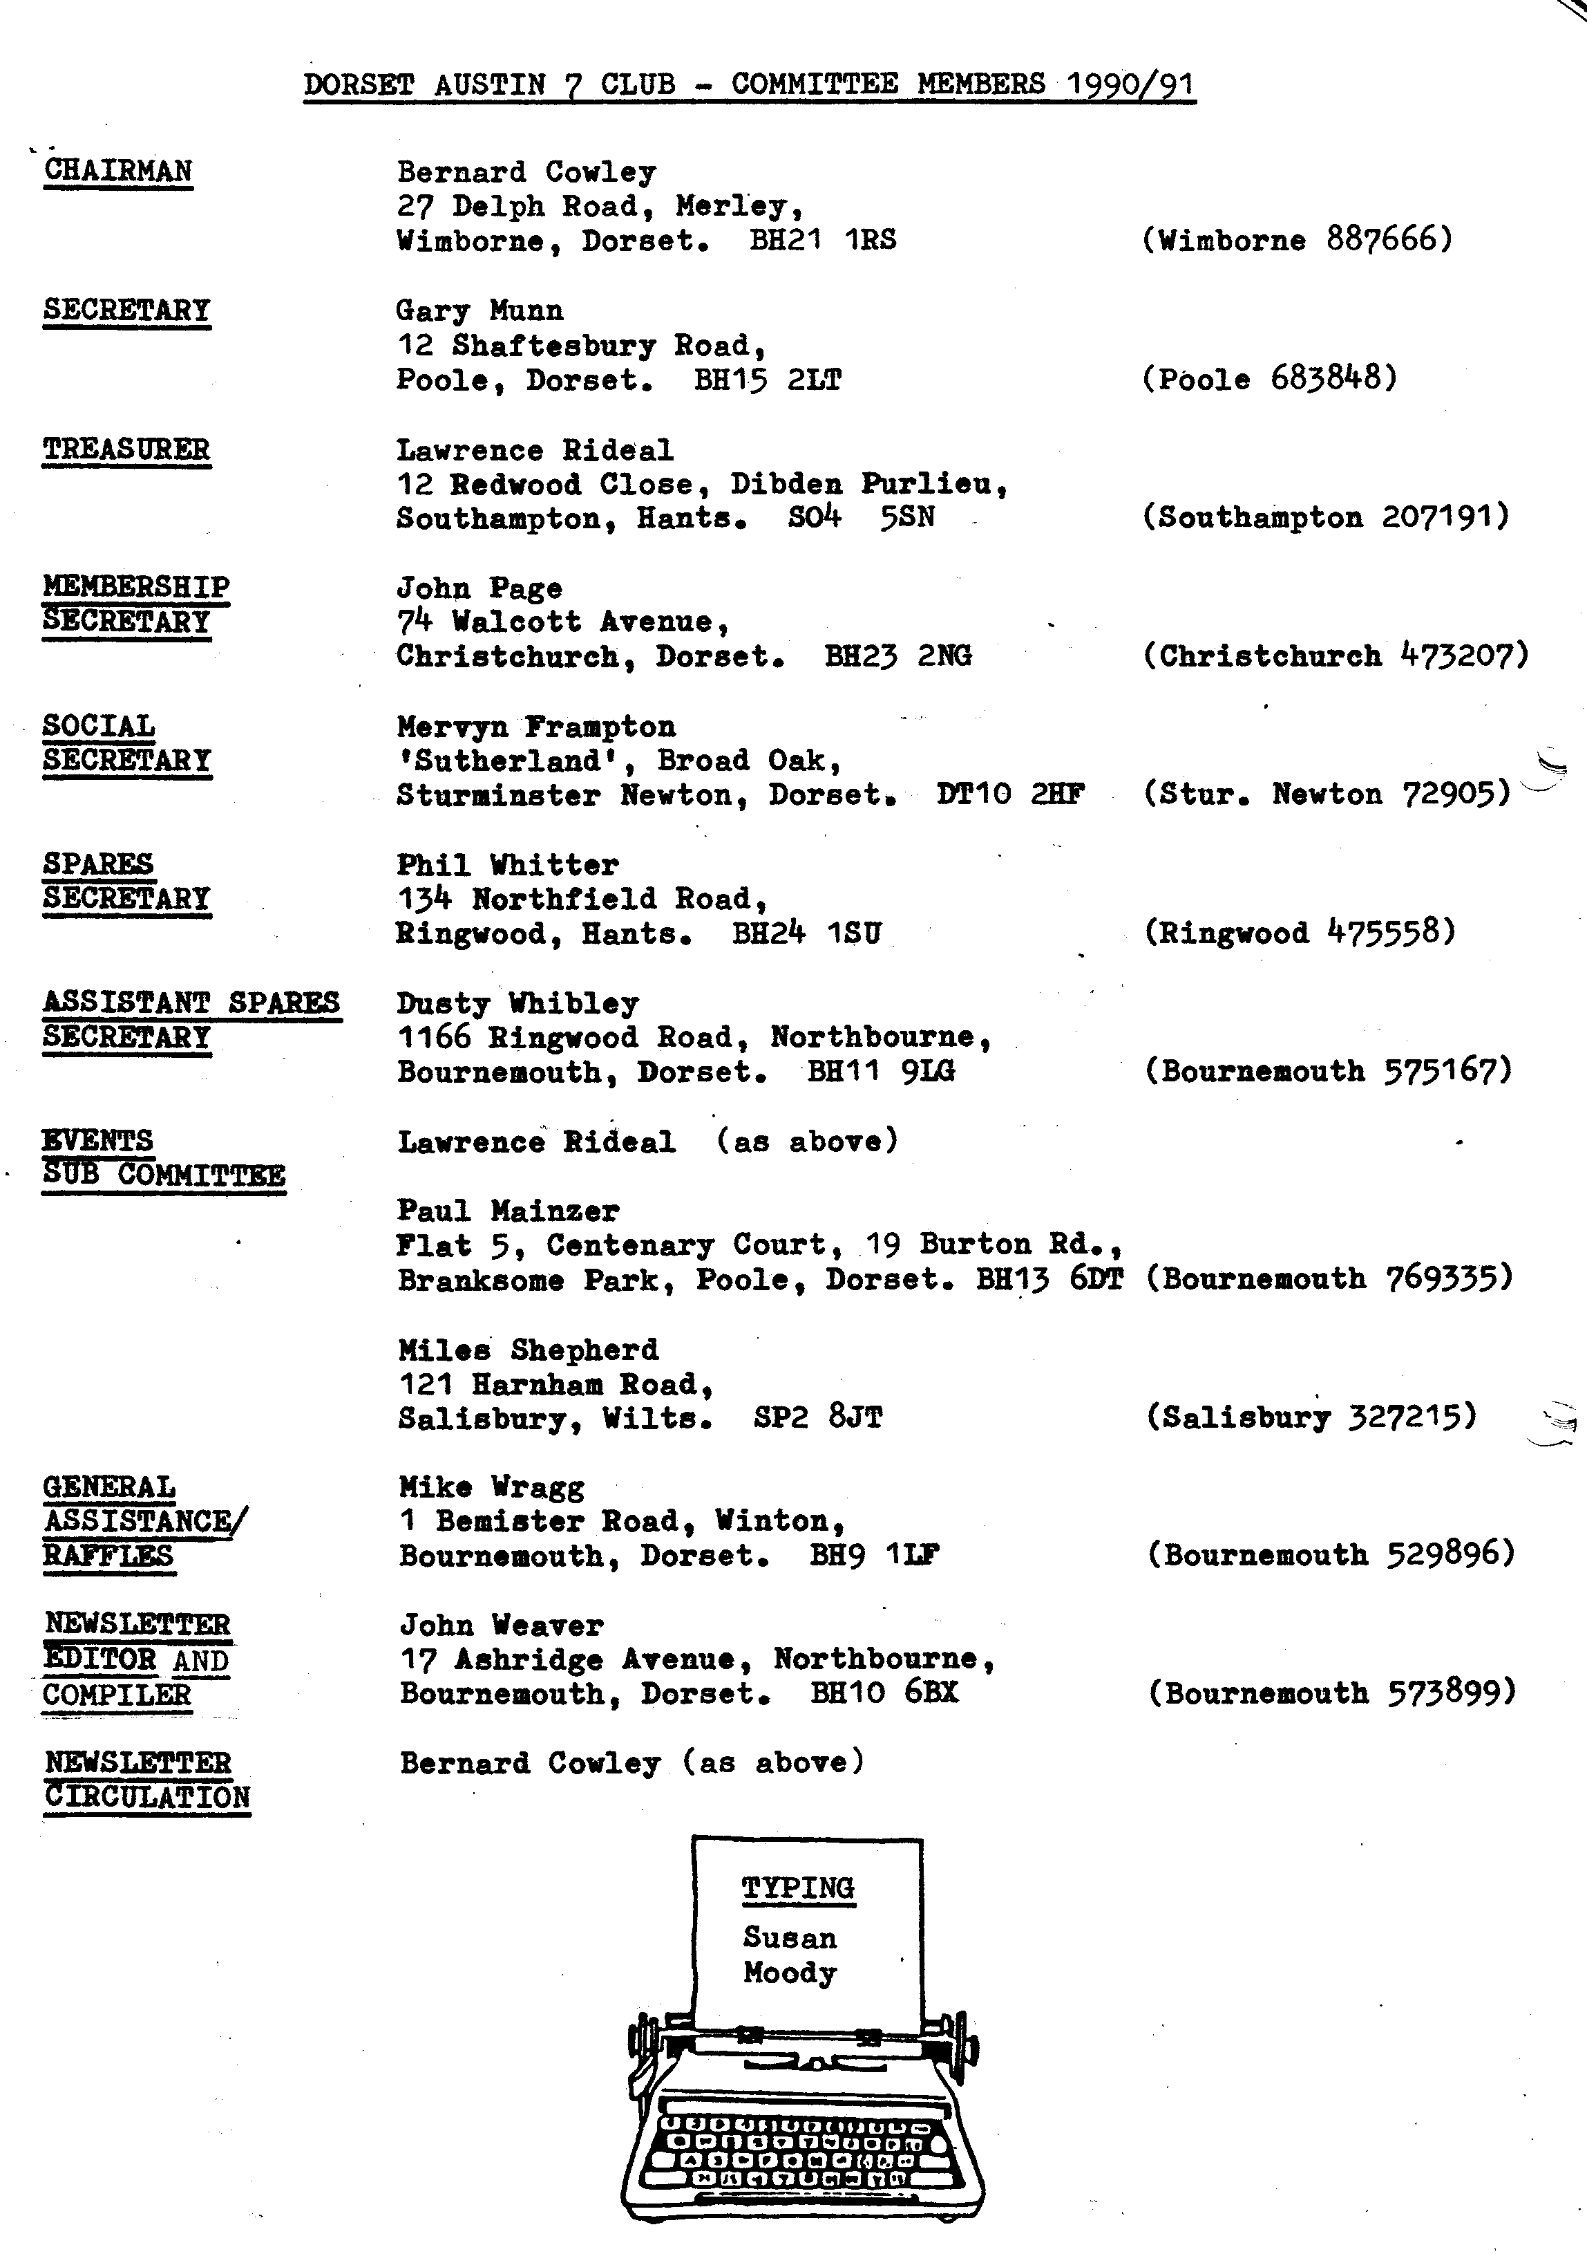
EDITORIAL JANUARY 1991
How were your Christmas and New Year celebrations? Writing this is part of my return to reality, with some happy memories and a slight feeling of exhaustion. As our eighth grandchild arrived in November, we were much involved with the eight youngsters and their parents. It was nice contemplating what had become of our genes - and trying not to trip over them!

This month's front cover is from an original drawing of 1926 and I've used it as a tribute to our lively and lovely Club ladies. True to tradition the Club New Year began with the New Year's Day Run - see Gay's report within - and we seem well set for another busy year as DA7C membership continues to increase.
Congratulations to David Whetton who made the news in the Daily Telegraph and Evening Echo with a new maths book (see within). No bodging here.

Also within the solutions to the last two DA7C crosswords; the beginning of a fascinating long and detailed 1930's road test of an A7 (thanks Bernie) and B.B.'s latest profile.
Don't forget the Skittles Evening on 26th.
With good wishes for a happy and successful New Year to everyone.
John

SECRETARIAL
Well Folks,
I sit here Christmas over and New Year just around the corner. What has happened to the year?

On behalf of our Committee may I wish you all a happy and prosperous New Year.

Talking of Christmas, I should like to thank Merv for his efforts at organising this year's meal. It really was nice to sit back and let someone else have the headaches of organisation. I think we all agreed that the food (when it arrived) was excellent and the 'free' wine was certainly plentiful. Cheers Merv!

On a more sombre note, I have to report that despite the fact that poor old
Vic Steele was killed at the beginning of September, he has still not been laid to rest! Let's hope that by the time you read this, this unbelievable situation will be over. I understand what's left of the Austin will probably be offered for sale. It would be nice if someone in our Club could take it on and repair it. Watch the newsletter.

I myself have recently purchased an early '36 Ruby for restoration. It is basically sound but needs a few parts (see Wanted Section in this Newsletter). I must be a glutton for punishment, well I suppose it might keep me out of the pubs!
Cheers,
Gary

The New Year's Day Run 1991

A pleasant and refreshing run arranged by John and Cynthia Page.
Thirteen splendid Austins assembled in Wimborne Square, the 10.45 sharp start was a bit blunt but the atmosphere was very jolly. This happy throng was augmented by those in moderns. Some revellers of the previous night were still revelling while others were rather subdued but it was a good opportunity to wish good friends a Happy New Year. A cheerful greeting from the local constabulary added to the carnival atmosphere. It would be easier to list the missing regulars from this gathering than to name those present.
A countryside route took us to Sturminster Marshall. We then joined the A31 for a short distance around the Drax estate leaving it at the World's End for Wareham. Dusty and Jane joined us on the way, but a minor failure back up the line delayed us for ten minutes or so. George liaisoned from front to back keeping us all informed - quite a task.
We progressed through Sandford, Wareham and Creech, a sharp hill here caught someone else out and there was a further delay. Once more, George our runner kept an eye on the rear of the column.
Talking of hills and long columns, a most impressive sight was our procession negotiating the hairpin bends of Knowle Hill, from above. Had we dared to stop it would have made a most impressive photograph.

Through Corfe and on to Kingston, we reached the Scott Arms at 12.30. Although busy the staff coped with us well, it has once more changed hands but the food and its prompt arrival were impressive.

In no hurry to leave such pleasant company, one or two smaller groups set off on various routes home, but by far the largest group left for Swanage for a bracing walk. The weather was quite 'harsh' by then but fortunately I was spared this `delight' when John and I went for a ride in the car!! (As you may not know we returned to Kingston where I'd left my camera in the pub. Ed.) We rejoined the walkers in time to decline a cuppa and head for home.

Our return on the ferry required queuing, but not for too long - while waiting we enjoyed our own cuppa. The weather had really deteriorated by then but it just added to our happy glows of contentment.

The thought occurred to one or two committee members along the way that to help the 'Georges' of the world and other road-users, such a large party would have found it easier split into two groups. Perhaps in the future…
GAY

WANTED FOR GARY'S 1936 RUBY

2 bearing 'bottom end', front and back bumper bars, cut-out, horn, fuel pump, semaphore indicators, one side light lens, glass and front, tyres and the right angled metal sections which fit between the cow horns and radiator surround to hold the radiator, what ever they are called!

Gary Munn - Poole (0202) 683848
**s********
HEREWITH the details of David Whetton's book
IN THE INTEREST of all the DA7C has recently joined the Federation of British Historic Vehicle Clubs. The Club, among other things, represents the interests of members to government, both at house and in Europe. Veiled 'green' threats have been made in respect of older cars and we need to be aware of any proposed legislation that may affect our interests and act accordingly.
WELCOME to new Club Member, L Dodson, who wrote an interesting letter regarding his 1937 Ruby which was purchased from a lady in Bournemouth in 1966 for £15. Completely restored in '87-'88 it sounds a nice car.
AMATEUR THEATRICALS, are among the interests of Gordon and Biddy Brown. B.B, is producing a play to be staged shortly in Lymington. When did you last see a
live performance (apart from the Club idiots)? Biddy has passed on the following details and hopes for support:

STOP PRESS WANTED URGENTLY I STOP PRESS I WANTED URGENTLY I Brian Toalster has a broken tooth on his 'crown wheel. Can anyone help with a crown wheel (and pinion if poss.) for a 1931 Box?
Tel. BH. 514818
AUSTIN 7 BEGINNINGS - 5 - a story of Austin Folk. Hilary and Phil Whitter.
However long you may have been a Dorset Austin 7 Member, you cannot fail to be but highly impressed, amazed and very thankful at the incredible range of spares which Phil produces, seemingly out of a hat, (for such is his efficient method of storage). We've all seen him boyishly bounce into the club room, full of enthusiastic smiles, effortlessly, it seems, lay out the ever growing amount of spares; call out what's new this month and, whether you have an Austin, drive, do or do not maintain your car, be drawn by his charisma to look in wonder at all the 'goodies' he has so lovingly and time-consumingly collected. Here is a man who cherishes unselfishly all of our cars, has been doing so for nigh on ten years and modestly says to any praise, 'well I've always collected bits and bobs'. Hilary, always smiling, quite obviously totally and unstintingly supports Phil in his mammoth efforts.
How did this all begin? How did Phil and Hilary come to, as they say, be 'into Austin 7's?’
It all started, although Phil didn't realize at the time, with the unbelievably 'hellish - noise' the vibrating brakes made in a reversing Ruby, owned not by Phil but a neighbour some two houses away. Every time Phil heard the noise he couldn't help but stand and watch. Sixteen year old Phil, totally mesmerized by the noise of the dear lady owner's car always packed up solid with her children always making a fab. noise... until the fatal day when an enormous ....'BANG' fetched him out to discover the car engine had totally seized up, like the Grandfather clock in that lovely song 'never to go again'. Into the garage they all helped to push the car where it became a dolls' house for all the local kids to play in. Eventually another sixteen year old, two houses the other side, bought the car for £5. Full of good intentions the young bloke took it to pieces intending to rebuild. For full twelve months he intended and intended - we all know that good intention, don't we? Phil, ever kind and helpful, relieved him of the worry by moving the bits for £4 and putting them into his garage to 'have a go'.
Meanwhile Phil was riding a motor bike, progressing to other cars including a 1933 Morris 10/6, in which he learned to drive; whilst the 'good intention A7 of reversing-brake-vibration-fame' remained in the garage but not forgotten. Eventually Ruby CMK 201, ZEBEDEE got onto the road and was moved to Hilary and Phil's flat at Iford Bridge in 1965 their wedding year.
ZEBEDEE, the A7 so fondly and aptly named: it virtually sprang along in hectic lollaps, became the vehicle to take them on holidays Wales, Cornwall, France etc. Many, many happy family outings have been enjoyed. The most famous not to say amazing run it ever did (as yet), was the John'O'Groats to Lands End Diamond Jubilee 1982 - in a record time of 20hrs. 11 mins; complete with original 417 tyres. The success of this run Phil stresses, was due to the co-driving of Willy McKenzie to whom much credit must be given. (The run is a whole story in itself and deserves I'm sure another retelling, another write-up!). Truly a wonderful car, doing as great a mileage as 12,000 miles one year as the family every day transport.
Many, many tales could the family tell of exploits in ZEBEDEE. One unique one has to come from a Cornish tour. Whilst in a Truro cinema, rain water ran between the petrol filler pipe into the petrol tank. Twelve miles back to their bed and stranded? NO, not resourceful Phil, he strapped a plastic funnel of petrol where it could drip petrol into the carburettor! (I don't pretend to know how that works - pencil sketch please Phil). 'Quite hair-raising' all that petrol slopping about, but at least it got us home!'

And where, you may well ask, is this famous Ruby? For many of you like myself thought that Phil and Hilary were/are 'BOX' BPJ 474 people. Read on, dear friends and in a roundabout way, you will hear.
'From Little Acorns do Oak trees grow' and so it is with 'hellish A7 noises'. I'll explain!
Early in the Beaulieu Rally days, Phil helped a retired Headmistress, one Joan Cox, with her broken down 1934 Box Saloon, became family friends, maintained it for her, eventually becoming the proud owner when Joan said she would like someone to take it on who she knew would treasure and care-for it. Quite a unique car since Joan had it from new 1934 until 1984.
Turning back to 1968 Phil found a Fabric saloon in the Purbecks and bought it ten years later. Glyn now owns it and with the proceeds Phil bought a 1927 Chummy OT 6068 and hopes to have it on the road for May, ready for a later trip to Southern Ireland.
Last year son Keith was given a 1934 pack of `bits to revitalize' and is enthusiastically doing just that!.
Back to ZEBEDEE, off the road since 1985, in the garage looking sad and sadder. Not for too much longer though for stalwart Hilary quite unable to accept such a fate for such a loving vehicle is...wait for it... going to restore her. ..HERSELF! Yes Austin Seveners. Under the guidance of Phil, Hilary is already-the proud possessor of overalls, gloves and even more has an authentic-not-to-work-on-a-car-without...you've guessed it, right along side her ...a mug of tea! Can you imagine it? a whole family of Whitters, an Austin 7 apiece to work on! Wonderful! Ladies, we just have to take our hats off to Hilary since we all know how difficult it is to fit in the cooking, ironing, entertaining, gardening, not to say Mug of Tea Making let alone taking on restoration. We all know Hilary and she is quietly determined to eventually have ZEBEDEE on the road as her own run-about with a knowledge of how that thing under the bonnet works. Good Luck Hilary.... and get a little rota out for the tea making!
To round off their story Phil was one of the founder members of the Dorset club, having seen an advert in Bernard Cowley's car at Beaulieu prior to the start of the club.
I end with Phil's words..'I enjoy the club for it's incredibly friendly, feet on the earth members who come from all walks of life. In fact I find that in all Austin 7 owners. Smashing people, all of them'.
Thank you both, Happy New Year and Hilary.. please don't get rid of the 'spring' in ZEBEDEE, it sounds such fun.

B.B. Dec. 1990.
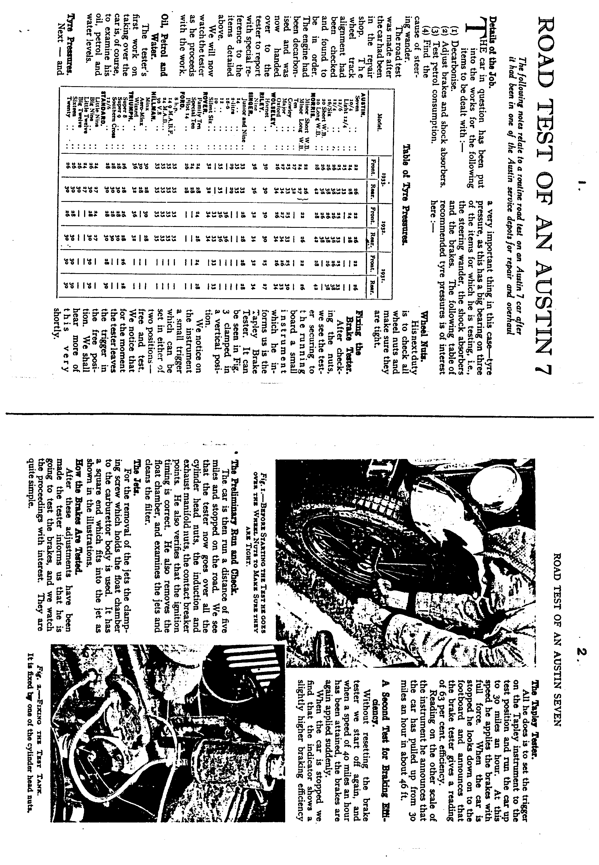

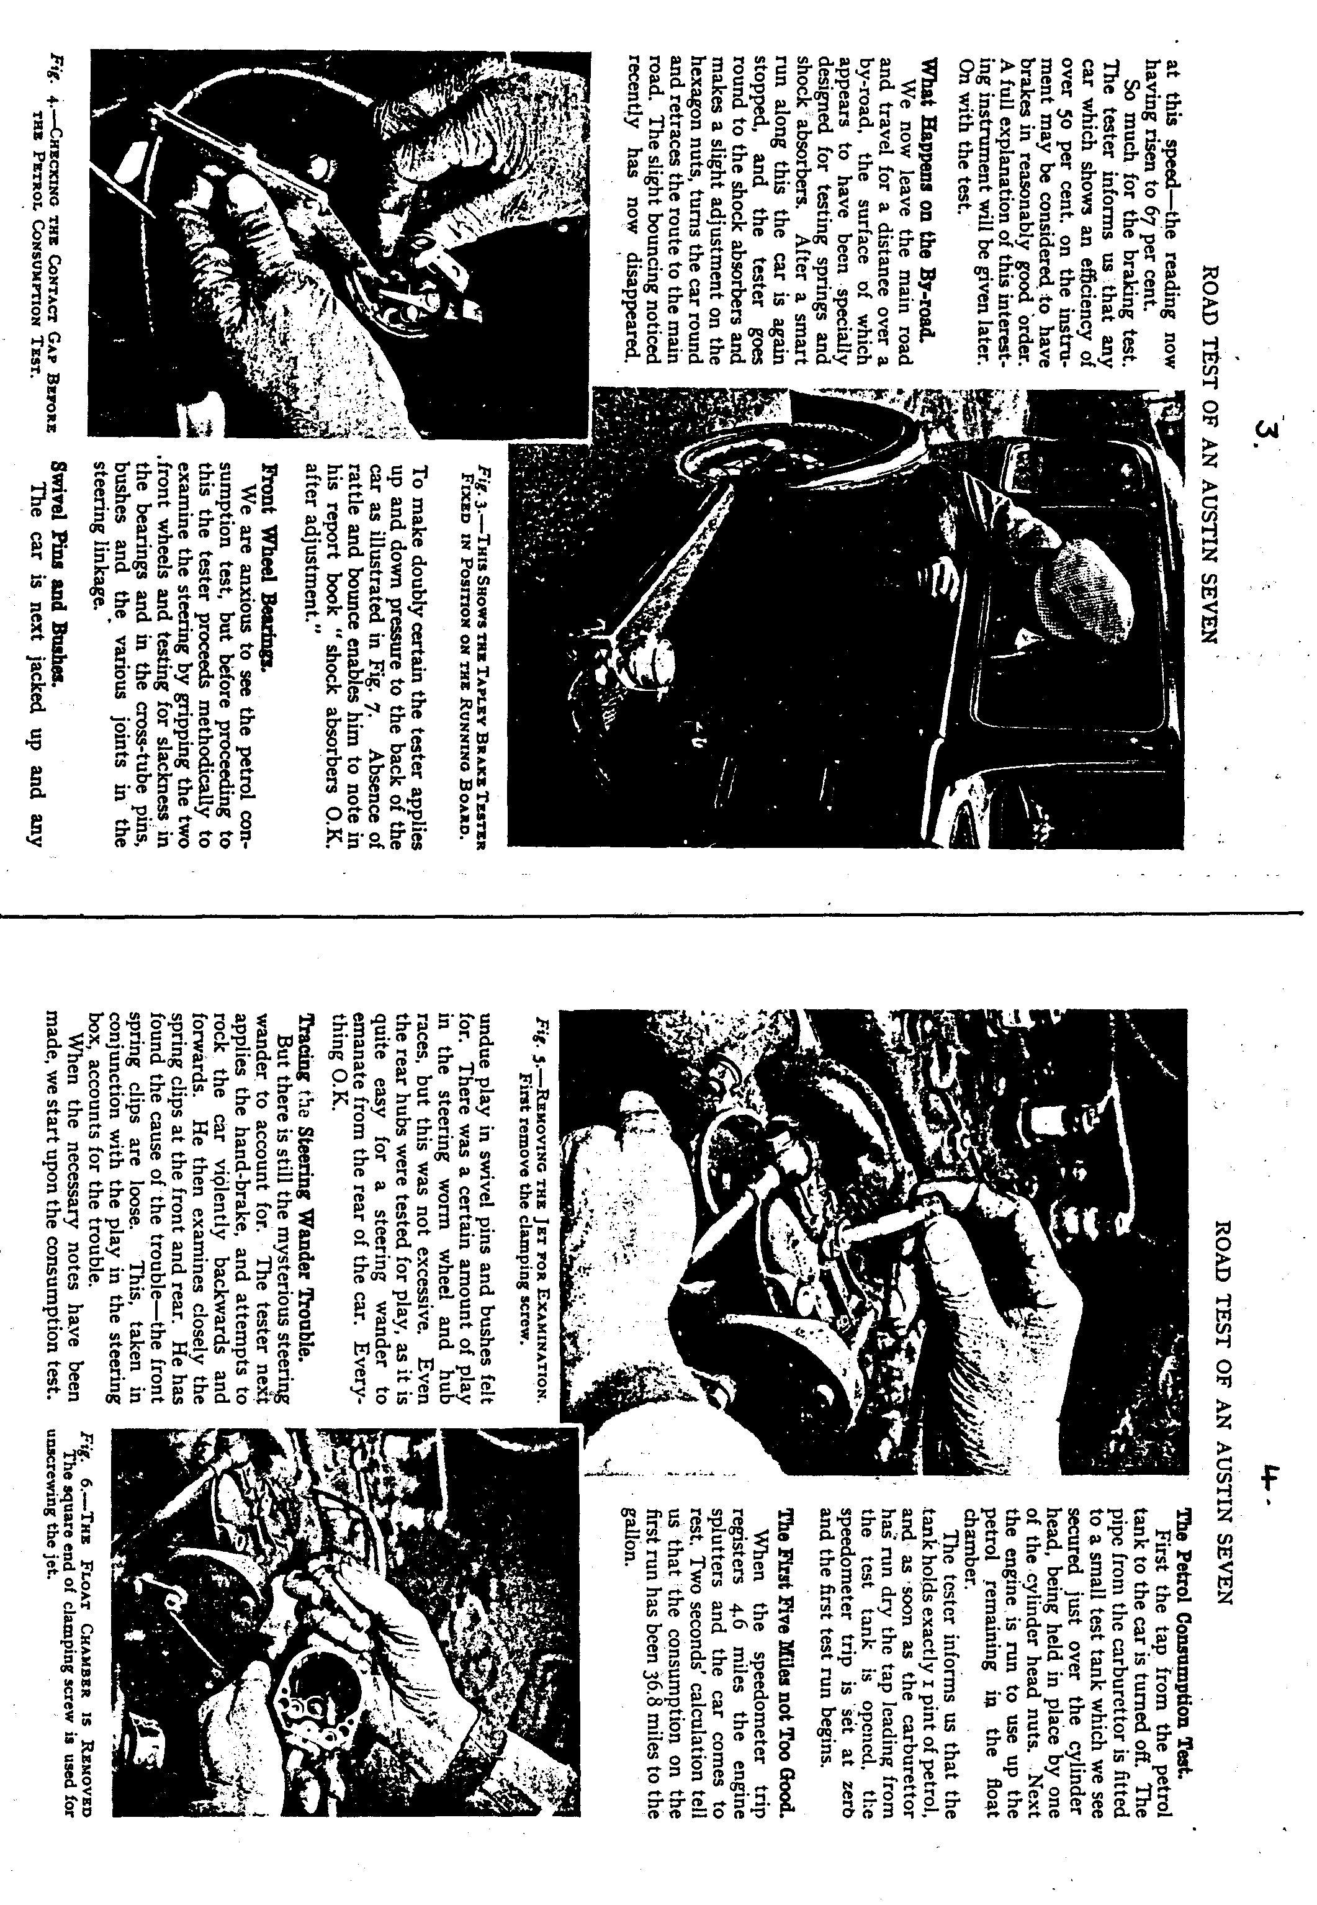

JANUARY Thursday 17th January. CLUB NIGHT at the Whincroft Hotel.
1991 8.00 p.m. A guest speaker with a talk on 'Old Poole'.

Sunday 20th January. CLUB RUN. A long Run to the Purbecks and West Dorset. Meet at the Viewpoint, Constitution Hill at 10 for 10.15 a.m. Please note the REVISED TIME OF MEETING - earlier than notified in December.
Thursday 24th January. COMMITTEE MEETING at the Tyrrells Ford. 8.30 p.m.
Saturday 26th January. DA7C SKITTLES EVENING at the Red Lion, Sturminster Marshall. 8.00 p.m. Book through Merv Frampton before 12th Jan.
FEBRUARY Thursday 7th February. '9 to Late' (for those who want to meet for a natter) at The Woolpack, Sopley.
Thursday 21st February. CLUB NIGHT at the Whincroft Hotel. 8.00 p.m. Quiz Night arranged by Mervyn Frampton.
Sunday 24th February. CLUB RUN. Details in the February Newsletter.
Thursday 28th February. COMMITTEE MEETING at the Tyrrells Ford. 8.30 p.m.

