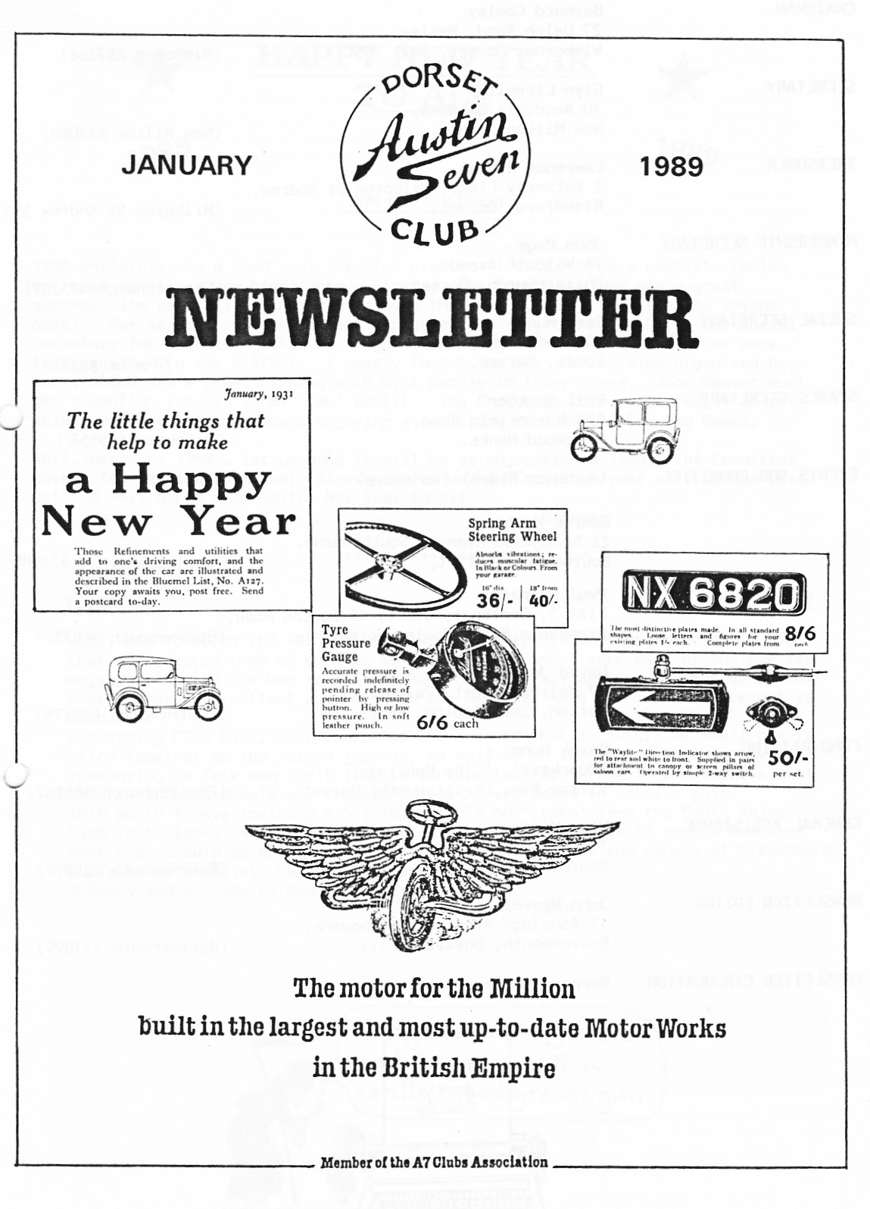
FROM OUR CHAIRMAN
1988 certainly was a good year for Club events - I will not do a complete review but must mention a few highlights. Firstly, the French holiday was a great success, I'm sure all on the trip enjoyed themselves, apart from the sea voyage home!! Our various runs where well supported and many thanks to Gary, our Social Secretary for organising the very enjoyable barbecue at Studland, where we were lucky again with the weather. I nearly forgot the Barn Dance, also organized by Gary, which was a great evening with most people in fancy dress. John Weaver must get a mention for his super 'Emu' outfit. The Christmas dinner was really enjoyable able again with forty members enjoying a delicious meal at the Crooked Beams.

Well, here's to 1989 - let us hope it will be as enjoyable as 1988•. The Committee have a few new ideas up their sleeve so let us hope our 14th year will be the best yet. A very happy and healthy New Year to all.
Bernard
EDITORIAL JANUARY 1989

Well, was it worth it? Of course it was! The festivities are over and I hope that you enjoyed them as much as we did. As Gay and I were away at the New Year we, sadly, missed the New Year's Day Run which, by all accounts, was a great success. What an excellent way to start the New Year this is! John P's report is within.
Concerning Club Runs, your Committee has decided that in future we shall aim to stick together on the return journey, as well as on the run out. This may be reassuring to folk who don't like to venture too far in the A7 and ensures that help is at hand should any trouble arise. I was asked to mention this. This month I have included a helpful article on 'Leaks' from the South Wales Club (not 'leeks' as you might expect), a lubrication chart to remind Members what they should be doing and an interesting analysis of the causes of breakdowns suffered by motorists between 1930 and 1935.
A happy and successful New Year to all! John

SECRETARIAL

Hi Gang. I hope you all had a Merry Christmas and wish you all a very Happy New Year. As I write this Secretarial I am thinking of the New Year's Day Run which I still have to organise. Pat and I hope to plan it during the holiday. Whilst on the subject of events and runs, if any one has an idea for a run or event please do mention it to a Committee Member. You will not be asked to organise it, unless you want to do so. It would be nice to get some new ideas for 1989. If every Member could come up with a new idea, we would be set up for years! The January Club Night should be of great interest as we are having a talk on electro-plating by Alderney Plating. I just hope we have the Barn Bar this month, as the room we used in December is definitely too small. Well, that's all from me, see you Club Night!
Glyn
CONGRATULATIONS to Bernard and Jackie - and also to Sarah and Peter of course - on the birth of their first grandson on CHRISTMAS DAY! A memorable event to be sure.
Welcome to the Club B and J. Gay and I also had an extra present for Christmas when daughter Jane, with Kevin's help, presented us with our seventh grandchild. Why don't we feel like old folk? One day I'll tell you the secret.
Ed.
A PURBECK RUN - Sunday 11th December

This is one of those runs where it is far more of a pleasure than a chore to write up the report. The Scott Arms at Kingston was the objective chosen by Gary and quite delightful it was too. This, together with the Langton Arms
at Tarrant Monkton, are perhaps two of the most pleasurable hostelries we have in the area.

Although not a massive turnout, eight cars in all, including Biddy and Gordon, John and Cynthia, Bernard and Jackie, Bob, John and Gay, Glyn, Emma and myself and of course Gary, whose run it was, the weather was reasonably kind; not quite as good as the previous Saturday but at least dry and anyway what could possibly spoil the Purbecks? They always seem somehow timeless and thank goodness unchanging. On the way we stopped for a parley with Jeff and Cathy in their E-Type and who later joined us in the pub for lunch. It must have been just after this stop that the petrol filler cap of our car decided to have a look round on its own. Thankfully, Glyn, who was immediately behind us spotted it flying away through the clouds of smoke he insists we always leave behind. Even more thankfully it was found. We were, of course, totally unaware of all this but I am truly grateful for this is one of those silly parts, which are so very difficult to get hold of. Thanks to you all for the search party. The Scott Arms, as was to be expected, was fairly full, so we took ourselves off to the back, downstairs bar - but nonetheless enjoyable for that. Afterwards we ventured out onto the Purbecks themselves, but not far and not for long. The wind was beginning to bite and someone mentioned hot crumpets and firesides. On the way home, we had another 'do'. The car was getting slower and slower and seemed, if that is possible, even worse than usual on hills. As I lifted the bonnet I could see one of the leads had broken away from the distributor. A simple matter easily explained, even so I appreciated very much Bernard and John coming back to see what the trouble was. Thanks to you both and a very big thank you to Gary for organising the run in the first place.
Ah, and Happy Christmas to you all! Paul

GLYN'S NEW YEAR'S DAY RUN

I have been told by Glyn it is my turn to write the report on his run, so here goes.
There were hundreds of cars in the car park in Ringwood on Sunday 1st January,
and sixteen of them belonged to the Dorset A7 Club. Three had doubtful parentage and thirteen were Austin Sevens. I cannot fill this page up with a multitude of names, so I thought registration numbers would make a change. You might check the list and tell me which is the incorrect one:- HA9543 AYT216 BPJ474 DUO803 FK2666 OW221 VEL604 RU7609 F02847 DSV499 FAU742 KX6835 JT6292 GK4219, plus Miles Shepherd in his Chummy, who left the pub before I did. The run to the Yew Tree Inn at Coombe Bissett was in the form of a treasure hunt with about ten clues to find on the way. Interest was increased by the fact that one clue had fallen down but never mind, most people found or guessed anyway. At the pub Pat (of Pat and Glyn) sorted all the entries and after careful checking
a winner was announced, but I cannot say who this was as I was sat in a very crowded pub next to Mike at the time!
After dinner some of us went to Salisbury to see Ted Heath shaking hands with his dinner guests as they left his fine house in the grounds of the Cathedral.
.
John P.
CAUSES OF BREAKDOWN
. The R.A.C. again issues its interesting analysis of ;
- failures dealt with by its _{"Get} .You Home" service.
O ONE of the benefits indirectly derived from the excellent "Get- You Home" Service of the R.A.C., is the evidence it provides annually as to the most prevalent causes of auto' mobile breakdown-data which is of great value to the motor industry as a whole, as well as to the individual motorist.
The 1935 percentages just issued, which ; can be compared with the breakdown figures for each year since 1930, again' confirm that the weakest part of the average car in. respect of dependability is the ignition system. In 1935 it accounted for nearly a quarter of the total failures-actually 22.9 per cent-and its responsibility for breakdowns has been increasing for the past two years.
However, it need not be assumed from this that the design or manufacture of the electrical equipment of the average car has deteriorated. To a far greater degree it may be an indictment of the average motorist's lack of electrical knowledge and his neglect of the electrical units on the car. Those- who have to repair and service motor : vehicles ' often find that the electrical system has been left to fend for itself, with the very minimum of attention or none at all, and this may well be the cause of the high percentage of ignition failures.
Another form of failure that is on the increase is that of the water circulation,' ⁻a fact which" points to the need for regular inspection of the various water joints to ensure that there is no leakage, as obviously cooling system failure, apart from accidental damage, will largely arise from neglect.
A welcome tendency shown in the R.A.C. figures is the reduction in cylinder, piston and valve troubles, and the lubrication system also appears to be increasingly- reliable, but the valve gear and cooling system; do not share this improvement.
The remarkably low percentage of brake failures-namely 0.3-is most reassuring. The brakes are clearly the most, reliable part of the car.
Safety' is also enhanced by the steady fall in the percentage of failures of the front axle and steering, and that for road wheels and suspension is also satisfactory, the improvement shown each year since 1930 having been more than maintained during 1935. For this credit can be given to the improvements in road surfaces and tyres.
The reverse side of the picture shows carburation troubles having more than doubled since 1930. Here, where the mechanical element is small, neglect of the elementary attentions required by the carburettor and pump, such as cleaning and the tightening of unions, must be a considerable factor in accounting for the rise in failures to 6.1 per cent, as against 2.8 per cent in 1930.
Lastly, it is significant that the percentage of breakdowns resulting from accident is the lowest in six years, for this is just another indication .of the growing safety of motoring. .
So You've Cot A Leak
Leaks normally come in two sorts - oil or water and in two dimensions - a drip or a veritable flood. .

Let's look at oil leaks first and for the scope of this ' article, I intend to confine myself to the engine. All Austin Seven engines seem to suffer to a greater or lesser extent and
even in recently re-built engines. there are three points especially prone:

1. Between the crankcase and the block.
2. Between the crankcase and the sump pan.
3. From the base of the petrol pump.

To cure the first of these is a big job entailing removal of the cylinder block and the insertion of a new crankcase-to-block paper joint. Most leaks here are not due initially, to failure of the joint but are due to the etude which secure the block being pulled slightly upwards which in turn pull a section of the alloy crankcase up around the studhole. Instead of the block seating fair and square on the crankcase it is actually sitting on a series of lumps, one at each stud. "Hell" says the owner, "The damn thing's leaking" - whips out a set of spanners and yanks at the securing nuts, thus pulling the studs even more and 'worsening the situation. The only cure is to remove the block, remove the stud from the crankcase and face up the top surface of the crankcase with light strokes of a large file to remove the high spots at the stud holes. Then lightly countersink the holes and replace the studs, grease the paper joint, fit it, press down the oil baffles, drop the block into position and bolt it down. Tighten but don't be too enthusiastic with the spanners and then after an hour's run re-tighten.

The cure for (2) is similar. Put a straight edge along and across the base of the crankcase as this will show up the high spots and similarly on the mating face of the sump pan.' If the latter is relatively un-bashed and the face of the crankcase is fairly flat you should not have too much trouble as the joint is fairly thick and a smear of "red Hermetite" will seal any slight gap. (If the surface miniature alps" resort once again to light strokes of that big file.) Take care though, on assembling excess sealing compound gets squeezed out on both sides and any that goes inside ends up, via the oil pump, on one of your oil jets!!!

And so to number (3). Don't bother over-tightening those petrol pump securing nuts because the leak is coming from the fulcrum pin
on which the pump lever pivots because the base of your pump fills I with oil. Take off the pump and look at the side of the crankcase. There is a hole below and almost mid-way between the two securing studs. This is a drain hole and there is a corresponding hole on the joint which goes between the pump flange and the crankcase. Oft times there is not and fitting a joint with a drain hole cures (almost) the leak. If it does not then you must make a new joint from Neoprene rubber jointing but do not cut out the centre just cut a slit to take the pump operating arm.

Water leaks at hose you all know how to deal with but leaky radiators are a specialist job for most people. Apart from those frightening wee discs called "core plugs" which covers the holes through which the sand core is removed after casting. These halfpenny (old type) sized discs corrode, leak. fall: out - always at the wrong time - and always seen to cause more than their fair share of despondency. And those which don't fall out can appear to be ^{remarkably} stubborn to remove. Right then, take a sharp punch or a small hammer and belt it through the centre of the core plug at a, slight angle once it is out of its hole. You will then find that it was supported by a seat which must be carefully scraped clean. The 'new plug will be seen to be domed and after the application of jointing compound (Hermetite green) to the seat in the hole, it is placed in position, domed side up. Now get a drift which 3s almost as big as the plug (a suitable bolt or a piece of solid rod will do) and tap the plug into position when it is seated and jointing compound is forced out all around. Hit it once with a fair sized hammer fairly hard. Wipe off the excess goo and you will see that the domed plug has visibly flattened, so just take the hammer and the drift again and give it another hefty wallop and the job should be finished

(With many thanks to the S. Wales Club and Y Saith for the above article.) .

EVENTS ⁷

JANUARY Thursday 19th January -CLUB NIGHT at the Elm Tree - 8.00pm.
A talk with information on electro-plating by Alderney Plating.

Sunday 22nd January - CLUB RUN - Meet at the Viewpoint, Constitution Hill, Poole - 10.15 for 10.30am - for a Purbeck Rangers Run with excellent pub lunch stop, followed by a Dorset Cream Tea at John and Gay's.

FEBRUARY Thursday 2nd February -'S to Late' (for those who want to meet for a natter) at the Manor House, between Parley Cross and Hurn.

Thursday 16th February - CLUB NIGHT at the Elm Tree. Please bring a photograph of yourself aged between 2 and 15 for a competition. Spares available._ -

Sunday 19th February - CLUB RUN -'The Piddle with Paul Run. Meet at Wimborne Square - 10.15 for 10.30am. .
Well folks here we go once again! We have decided to go for the same format as last year, The Diggory Venn live band in the Quarterjack suite of the Allendale Centre, Wimborne (opposite the Dormers). Fancy Dress will once again be optional, but certainly seems to make the evening go with a swing and of course there will be a prize for the best and most original idea.
As you can imagine this is a very costly event to organise, causing me many sleepless nights, so rally round all your friends - the more the merrier! It's bound to be a good value, fun evening out for a fiver, with a Ploughman's thrown in to the bargain, just ask the regulars!
There is a bar at the venue and of course we will run a raffle.
Please return the application to me as early as possible, but by 25th February at the very latest.
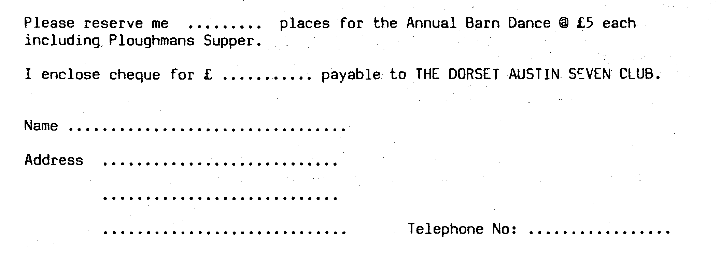
Gary

