EDITORIAL FEBRUARY 1991

I thought my eyes were deceiving me when I recently passed a 'modern' on the road with the registration number 7HP. A second look proved I wasn't dreaming and I reluctantly admit to a touch of envy. Can you imagine what that would raise at auction? It should definitely belong to an Austin Seven.

This month useful 1930s A7 Road Test is concluded and TRACING ELECTRICAL FAULTS, another useful article from that era, begins next month.

Jane Whibley has a neat original approach in her account of the January Run and B.B, continues her profiles. Now I know what it's like to be targetted by the tenacious Biddy!

Club Night is Quiz Night this month, so don't forget to bring your brains with you. See you there.
John

SECRETARIAL
Well Folks,
Just in from the garage, rebuilding the Ruby rear axle, after a thrilling day of degreasing the chassis etc. I think this must surely be the worst part of a restoration!
Unfortunately, due to circumstances beyond my control, I was late for Club Night. Obviously, living in Poole, I really wanted to hear the talk on 'Old Poole'.
What I did hear and see was fascinating and from what I have gleaned from Members, everyone enjoyed the evening. I understand there are guided walks around Old Poole that are interesting - any offers from anyone for a Club Run? (Done! Ed.)

We had a good turn out for the Run this month. No doubt a report will appear within.
I regret to have to advise that poor old Vic Steele still hasn't been buried. You know my views on this unbelievable situation - enough said!

Your Committee is looking into the possibility of having made-up spare wheel covers with some sort of reflective medium in them and possibly reflective tape for later cars. If anyone has any contacts for the above, or would like to quote for making covers, feel free. We all feel that most Austin 7 rear lights could be helped out by some other form of non battery-using device and this would appear to be one option.
Cheers,
Gary

LATE NEWS VIC STEELE. After a most unusual and disturbing delay Vic's funeral will take place at Bournemouth Crematorium on Wednesday 27th February at 12 noon. We are pleased to know that this will take place in Bournemouth and it is hoped that as many Club Members as possible will be able to attend, preferably in their A7s, to pay their last respects to a popular and long-standing Club Member.
You will remember that Vic died in a road accident in Kent whilst driving his familiar Austin Seven Opal.

The JANUARY RUN arranged by Dusty was very much enjoyed by all accounts. With Jane's recipe it had to be a success.

DORSET CRACKERS

INGREDIENTS!-George, Joy, Gary, John, Cynthia, Gordon, Lena, Paul, Emma, Ben, Marion, Frank, Jane, Marilyn, Jeff, Scott, Michelle, Bernie, Jackie, Daniel, Dusty and Jane

METHOD!- 20/01/91 - 10.15 - Poole, Studland, Swanage Corfe, Church Knowle, Creech, Tyneham, E. Lulworth Coombe Keyes, W. Lulworth, Winfrith Newburgh, E. Chaldron, W. Chaldron, Poxwell, Osmington Mills.
Take all your ingredients from the arranged meeting place and lead the way each one following the one in front. Easy...piece of cake !!!
Well this is it... if your recipe isn't right, your ingredients will soon let you know.

From the hill to the park, over the water to Swanage. Then leave the 'roads' and go via farm tracks and back lanes over Nine Barrow Down to Corfe. On again, admiring on the way beautiful views of the Purbecks, how fortunate we are to live in this part of the world. Arrival at 'The Smugglers Inn' 12.20, timing nearly perfect. Turn out your ingredients to the welcome refreshments awaiting. Now mix together with conversation and laughter and the result
'THE DORSET AUSTIN SEVEN CLUB'

When all your ingredients have had the necessary 'watering' time take those available for a gentle stroll along Ringstead Bay. Only those who attempted, and completed with honour will appreciate the words 'gentle stroll'. Coffee revival absolutely necessary at this point. Then return home, and we even managed to find a ford on the way just to keep Dusty happy, the final icing for our eight hour great day complete!

See you next time, with your wellies!! Love 'Cookie' (Jane)

FOR SALE
Remember Richard and Margaret Cressey's super Pearl Cabriolet with pram iron hood (1936 - early model)? It has original leather, rubber mats and running boards.
Its present owner, Fred Clothier, is selling it and it's ready to go for £6,000 o.n.o.

Telephone! (0258) 817652
THE PURBECK RUN Sunday 20th January 1991
This report is likely to be a little sketchy because we were only asked to do the Run report at the end of the Run so no notes were taken. This is as I remember it. By the way I am writing this at the end of the deadline and the cat keeps coming up demanding attention, well you know what Burmese cats are like, noisy and nosey.
We all met at the Viewpoint for an early start, makes a change for the Dorsets! However not before I at least, and several others, cheered when the cafe opened providing a bacon roll and tea to fortify for the trip. It was a pleasant morning, bright and dry, and there was a good turnout. I believe
we had 10 cars including a modern and off we set down Constitution Hill towards the Sandbanks Ferry. As we drove onto the ferry one of the staff said it was like being in a time warp! I know what he means. All of the
cars got on the same ferry so off on the other side we headed for Corfe Castle where we met up with Jane in her Opal.
Dusty found some very attractive country, A7 style roads and some impossible hills, down to first for at least part of the hill up onto the gunnery range. The countryside looked wonderful and as we progressed without incident and without losing anybody we all enjoyed Austin Seven motoring the way only the Austin can provide it. They really are fine little cars with great character and charm. As I said earlier, I made no notes so I can't tell you the route we took, but I can tell you at one stage we were overtaken by a cyclist rally! Boy were they working hard. We eventually made our way to the Smugglers Inn at Osmington where we enjoyed a really good lunch at excellent value. What a delight to visit such a well-run pub. Dusty suggested, after lunch, a walk down to the beach at Ringstead Bay so some of us set off for a 'walk'. The short journey quickly covered we set off in our Sunday best shoes for the beach. Dusty, Jane, Joy and I, Frank, Ben and Marion, also Jeff and Marilyn, a happy little band heading the mile or so to the beach.
Well, a typical Dorset outing, by the time we got to our spot for the 'walk' the cars looked like they had been in mud for miles. Then off we go down this path all muddy and in places quite steep. We slithered and slipped all the way down to a very attractive natural beach then up again which was tricckyy!
For me it was one of the best outings we have had for a very long time. All the elements were there. All friends together, no breakdowns, no delays, a lovely day, good hostelry, lots of laughter, a great 'walk' (some WALK!) and a pleasant Run back through Corfe and back on the ferry. It was a 10 a.m. departure and we got back a little after 6.
Congratulations Dusty and Jane. A great day out.
George Mooney.
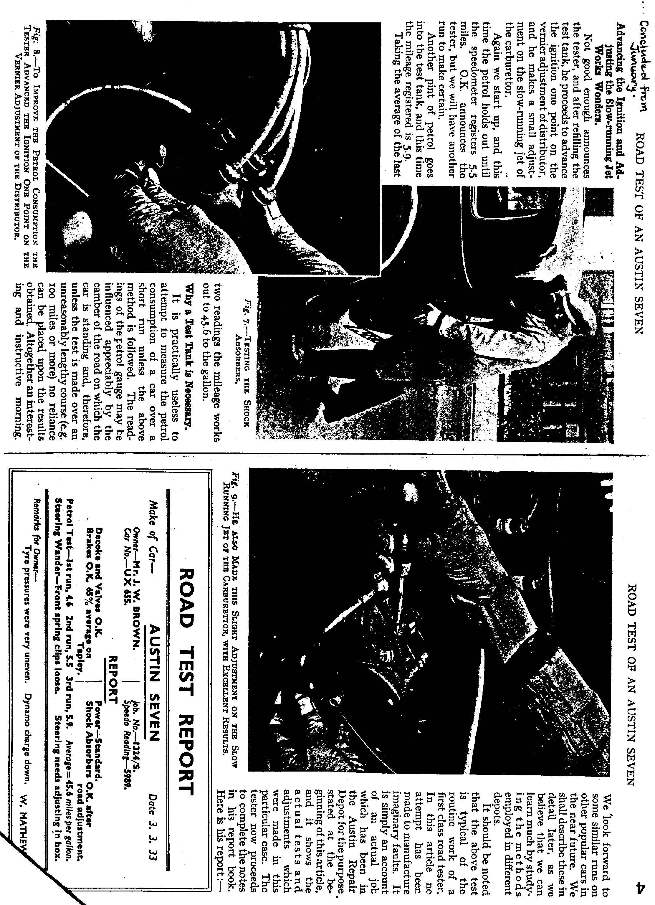
AUSTIN 7 BEGINNINGS - 6 - A story of Austin folk. John and Gay Weaver

Without a doubt one of the most important things which keeps the Dorset Austin 7 Club together is the Newsletter. I'm sure that I speak for all of us when I say that one looks eagerly from the first light of the third Monday of each month for the post to arrive, delivering the buff six by eight envelope bearing the unpredictable, lively, informative and amusing Newsletter. Over the last four years we have seen evidence that our Newsletter is being cared for by a caring person! interesting little snippets! Father Christmas's hat left behind as he rushes out; contrasting with the relaxed Father Time of the Old Year advising, 'Check the oil in your back axle'. The latter a heartfelt message from one who cares ....or knows a little of these things ! Seriously though, putting together a Newsletter of eight sides takes much time! inserting the interesting logos, arranging copy, checking information, chasing contributors around, finding an attractive idea for the front page etc. etc. Look through some of your back copies and you'll not only see what I mean but have other points to add. John is the Editor who puts this all together, makes it tick, oils the wheels and is very ably abetted by Gay who produces amusingly original cartoons. How did all this happen? How did a Headmaster of three Primary Schools over twenty-five years with an all time-consuming though interesting job suddenly appear on the scene, become an enthusiastic A7 owner and Editor of the Newsletter ?
A story of 'Seek and ye shall find', except in John's case although he was seeking an interest to fill the great yawning gap, which the all-consuming job he had just retired from had left, he had in fact been so long without the pleasure and luxury of an outside interest that he didn't really know what would most interest him in the great outside world. He did know that he wanted something of which he knew nothing, something totally different from his life's work, something that he could learn about, something which both he and Gay could enjoy. An innocent abroad was John !
Going to pick Gay up he spotted an Austin Seven for sale in Victoria Park Road, Bournemouth. Idly he thought, 'That's interesting', and having a few minutes to spare walked round it, kicked the tyres, enquired of the bearded owner,'How much would one of these cost then ?' Frowning at the reply, he was further told that such a purchase could not only be an enjoyment but an investment. Round John went again, adding a shaking of the car to the original kicking, looked at his watch, muttered, 'Interesting', and fled to collect Gay, telling her of how he had filled in his few waiting minutes. Gay half raised her eyebrows and agreed to share John's amusement by stopping off to see the said car. However, an Austin Seven about which John and Gay knew nothing, had never contemplated buying especially at a price which appeared to be rather high, had to be regarded as a five minute bit of amusement. Off home they went dismissing the incident to be of no consequence.
Ha! Ha! Austin Sevens don't go away just like that do they ? So it was in
this case. Two days' time found John, 'Just idly dropping in at the garage
to see whether the car was still there, if so could any sort of deal be done ?!` So it was that the famous late 1932 'CHOCBOX', OW 3654, Glyn's brilliant name for a brown Box Saloon which he had restored, came into the proud ownership of John and Gay. During the inevitable 'run around the block' the bearded Victoria Park Garage proprietor and current owner of the car suggested that John and Gay should join the Dorset club saying, 'You're just the sort of people who'd enjoy the Club and get a lot out of it'. They did just that and in next to no time John was invited onto the Committee to find that the Club was in fact looking for an Editor - ideally one who was retired and had the time! What could he say? Fortunately for the Club he accepted. Both will tell you what a wonderful thing the Club has been. It packaged school up and put it totally away into the dim-and distant past, it gave John something completely new to learn about, new friends and good companionship; and Gay her interest in the costume of that era. We've all enjoyed their costumed get-ups have we not? It caused them to buy and enjoy playing a wind-up gramophone and they have made a good friend of the owner who sold them the car. 'He's just about forgiven me for being a schoolmaster', said John. In so many ways has the Austin 'a bit enriched their life. 'It's been marvellous,' says John, 'especially the warm friendships and Club Runs.' Club Runs have been exciting and memorable, including Guernsey '87, Bayeux '88 and others, perhaps more exciting and memorable than they would have wished e.g. a left-on hand brake causing smoke to pour from a back wheel, a starter-switch fire when returning from a Spye Park Rally and, early '89, running into the back of an abruptly braking 'modern' on a roundabout at Sturminster Marshall. (More Club benefits here - Phil's stock of spares and repairs by our own Munwellyns. - Ed.) John, are you sure you wouldn't rather be back at the chalkface, even with all the changes, new curriculum etc. etc.?
The CHOCBOX has since been replaced by another late '32 Box, FK 5382, restored by Terry Jefferies. (Chocbox owner! Look out you never know what powers that dear car has!)
Finally you'll all be asking, 'Who is the mysterious bearded garage proprietor?' To that I say .... WATCH THIS SPACE for eventually ALL WILL BE REVEALED!
B.B. Jan. 19

WHAT A GRAND TURN OUT for the Skittles Evening. Merv was on the ball (and bawl) to good effect, ensuring things ran smoothly throughout the evening. The buffet was excellent and surprisingly provided more good grub than fifty hungry bowlers could wash down.

Some were surprised by their success at skittling and some by their lack of it, which adds to the fun on these occasions. Bernie's 'Chummies' won the team event, but the real success was Keith Whitter's triumph in the knock-out competition. It was great to see one of the younger Club Members carry off the spoils.

Mike provided another worthwhile raffle, so others carried off some goodies too. Thanks Merv and thanks Mike it was another very enjoyable evening.

BERNARD REPORTS that he has sold the Model T Ford and is now trying not to listen to Jackie's hints about a new carpet.

F.B.H.V.C. Last month's item, line 3, should, of course read ... 'at home and abroad'.

CONGRATULATIONS to Fran and Merv who are now the proud grandparents of Gemma Marie who arrived on 24th January.

THERE IS SOME TALK at the moment of a possible Club visit with A7s to Spain in May or early June. If you are interested and would like further details, please contact Bernard.

NEW MEMBER A warm welcome to C Biggin. Look out for him at Club meetings.

` SPECIAL FANCY DRESS EVENT
BOOK NOW
A 'Tramps Evening' has been arranged for Saturday, 2nd March, 1991, in the Club Room at the Whincroft Hotel, Ferndown from 8.00 pm to 11.30 pm. The cost will be £7 per head, to include live music and an excellent buffet. Fancy dress is optional but lets see plenty of tramps on the night! Prizes for the scruffiest man and woman!

Please return the slip below to me before 26th February. It's best to book early.
Mervin.

Please reserve places for the 'Tramps Evening' on 2nd March, at £7 per head. Cheques payable to 'Dorset Austin 7 Club'.

Name:
Address:
..........................................................................
Tel. No.:

Return to!- Mr M.Frampton, 'Sutherland', Broad Oak, Sturminster Newton, Dorset, DT10 211F
EVENTS

FEBRUARY
Thursday 21st February. CLUB NIGHT at the Whincroft Hotel. 8.00 p.m. Quiz Night arranged by Mervyn Frampton.

Sunday 24th February. CLUB RUN in the Forest. Meet at the Cat and Fiddle at 10.15 for 10.30 a.m.

Thursday 28th February. COMMITTEE MEETING at the Tyrrells Ford. 8.30 p.m.
**********.
MARCH
Saturday 2nd March. 'TRAMPS EVENING' in the Club Room. 8.00 p.m. (See within.)

Thursday 7th March. '9 to Late' (for those who want to meet for a natter) at the Lambs Green Inn, Corfe Mullen South.

Thursday 21st March. CLUB NIGHT at the Whincroft Hotel. SHOW YOUR PHOTOGRAPHS EVENING. An opportunity for Club Members to show their photographs of Club events, restorations, cars, car people and places or anything else of interest to other Members. Please bring photographs ready mounted or in albums that can be handled. 8.00 p.m.

Sunday 24th March. CLUB RUN. Details in the March Newsletter.

Thursday 28th March. COMMITTEE MEETING at the Tyrrells Ford. 8.30 p.m.

Rallies etc. arranged:-
Sunday 9th June. Brockenhurst Rally - in aid of local Fire Service. A small, enjoyable country show.
Saturday/Sunday 13/14th. July. Lymington Vintage Show - a bigger event - good camping - Barbecue on Sat. evening with the Plonkers Agricultural Orchestra - great fun - recommended by John and Gay.
Sunday 14th July. Upton Country Park Summer Show - George and Joy say they enjoyed a good day out there last year.
(If you hear of any forthcoming events please let your Editor know.)

