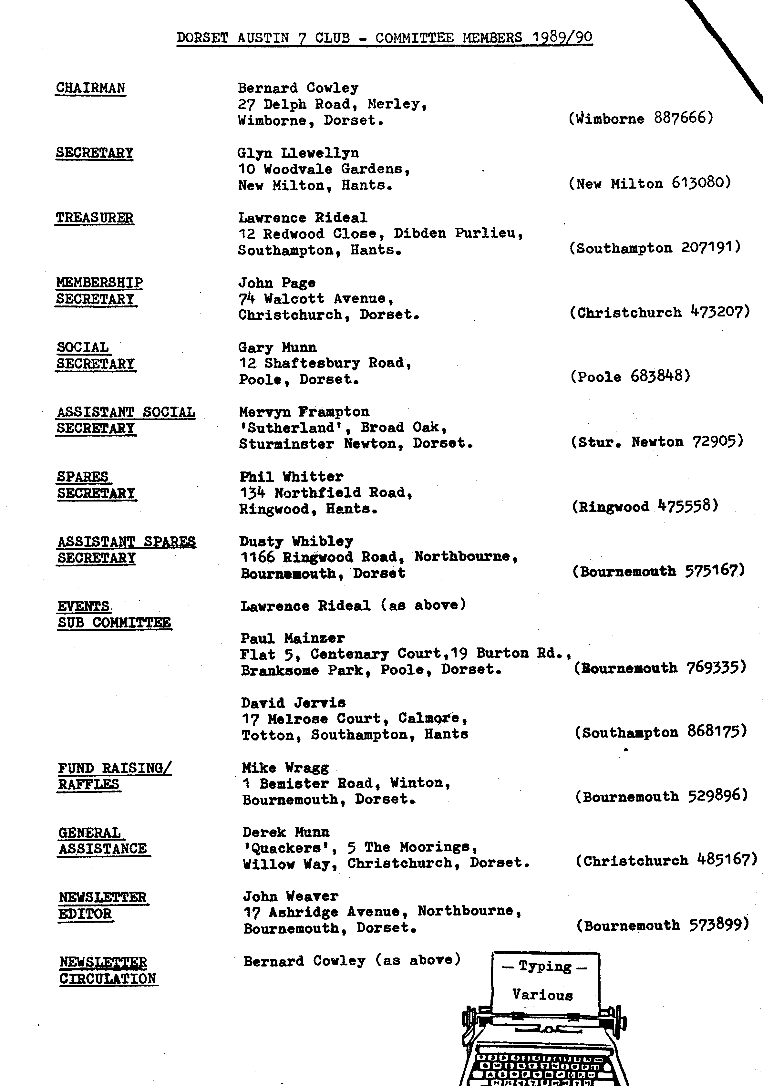
EDITORIAL, FEBRUARY 1990,

I think Club Members will be surprised to read the rather gloomy Editorial in the latest Austin Seven Clubs' Association Magazine - No. 1990 A where it is suggested that some 'smaller' A7 Clubs, with less than 100 members, are struggling, lack interest and are not really viable.
In the DA7C (approx. 70 members + families), a so-called small club, we have a great deal of enthusiasm, excellent attendances, a wide range of spares, are comfortably solvent, participate in many 'home and-away' events and enjoy improving and running our Sevens.
What more could we want ? Isn't it rather the larger motor clubs that are more likely to become impersonal, cover too wide an area to make regular attendance possible, start to take themselves too seriously and fail to maintain interest ?
We may not be perfect, but we do seem to be following a successful and happy path.
See within a report on the January Run to Portsmouth, the results of Merv and Fran's Quiz Night, a special DA7C Crossword Puzzle, something for bright sparks and other contributions.
This month's cover picture is of Bill Quayle's long-owned Nippy with Mr. Nicholson, of the Nicholson Collection, and the famous - Chocbox (see 21 Across!) , in the background. Thanks, Bill, for the photograph. See also Gay, Jill and Brian.
Have you a picture of your Seven that could be photocopied for a cover picture ?
Keep the wheels turning !
John.

SECRETARIAL
Hi Gang,
I hope that you have all avoided damage during the recent storms. One or two wooden garages and sheds near me have collapsed, hopefully there were no 'Sevens' within!
The Quiz organised and run by Merv and Fran last Club Night was a huge success, definitely the best ever. They had obviously put in a great deal of work, for which we thank them very much.
On their way home after the New Year's Day Run two new Members were rather surprised to observe an Austin 7 wheel passing them. It was not until there was a sickening crunch from the rear of the car that they realised that it belonged to them! Never daunted, however, they refitted it, pulled out the twisted wing and back plate and trundled home. It just goes to show you must 'keep your nuts tight'.
We had a good attendance for the late January Run to H.M.S. Alliance with 11 cars. (See report elsewhere in this Newsletter.)
Finally, do not forget to send in your form for the ‘50s and ‘60s Evening', or phone Pat on New Milton 613080.
See you Club Night.
Glyn,

MARCH NEWSLETTER - Contributions welcome, by 23rd February.
Next month - some useful tips on repairing or rebuilding the roof of your car.
MERV AND FRAN'S QUIZ NIGHT
You won't have forgotten that the January Club Meeting was 'Merv and Fran's Quiz Night'. Although your flattened Editor was at home cursing his slipped disc at least he was spared having to display his ignorance and racking his poor old brain!
I cross-examined Gay when she arrived home and heard all about Merv's excellent organisation and presentation. Not only that, she was able to bring home the questions for me to see - complete with answers I'm glad to say. Since then Merv has kindly sent ms a table of results which you can see below.
The winning groups of four were the Dreadnoughts, namely Bernard, Jackie, Daniel and David, tying with the Freebooters, George, Joy and two new members whose names I don't yet know (sorry folks). The wooden spoon went to the Knockabouts, who shall be nameless!
Instant results were possible on the evening due to the running marking and recording of Fran and her friend Audrey.
I was sorry to miss the fun and it's clear that warm thanks are due to Merv, Fran, Audrey - and Whitbread and Ringwood Breweries.
After the event Merv sorted out a few subversive answers from the papers which are also included here for your delight. (See over)
Thanks Fran!
Quiz Night Howlers

Where is the Marianas Trench ? - Portsmouth,
What is the former name of the River Zaire ? - Stour.
Where did the game of squash originate ? - In the bottle.
Vilnius is the capital of which Soviet Socialist Republic ? Isle of Wight. How do male moths locate female moths in-the dark ? - Shiny nuts.
Why are terriers so called ? - They tear about.
- They terrify people and bite your bum.
Which king died in the Battle of Bosworth ? - King Kong.
If you lapidated someone what would you have done to them -Remove tonsils.
- Cut -their ears off.
What do the French call 'La Manche' ? - Lunch.
Which Shakespearian character's wife was Leah ? - Billy the Kid.
Talk about nil with no passes!

Since reporting on Quiz Night I have just received a further offering on the subject from daughter Jane, who left her nippers with Kevin and accompanied Gay to the proceedings.

Dad -
When wearing your nose-shaper (See page 8, Jan* Newsletter)
Which you purchased through this paper,
You serviced 'Frilly Knicks' (FK 5382)
And got into a fix.
2 3

The story told to me, Reshape your nose? More drastic
Was that since you couldn't see, You've lost your back's elastic,
You bent at a strange angle - Slipped a floppy disc
Your socket-set to dangle. And at Club night you were missed!

4 5.
My own A7 is funny; Your Club has style and fun and nerve
More like a Nissan Sunny, The Quiz was really clever Merv.
The Owners' Club's in Tokyo - I'd love to see you all again -
On Thursday nights too far to go. But may I-keep my nose the same?

Jane Dey.
------------------
A HELPING HAND
The savage gales on the 25th January affected many of our homes and gardens to some degree, but worst hit must have been Chris and Linda Smith's house at Poulner. Old Farm House, Cowpitts Lane, part of which was built in 1650, is a listed building onto the end of which crashed a heavy 100 ft. pine tree. The fire brigade cut off the main branches and tried to make the house waterproof. As well as no electricity supply there was water in the bedroom and dining room and no doubt Chris and Linda felt pretty shaken. Many old peg tiles on the roof have been destroyed together with other damage.
We're proud to report that on Sunday a sizeable working party of Club Members turned out to help with the clearing up, complete with light equipment and petrol driven chainsaw. Phil and Hilary live fairly near and Hilary kindly fed everyone. A great gesture, those involved, and typical of the camaraderie existing among the 'Dorsets'.
We hope that Chris and Linda were were encouraged and we fervently hope that they will soon be out of their mess. We send our warm wishes and are thankful that no one was injured.

THE RUN TO H.M.S. ALLIANCE, GOSPORT SUNDAY 21ST. JANUARY 1990

We awoke to a rather damp Sunday morning and made our way to the
Cat and Fiddle at Hinton where we were to meet other 'Dorsets' for the day's Run. We were amazed to find that there were 10 cars in the car park, as it was not a very nice day. Pat and I were to lead the way to Romsey where we were to meet our leader for the day, David Jervis. We were soon bowling along through Lyndhurst then via Cadnam to Romsey, where we all arrived safely to find David waiting. Unfortunately Mary had 'flu so he was on his own and had to drive and navigate himself. He had obviously done his homework, however, as we drove along narrow lanes through the villages of Ampfield, Bishopstoke Fair Oak and Shedfield not using an `A' road until we 'came out' at Fareham. On then to Lee on Solent and the Swordfish for lunch, where we realised that we had 'lost' two Chummies. No panic though, they shortly arrived explaining that they had both run out of petrol!
After a good lunch we set off for the short Ran to H.M.S. Dolphin
and the Submarine Museum housing H.M.S. Alliance, a 1940s diesel submarine. David had negotiated a party rate for us and we all boarded the boat (NOT SHIP the guide explained) where we were given a very interesting and informative talk by our Guide who had served for 22 years in submarines.
After the tour we all trooped off to have a look at another much earlier 'boat', The Holland, which was Britain's first submarine. It had been salvaged from the seabed and restored several years ago. She certainly seemed very primitive compared with Alliance. By now we were in need of refreshment, so off to the coffee shop.
The weather by now had deteriorated further, it was blowing hard
and pouring with rain. Pat and I did not travel home with the rest as
we were visiting our son in Gosport. I decided to return via the motorway, where it was just my luck to have a puncture!
A really super day out. Many thanks, David.
Glyn.

WHAT A GAS

Older Club Members will remember the efforts made during the Second World War to find an alternative fuel to petrol for motor cars. The occasional car could be seen with a large, increasingly floppy bag of
gas on its roof. I've recently discovered that a car converted to run on coal gas could in fact carry its own miniature gas works. The item below is from the Daily Express of Thursday 9th November 1939 tells the full story.
I wonder how many of these units were made and how successful they were in the long run. Can anyone remember hearing of an A7 converted to gas?

A DA7C CROSSWORD PUZZLE
As the recent Wordsearch puzzle seemed to go down quite well, how about trying this crossword puzzle ? It is compiled with Dorset Seveners in mind.
Why not begin with four well-known Club names at 1., 10, and 14 Across - and 20 Down.
Have a go! It's not too difficult. Solution next month.
ACROSS DOWN

1. DA7C 'spare man'. (7) 1. A wriggly kind of gear. (4)
5. See this growing on Forest runs. (5) 2. Do these tyres originate here?(5)
8. '**•'* Whitworth' for bikes. (5) 3. A garden lattice. (7)
9. Crossed the equator?(7) 4. Worn by a sailor or smoked by
10. Buy your Club sweatshirt from a fool. (6)
this lady. (3:9) 5. A measuring instrument. (5)
12. Loutish.(6) 6. A snake - but could describe
14. He has Joy with Henrietta. (6) most A7s. (7)
17. Protects main part of A7 cooling 7. Put at risk. (8)
system. (8:4) 11. Puts right. E
21. Glyn's first A7 restoration. (7) 13. Involuntary stop or dying away.(4:3)
22. Extra plus. (5) 15. These fumes can be dangerous. (7)
23. Indian instrument much heard in 16. Gradually persuades. (6)
the 60s. (5) 18. Not red or green. (5)
24. Meet the demand. (7) 19. Swear words. (5)
20. Half of Munwellyns, (4)

SOME POST-WAR LANDMARKS
Do you remember that petrol rationing was imposed in December 1956, but abolished in May 1957?
- With the 50s in mind it may be of interest to be reminded of the following:-

Sept. '50 - Soap rationing ended. Feb. '52 - Identity cards abolished
Oct. '52 - Tea rationing ended. Feb. '53 -Sweet rationing ended.
July '54 - All food rationing ended.

After 1960 there were no further call-ups for National Service.

FOR SALE A 1926 Austin 7 Saloon (the first year Saloons were produced)
Sold as complete. Engine and gearbox need to be sorted and fitted. For full information 'phone John Downs (Eng.) 0621 772096.

WIDER EVENTS
Club Members Gordon and Biddy Brown have written commending the 6th Brockenhurst Park Vintage Vehicle and Country Fayre which will take place this year on Sunday 10th June.
This Rally is one that they regularly support and enjoy, and which last year raised a record amount of money for the Fire Services Benevolent Fund.
It seems to be a rally worth supporting.
Your Editor has three entry forms for Club use. Details and entry forms are also available from Mr.J.E.Carpenter,-'Riverbank', Martins Road, Brockenhurst, Hants, SO42 7TP.
EVENTS

FEBRUARY Thursday 15th February. CLUB NIGHT at The Dudsbury. 8.00 p.m.'Feely Bag' Evening.

Sunday 18th February. CLUB RUN as for December i.e. to Downton, nr. Fordingbridge. Meet at the Furlong Car Park, Ringwood at 10.45 for 11.00 a.m.

Thursday 22nd February. COMMITTEE MEETING, at the Tyrrell's Ford 8.30 p.m.

SATURDAY 24TH FEBRUARY. THE '50s AND ‘60s EVENING AT THE DUDSBURY _- FROM 8 TO 11.30 P.M.

Thursday 1st March. '9 to Late' (for those who want to meet for a natter). The Manor House, near Parley Cross, on the Hurn road.

Thursday 15th March. CLUB NIGHT at The Dudsbury. 8.00 p.m. Noggin and Natter. Spares available.

Sunday 18th March. CLUB RUN. Details in the March Newsletter.

Thursday 22nd March COMMITTEE MEETING at the Tyrrell's Ford. 8.30 p.m.

