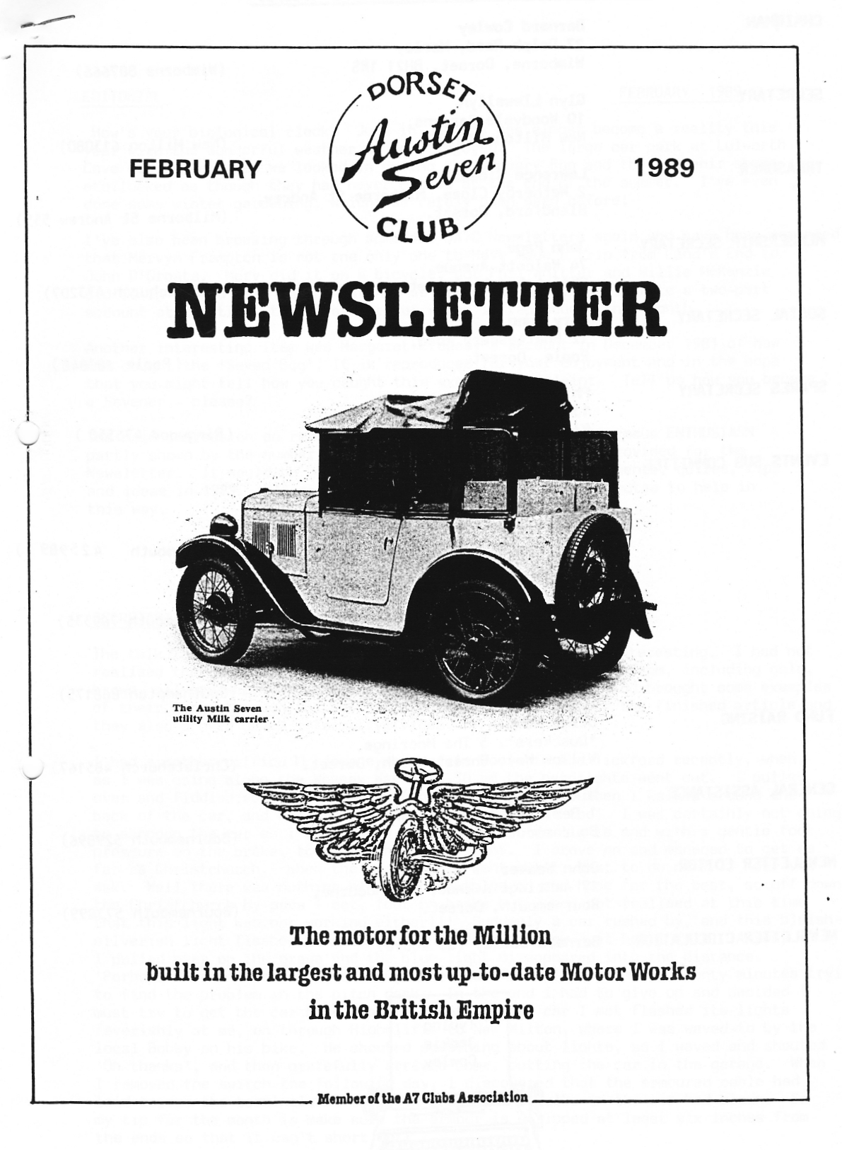
EDITORIAL FEBRUARY 1989

How's your biological clock? June in January has almost become a reality this year with the wonderful weather we have enjoyed. The large car park at Lulworth Cove was packed when we looked in during the January Run and the souvenir shops etc. looked as though they had never closed at the end of the summer. I've even done some winter gardening, which has rarely been seen before.

I've also been browsing through some old DA7C Newsletters again and have been remind that Mervyn Frampton is not the only one to have made a trip from Land's End to John O'Groats. Merv did it on a bicycle, but Phil Whitter and Willie McKenzie did it in record time in an Austin 7 at Easter in 1982. Phil wrote a two-part account at the time, the first part of which is reproduced this month.

Another interesting item was Margaret Cressey's account in December 1981 of how
she caught the 'Seven Bug'. It is reproduced for your enjoyment and in the hope that you might tell how you caught this exciting complaint. Tell us how you became a Sevener - please?

The main impression on reading the old Newsletters is of enormous ENTHUSIASM partly shown by the number of small items that Members had provided for the Newsletter. It would be good to have some new snippets, comments, quizzes, tips and ideas in 1989. Please think if you could spare a few minutes to help in this way. John

SECRETARIAL
The talk last Club Night by Alderney Plating was extremely interesting. I had not realised that there were so many different coatings to choose from, including gold, brown, silver, white and black. The fellows from Alderney had brought some examples of their work, through the various stages of preparation to the finished article an( they also showed us an informative video.

I had a rather difficuIt journey home from Poole in the Tickford recently, when,
as I was going along the Wessex Way at 6.30 pm the headlights went out. I pulled over and fiddled about in the dark (no torch of course) then I walked around the back of the car, and horrors the rear lights were out too! I was certainly not going to abandon the car so I decided to plod on with side lights and with a gentle foot pressure on the brake, to light the brake light. I drove on and managed to get as far as Christchurch, when the side lights went out!! What to do now? I hear you ask. Well there was nothing else to do but plod on and hope for the best, so off down the Christchurch by-pass I set, foot on brake but I had not realised at this time that this light was not working either!!! Suddenly a car rushed by, and this bluish silverish light flashed from its roof. I bet you know just how I felt. Anyway I pulled over on the grass and the blue light disappeared into the distance. 'Perhaps he didn't see me', I thought to myself, so I spent about twenty minutes try to find the problem in the pitch dark. In the end I had to give up and decided I must try to get the car home, so off I set. Every car I met flashed its lights feverishly at me, on through Highcliffe to New Milton, where I was waved to by the local Bobby on his bike. He shouted something about lights, so I waved and shouted 'Oh thanks', and then gratefully arrived home, putting the car in the garage. When I removed the switch the following day, I discovered that the armoured cable had laid across the terminals at the back and all the bulbs in the car had blown. So my tip for the month is make sure the armour is stripped at least six-inches from the ends so that it can't short out!
EDITORIAL continued ....
I have had a letter from the 750 Motor Club about two events they are running. The first is at Easter '89 and is organised by the North Herts Centre and is the Lowestoft to Land's End Run which will start any time between 8 am and 6 pm 25th March, finishing anytime between 6 pm 25th March and noon 27th March. Choose your own route and pace, plaques for each starter, and a certificate for every finisher within the time allowed - and there is an optional Austin 7 holiday in Cornwall after the Event. Entry fee £5 per car. Details from Ken Cooke, 26 Whomerley Road Stevenage, Herts SG1 1SR. Telephone 0438 354001.

The second Event is called the EEC Run (five European Capitals - Amsterdam, Brussels, Bonn, Luxembourg and Paris in five days - one for each decade of the 750 Club's history) including two nights in Amsterdam, two nights in Paris and optional extra night and Social in Boulogne. Contact Ken Cooke, address as above, Sounds great!

We are very sorry to hear of the illness of Robin Newman, Secretary of the Austin Seven Clubs' Association and one of the leading Members of the South Wales A7 Club. The DA7C wishes him well.

Well that's it from me this month. See you Club Night. Don't forget to bring your PHOTO. Glyn

GRATEFUL THANKS TO Club Member Eddy Harris for the gift of a number of plastic stick-on DA7C badges received last month.
WELCOME TO our newest Member Ian Reeks who introduced himself last Club Night.

THE PURBECK RANGES RUN - 22nd January
Having been woken bright and early, not by a possible punter for my Riley Elf,
but by Glyn, I decided to dig the Chummy out from the back of the garage and unfurl the hood. Armed with sheepskin coat, and hat, I set off on the long
trek to the Viewpoint, Poole for the start. There we were met by eight Austin 7s and a bubble car and their owners. George had chosen a very picturesque route across the ferry on to Corfe Castle and across the Purbecks, which were enhanced by an almost summer's day and no grockles! Our friends in the bubble car hit a patch of mud down one of the seldom used lanes, but thankfully after negotiating both roadside banks and performing a graceful pirouette, managed to keep the beast on the straight and narrow - you really will have to fit that fourth wheel!

Lunch was served at the Sailor's Return, which has recently changed hands, at Chaldon Herring. The food, beer and welcome were tremendous, so as usual the Dorsets were reluctant to leave! On we meandered to Lulworth Cove for a wander on the beach in the sun, to work off the lunch and prepare for tea at John and Gay's. (A really good day for the diet!) Gay had, as usual, prepared an excellent spread. So with a hearty lunch, tea and a big dinner at Mum and Dads the diet has now started; perhaps cut out the solids. Many thanks George, Joy John and Gay.
Gary

PS Don't forget the Barn Dance 4th March - Book Now!!

FOR SALE

Riley Elf. 1964. Excellent condition with recently reconditioned engine/gearbox, wings and respray. Taxed and new MOT Well worth a look! £995 ono

Gary - Poole 683848 evenings
WANTED

1. Four 19" chrome centre wheels. 2. Ignition Switch for '33 Box.

Stewart Latham - Childe Okeford (0285) 860776
From one Extreme to the Other by Phil Whitter

It was a cold, wet day as Willie and I .set off from Poole at
l0 am on the Wednesday before Easter, laden with two cwt of spares, water and oil but minus the shovel I had brought - "we wont need that" said Willie, We drove steadily on through wind and rain to the M5 and then apart from petrol stops just kept going until-we reached the A74 north of Carlisle when we stopped for a meal at Cramford. When we came out of the Little Chef the pumps were shut, so full of confidence at seeing lots of other petrol stations we pressed on but where were they? North of Glasgow we saw a services, sign and left the motorway to find ourselves in a black "nothing" so we reversed out and back onto the motorway (remember we could not
see far as I had reduced the lights to a 24 watt n/s lamp and a 6 watt o/s.)
By, now we were getting worried and wished that we had filled up the five gallon jerry can we were carrying .-Eventually running on nothing but 'hope' we found Hamilton services and were able to relax again: We pressed on and reached Perth by midnight where we booked into the five star public car park adjacent to a fun fair but far enough away not to be mistaken for a ride.. Sleeping in the front seat of a Ruby in freezing conditions is not easy nor is it easy
to get into a sleeping bag outside the car and then get back in again: By six o'clock on Thursday morning I decided to get up (I mean get out:) and check the car over. Willie was asleep on the tools I wanted so I decided to jack the car up with him in it and top up the back axle with oil (which was disappearing along the torque tube) Willie was 'up in the air' when he woke up but soon came down when I released the Jack.
When the engine was started we noticed a whine from the timing gears and then found that when the clutch was pushed in it stopped. The car had been running smoother than ever before on its way up and the rebuilt engine had been run in for 1000 miles in the fortnight before the event so I was a bit annoyed that it had suddenly developed a noise. When I shone a torch down the oil filler alas the crankshaft had nearly a quarter inch of end float - obviously something was amiss with the front bearing location: We decided that as the engine was running so well we would press on to John O'Groats and hive a look at it when we arrived.
As we continued Willie had to put up with me constantly talking about the possibilities of what had caused our problem and the options open to us for the trip back. However, as we pushed on up the A9 it was the bad weather which became the main talking point - wind, rain and snow. Who said leave the shovel behind: Eventually we reached Inverness and stopped for dinner and a wash and shave in the Little Chef toilet..
Soon after we set off on the last part of the journey to John 0'Groats (140 miles) we had a good laugh at an original Teddy Boy (before my time) complete with crepe shoes but he did not appreciate Will's blast on the horn.
It was a long drag up to John 0'Groats with the weather alternating between snow and sunshine and we 'were glad to arrive at the farm at 4pm (the trip up had taken 30 hours including our night stop. We were made very welcome and it was not long before the Austin was in the barn and we were taking the sump off. The oil was silver with metal dust and there was a hole in the filter gauze. When this was removed all was revealed - that infamous rear bearing lip had broken up and some larger bits had been knocked through the gauze. The crank was free to drift with the bearings in and out of the front housing. After -some discussion it was decided to keep the engine in 'use but to change the oil twice and keep the clutch pushed on the 'overrun' to stop the crank from drifting back.
After a pleasant meal we decided to sample the liquid refreshment of the John O'Groats Hotel. We were given a good welcome by the proprietor until he discovered we were staying down the road: Apparently we were the first Austin to arrive at John O'Groats and so we could not join any other Austineers for a drink. The only bar open was the public 'shack' across the car park and although Willie has been in some rough bars this took some beating - the barman looked as if he had been hit by a table the night before. After a quick drink we decided to call it a day and returned to get some very welcome sleep. (to be continued)

John O'Groats - Lands End Charity Sponsorship
Willie and I would like to thank all those who so generously supported our sponsorship for PHAB. It is hoped to present the Poole based PHAB club with something approaching h300 towards their new bus at the end of this month. Final details in next months newsletter.
Thanks again,
Phil Whitter, Willie McKenzie.

Valve Cotters - Seven.
Q I am about to decarbonise and grind-in the valves of my Austin
Seven, but before doing so seek your advice concerning the valve cotters. I have had considerable trouble in fitting these on previous models, and eventually
purchased a pair of cotter pliers for the purpose. I see now, from the handbook,
that the valves have cotter pins in place of the split-cone cotters formerly used, and, consequently, as the cotter pliers are now unsuitable, I am wondering
whether any special tool is necessary for removing or replacing the cotter pin in each valve stem. The illustration shows the pin held by a pair of ordinary pliers. Are these suitable?
When the slots in the valve heads are in line the hole in each valve stem is conveniently situated for inserting the cotter
A You will find reassembling the valves after grinding them in very much easier with the pin-type cotter as now fitted on the Seven, than with the split-cone cotter formerly employed. The only requirement to remember when refitting each cotter pin is to have its hole in the valve stem facing outwards, so that the pin, held in a pair of ordinary pliers as illustrated, can be inserted into the valve stem. By seeing that the slots in the valve heads are in line it will be ensured that the cotter holes are in a suitable position for refitting the cotter pin in this way.
The Seven Bug
When I first met Richard, it was several weeks before he mentioned that he owned an Austin Seven, which at the time meant little to me. About a month later he took me to see the R.N. Saloon which was stored in a friend's barn for the winter (it's used all year round nowadays). I can remember feeling slightly disappointed when he opened the door of the large and lofty barn to reveal a little blue and black box tucked away in one corner. I didn't know a thing about cars, ancient or modern, and wondered why Richard was so enthusiastic about the fact that the Austin started first time - with stale petrol!
However during that summer some of Richard's enthusiasm rubbed off onto me and I enjoyed going to various rallies, although I couldn't tell one Seven from another, except that some were open_. and others closed.
by the following summer I was sufficiently fond and confident
of the car to agree to go on honeymoon to York in it and after unravelling the several rolls of loo paper in which the car had been wrapped, we headed north, smelling strongly of kippers: The car did not go very well on the journey - the engine was missing by the time we got to Frome, about 12 miles away. It was such a hot day that the petrol was evaporating in the. carburettor We eventually reached York and for the rest of our stay, when travelling, simply took the bonnet off to cool the engine.
By the end of our honeymoon, my enthusiasm was building up. I started to read Richard's A7 books end newsletters and didn't automatically switch off when Richard started talking A7.
A couple of years later Richard decided to have the Box resprayed. He was to prepare the car for spraying himself and as he removed the wings, et cetera, they had to be stored somewhere. The obvious place was the dining room. I was rather dismayed since it had taken the three years that we had been married to clear it of two bicycles, one B.S.A, motorbike and several piles of junk. To teach the sideboard was rather like attempting an assault course. I was always tripping over something but gritted my teeth - it was all in a good cause after all.
Gradually I found that when someone asked me about the Box, I was able to tell them quite a lot. I was rather surprised when
I walked round the Berkeley Rally giving a friend a short run-down on the different models. Where did I acquire all this information? I suppose when you live with someone who lives and breathes a7 90% of the time, you're bound to absorb something.
I realised I was becoming equally fanatical when I insisted that our new-born daughter should travel home from hospital in the Box, despite the fact that it had been snowing the day before and it was an extremely cold and foggy afternoon.
We have recently acquired a very original Pearl Cabriolet and are worming towards having it on the road next year. I decided I would like to be actively involved in the restoration this time
(I'm not sure if Richard is pleased by this decision!) and I'm doing the fun jobs, like cleaning and treating the upholstery, polishing the chrome and shortly, rubbing down the chassis.
What prompted me to write this? Well, this morning, whilst picking my way across the dining room floor, I tripped over the Pearl's back seat. I was about to curse Richard when I remembered - this time I'm the culprit.

Margaret Cressey

EVENTS
FEBRUARY Thursday 16th Feb. CLUB NIGHT at the Elm Tree. Please bring a photograph of yourself aged between 2 and 15 for a competition.
Sunday 19th Feb. CLUB RUN - The Piddle With Paul Run. Meet at Wimborne Square - 10.15 for 10.30 am.
Thursday 23rd Feb. COMMITTEE MEETING at the Tyrrell’s Ford - 8.30pm
MARCH Thursday 2nd March '8 to Late' (for those who want to meet for a natter) at The Broadway, Castle Lane, Bournemouth
Saturday 4th March ANNUAL BARN DANCE Quarterjack Suite, Allendale Centre, Wimborne. 8.00 pm Bookings are necessary before 25th February
Thursday 16th March CLUB NIGHT at the Elm Tree. This is a Quiz Night. 8.00 pm
Sunday 19th March CLUB RUN to The Sparkford Museum Nr Yeovil. Meet at Wimborne Square at 10.15 for 10.30 or Sturminster Newton Mill at 11.15 am.
Thursday 23rd - Tuesday 28th March CLUB EASTER RUN to JERSEY
Thursday 30th March COMMITTEE MEETING at the Tyrrell’s Ford 8.30 pm.

EXTRA EVENT
FRIDAY 10TH MARCH - 8.00 pm
We have been challenged to a skittles match by the A30/35 Owners Club at The Clay Pipe, Sandford. Please all turn up to support the honour of the DA7C!
Food available at the bar.

WIDER EVENTS
1. See Glyn's Secretarial.
2. Lymington Vintage Show 8th and 9th July. Details from Mr&Mrs D Knight 96 Gosport Street, Lymington.

MARCH NEWSLETTER - Your contributions welcome by 25th February.

