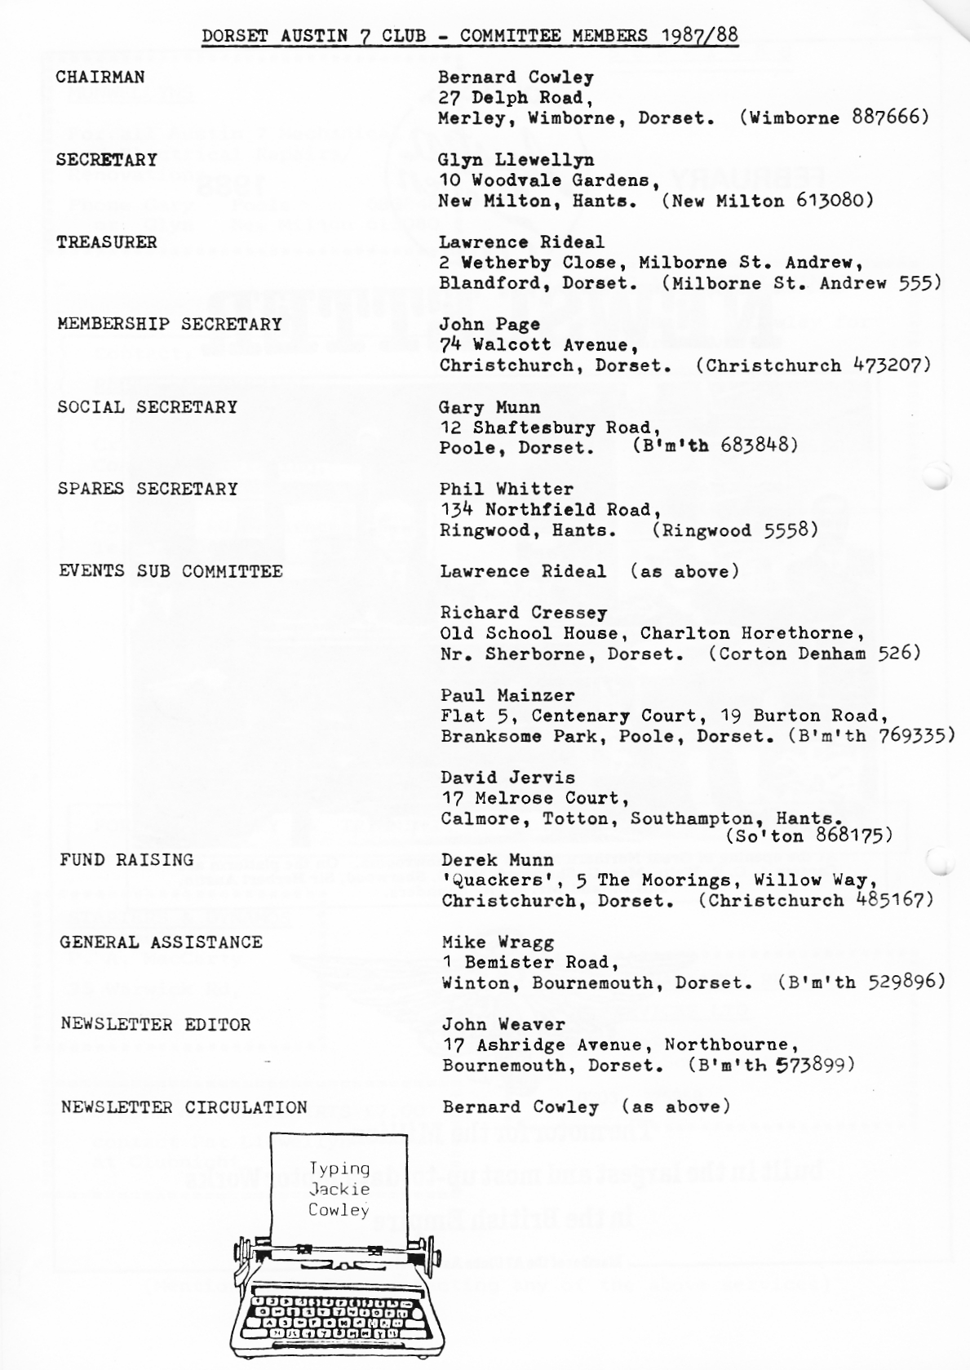
EDITORIAL

The mild winter seems to be enabling members to keep the wheels moving forwards instead of sliding sideways as they did on the ice and snow this time last year. Let's hope it lasts. It was cheering to see a bank of Snowdrops near Cranborne on the January Club Run and even the first cuckoo doesn't seem so far away now that the days are lengthening.
However, it's still cold enough to keep the car windows shut as much as possible - that is if you are travelling in the comfort of a Box or Ruby. Glass is, of course, a vital component in the car's structure. Those unfortunate enough to have been in a bad smash will not need reminding that the nature of the glass is all-important.
Included this month is an article that appeared in the mid-thirties describing the manufacture of the glass fitted by Austin, which I hope may be of interest. I wonder if all today's vehicle restorers pay as much attention to the glass in their cars as to the glasses in their hands - field glasses of course. No not filled; field.
I must stop reflecting. Good wishes to all!
John.

SECRETARIAL
Hi Gang. Unfortunately Pat and I missed last month's Club Meeting at The Elm Tree. I understand our Phil had a warm time changing a tyre!
The run and cream tea which followed, last month, was very well attended and we all had a great day, thanks to Gary for the run and to Gay and John Weaver for their terrific hospitality *
I had quite an interesting experience recently when Kim Henson approached me to do an article on my Ruby, something to which I readily agreed. Kim came over one evening and we chatted for about three hours about the car and our experiences with her over the years. A few days later a photographer from London came down, and we took the car off to have a few photos taken. Three hours and nine rolls of film later Andy, the photographer, stated that he thought he might have enough pictures!! I am looking forward to seeing the article and pictures in Classic Mechanics next issue.
I understand that the restoration of Bernie's Ulster is progressing well. I believe he now has two of them.
Gary is rushing on with his Chummy, the body is now away being welded by Keith Roan and should be back by the time you read this. Gary tells me the car will be ready for the Summer.
Another Member's Chummy is also taking shape, that of Paul and Emma Mainzer, though Paul explained that he is in no hurry, as he still has some parts to get, and is not so dedicated to his overalls as Gary!
I have almost finished the Opal, just a few fiddly little jobs to do before
it goes in for its new hood and side screens ready for the French holiday at Easter. That's all from me this month, see you Clubnight. -
Glyn.
NEW MEMBERS
A warm welcome to the following:- L. Rumbol, Colehill; R. Savage, Milford on Sea; D. Kydd, Chilfrome, Dorchester; and R. Saunders, Whitford, Axminster.
We hope that all new members will make themselves known at Club Meetings.

THE DORSET CREAM TEA RUN - Sunday 24th January

After a chance remark to our Editor on the last Club Run about the lack of female involvement in the Newsletter, guess who got lumbered with the article this month?
Glyn and I were the first to arrive in the Ruby at Wimborne Square, soon followed by five Boxes, another Ruby; one Chummy, one Big Seven, one Morgan and an unmentionable 'modern' held together with sticky tape.
After terrible weather on the Saturday, Sunday was a beautiful day and as we started off on the run it was more like Spring than the middle of January.
We went through some beautiful little villages. It amazes me that we have been going on club runs for over ten years and we still visit places we have not been to before. Gary was going great guns with Suzy (his dog) navigating until we took a wrong turn which led up to the Manor House. As the road was very narrow nobody could turn round, and as we were discussing the problem the owner of the house came out and suggested that we went up his drive past his house and out of the other gate. This we did waving to his family as we passed the door. He even moved his car to make more room. I wonder if that would have happened if we were in 'moderns'?
We carried on to the Fleur de Lys pub without much trouble where we said goodbye to Kim Henson who had to take his small daughter home. An hour of so later, suitably refreshed, we all headed to John and Gay Weavers' house for part two of the day.
Once inside Headmaster Weaver, complete with suitable hat, organised us into four teams which were given apt names:- Cylinder Heads - Shock Absorbers - Wheel Nuts and King Pins. After several rounds of Trivial and Car questions the Shock Absorbers won by a narrow margin.
After all that mental exercise we were ready to tuck into Gay's delicious cream tea.
At about 5.30 pm we said goodbye to everyone and made our way home. I really enjoyed the day, the interesting run, good pub grub, a super quiz and a really delicious cream tea. Thank you Gary for the run and to John and Gay for an enjoyable afternoon and super tea.
. Pat Llewellyn.
Jo has written an enthusiastic account of the Dorset Cream Tea Run too, saying how very much she enjoyed all the events of the day. It also added to her delight that the Run took in Witchampton, where we passed not only her Auntie's house, but 'White Farm' where her Mum worked years ago, and the lanes of Long Crichel and Gussage St.Michael - an area she has known since childhood. Phil's speedy reversal up a muddy track when we became lost, left her spellbound and she was also impressed by his skateboarding demonstration in the pub car park!
I think Pat's 'official' account covers the rest of what she said. Thanks, Jo, for your appreciation.
INFORMATION REQUIRED
Club Member Jeff Bridge is wondering what oils experienced Seveners put in their cars and has suggested a survey among members. It seems a good idea when there are so many alternatives.
On Mike's recommendation I use a straight Servol SAE 40 for my engine and gearbox, with SAE 140 in the rear axle. Please be prepared to give your preference at the next Club Meeting.

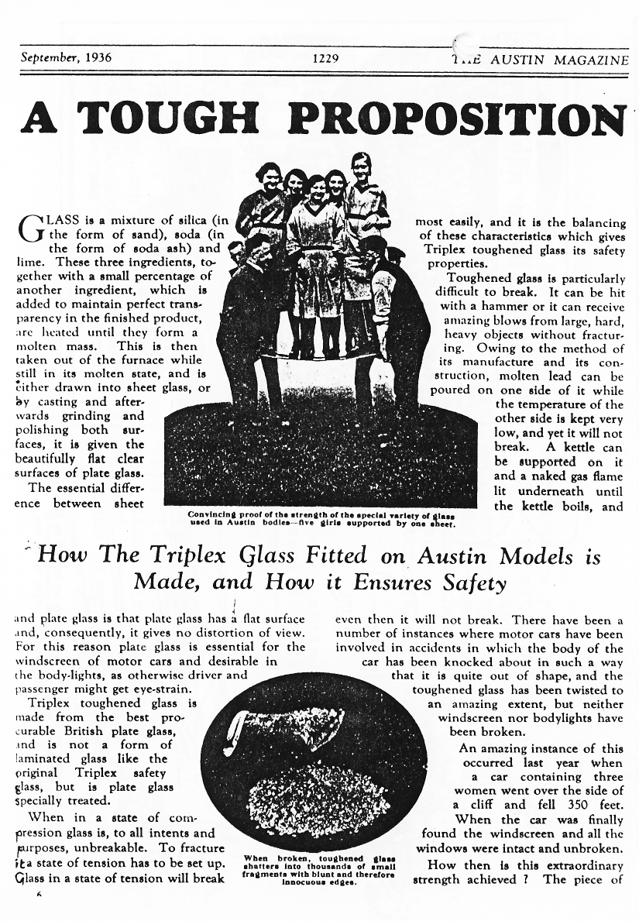
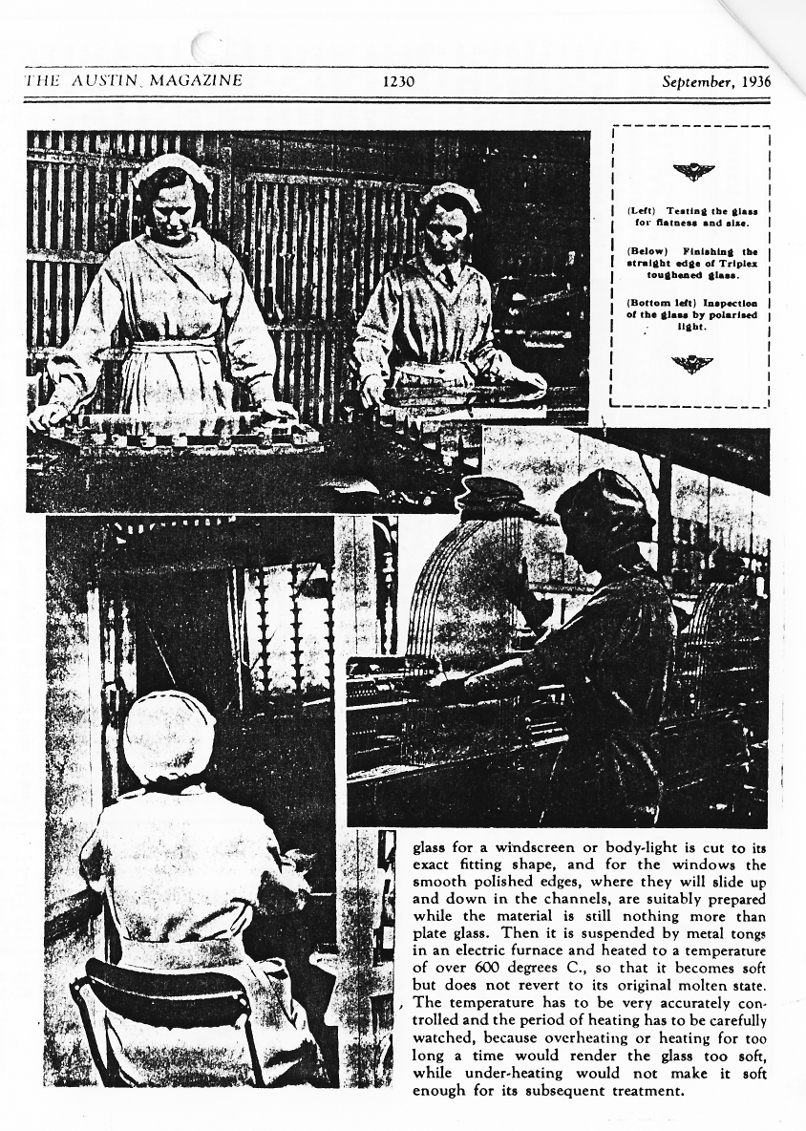

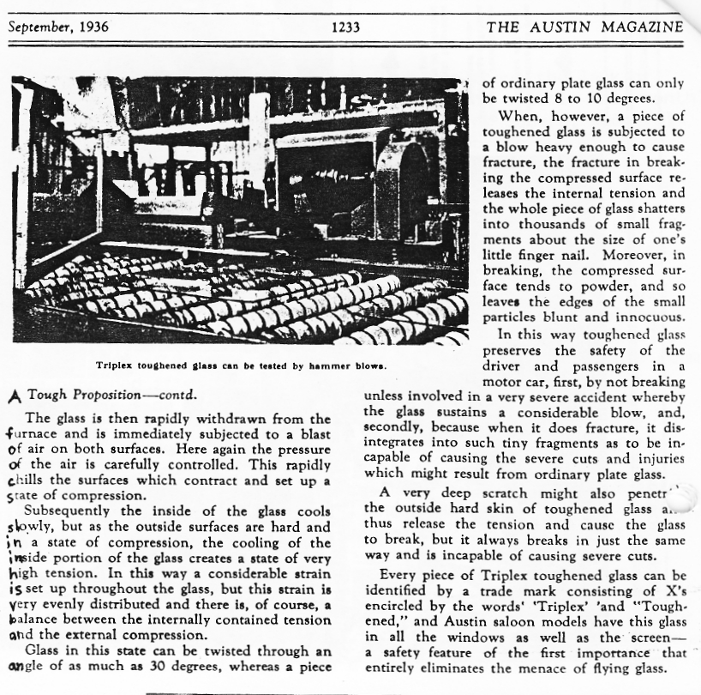

BODGERS CORNER AND TECHNICAL TIPS DEPARTMENT

As he is still awaiting the return of the Opal's block from the engineers, David Whetton's saga will not be continuing this month as expected, but no doubt we shall be hearing from him again when time and circumstance allow.
Wondering what to include as 'the technical bit' I dipped into past DA7C Newsletters. Bernard has kindly lent me his file which contains all the Newsletters from the beginning of the Club in February '76 up to December '82. It makes fascinating reading and I shall have more to report from these as time goes on. For the moment my eye has been caught by Phil's technical tips in the Newsletter of August 1982 - here reproduced mainly for more recent members.
Phil also gave us a very useful tyre changing demonstration at last month's meeting; but don't let's leave it all to Phil. There must be other Members with tips to pass on through the Newsletter. Could you spare half an hour to do some jottings and let me have them? I don't mind 'writing them up' if necessary. Think about it - even if only one Member benefits it will be worthwhile.

TECHNICAL TIPS

Ruby Petrol Filler Rubber
Is your petrol pipe into the tank blocked by a tatty, leaking original filler rubber? These unobtainable items cause lots of problems and can be extremely difficult to replace.The filler rubber from an early Datsun 1200 or 1300 saloon will fit perfectly - just cut off the angled piece to the right length and you have a replacement which I found I was able to fit in half an hour -providing you can fiddle it in place from underneath and through the boot lid.

Gudgeon Pin Clamp Bolts
probably the worst disaster that can happen on your engine is to have a gudgeon pin clamp bolt work loose and come out. On its way out it will probably bend the con rod, score the bore and break the piston, It will drop on the gauze filter, be picked up by the crankshaft and lash a star like crack in the side of the crankcase. The answer to this is not to use locking tabs but to ensure that you have new high tensile bolts fitted with spring washers and do them up really tight using 'Loctite' etc.. on perfectly clean threads. (P.S, we have them in the club spares!).

Engine Cutting Out At High Revs.
I noticed that for some weeks my car had been cutting out and losing power at high revs-. Closer inspection revealed small amounts of brass dust in the distributor caused by the rotor arm being loose on its peg. Changed the rotor arm and no more problems.

Fire Risk
I have twice had starter switches (ruby type) catch fire because dirt trapped inside them combined with oil (starter is just below the filler cap) has caused an internal short circuit. Check yours by flicking the switch lever backwards and forwards and sideways to see if it sparks. To rectify any problems dismantle and clean. Phil Whitter
FOR SALE
Paul has discovered that John Barlow in Nottingham has the following A7s for sale: 1. A 1929 Van with a new Artesi body, for £2450.
2. A 1930 short wheelbase Saloon, with a nice body in p-rimer, for E1200.
If anyone is interested in either vehicle Paul (B'mth 769335) can provide further details.

WANTED Desperately needed for '34 Box Saloon - 1 pair headlights and 1 petrol
sensor unit. Julian Wilde, 15 Greenacres, Downton, Salisbury. 0725 21175)

NOT OFTEN do we see a Big Seven on the monthly Club Run and were glad to be joined by Kim Henson last month - accompanied only by 13 month old Rachel.

JUDGING BY Rachel's confidence Kim can handle a nappy change as easily as an oil change.

GOOD TO SEE the new aluminium Club badge appearing on some cars - and painted in Club colours.

NO BROKEN BONES in the John and Cynthia Page family after their skiing holiday near Geneva. They had a great time and, of course, drove there and back.

GREATER POWER has been sought by our Chairman judging by that flashy red Stag. With all of 2,995 cc to feed the garage stamps must be mounting up pretty fast!
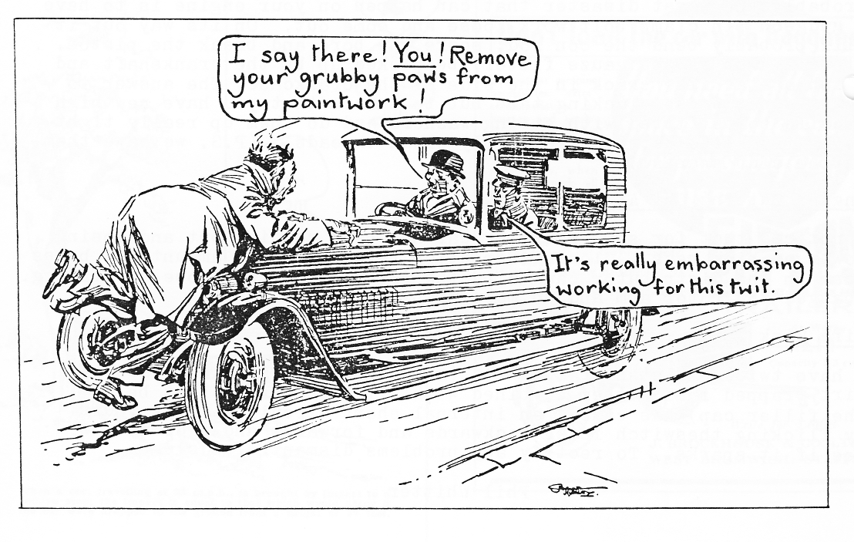

EVENTS FEBRUARY

Thursday 18th February. Club Night at the Elm Tree at 8.00 pm. We are privileged to have a visit from the Beaulieu Road Show Team. An illustrated talk with slides will describe the history and running of the Motor Museum. Should be interesting and entertaining.

Sunday 21st February Club Run 'A West Dorset Wander'. Meet at Wimborne Square at 10.30 for 10.45 am.

MARCH

Saturday 12th March Skittles Evening with the New Forest Morgan Club at the Old Barn Farm Inn - 7.30 pm. See January newsletter.

Thursday 17th March. Club Night at the Elm Tree 8,00 pm Sunday 20th March Club Run
Gary is still trying to match a suitable venue with a suitable band for the Club Barn Dance. Early indications are that this will take place on Saturday 7th May. Be sure to keep that evening free. More details next month.
WIDER EVENTS
I was aware that last year various Runs and Rallies took place about which many Club Members knew nothing until they were over. I wonder if this year we can keep each other better informed. If you know of an event which may interest Members please let the Editor know.
So Far I am able to notify the following:

Sunday 8th May Bournemouth and Poole Preservation Club Annual Vintage and Classic Road Run. This starts and ends at Bournemouth Pier Approach, taking in Blandford (short break; and Ringwood (lunch break;. The Editor has further details. Entrance fee a2.

Sunday/Monday 29th/30th May Hants, Veteran. Vintage and Classic Club will be holding their 'Cavalcade of Transport' at Salisbury Road. Andover. The showground will be open from F_{r}id_{ay} 27th May for camping and caravans. Further details from Malcolm Treasure. 112 Colenzo Drive, Andover, Hants. 0264 56747`

Sunday 29th May The Weymouth Vehicle Preservation Society's Vintage and Classic Vehicle Run - supporting Telethon '88. The entry fee is £5 and further details can be obtained from Mr P Redshaw, 2 New Coastguard Cottages, Osmington Mil is, Weymouth D13 6ED.

Sunday 12th June The Esso Bristol to Bournemouth Vintage Vehicle Run. Entry, fee a15.

