NEWSLETTER
December 1998

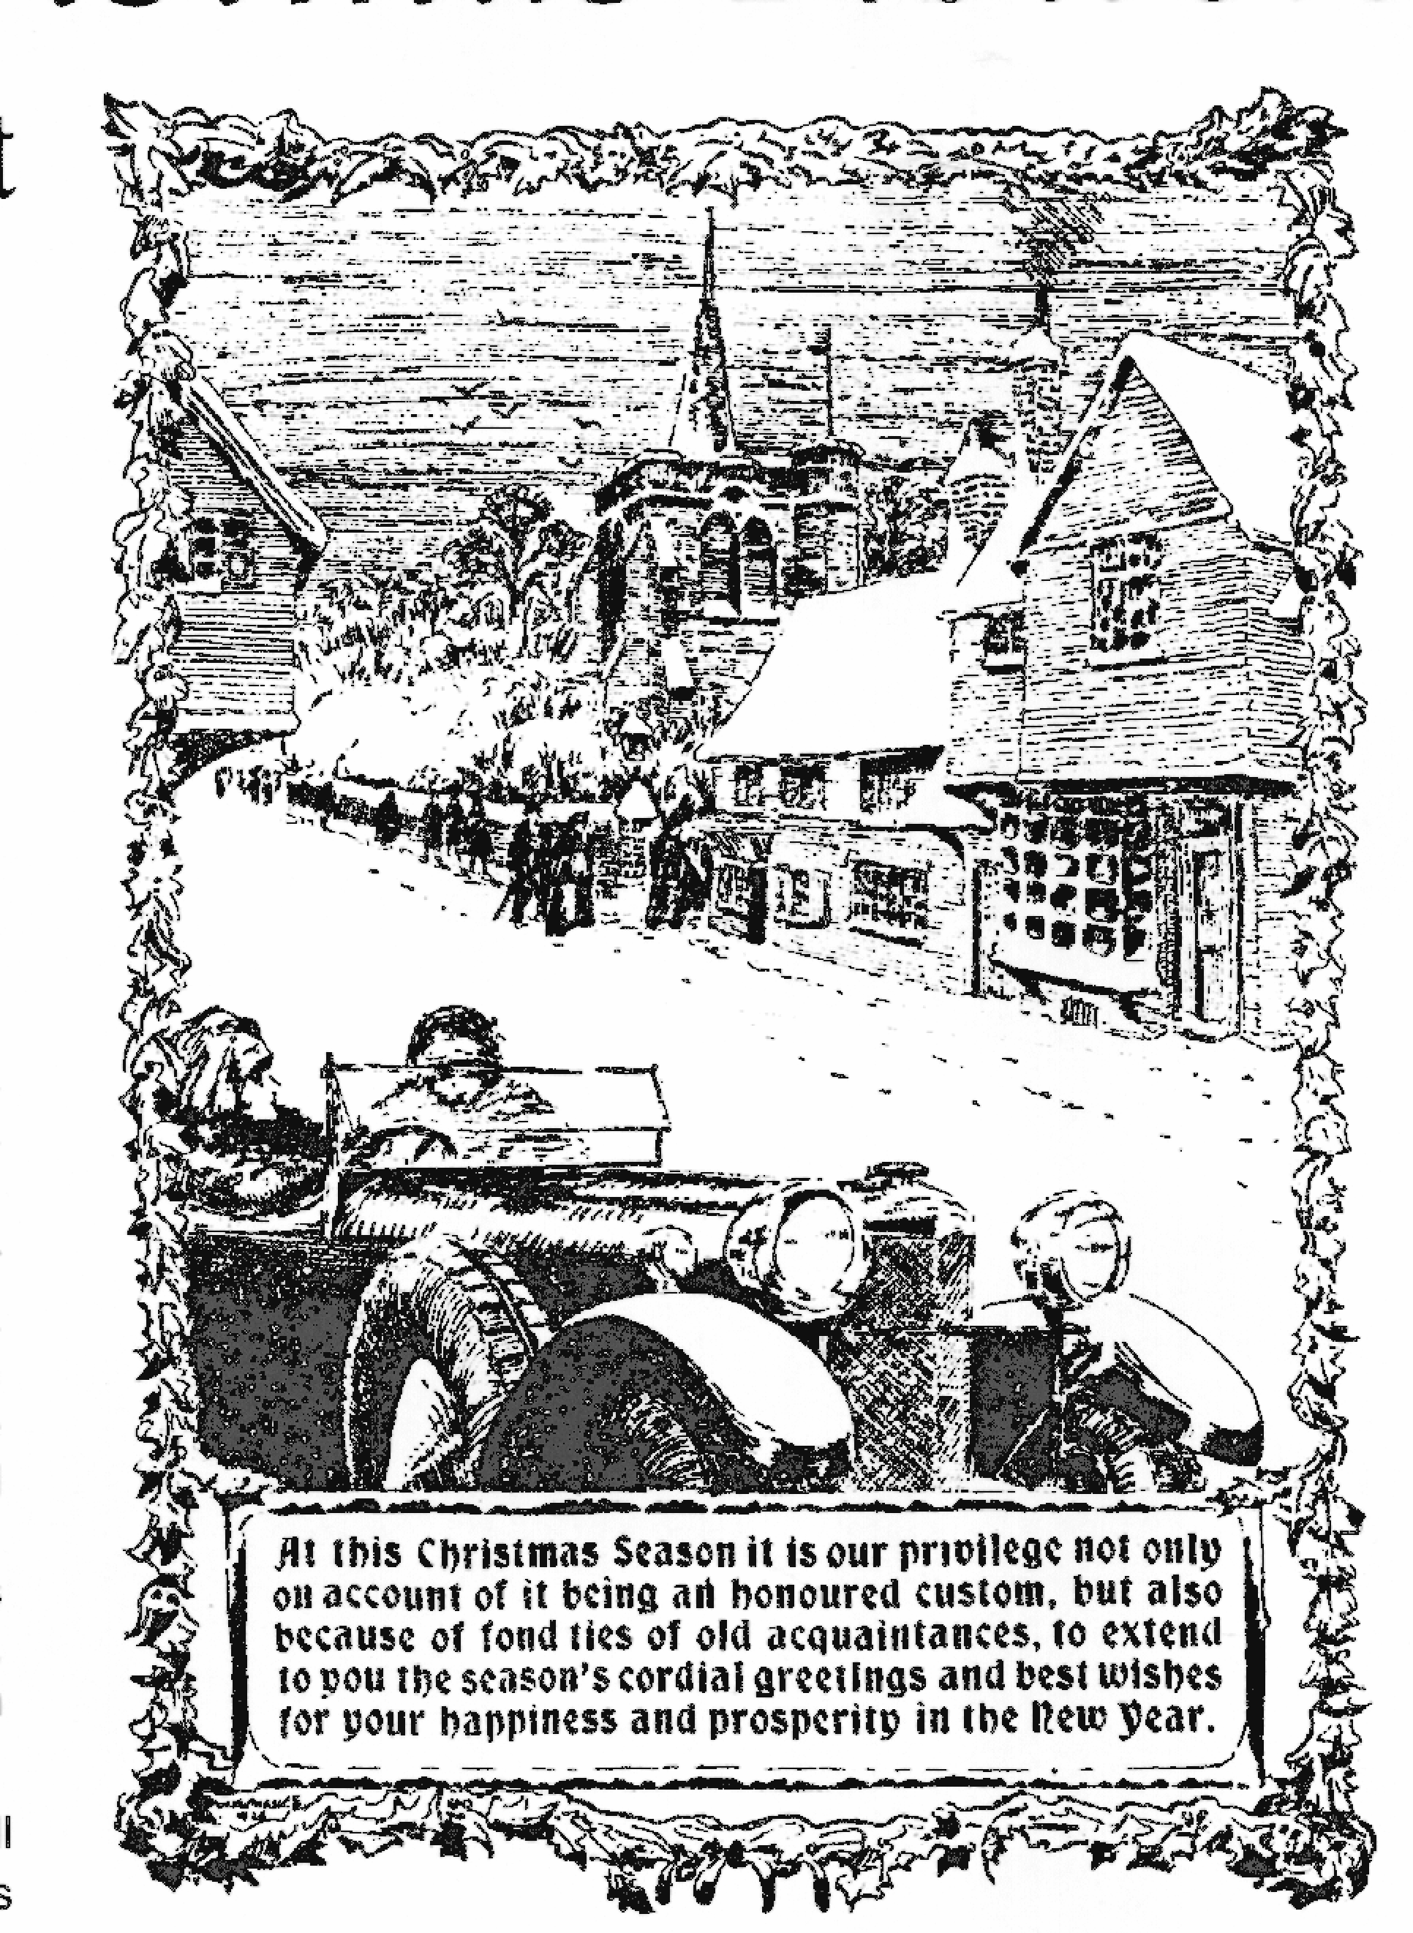

The motor for the Million
Built in the largest and most up-to-date Motor Works in the British Empire

Member of the A7 Clubs Association

COMMITTEE MEMBERS 1998
CONTENTS

Club Contacts 1
Editorial 2
Secretarial 2
Club Run 3
Committee Business 9
The Way We Were 9
Here & There 10
Family News 10
AGM Update 10
Future Events 11

FEATURES
Pit Stop 4
Technical Torque 5
Edinburgh Trial 7

Chairman Bernard Cowley
27 Delph Road, Merley
Wimborne, Dorset, BH21 1RS (01202 887666)

Secretary Glyn Llewellyn
10 Woodvale Gardens
New Milton, Hants, BH25 5EE (01425 613080)

Treasurer Lawrence Rideal
12 Redwood Close, Dibden Purlieu,
Southampton, Hants, SO4 5SN (01703 207191)

Membership John Page
Secretary 74 Walcott Avenue
Christchurch, Dorset, BH23 2NG (01202 473207)

Spares Phil Whitter
Secretary 134 Northfield Road
Ringwood, Hants, BH24 1SY (01425 475558)

Events Gary Fatt
Secretary 98 Bear Cross Avenue, Bearwood
Bournemouth, Dorset, BH11 9NZ (01202 572621)

Newsletter Gary Munn
Distribution 12 Shaftesbury Road
Poole, Dorset, BH15 2LT (01202 683848)

General Pat Llewellyn
Committee 10 Woodvale Gardens
New Milton, Hants, BH25 5EE (01425 613080)

General Roger Ballard
Committee Kea House
Laverstock Pk.

CLUB NIGHTS
are held on the third Thursday of every month at The Tyrrell’s Ford Hotel, Avon (on the Ringwood/Christchurch Road)
B3347
Salisbury, Wilts, SP1 1QL (01722 323570)

General Mike Wragg
Assistance 67 Uplands Road, West Moors
& Raffles Ferndown, Dorset, (01202 895622)

Newsletter David Whetton
Editor 129 Lonnen Road,
Wimborne, Dorset (home: 01202 848743)
BH21 7AU (Fax: 01202 876661)
(Email: davidw@fernup.dorset.sch.uk)

Club Regalia Jackie Cowley (01202 887666)

This month's cover photograph features

EDITORIAL

David

Deadline for the next issue is . Please send material to me by post, fax or E-mail or pass it over at Clubnight.

SECRETARIAL

Well Folks!

Gary

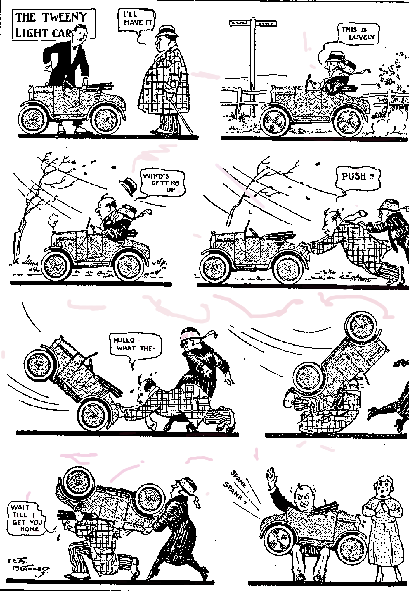


AUSTIN SEVEN
LUBRICATION

part 3

Wheel Bearings.

Front Hubs.
Every 1,000 miles remove road wheel and turn the hub until the filling plug is at the top. Now remove the plug and screw in the special adaptor provided in the tool kit. Apply six strokes of the grease gun filled with Wakefield CASTROLEASE Medium (see Fig. 6). Do not forget to replace the filling plug after detaching the grease gun.

Rear Hubs.
fig.6
Lubrication of the Rear Hubs should be carried out in the same manner as for front hubs. In some instances, however, a grease nipple is fitted in place of the filling plug shown in Fig. 7 below. When this is the case the screw-in adaptor will not, of course, be necessary.

Brake Gear.
Each rear brake cam spindle is provided with an oil-less bush which does not require lubrication. No attention is therefore necessary at these points.
Front brake cam spindles are lubricated from the swivel. pin and require no separate attention.

Brake Joints.
Every 250 miles apply the oilcan to keep the brake gear efficient and easy in operation. The joints are clearly shown on the Oiling Chart at the end of the book.

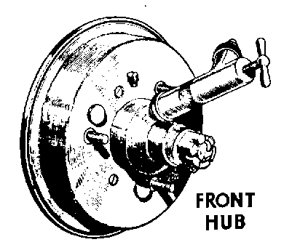
Suspension Springs.
Spring Anchorages and Spring Shackle Pins.
These are all provided with easily accessible grease gun nipples to which CASTROLEASE Medium should be injected with the grease gun every 250 miles. There are six nipples in all. The one fitted to the offside rear spring anchorage is illustrated in Fig. 7, and the remaining five nipples may be located by reference to the Oiling Chart at the end of this book.

Spring Leaves.
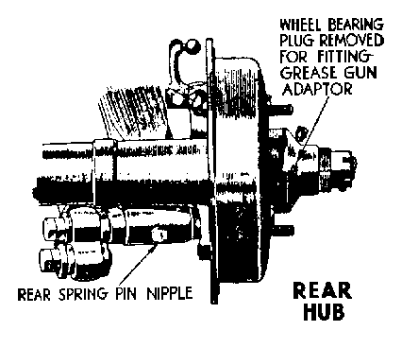
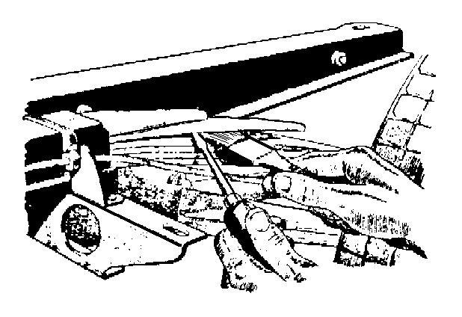
Every 10,000 miles it is necessary to lubricate these. In order to do this the weight of the car must be taken off the springs and the spring leaves prised apart with a screwdriver or similar instrument. To take the weight off the front spring place the jack under the short cross-member just forward of the engine. The jack should be standing on a wood block for this purpose. The rear springs may be attended to one side at a time by jacking the car beneath either end of rear cross-member. Having prised the spring leaves apart, apply Wakefield CASTROLEASE "G" with a stiff brush between them. This operation is illustrated in Fig. 8.
fig.7
Radius Rod Anchorage.
The radius rods are anchored by means of a ball flange and cups attached to the front cross-member just below rear end of the gear box. Every 1,000 miles a few drops of engine oil should be applied at this point.

fig.8

Opal Rustling?? - by our roving reporter, Peter Trebilco
It was in the dead of night recently, on the edge of the New Forest, when strange sounds were heard outside. Local dogs started barking as the wind picked the remaining autumn leaves from off the trees. DA7C Member, DAVE TANNER, curious as to the events unfolding outside left the warmth of his bed to check that his Seven was still safely tucked up in the garage. Surely no-one was out at this unearthly hour to steal the OLDEST REGISTERED OPAL in the country? But what was the origin of the great shadow cast by the solitary street light?? Only a New Forest pony that had somehow managed to cross the cattle grid at the end of the road and was now frantically trying to find a way out of the cul-de-sac!

PIT STOP

750 TROPHY CHAMPIONSHIP TABLE AFTER 7 ROUNDS
Points | Class | Driver | Mallory  23/3/97 | Snettert'n  06/04 | Cadwell  04/5 | Lydden  17/5/97  2 rounds | S'stone  (Stowe)  03/08 | Pembrey  20/09 | S'stone  18/10
28 | B | Ronnie Haynes | 5 | 1 | 4 | 8 | 10
6 | B | Vince Leek |  |  |  |  | 6
4 | B | Keith Hamer | 1 |  |  | 1 | 2
21 | A | Graham Goode |  | 4 |  | 10 | 7
12 | A | Graham Chambers |  |  |  | 6 | 6
9 | A | David Whetton |  |  |  | 4 | 5

THIS MONTH,
COMMITTEE BUSINESS

THE WAY WE WERE - a blast from the past
From the Club magazine for December 1977
“It is good to see Gary Munn using his ’30 Box this winter - best of luck with the driving test! Wel;come to new member Reg Stones from Highcliffe who has a ’33 Box and a ’38 Big Seven. (see this month’s adverts – Ed.!) I thought it might be a good idea to compile a list of local restoration services. This would include wheel building, shot blasting, spraying, welding etc. - don’t keep those names to yourself. A friend of mine, John Dibden, is rebuilding his ’29 Chummy to take on holiday to France. He has had his crankcase bead blasted by Armour Motor Products at Winton and the finish is like silver paint. John has also used Armour epoxy enamel on his wheels and it certainly gives a fantastic gloss.
Phil Whitter
BEARINGS: If you want any bearings for your A7, I can get them at 40% discount. Phil

On Saturday 4th February we will be holding a Social Evening in the MONMOUTH ASH at Verwood. This is the big ‘Get together’ of the DA7C calendar so bring your wife/girlfriend/friends along. Chicken, sausage, jacket potato and roll for £1 per head. Let social secretary Gary Munn have your details.

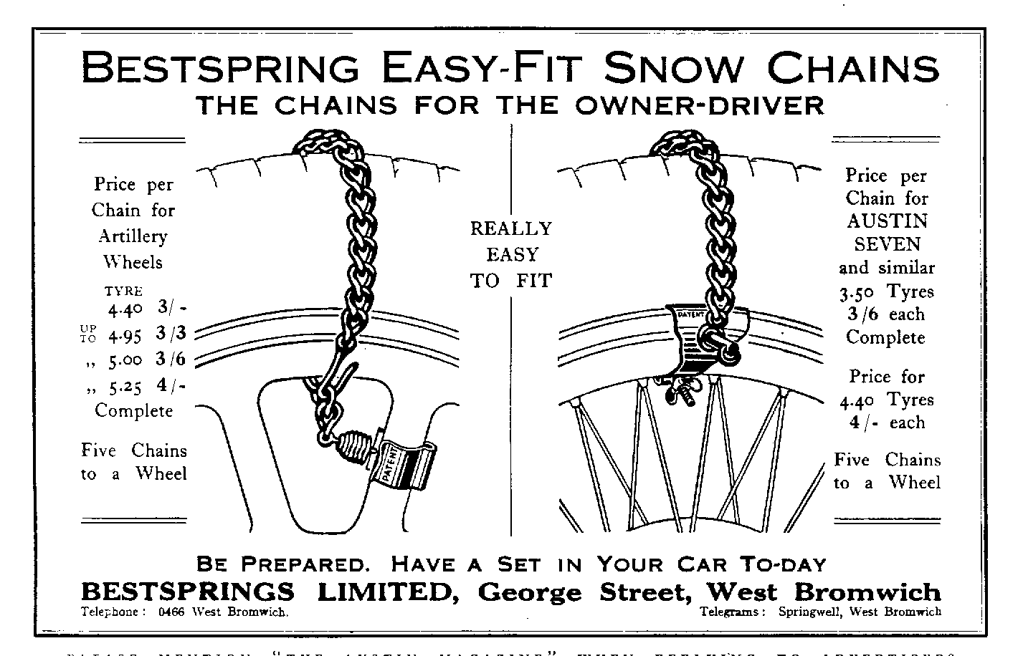


NEW MEMBER

FOR SALE
VW CAMPER. 1973. Much work done incl. Engine, new wheel arches, long MOT, and nearly tax-free. Sound & tidy £1695 - Gary (01202) 683848

Since the age of 16 I have accumulated a vast personal stock of secondhand spares which I need to reduce. So, if there is anything you want particularly please let me know. Phil Whitter- (01425) 475558 or spares nights.

1936 RUBY. Reliant 750 ohv engine fitted. Euro-toured car. Bumperless model. Good reupholstered interior. Requires top coat as currently in primer. £1350 or £2000 with re-spray and MOT. Space required for Chummy. Charles Lyford (01703) 898916.
Chassis', mag/coil engines, 3/4/speed gearboxes, axles, road springs, wheels, brake parts (incl. Girling), body parts, headlights, sidelights, instruments suitable for specials, original handbooks and1927/39 parts lists, seven-related books, hundreds of items at sensible prices.
For sale: my own 1934 chrome rad van immaculate condition after recent "wings off" professional respray. Fun to drive with advertising/film work potential, V5, MOT, £5,600. (Non-running road/race 7 "special" requiring restoration or Morgan 3-wheeler or flat-rad 4-wheeler requiring restoration + Morgan spares or pre-74 single seat racing car, any formula/condition considered in part exchange)
Ken Medlicott (01963) 440604 (T)

WANTED
An "ELTOS" alloy remote gear change for a 4-speed A7 gearbox. I am looking for one for my Ulster Special project and will buy or exchange for virtually anything A7. (Is this man desperate? Ed.) Phil Whitter- (01425) 475558
oO CLUB EVENTS Oo

September

Thursday 18 Sept. Clubnight.

Sunday 21 Sept. Club Run.

Thursday 25 Sept. Committee Meeting.

October

Thursday 2 Oct. Eight-till-Late

Thursday 16 Oct. Club Night..

Sunday 19 Oct. Club Run.

Thursday 23 Oct. Committee Meeting. Tyrell's Ford

oO OTHER EVENTS Oo



Happy Motoring

