

THE WIGHT VIEWS WANDER
AUTUMN - SEASON OF MISTS AND MELLOW FRUITFULNESS 24TH NOVEMBER
- And what better way to spend a sunny Autumn day than in the company of good friends and trusty motor cars on a Club run through the New Forest, (I think Frankie Howard would call this bit the prologue).
Anyway, it came to pass that on the morning of 24 November, assembled in Ringwood Cattle Market, was a not inconsiderable number of Austin 7 drivers and passengers wondering where they were going, when and with whom .... I was not totally uninvolved in delaying our organiser, John Page, and as a consequence, or should I say penance, was chosen from the band of many willing volunteers to act as scribe for the day.
Eventually we set off into the Forest (sounds like the Famous Five doesn't it) through Rockford, Moyles Court and Appleslade Bottom. It then occurred to me that there must be more Bottoms in the New Forest than practically anywhere else Digden Bottom, Dogwood Bottom, Linford Bottom, Great Bottom - Not to mention Scrape Bottom and the Butts - Sorry, I did!

We continued across Broomy Plain, under the A31, into Bolderwood skirting the Deer Sanctuary and along Bolderwood Ornamental Drive where the beech, oak and other trees, wot I don't know the names of, were magnificent in their Autumn splendour - I ask myself who needs to go to New England when they can have the New Forest!
We then crossed into Rhinefield Ornamental Drive, planted out in about 1860, at the end of which stands that ancient pile, Rhinefield House - actually, all is not quite as it seems, for the place was not built until the early 1900's. It latterly came to fame as home of Oliver Cutts, provider of naughty medieval banquets and is today owned by Maggie's clean-up man, Richard Branson. In more gentile times I believe both Kaiser Bill and the Queen Mother stayed there, although I understand not together!

In Brockenhurst we splashed through a narrowish, deepish ford (now obligatory on A7 runs), away from the main street and unbeknown to most people, and re-entered the Forest, round the back of Boldre and into Pilley - The Red Lion Inn at Boldre was once used by Lymington Smugglers for storing contraband. Nowadays, the Landlord contents himself by serving a decent pint and looking after his collection of chamber pots - now ornamental and no longer functional!

Winding, real A7 sized lanes, led us on to the Wagon & Horses at Lymington for lunch which was served speedily and efficiently - the beer was well kept too! We first visited this Pub in a Club run in about 1979 - nowadays the cars in general are looking even better and only the owners showing signs of wear.

Lymington was explored in the afternoon and most were home by dusk. Many thanks to John for the organisation. Apologies to Scott for losing him!

Lawrence
EDITORIAL December 1991

Another December already - amazing! Club life goes on apace whatever the season. Perhaps a suitable Club slogan would be, 'The DA7C never hibernates', or ' The Dorsets never sleep'. It's surprising how many people unconnected with Sevening assume that we tuck our cars up for the winter. Perhaps you can think of a better slogan. Let's-have a competition for the New Year - send in your slogans folks!

My thanks, again this December, to all those who have contributed in any way to the Newsletter during 1991. The interest of Members is encouraging and ensures a spread of interest. Particular thanks to Biddy Brown. This month's profile is her fifteenth and she hasn't faltered since the first one appeared. This month the Whibleys get the treatment.

Events for the New Year include the traditional New Year's Day Run and a Skittles Evening which can't fail to be another fun-filled occasion in good company.

With every good wish for Christmas and 1992, John
JANUARY NEWSLETTER. Items welcome by 28th December.

SECRETARIAL

What a successful auction! Over £100 to the Club, largely helped by a most generous donation from Murray Pacey's wife of some of the late Murray's historical motoring books. It was as ever a friendly and lighthearted affair as seems to be the norm for our Club. Long may it continue.

I understand Bob Stanley has purchased the Boat-tailed Special I built and had to sell some years ago. I am really looking forward to seeing it again, although I understand it has succumbed to the ravages of time a bit!

As you know, Merv has finalised the details for the Christmas Dinner again at the Manor Arms, Christchurch. Last year's do was excellent and good value, but dogged by poor service - however we have been promised better this year. If you have any donations for the bumper Christmas Raffle, the more the merrier!

Well Christmas looms up. If has been another good year for the Club. I believe membership is higher than ever before, it is quite noticeable at Club Night, the number of new faces we see. It would be nice to see some 'new' cars on Club Runs as well, perhaps a few for the pre-Christmas Run which is only a short trundle to the Purbecks.

Anyway, if I don't see you before, on the behalf of the Committee have a Merry Christmas and a more prosperous year next year.

Cheers
Gary
AUSTIN 7 BEGINNINGS - 15 -- A story of Austin folk.
Dusty, Jane & Scott
Scott Whibley, the young, dashing son of Dusty and Jane; very first winner of the Vic Steele Memorial Cup for 'Best Achievement of the Year 1991'. Those present at the October A.G.M. saw, were pleased, and quite rightly applauded enthusiastically, the worthy young winner of this award. One felt that dear old Vic was right there in spirit too, happily smiling and nodding with complete approval. Totally deserved we all agreed, but how, one had to ask oneself, how did a young lad like that actually come to get started?
As they say, to begin at the beginning....
Way back during Scott's Junior School days, Mum, Jane, used to chat to no less than Hilary Whitter. To quote Jane, 'There was I, little shy orphan, and Hilary, true to her ever generous self, took me under her wing'. The friendship continued and grew for around two years; yes for two whole years during which time both Dusty and Jane had visited the Whitter household. One day (sounds like a fairy story? Well it is!), yes one day, Dusty happened, for the very first time, to see Phil's garage door open, not only open but revealing 'an old car'. Dusty already a lover of old cars, having since the grand old age of sixteen been into various cars, bikes etc., a) just couldn't believe his eyes and b) couldn't believe that during all this time he hadn't somehow or other stumbled on the info.
'Is this yours Phil?' he enquired. Phil nodded.
Dusty, as we all know, a lively 'aware' fellow, was totally bowled over. I mean how could he not have somehow discovered the fact earlier?
'What sort of car is it?' quizzed Dusty, not then knowing anything about Austin Sevens.
Pretty nippily, Dusty was generously offered 'a go', AND didn't think much of our beloved Mighty Mouse. Privately he felt it to be one of THE most obnoxious cars he had ever driven! However, with accumulated knowledge of the engine, and working parts, he was slowly totally converted into realizing that this was no ordinary car, in fact its classic simplicity and efficient basic-ness had much to be admired. In a word, they Dusty and Jane were 'hooked'. Speedily, Phil was commissioned to look for a Seven. That search led to Bernard's ex. 1931 Box KX 6557 which Dusty bought in 1982 for the right-royal princely sum of £1,500. (Dusty was in fact quite smitten with Bernard's Chummy, but B was not selling!)
Dusty and Co. were promptly in the club dashing up to Longbridge for the Diamond Jubilee in 1982. 1983 found them in France with the club. On return they all 'leaped into the Box and dashed down to Yeovil ' I well remember, everyone being very worried about that', reminisces Dusty 'Very worried, they all were, that all four of us were going off on our own!'
Over the years they have won many accolades with the driving tests (see October magazine for their, dare I say it, somewhat cheeky speed driving against Jaguars et al, at the Bath and West Show): Braemore, Spye Park and Beaulieu awards. The latter being of course a real feather in Dusty's hat. I mean to win FIRST IN CLASS for two years running at BEAULIEU is truly 'top notch', What? Typical of Dusty. He modestly reveals this information - later Jane casually says: Did Dusty tell you that

t ?'
THIS PAGE TOO FAINT TO BE PICKED UP BY OCR
A :Giia' - 1`?, v~ the car ~% i i Cf ',~!•: . i: ~t s1=iC winter 2'=,
F,~ t t~t1, ifl Onc
ximos f, completely 4v'"PC:Cd the Bo... ?•LlSt`s' .`°_' -a
ii!`.., the state ot T2u+^a +aijm.r e~-__'t-t .` _ _ .. -_rl ='t ,1rw8.t'Ci tic :tas Cau ;a'_ be grateful .O the Cras+-kin;al he '371 _:T ...,ai, 1L '=.~cy'qF'd i_F„, t:'tee to p of ,.`1C LdT n`•p irln:g ',t!C inclusion of SUn roof in the i_._ i t:lt~
Et ~ :
OPR 14:4 - an A J 5, VAti; ? L _5 lyj:J OMMY• VU 4516 - 19_'•. UL; `:'P Rand a MK,
,
JAGUAR, are amongst Dusty's ;-ollection. A-111 are various states of or Waiting to
restored, in daily use e+i=.etC. l:`:terCSt:n,- collection of Number 11:ates? 41ttV Jim. C i enna!-:an coined the van ' t_tTHEh'. PEOPLES kiJB3 iS'H !!
The Dorset Austin Club abounds with the enthusiastic, energetic WhibleyS: -Is ?an=
wz tC: 'f1eT` da:_itlng hf1tS, sm11E'S and warm CheF'r y wt~r C~'~ tst ,~sTT'2c` ii:?; D?.1sty, noW a Very r(+Y'`njj, knOW12d~-Teable a;57.'stan* tC f'hil Wfll`tei i?n tI'!s? 7.i1Valua'il"le SO$re5 SCenP_ and ' WOnda;'}uliy gerierOUS adV1Sor to drly0i1F s2e4Sliig C,-Ar neip a:7d iritC.
SC'OTT, since the a;e of nine, ha: showri similar practical enthusiasm for the Aastins, <at the age of fourteen?, persuading his Dad th3t he Wanted to build one'. inC(?ilra€?lngly Dust y outbid the rest Ot us f Or four Or f 1Ve, S2Vent2en inCh wheels - for z3 - ttie lot! Sr_ott was in business. Slawly he gathered together a£40 chassis from Beaulieu; an engine for a Chri•atmas present; a fibre gla•ss body from Chris Uould (out of his uwn hard earned money; Iikewise wings. 5ympathetic friends iike John l-awns ofter! cc%me up trumps, on a'JCGtt- favoureil- deal`, to heip the lad alorig. The wnrtd may love and help'; those whc _:now g?nuine determination BUT at the end of the day he, Scatt, is doing it a11 -'his way'.
A truly deserving win'ner of the Vic Steele award!
W:hilst the Glhibleys more than.a.ppreciate the caring camaraderie far which the Darset Club is reknowned; we all know how much they, themselves, do to foster it.
May i then, in a typically 'Whibiey Spirit', wish ali readers a Happy Christmas and a Happy, Sefe, Austin- Sevening Ne w Year'.
~. B. Nov, luyl. ` .
0
- Q o
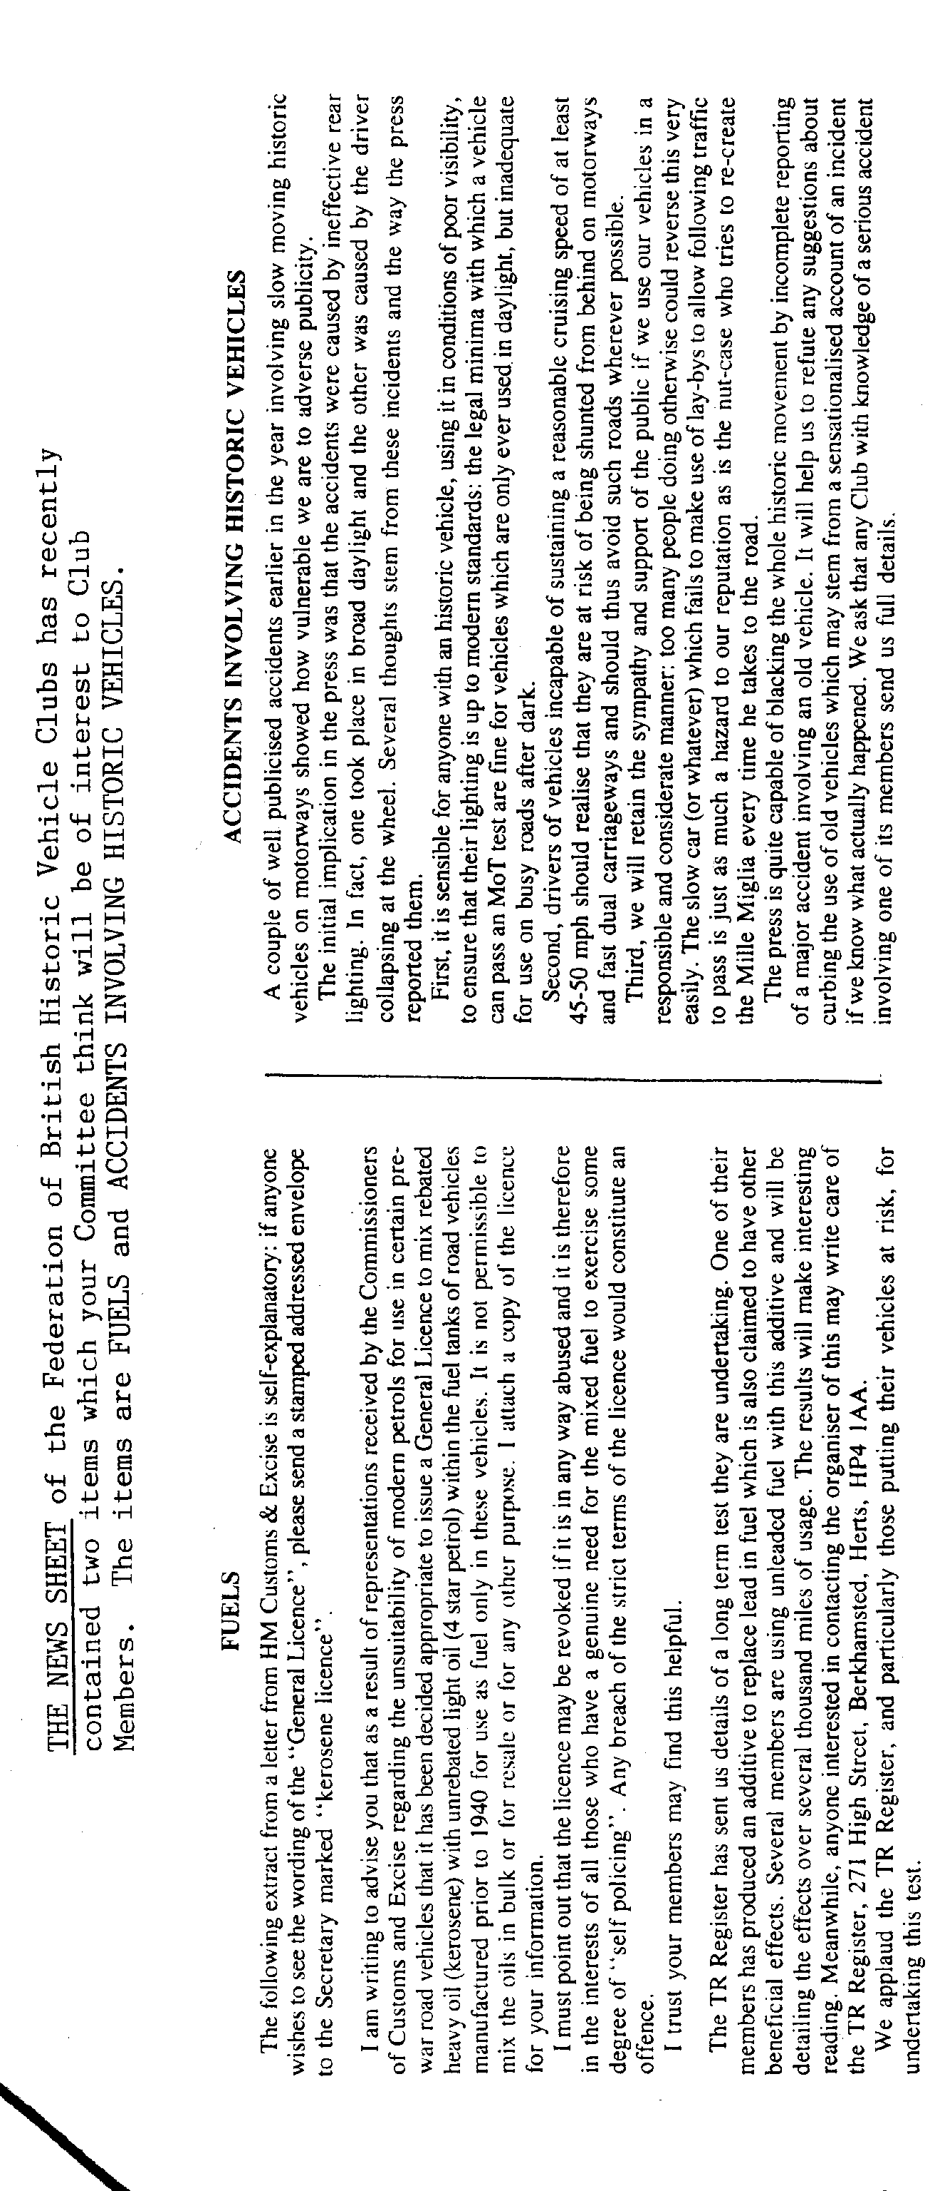
WELCOME to new Club member C Mason of Wareham.

IT SEEMS THAT the Opal advertised in last month's Newsletter was a PEARL, otherwise the details are as before.

PLEASE NOTE under EVENTS. The '9 to Late' meeting in January will be on the second Thursday of the month instead of the first.

SURPRISINGLY, in view of the excellent support we have for most events, there were insufficient numbers to make the hire of a coach to the Glastonbury Floodlit Carnival viable. For some reason this event was not what Club Members wanted, so our hardworking Social Secretary is keen to know what social events would be more likely to be supported and has prepared a small questionnaire. You should find two of these with your Newsletter, one for you and one for your partner. Please take a few minutes to complete them and let Merv have them in the way he requests. It would be a help.
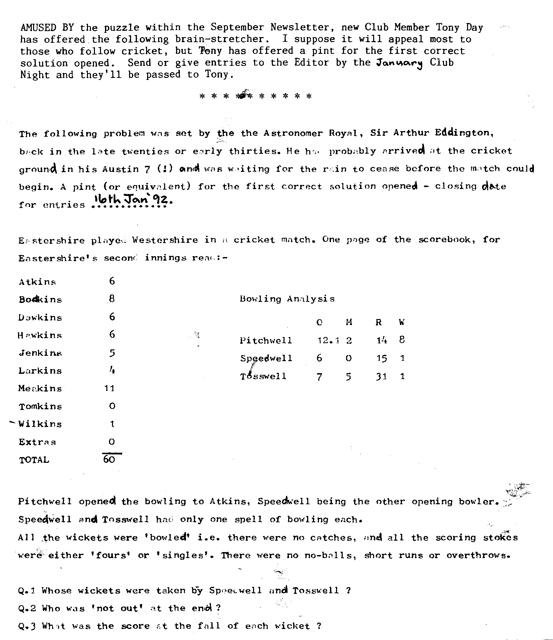

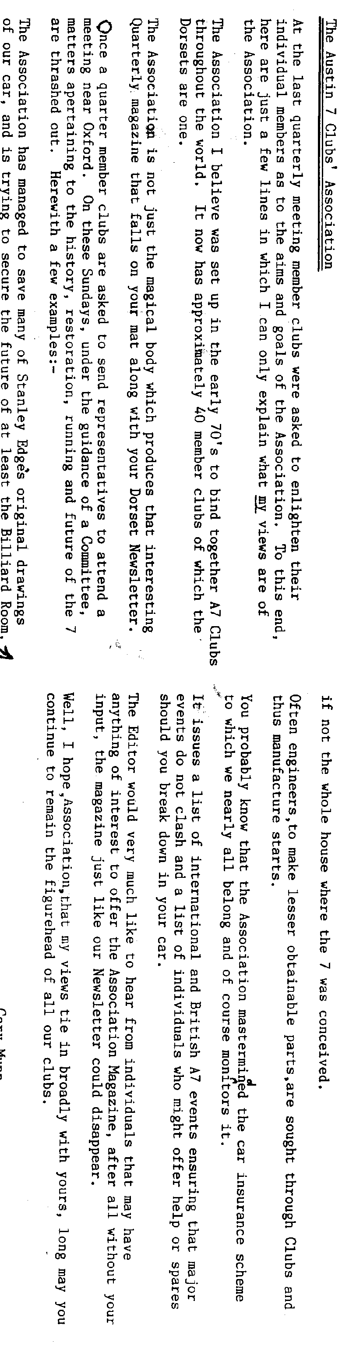
DORSET AUSTIN SEVEN CLUB

SKITTLES EVENING

A Skittles Evening has been arranged at The Old Barn Farm Inn, Three Legged Cross on Saturday 25th January, 1992. First ball away at 8•00 pm. Various basket meals will be available and the cost includes hire of the alley.

Please return the slip below before the 14th January if you would like to attend, also please indicate baskets meals required. You don't have to play Skittles if

you don't want to.
Mervyn.
- BOOK NOW!

