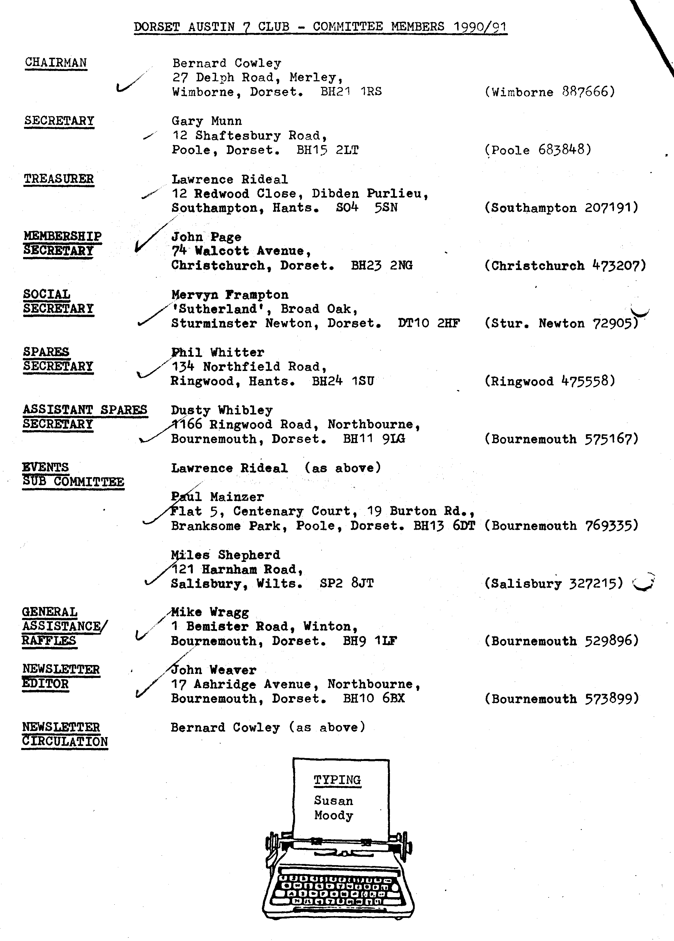
EDITORIAL December 1990

There is no doubt in my mind that Christmas comes round more quickly as the
years pass by - could it be another indication of the infamous 'greenhouse effect'? More likely it's because we all keep so busy and look forward each month to Club activities. Whatever, it's certainly pleasant again this December to recall the many happy get-togethers and the progress made by the Club in 1990.

My thanks to all who have sent in reports and items for the Newsletter during the past year. The greater the variety, the greater the interest and I hope to hear from more folk, especially newer Club Members in 1991.
Biddy continues her profiles this month, there's a report from Lena on another successful and interesting Run and our new Social Secretary has made arrangements for the first social event of the New Year.
Also thanks to Mike Topham who has lent me one of the latest additions of his book collection - a 'car fun' book which contains quizzes, games, puzzles etc. worth reproducing.
Here's hoping that Christmas 1990 will be all that you would wish for yourself and your family.
John

SECRETARIAL
Well folks,
By the time you read this, the Club's Christmas Dinner will probably be over and you will all be rushing about with final festive arrangements! On behalf of the Committee may I wish all our Members a 'Merry Christmas' and a 'fault-free’ and enjoyable year Austin 7-ing in 1991.
I think we have had a near record turn-out for our Auction Night and as ever there were many bargains to be ferreted out. I myself purchased a 1935 Bar-let portable typewriter, which I have cleaned up and now sits gleaming on a table in my house. (No John, that's not an offer to type the Newsletter!)
The October run attracted great support once again and no doubt you will shortly see a comprehensive article press-ganged out of some 'willing' volunteer!
On a more serious note, I have received a letter from the Pre-War Austin 7 Club, advising that Clubs have now been allowed by the D.V.L.C. to authenticate claims for the restoration of registration numbers. The letter urges that all Clubs write to Swansea to request that they be included on the register. Naturally, this will be discussed by your Committee and I will keep you informed on progress on what seems an important breakthrough!
Gary

2
FORAY INTO WILTSHIRE Sunday 18th November 1990.

A nice brisk Autumnal morning for the Dorset A7s’ monthly run. Eleven 7s set out from Wimborne through un-spoilt villages - the Tarrants and Donheads, beautiful views, gorgeous autumn tinted trees under a blue sky.
Apart from an unauthorized pit stop for refuelling, in a narrow lane at the summit of a steep hill (I have forgotten which Austin needed this service), we arrived without further incident at the White Hart in Bishopstone. We
were joined by two more Austins and their owners.
In spite of our numbers, we were very quickly provided with excellent meals, generous helpings and friendly service.
After lunch our next destination was 'Old Wardour Castle'. The building was started in 1393 by Lord Loval. Hexagonal in shape and standing in a lakeside setting, it was not a fortress but was built for comfort and lavish entertainment, at the same time equipped with some defensive provisions.
The castle was badly damaged during the Civil War, and was never restored; but was preserved in the 18th century as an interesting feature of the landscape.
Unlike some ruins there is a substantial part which can be explored. Several spiral staircases leading to living accommodation - almost like apartments with the garderobe en-suite. One wonders if Wimpy or Barratt's ancestors had a hand in the construction? Wandering round the corridors I decided the air conditioning was superb, but there wasn't any evidence that Sid or Everest had done their stuff.
Many thanks to Paul and Emma for organising a most enjoyable run - a scenic route, nice hostelry, and a spot of English Heritage.

Lena.

,

Thanks to Gay for another original cartoon.
AS IS EVIDENT at Club Meetings, our Membership continues to grow. This month we welcome Dennis and Mary Stringer and Pat and Gordon Cowie. I hear that the Cowies have three A7's including a 1930 Swallow Saloon - the first of these rare cars in our Club.

WARM THANKS to Pat Llewellyn who for some years has handled the ordering and selling of Club sweatshirts, tee shirts and ties. Pat has handed over to Margaret Seymour who is now the lady to see for these desirable items.

THE MONTHLY RAFFLE has recently benefitted from some useful gifts from Club Members. Our thanks to those who have donated items especially to the Moodys and the Tophams who have recently contributed some very interesting bottles.
If other Members would like to donate raffle prizes on Club Night, or especially at the Christmas Dinner, they will be very welcome.

AT THE NOVEMBER AUCTION £185.50 changed hands making a profit for the Club of £19. Well done Bernie, Phil, Jackie and Daniel who ran the event.

HAVE YOU PAID your subscription for 1990/91? (I shall say this not even once more!)

IN HIS HASTE to send in a report on the October New Forest Run for the Newsletter, dear old George got his verbals in a twist. Keith Mitchener (if he exists) was not on the Run, but Keith Mitchell was, and is the owner of the Pearl that George admired. We're sorry about that Keith. I think that George believed that if he made a mistake we wouldn't ask him to write a report again, but we shall- we shall.

Apologies too to Neil Mitchener who could be seen on the November Run, with his Big Seven. '
AUSTIN 7 BEGINNINGS - A story of Austin folk
Mervyn and Fran Frampton

"Merv - Dorset A7 clubman of 1990, how did you get started with Austin 7s?”
"I suppose you could say it was money really!"
Way back in 1959, young and fairly well impoverished, Merv was courting his now wife, Fran. Mode of travel - a Lambretta - exhilarating! fresh air, feel of speed, wind in the hair, all the sensations that youth loves! Except that it is when winter strikes causing one to come a, ney, two croppers. Once could be allowed, but twice was too much for his dear Dad. Post haste Merv was taught to drive and duly passed his test in a modern. Then, excitedly, to purchase his very own car, his first! Don't we all remember our first car? Round and round he went; should he have this, that, colour, make, size...? Today one cannot believe it possible that way back in the dark ages of 1959, Merv with all of £25 could only afford a 1934 Austin 7; reg. TK 9479.
Only afford or not, he proudly took Fran for their first outing in it, to the cinema; remember the days?, 'two one and sixes please and a Mars Bar'. (The latter if you were really in the money). How they enjoyed that evening; even the beating rain on the cinema roof enhanced their pleasure; for hadn't they now A CAR freeing them of the rigours of the wild elements? Even emerging to torrential rain, Merv commented proudly 'thank goodness we've got a car not the old Lambretta, else we'd be getting soaked to the skin!!!’ Ha! Ha! You've guessed, haven't you - yes, the roof, (sunshine), leaked worse than the proverbial sieve. Fran, being a practical girl, uncomplainingly put up her umbrella, - yes inside an A7! Wonderful. Well, for her. For Merv, not so since all the water from the brolly gushed right down his neck. They were both nigh-well soaked on arriving home!
No probs. though, Merv merely stripped the whole roof off, nailed a bit of hardboard on, painted it with layers and layers of thick paint and kept going. Not only kept going locally but used it for their honeymoon, driving up to Scotland, John '0 Groats, and back in 1961.
Sadly, the then dreaded, now taken for granted, M.O.T. came in and TK 9479 had to go. Can you believe it - to the local school for £5 for the kids to play around in! Eventually the local Fire Brigade used it to practise cutting people out of. Needless, Merv, for sentiment sake, still has the original documentation.
His present AJH 64 he bought for £600 and joined the Dorset club. However he did not feel he really was entitled to take an active part until the four year restoration was complete. Needing to use it for the wedding of his daughter in March 1985, aided and abetted him to complete, which he did, the day before!
Merv and Fran, both with a ready smile and a welcoming greeting, are tremendously active and enthusiastic members of the club. Whether or not you've had the pleasure of one of their incredibly delicious teas, (I'd say banquets), I know you'll agree. As in fact your votes showed by unanimously voting Merv in at the AGM, as well deserved 'Clubman of the year'.
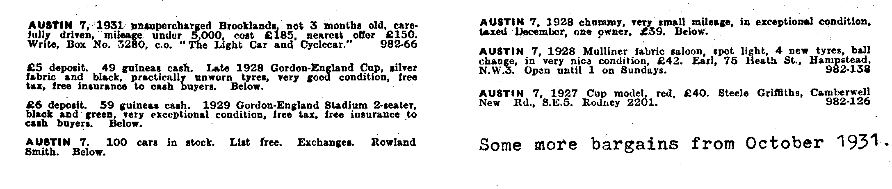
B. B. Nov, . 1990.

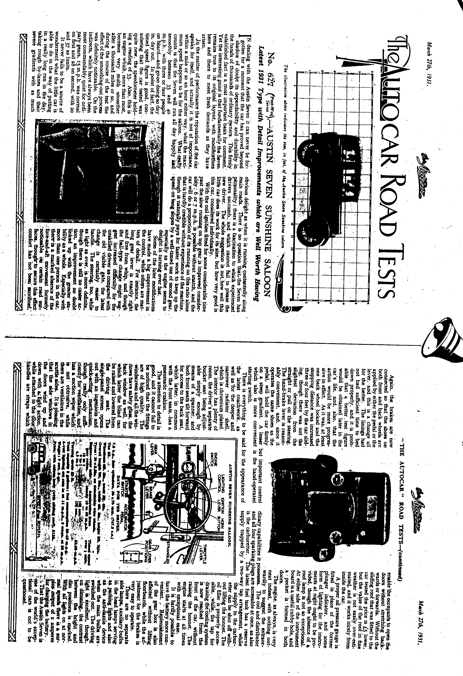
DORSET AUSTIN SEVEN CLUB
SKITTLES EVENING.
A Skittles Evening has been arranged at the Red Lion Inn, Sturminster Marshall on Saturday 26th January 1991. First ball to be bowled at 8 p.m.
A buffet will be provided and the total cost of the evening will be £3-50 per person, this includes the hire of the alley.

Please return the slip below to me before January 12th if you would like to take part, you don't have to play Skittles if you don't want to.
Mervin

Please reserve places at the Skittles Evening on 26th January. Cost including buffet will be £3.50 per person. Cheques payable to 'Dorset Austin 7 Club' please.
Return to:- Mr M Frampton, 'Sutherland', Broad Oak, Sturminster Newton, Dorset. Name!
Address!
.............................................................................. Tel. No.!
EVENTS

DECEMBER Saturday 15th December. DA7C CHRISTMAS DINNER.

Thursday 20th December. CLUB NIGHT at the Whincroft Hotel. 'Noggin and Natter' 8.00 p.m. SPARES WILL BE AVAILABLE.

Thursday 27th December. COMMITTEE MEETING at the Tyrrells Ford!. 8.30 p.m.
1991

JANUARY - Tuesday 1st January. NEW YEAR'S DAY RUN. Meet at Wimborne Square at 10.45 a.m. sharp.

Thursday 3rd January. '9 to Late' (for those who want to meet for a natter)' at The Angel, Longham.

Thursday 17th January. CLUB NIGHT at the Whincroft Hotel. 8.00 p.m. A guest speaker with a talk on 'Old Poole'.

Sunday 20th January. CLUB RUN to the Purbecks. Meet at the Viewpoint, Constitution Hill at 10.45 for 11.00 a.m.

Thursday 24th January. COMMITTEE MEETING at the Tyrrells Ford. 8.30 p.m.

Saturday 26th January. DA7C SKITTLES EVENING at the Red Lion, Sturminster Marshall. Details within.

