EDITORIAL AUGUST 1989

Special thanks to a number of contributors this month.: Your interest is appreciated and helps to maintain variety in the Newsletter.

I hope that I won't end up before the beak for photocopying part of Kim ' Henson's⁻sidevalve article in the July 'Practical Classics', and the picture of
Nick with his Prefect.' Copyright runs out after fifty years in the normal way,
so I'll hasten to thank 'Practical Classics' and say that I'm sure that this
reprint will encourage every DA7C Member to buy that excellent monthly magazine .on a regular basis.

Have you underlined 9th and 10th September in your diary? These are the dates of the amazing'Beaulieu Autojumble this year. If you've never been, be sure to go, even if you don't need any bits and pieces. It's a unique experience. If you're buying or selling,- best of luck. We wish you dry weather but beware of marks, guilders, francs, liras, pesetas and brass buttons. They'll all be there!

Keep smiling!
John
SECRETARIAL

Hi Gang. There was a super turn out for a run from the Elm Tree to our new venue at The Dudsbury on Club Night. 28 Austin-Sevens, a Big 7 and an Austin 10 were parked outside The Dudsburv, when after a slight misunderstanding (the Landlady had her dates mixed) we were made most welcome and 'our bar' was unlocked. The room was soon buzzinq with convivial conversation. Everyone I have spoken Lo so far seems pleased with the move, so let's hope that this time we have found'a more permanent home.

Our Barbecue at Studland proved even more popular than ever this year and was, as usual, great fun. By popular request MW did not go 'skinny dipping' this year, but an even greater number of us than last year did go for a swim⁻later in the evening. We were entertained by Gay playing her accordian which was very popular. I trust our Ed has a write-up from someone. (Not so; but thanks within. Ed.)

Eight A7s met at the View-point for the evening run to Kingston, nr. Corfe Castle. The venue was the Scott Arms where, as usual, we were made very welcome, although they were very busy, particularly at the food counter.

This month's Club Night is an informal Concours on the lawn at The Dudsbury, so don't park in the car park, drive past and through the gate, where you will find us lined up ready to be judged by the Landlady (who incidentally donated the money for the room last month for a Concours prize). So come on you lot, get polishing!

Well that's it from me this month. Unfortunately I could not make the run to Southampton in July due to other commitments but I hope to see you all on Club Night.
Glyn
THE COVER PICTURE this month is of Lawrence's Special - some more of-Terry Jefferies' handiwork.
THE NEW CLUB VENUE seemed to go down very well at the July meeting. It seems ideal, but in order that Phil can enjoy the occasional meeting without the business of spares, and to save some of the humping about, spares will only be available at alternate Club Meetings from September. If the month is an odd number in the calendar,spares will be available. However, Phil will endeavour to bring along any special requests on the even number months, BUT he must be given plenty of notice, he leads a busy life.
IN RESPONSE to the appeal to Club Members in April for donations in memory of Rachel Smith, a sum of over £100 was raised to be shared between the Leukemia Research Fund and the Wessex Cancer Trust Children's Fund. Warm thanks to Club Members whosupported the appeal and the special raffle, the result of which is included.
THANKS to Pat, Glyn and Gary for providing the food for the Barbecue. It was excellent. Well shopped, Pat! Also thanks to John P. for the excellent auxiliary electric lighting. It helped make the evening.

MARGARET CRESSEY has written to thank those who took their Sevens for display at the Charlton Horethorne Village Feast Day. She says that the day proved to be a great success and the village school's half-share of the profits amounted to £487.
As Lena reported last month we thoroughly enjoyed the occasion.
It was good-to discover that the Cressey family had made the long run to Studland for the Barbecue and nice to meet Margaret's parents, who joined the swimmers in the briney.

DID YOU SEE Gary's television appearance in his A7? The programme 'Police Five' was showing the scene of a recent robbery when our unsuspecting hero drove by in the background. We understand that he has been seen since hanging around the TVS building waiting for his cheque. NB There is no need to notify the police if you know where he is now.

WELCOME to our latest Club Members: R M GREEN and LEN EDBROOK
and REWELCOME to: DENIS DOLAN and MALCOLM PAGE

DA7C SWEATSHIRTS AND TEE SHIRTS are still proving very popular. Pat has a good selection at present and will be pleased to make them available at Club Meetings. Current prices are:

SWEATSHIRTS £8, TEE SHIRTS £4.50, TIES £4.50 You won't find this value in the shops.
Practical Classics. July 1989
AUSTIN SEVEN

I spoke to the owners of several Austin Sevens, most of them members of the highly active Dorset Austin Seven Club. Their cars included a 1925 Chummy, a Nippy, `Box' saloons, a Ruby, a Pearl Cabriolet and two Big Sevens! In fact there is a tremendous choice of body styles, performance potential and character within the range of Sevens produced until 1939.
Many of the owners I spoke to had restored their cars from wrecks and often their Sevens had provided their first taste of restoration work. All agreed that the Sevens are relatively easy vehicles for anyone to restore - even those without a great deal of mechanical knowledge. To start with the Austins are of compact size so that even a major restoration can be carried out in a normal single garage. In addition, the essence of the Seven's design was simplicity, so that there is nothing to defeat an enthusiastic person, whether he is rebuilding the engine or carrying out a body-off chassis' restoration.
Since the spares availability is very good - in fact better than for any other pre-war car - and the club scene is also thriving, the necessary parts and advice are readily available for rebuilding most Austin Sevens. Of course, some components specific to the rarer Sevens are now difficult to find, including the Nippy, ' Chummy and Big Seven models. However, there are usually fellow club members who can point people in the right direction in their search for spares.
All the owners agreed that the sidevalve engines -in particular the later, three bearing units - are long-lasting. Given care (especially frequent oil changes, perhaps every 1,000 miles or so), they should give many, many miles of trouble-free motoring. However, should a problem occur, it doesn't normally take too long to remove the affected component, or even to take the engine out for rectification. Indeed, some owners spoke of major overhauls being carried out at the road= side... In most cases it is increasingly high oil consumption, developing over a long period, which spells the need for overhaul.
As with all sidevalves, a cylinder head gasket change can be accomplished very quickly. indeed, should the need arise.
Parts are also readily available for routine servicing and, in general, the prices asked for items such as plugs, points and so on are, reasonable.
Low cost of ownership was also mentioned by all the owners I spoke to as being an advantage of Seven ownership. With normal fuel consumption averaging over 40mpg (and up to 50mpg under gentle touring), petrol costs are low. In addition, the Seven qualifies for the Government's concessionary £60 per year road tax rate, and comprehensive, unlimited mileage insurance can be obtained for a Seven from under £20 per annum, depending on your no claims bonus potential.
Even today, an Austin Seven can be used every day to provide economical, reliable and highly individual transport.
Club membership was universally regarded as an important part of owning a Seven. As an example, the Dorset Austin Seven Club provide an excellent spares service, a high quality monthly newsletter, regular (and sometimes very adventurous) runs, and trips to rallies around the country, as well as occasional visits overseas.
Today, some 50 years after production of it , ceased, the Austin Seven is still one of the best-loved cars ever made.

I PROMISE not to mention petrol again after today - unless bribed to do so. Miles has passed on the following which comes from the Federation of Historic Vehicle Clubs. Thanks Miles.

LEADED FUEL from The F.B.H.V.C.
It is frequently promised that leaded fuel will be available to the end of the century, but for : environmental reasons it could be phased out earlier. Potentially, this has very serious implications for owners of all but the very newest and very oldest petrol engined vehicles. ,
The lead in conventional fuel acts in two ways, first as an octane booster and second as a lubricant for the valve seats. Other additives, additional refining or a combination of both can provide an acceptable octane rating without the use of lead. But no other additive so far discovered can protect the valve seats from wear in the same way that lead does. New vehicles designed to run on unleaded fuel have specially hardened valve heads and %eats. Older vehicles do not, and consequently are prone to very high rates of wear on the valve seats if used with unleaded fuel. The effects are more pronounced with high compression, high revving engines.
From an environmental aspect, the Federation sees no merit in endeavouring to delay the phasing out of leaded fuel, and recognises the danger in making representations to government to permit the continued manufacture of leaded fuel, albeit in small quantities; It is a fact that the reasons for wishing to remove lead from fuel are sound and the movement would lose very significant support in the public eye if it were to request special treatment on this emotive issue.
The best hope is that someone will come up with a suitable alternative additive. One scientist known to the Federation believes he has the answer, but his product has yet to be I tested and proven to be environmentally friendly. The commercial backing for the full evaluation of the product has not yet been obtained. Suggestions as to how such backing might be obtained will be welcomed-contact the Federation Secretary at Elton House, `:Church Lane, Tydd St. Giles, Wisbech, Cambs. PEI 3 51-A. ; Lead levels in fuel were originally 0.8 gm per litre. This was reduced first to 0.4 gm per litre and now to the current level of 0.15 gm per litre. Remember the tax on unleaded fuels has been reduced and thus unleaded fuels are cheaper.
Miles has also kindly passed on some magazines of the Malaysia and Singapore Vintage Car Register. In my first flip through I came upon the following among the serious stuff which I considered a bit chortlesome:

TRAVEL IN JAPAN 50 YEARS AGO
For those members who may be undertaking a driving trip through Japan. the following are the Rules of the Road as they applied more than fifty years ago. Translated
into English they are:
- At the rise of hand policeman stop rapidly.
- Do not pass him or otherwise disrespect him.
- When a passenger on foot heave in sight. tootie the horn trumpet at him. Melodious at first, but if he still obstacle your passage, tootle him with vigour. Express by word and warning "hi, hi".
- Beware of wandering horse that he shall not take fright as you pass by him. Do not explode exhaust box at him. Go soothingly by.
- Give big space to the festive dog that shall sport in the roadway.
- Go Smoothingly in the grease mud, as there lurks the skid demon.
- Avoid tanglement of dog with your wheel spokes.
- Press the braking of the foot as you roll the corner to save collapse and tie up.
THERE ARE OCCASIONS when to wear the right period costume in the A7 goes down well and there are even competitions at some rallies for 'car and costume'. Biddy Brown has had photocopied some interesting pictures and info. on English Costume from 1918 to 1939. It covers men's and women's formal and informal wear, including hats and shoes. We can't reproduce it all, but below is a sample. If you want to know more, your Editor has the rest in his file and will be pleased to let you see or photocopy
it. Thanks Biddy.
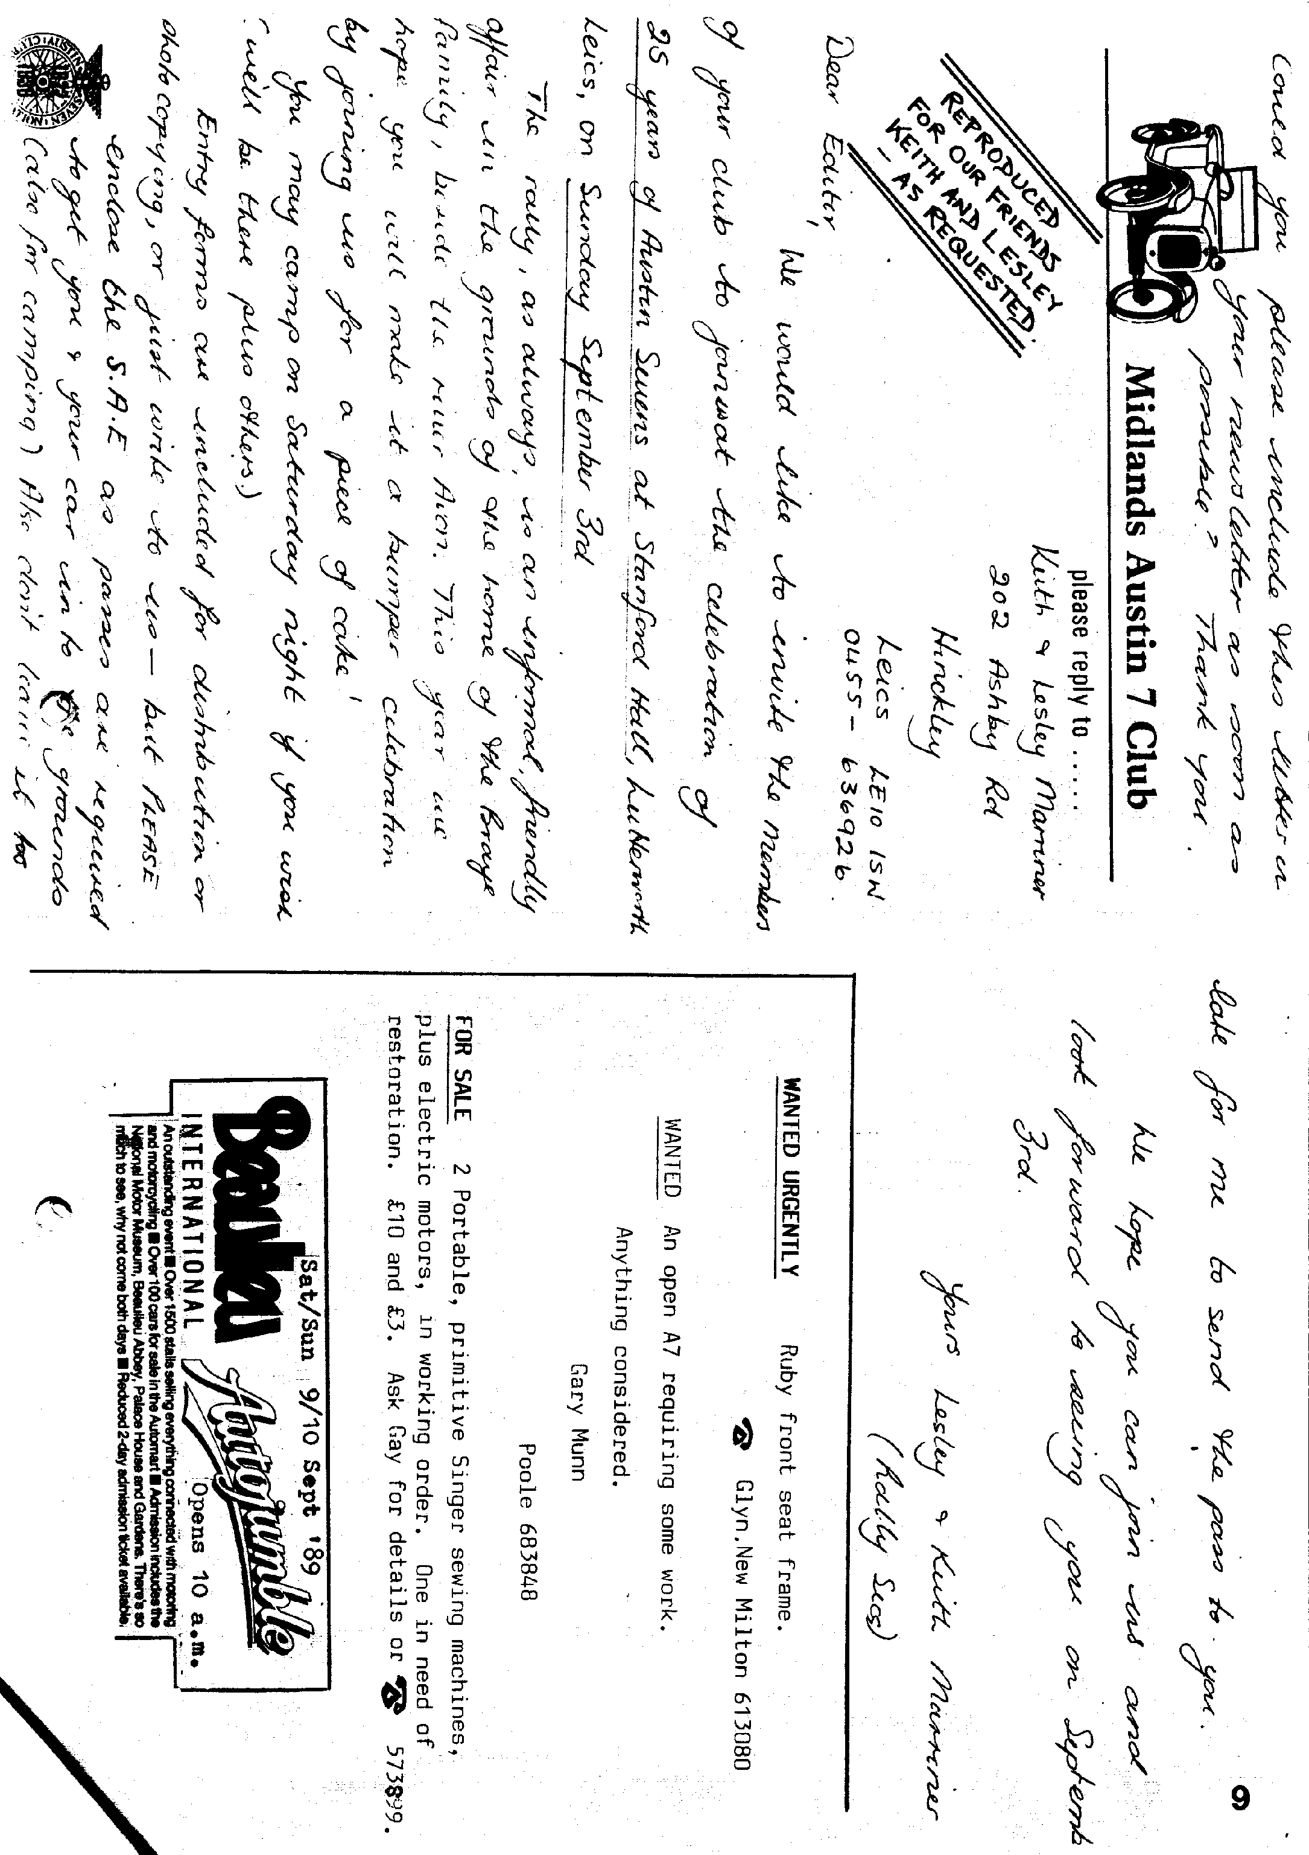
HOBBS GEARLESS TRANSMISSION.

Inventors since the beginning of motoring have been striving to discover some means of varying the gear between the driving and the driven members in a motor car automatically and in an infinite number of different ratios. Theoretically, the perfect gear is that which maintains the engine's speed constant while it adjusts the relative speed of the road wheels to all variations in the load placed on the vehicle. Thus on a hill' the perfect, infinitely variable gear would gradually lower the gear ratio as the steepness of the hill increased and would, therefore, allow the car to move more and more slowly while permitting the engine to turn at exactly the same rate all the time.
The ordinary gear-box is a compromise, offering perhaps four fixed ratios and relying upon the flexibility of the engine to span the gaps between the optimum engine speed for one gear and the next. Infinitely variable gears have been invented from time to time, the Constantinesco (q.v. torque converter being one which was successfully tried in a car. Others have depended upon friction (see Friction Drive), that used on the early G.W.K. light cars being an example. In this form of drive an infinite variety of ratios is possible between neutral and top gear, but in practice the gear-changing lever is moved a set distance between one ratio and the next.
Nearly all mechanical infinitely variable gears, as distinct from those depending on friction, employ some form of ratchet, though it is very often called by a different name. Among the most interesting mechanical infinitely variable gears is the Hobbs " gearlesa " transmission.
The essential element of this transmission is an epicyclic train consisting of a disk carrying two planet wheels on each of which there is an eccentric weight, throwing the planet wheel markedly out of balance. Meshing with the planet wheels is a sun wheel keyed to a shaft fitted to the forward end of a long laminated spring shaft. This spring shaft, together with a roller clutch of special type, takes the place of what, in other types of infinitely variable gears, would be the ratchet, or " mechanical valve." In other words it smooths out the drive and converts it from a series of impulses to a steady flow.
The action of the gear is mainly the result of the unbalanced forces set up when the two planet wheels with their eccentric weights are rotated on their disk by the engine. It is clear that the weights will tend all the time to fly out, and that if the disk were turned fast enough, the weights would, under the influence of centrifugal force, remain out and would prevent the planet wheels from turning at all. This condition, being the simplest, may be considered first.
Imagine the disk mounted on the engine and carrying its two planet wheels with their eccentric weights. Imagine that the engine is started and that the disk rotates and that a slight braking effect is placed upon the planet wheels. The planet wheels will then rotate independently as well as with the disk. But as the speed increases, the eccentric weights will tend to fly out with increasing force, and if the planet wheels are still to rotate independently, a much greater braking effect would have to be applied to them. If it is not applied, then the disk will rotate, carrying the planet wheels with it, those planet wheels not rotating independently at all.
If, therefore, the planet wheels were connected with another gear wheel, a sun wheel, for example, the sun wheel would be taken round with them as if the whole assembly were locked together. In this condition the driven shaft keyed to the sun wheel would be rotated at exactly engine speed and a direct drive top gear would result.
But supposing now that a braking effect, which might result, for example, if the car were being driven up a hill or being started from rest, were applied to the sun wheel. If it were strong enough it would overcome the centrifugal force acting on the eccentric weights and force the planet wheels to spin independently as well as with the disk. And in so far as the braking effect is increased so will be the speed of the planet wheels. The result is that as the braking effect (or load on the car) increases, the gear will be progressively lowered.
A complication is brought into the operation of the gear by the action of the eccentric weights, which do not move with perfect smoothness, inasmuch as they are moving freely in one direction and under constraint in another. They are balanced one against another, but even that does not entirely smooth out the drive, and therefore behind the sun wheel is introduced a roller type of clutch, which, however, can be controlled by the driver for reversing, and the previously mentioned spring shaft made up of a number of laminations. The drive is transmitted through this clutch and along the shaft, so that all jerkiness is damped out and a smooth turning effort is achieved.
This gear has been tried with success in an experimental car and has attracted a great deal of interest from engineers.

EVENTS

AUGUST Saturday 12th August - Evening Run to The Drovers, Wimborne St.Giles. Meet at Wimborne Square at 7.30 pm

Extra Sunday 13th August - New Forest Run and to Brian Williams' home. Bring your own picnic lunch and swimming costume. Meet at Ringwood Furlong Car Park at 10.15 for 10.30 am.

Thursday 17th August - Club Night - An informal Club Concours d'Elegance at The Dudsbury. 8.00 pm.

Sunday 20th August - Club Run to Witsbury, nr. Rockbourne. Meet at Ringwood Furlong Car Park at 10.45 for 11.00 am.

Thursday 24th August - Committee Meeting at the Tyrrells Ford 8.30 pm.

SEPTEMBER Thursday 7th September y'9 to Late' at The Old Thatch, Uddens Cross, on the old Ferndown to Wimborne road. (For those who want to meet for a natter.)
Thursday 21st September - Club Night at The Dudsbury. Spares
:
Evening. All Club spares plus a selection of second-hand items available. 8.00 pm.

5 Larch Grove
13.7.89 Warwick CV34 5TA
Lickey Grange - Austin Appeal (0926) 497641

Dear Austin Fan,
As a matter of some urgency, the Bromsgrove Planning Committee asked the DoE for Listed Building protection two months ago for Lickey Grange,- which was refused.- Since then, the Planning Committee have instructed the Chief Planning Officer to request the Minister at the DoE to reconsider and have placed more historic evidence before him.
YOUR efforts have brought the battle this far. We now have Bromsgrove Planning Committee, Birmingham City Council, public opinion and the weight of Austin enthusiasts the World over fighting this case. This surely proves its merit?

We need a final push to get a preservation order placed on the house and we do this via lobbying. WE NEED YOUR HELP PLEASE - inundate them with letters.

Please write a brief letter stating:-
You support Bromsgrove Councils efforts to obtain listed status for it. You are opposed to the planning application to demolish Lickey Grange.

Please send this letter as soon as possible to:-

Sir Hal Miller. MP for Bromsgrove Your own MP
The House of Commons The House of Commons
Westminster Westminster
London.
London
AND,
Dept of the Environment
Listing Section,
Lambeth Bridge House
London SE1 7SB .

Finally, the "Lickey Grange- - Austin Appeal" is still open to receive donations, both large and small, public and anon. to the fighting fund. Payable to Lickey Grange - Austin Appeal, C/o Howard Annett, Burnt House, Rowhook, Nr.Horsham, West Sussex.

Thank you for your support - and please, don't delay - write today
Yours sincerely,

L.N.Gammon

