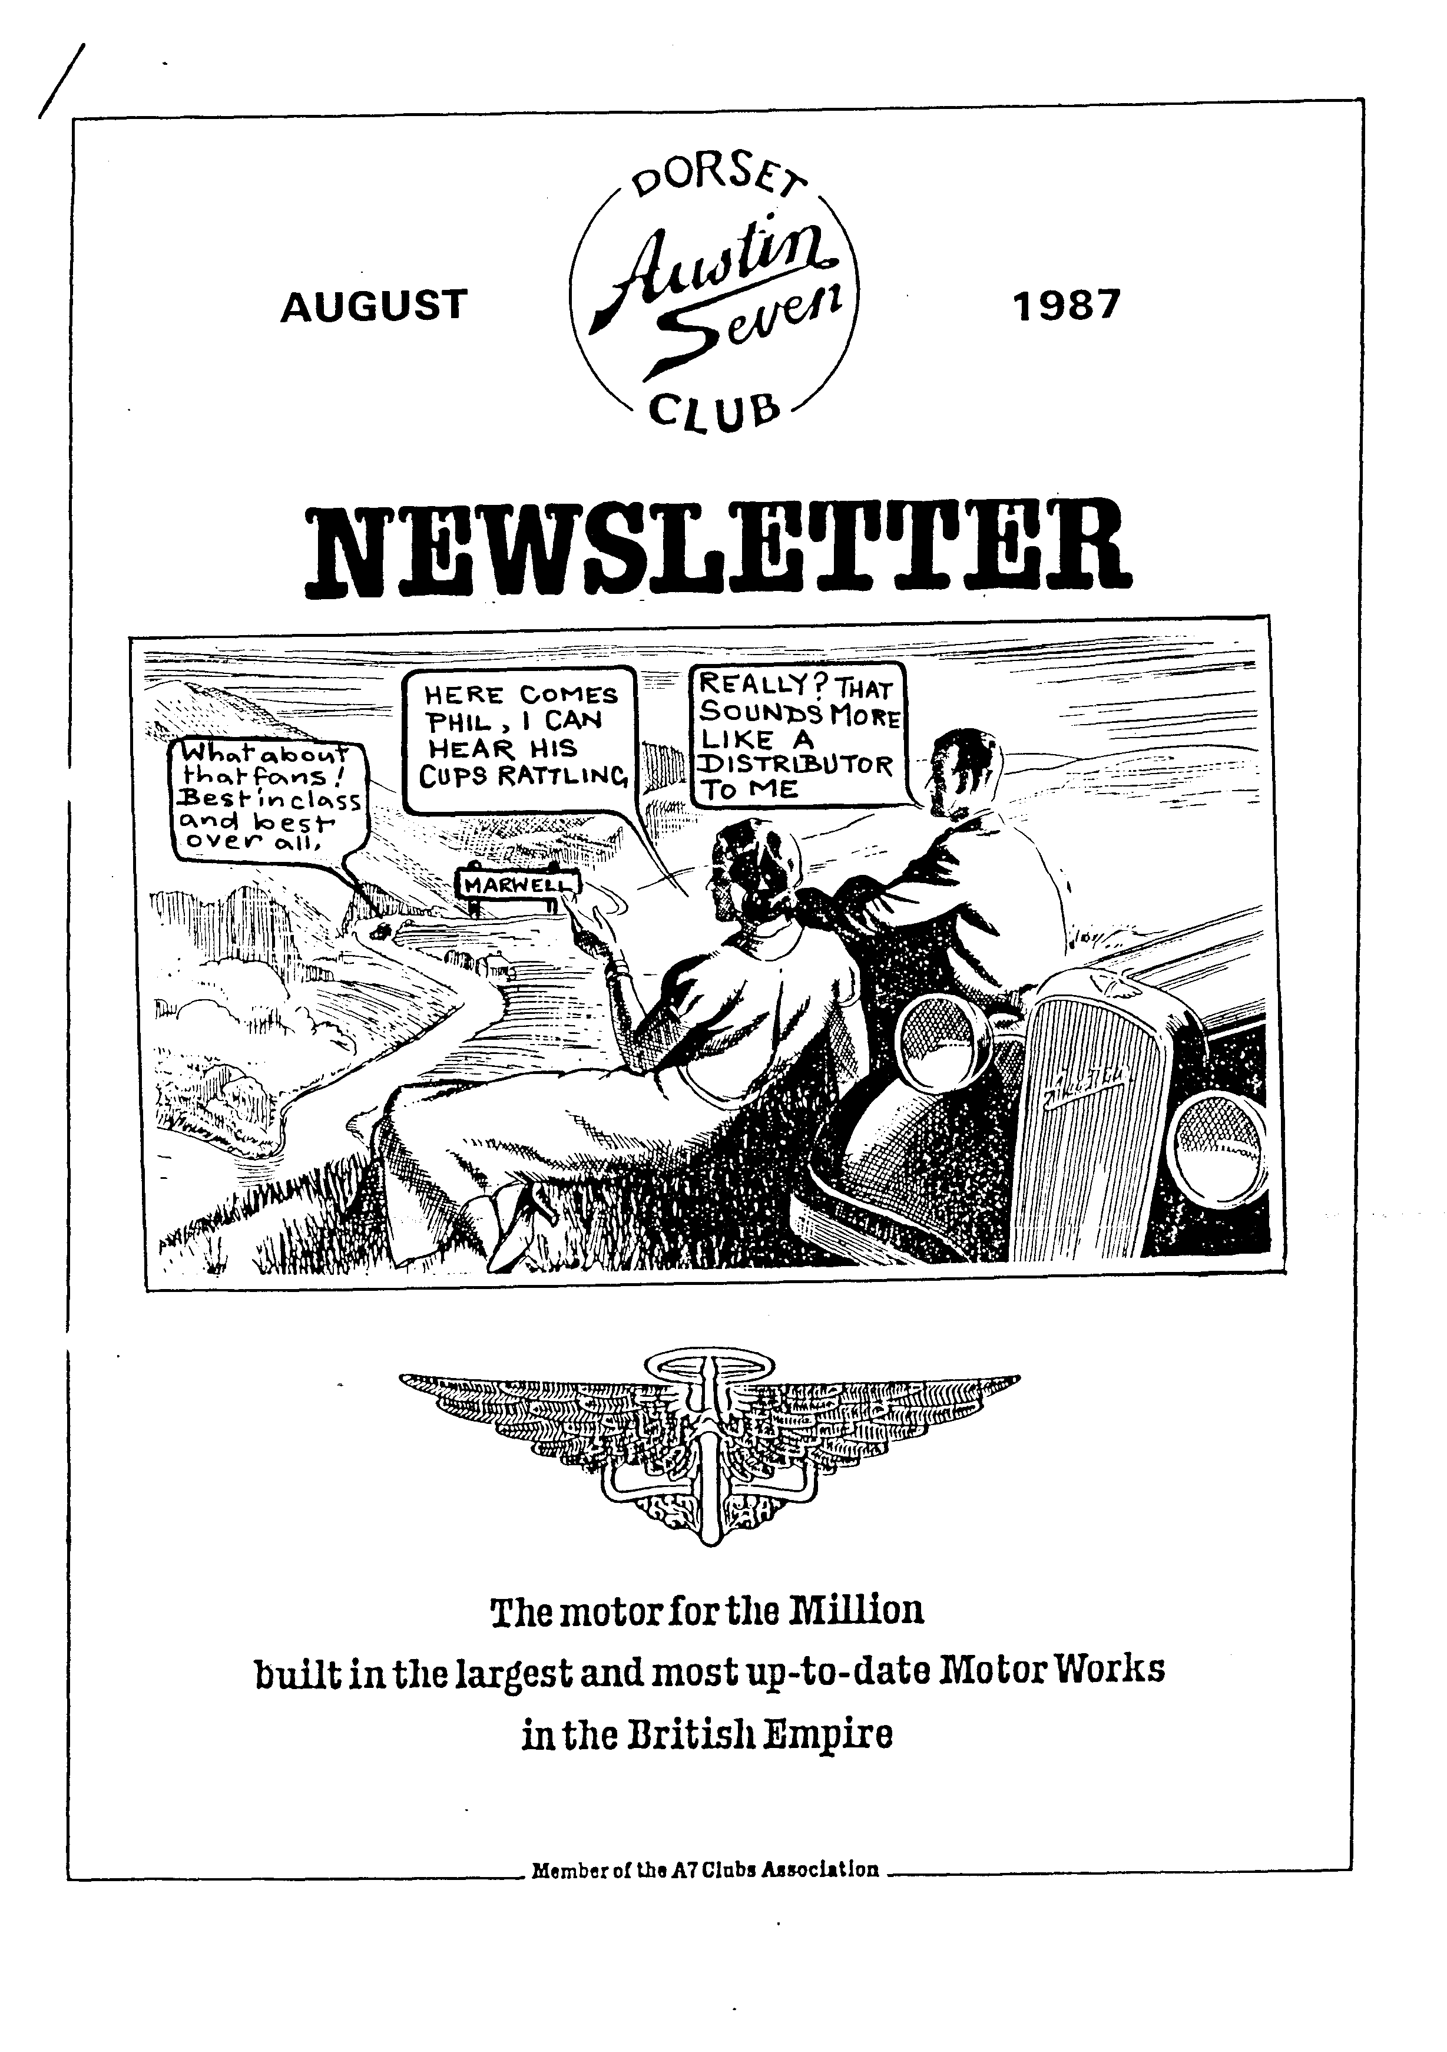
SECRETARIAL ' Hi Gang 1

Phew, it's hard to believe that at the National Rally at Beaulieu, just three weeks ago, temperatures were in the eighties, and this last Week-end at Marwell Park, where the Solent Club held their annual rally we all walked round in coats, carrying umbrellas. Talking of the Solent Rally I notice that 'Dorsets' took most of the 'pots' again this year; even my old Ruby won its class : Dave Tanner came 1st. with his Opal, Bernie won the Rose Bowl (again) and Phil and Hilary Whitter won two cups, then promptly broke down on the way out. Must have been the weight of the 'pots'

I understand our Editor, John Weaver, and Gay have been off sunning themselves in some exotic clime, so I'm not sure if he is 'doing' the Newsletter or not this month. Hope they are enjoying themselves anyway. (I am and we did : Ed.)

Member and ex-Secretary George Mooney is in hospital in West Germany having treatment for a kidney disorder. All the best, George, from all of us. Hope you will soon be back 'in the pink'.

I don't quite know what's happened to our monthly runs this summer, but there seems to have been a bit of a hiccup with no runs in June or July apart from the evening ones.

Pat and I are now tourerless as I sold the Special at the Beaulieu Rally. I shall just have to get on with the Opal now.

See you Club Night. Glyn.
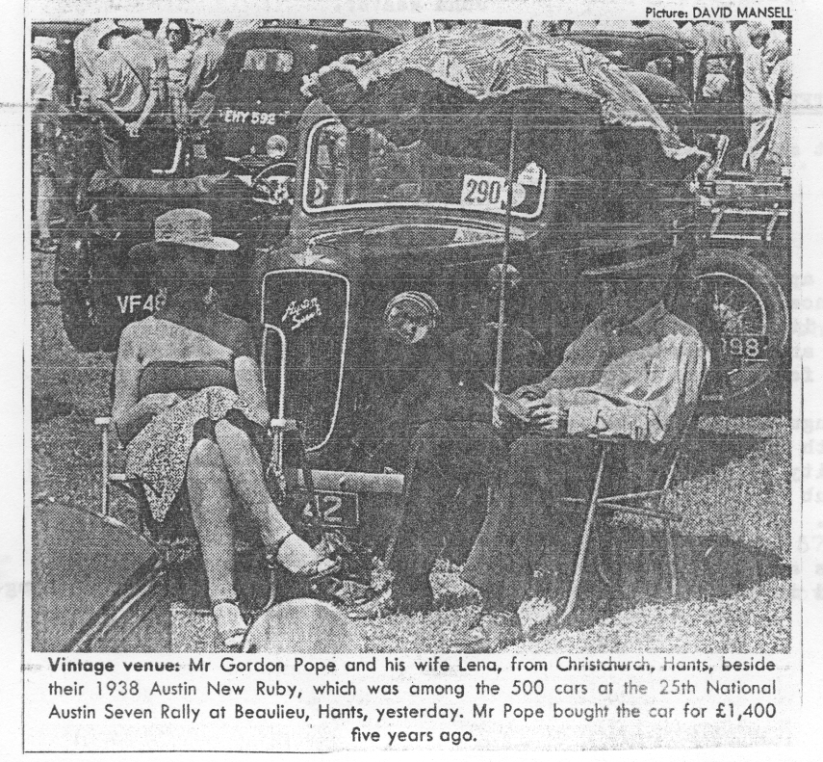
DID YOU SEE.... Gordon and Lena featured in the Daily Telegraph after the National Rally ?
This was the only mention of the event.
The 'Dorsets' strike again! Publication of the picture brought them letters from old friends in various parts of the country.
MOTORING MEMORIES

It must be a sign of advancing years to be recounting your early memories of motorcycles and cars yet there is something special about those first encounters of the mechanical kind which can never be repeated and which others may find interesting and perhaps amusing - so here is the brief story of my motorcycle days.
At the age of fifteen one looked enviously at the Nortons, the Triumphs, the Velocettes and the mighty Vincents. However, a visit to the local dealer on your racing bike soon brought home the harsh reality of that all important commodity called money ! Do you remember 'Mentanes','Jenkin and Purser', and 'Dardani and Large' ? I worked out that if I could earn about F,20 I could get mobile with a well-used 125 c.c. two stroke "trade in". Easter was approaching and if I worked non-stop in the kitchens of the Pinecliffe Hotel
I could expect to get £19 for 19 days work. How I sweated during that holiday and I soon appreciated that Italian waiters actually did threaten each other with knives I
I arrived at Dardani and Large clutching my hard earned cash and intent on striking a bargain. The larger €40 and €50 bikes were soon eliminated and my choice narrowed to the up-to-€30 range. Finally I settled for the power and glory of a shining black (well "shining" in my eyes :) 125 c.c. Norman powered by a Villiers engine and for €19 they delivered it as well. At last I had crossed that magical barrier into the world of motorised transport.
I was not yet sixteen so a few months were spent reading manuals and polishing everything ready for the "off". A basic crash helmet was purchased and enhanced with chromium tape speed 'V's. A secondhand WW2 flying jacket completed the outfit (purchased from a friend for €2) - now I could even appear in Joe's Cafe at the end of the Christchurch bypass !
At last my birthday arrived and despite restrained worry and anguish from my parents I set off to master the wonders of gear changing and the throb or should I say "phut" of power up to 50 m.p.h.
My three paper rounds paid for the petrol and other essentials, but having been successful on my test the demand for more power and some cross country excitement meant looking for a trials bike which would satisfy these desires: Money was again the limiting factor so I took a summer vacation job selling ice cream for Bournemouth Corporation from Alum Chine teamed up with Tony Blackburn (before he became a D.J. !). Tony had a new Ariel Leader - lucky so and so - you couldn't pull the women with a 125 Norman. I always remember that when it rained we rushed to the other end of the prom. as far
as possible⁻ from the--cafe- so we wouldn't--have--to serve-or-wash up,- Another - favourite trick was to secretly throw "dry ice" into the water and watch the antics of the brave holidaymakers who investigated the smoking, bubbling sea 1
The proceeds from the ice cream selling financed a 197 c.c. James trials bike, but this encounter was short-lived as-it had lots of acceleration but no speed and my Castrol tin silencer filled with wire wool did not improve either its performance or relationships with the neighbours.
I had always secretly fancied myself as a leather capped Marlon Brando type with dark glasses riding a Harley Davidson and a friend was instantly the envy of us all when he appeared on a 500 c.c. Ivory Calthorpe (what magic in that name t)
I was soon to leave school and join the Post Office Telephones as an apprentice and money was tight so how could I aspire to a Harley Davidson or something similar ? The answer to this came one day when a friend announced that he had a 600 c.c. Panther with sidecar attached which had to be removed from his parents' garden A.S.A.P. An inspection was arranged and there under some trees was the unlikely answer to my dreams - a 1936 600 c.c. single cylinder Panther with the original yellow leaping panther transfer on the flat tank, girder forks and a sprung saddle. The exhaust pipes were rusted out and the vestiges of a sidecar were attached to a chassis. I was assured it ran and after several attempts it fired up sounding more like a stationary engine. "Is there oil in it ?" Z asked. This was confirmed by my friend undoing the sump filler and with neither of us knowing about wet sump crankcase pressure there followed a massive spray of oil which totally

covered his mother's line of clean washing : With even greater pressure on him to dispose of this monster I parted with €Z and with the help of some friends we pushed it some two miles home. Mum and Dad were very forgiving ("It all keeps him off the streets") and there followed several weeks of concentrated restoration which included shiny new silencers and a pair of "Harley bars" from Ken Graham in Charminster Road. Outside Ken's shop one of the local cafe racers had left his Manx Norton, and the contents of the lubrication system in the form of several pints of Castrol R had just deposited itself on the road when a makeshift oil plug had become dislodged. (Remember all the bikes outside Ken's place ?)
I was very proud of an addition I made to the instrumentation in the form of a large brass pressure gauge from Hamworthy Engineering which read from 0 - 150 (the casual observer might think 150 m.p.h.) but in fact although it looked good it only registered crankcase pressure of almost 5 p.s.i. "Tiberius" as it was affectionately known was a real handful because being basically a sidecar bike you had to hold it upright on bends to prevent the exhaust pipe hitting the ground and I also remember the brakes were similar to an Austin Seven. With sidecar gearing it had tremendous pulling power but lacked top speed which was probably just as well as it started to wobble at over 60 m.p.h. .
After a spell solo I decided to try it with a sidecar attached and
many hours were spent refurbishing the remains of the existing sidecar.
A friend's father who was a blacksmith even made some wrought iron scrolls for the front of it which I painted gold. The first time out with the
sidecar I did not appreciate the pull on the steering and promptly shot across the road hitting a neighbour's wall. Fortunately no serious damage was done and sidecar driving technique was soon mastered.
There followed a series of camping expeditions with the sidecar with three of us being carried and this was when the amazing pulling power of
a 600 c.c, single cylinder was really appreciated. For a short spell I even tried just the chassis and had great fun on corners jumping off the bike and onto the chassis.
In spite of all this, motorcycles were beginning to pall and the onset of my seventeenth birthday focussed my attention on the need for a car and having savoured the delights of a pre-war motorcycle I would only be content with a pre-war car.
But that's another story I
Phil Whitter.
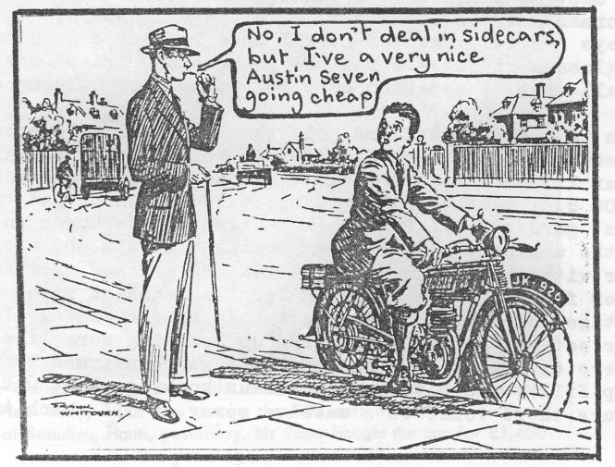
RESTORING BRAKE EFFICIENCY
Preventing Oil Penetrating to the Brakes of the
Austin Seven and Relining the Shoes
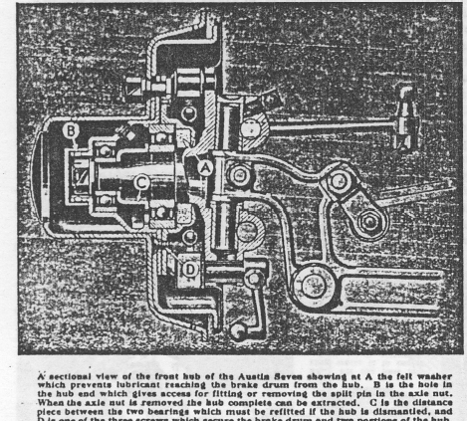
difficult to deal with as it is located inside the end of the hub. The head and ends of the pin should first be chiselled off with a small cold chisel or sheared off by driving the box spanner onto the nut. Then, using a suitable drift through the hole in the end of the hub (which should be turned until in line with the split pin) the remains of the pin can be driven clear of both the nut and the axle end.
When the nut is off it may be possible to prise the hub off the stub axle, but if the hub em actor is required, its body can be screwed home on the thread of the outside of the hub and its screw tightened firmly on to the axle end. By continuing to tighten up this screw
, the hub will be withdrawn from the axle. If it proves stubborn, a smart blow with a hammer on the head of the extractor screw when tight will usually "start" it.
IN our last issue we dealt with Austin Seven brake adjustments and with maintenance as far as proves possible without removing the hubs. Here we propose to take the subject of brake attentions on this model a step further and deal with the rectification and prevention of "oil on the brakes," as well as the process of relining, for both of which hub removal is essential.
Access to the hubs of either the front or rear wheels first of all entails removal of the wheel itself and then the brake drum, the latter being secured to the hub by three screws which also hold the two portions of the hub together.
For withdrawing the hub a small extractor is supplied in the tool kit. The front hubs are free for removal when the axle nut and its securing split pin are removed. The nut will be found behind the hub cap and will require a 7/16 in. box spanner which will fit inside the. hub casing.
The split pin may be found somewhat
1 tie procedure for removing the rear hubs is somewhat different, due to the inner portion of the hub retained by a bearing nut.
When the axle-nut has been removed and the extractor screwed into position, the outer portion of the hub is first withdrawn. As it is mounted on a taper on the axle shaft and is keyed to the shaft as well, it may prove more difficult to withdraw than the front hub, and the practice of tightening both the body of the extractor and the screw well home, and then giving the head of the latter a sharp blow to start the hub, will most likely prove essential. Do not mislay the key ; it will be found in the axle-shaft when the hub is clear. The paper washer located between the two portions of the hub should also be saved unless damaged so that a renewal is desirable.
The large nut which retains the wheel bearing and inner portion of the hub is now accessible, and can be screwed off the end of the axle casing when the tab of its locking washer has been bent back.
Subsequently the inner portion of the hub and its bearing can be prised off the axle casing ;
Restoring Brake Efficiency -contd.
if it proves stubborn the outer hub should be refitted up to it and secured by its screws, whereupon the extractor can again be used to withdraw both. portions of the hub together.
In- both the front and rear hubs of the Seven the oil or grease is prevented from penetrating from the hub to the brake drum and shoes by a felt washer located behind the ball bearing in the inner hub shell. Splitting the hub gives access to this bearing, which must be removed from the inner hub casing before the felt washer
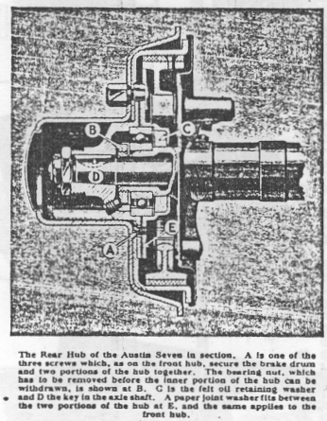
can be reached. When the inner hub is dismounted the bearing ran be tapped clear from the rear side. With it will come the retaining plate for the felt washer, to leave the latter fully exposed. The washer is in the form of a ring and can be readily extracted from its housing.
The new washer should be soaked in hot liquid tallow and fitted while warm and moist so that when the tallow sets it will make an effective oil seal. The retaining plate should be immediately pushed into position with its concave face outwards and the bearing tapped home to bed on it.
When reassembled there should be no recurrence of oil leakage unless or until the hub
(or possibly the axle where the rear brakes are concerned) is overcharged with lubricant.
The question of brake relining is often involved when lubricant has reached the linings as, quite apart from wear, relining may be required because oil has permanently impaired their braking efficiency.. Naturally, an attempt will first be made to overcome the oil leakage if the linings are still capable of further service if protected from oil. Actually, leakage past the felt hub washer may terminate with a reduction of the supply of lubricant to the hubs and/or axle, . in which case renewal of the felt washer may prove unnecessary.
.
As mentioned in the previous article, all oil inside the brake drum, on the back plate of the brake or on the exterior surfaces of the shoes and hub, should be washed off with petrol. The linings should also be washed with petrol and if they fail to give efficient braking after this treatment relining can be assumed to be the only remedy.
The need for relining as a result of wear will be obvious from an examination of the linings which; in this event, will be so thin as to leave no clearance above the rivet heads.
The shoes are held in position on the axle -by the brake springs and can be readily detached when the hub is off. They should be identified so that the same pairs can be reassembled together after the relining process.
Removal of the old linings presents no difficulty. The easiest method of doing this is to punch the hollow rivets through from the inner face of the shoe holding it the while in a vice. If the rivets are not of the hollow type their heads can be cut off with a cold chisel so that the rest of the rivet can be punched clear. Alternatively, the old linings can be prised off the shoes and
the rivets removed subsequently. The shoes, although of aluminium, are fairly substantial, but even so it is advisable to avoid being too vigorous at any stage of the process so that there is no risk
of damage or distortion. The surface on which
the new lining has to bed should be cleaned off so that the lining, which is supplied already
curved to the correct radius, can sit securely on the shoe. Needless to say, the side with the countersunk rivet holes will be uppermost. Four hollow rivets will be required for each lining, and the rivet must be supported on a punch held in a vice while its head is riveted over. The two centre ones should be fitted first and riveted well home so that their heads bed down into the countersinking in the lining. Then the end rivets can be fitted to make the lining secure
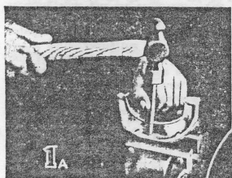
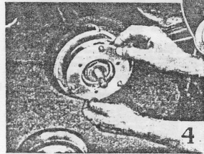
with all the rivet heads well countersunk.
Each shoe can be similarly treated and it is essential to reline at the one time all four shoes on the one axle. Actually, of course, it is desirable to reline all four brakes, both front and rear, when undertaking this attention, but if for any reason only one axle is dealt with, it will obviously be necessary to recompensate the operation of the brakes as between the two axles.
With the lining fitted, it should be "backed off" at each extremity, i.e.., tapered down to half thickness, extending about half-an-inch from the end. This prevents brake "grab" and uneven operation. The surface of the lining should also be roughened slightly with a rough file.
After re-assembling the shoes in their correct pairs on the axle, the hubs can be refitted.
At the rear it will be necessary to tap the inner hub with wheel bearing, etc.., into position on the axle casing so that its securing nut can be tightened until quite firm and locked with its washer. Then, before fitting the outer portion of the hub, the bearing should be smeared well with grease to provide initial lubrication, the key inserted in the end of the axle shaft, and the paper joint washer (or preferably a new one) fitted to the joint surface of the inner hub.
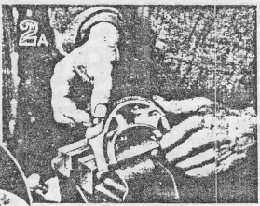
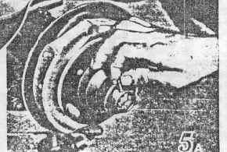
The outer hub can then be replaced on the axle shaft and key and driven up approximately into position. The hub can be finally pulled up into position by the axle nuts, which must be secured by its spilt pin when home. With the outer portion of the hub located the inner hub shell should be prised outward if necessary so that the two hub flanges meet with the holes for the three securing screws in alignment.
The front hub, if split, also requires the paper joint washer (or a new one) to be fitted between the two portions of the hub, and an initial supply of grease supplied to the bearing, but in this instance the hub can be assembled before being refitted on the axle.
When the front axle nut has been tightened, its split pin must be fitted, for which one of the slots in the nut and the hole in the and of the hub must be aligned with the hole in the stub axle.
If relining has been undertaken it will be necessary to slacken off the brake adjustment before the brake drums can be replaced. Tighten the three securing screws for each drum evenly, a turn or so at a time.
Finally, before the wheels are fitted, a good charge of grease should be given through the grease plug on each hub.
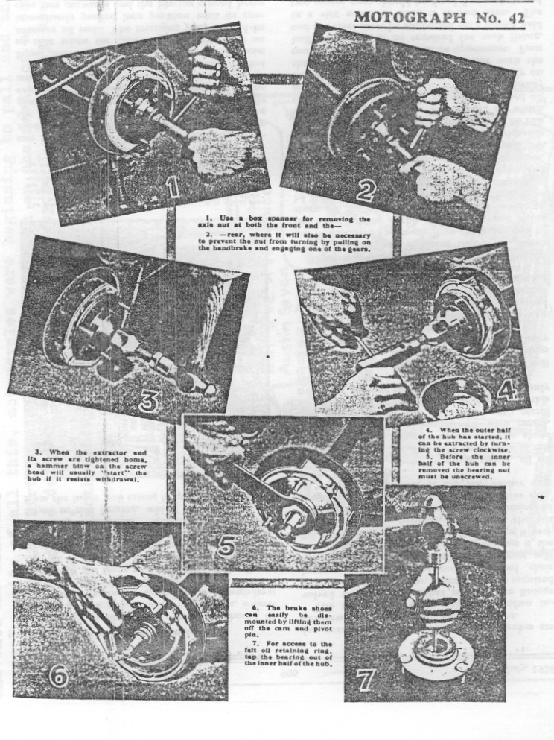
.
Competition Results ,

At least two people, were interested in last month's 'Name the Radiator' Competition. The first was myself, who prepared it, and the other was Bill Quayle - the one and only entrant. Before Bill's entry arrived an entry with only one right would have won the comp. However, Bill had an amazing 8 correct answers. Pretty good in view of the difficulty, Well done, Bill. He will be awarded the Radworld Preliminary Challenge Cup - as soon as the metal detector boys can find it.

The correct answers were :
1, Austin 2, Jowett _{.3.} Hillman 4. Sunbeam 5. Calcott 6. A.C. 7. Riley 8. Standard 9. Swift 10. Bentley

If you couldn't manage to identify those try these
Bill also came up with two possible captions for the motoring cartoon which showed a puzzled man regarding his engine compartment, with bits of engine around his feet.
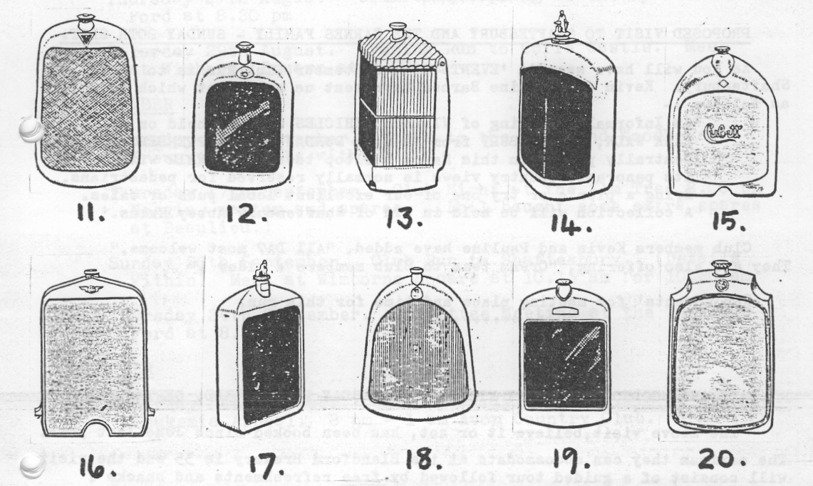
Both of Bill's entries raised a chortle for me - so here they both are :
"Gary - if it is really a three bearing job as he said - we've lost one;
and
"Now where do I .look for my cap badge, Pat ??"
Thanks Bill I
++++++++++++
FOR SALE AUSTIN SEVEN SPECIAL. ₁₉₃₅ Ruby chassis fitted with new open, aluminium, 4 seater body, with hood and tonneau cover. Taxed and with MoT Certificate. Interesting registration - AAA339. Z2,750. Ring Mike Wragg on B'm'th 529896 or 531464.

THE SECOND CLUB VISIT to the Nicholson Collection at 'Rufford', to support the Salvation Army Fete saw a keen turn-out of twelve Club cars. We looked splendid lined up in such a setting as the band played and it was interesting to see the Collection again.
In spite of his exotic cars Mr. Nicholson dropped some heavy hints to your Editor that he would like to try an A7. He was invited to do so, looking quite excited as he climbed into 'Gabrielle J,', and set off in his grounds. He didn't seem to think much of my clutch, but nor do I. Apart from that he clearly enjoyed his mini-spin. Perhaps I shall drop him some heavy hints about the 1928 Le Mans type 4 1/2 litre Bentley next time I see
him. Fair's fair.
It was a very friendly and pleasant afternoon. Mr. Nicholson was certainly grateful for the turn out of 'Dorsets'.
+f++++++++
PRO-DOSED VISIT TO SHAFTESBURY AND THE BARNES FAMILY - SUNDAY 20TH SEPT.

As you will have seen in 'EVENTS' the September Club Run is to Shaftesbury. Kevin and Pauline Barnes have sent us a leaflet which reads as follows :
'An Informal Gathering of VINTAGE VEHICLES will be held on
PARK WALK, SHAFTESBURY from 12 noon SUNDAY 20TH SEPTEMBER. ` Centrally placed in this Saxon hilltop town, Park Walk with its panoramic country views is normally reserved for pedestrians. Bring a picnic or try one of our excellent local pubs or cafes. A collection will be held in aid of Shaftesbury Abbey Ruins.'

Club members Kevin and Pauline have added, "All DA7 most welcome." They are also offering, "Cream teas to Club members + cider

See 'Events' for meeting place and time for this run.
++++++++++
HALL AND WOODHOUSE BREWERY VISIT - THURSDAY EVENING 3RD. SEPTEMBER.
The above visit, believe it or not, has been booked since June last year.
The maximum they can accommodate at the Blandford Brewery is 35 and the visit will consist of a guided tour followed by free refreshments and snacks j °
Meet 7.00 p.m.. at Wimborne Square or at the Brewery at 7.25 p.m.. I must have numbers beforehand; so to ensure your place you must book early using the attached form.
Remember - 35 people maximum : The visit is free : Gary.
- . . . . • • e e , e • • . . e s , e • • e . e s . •

Return to Gary Munn, 12, Shaftesbury Road, POOLE, Dorset, BH15 2LT.

Please reserve me ..., place/s for the Brewery Visit on Thursday 3rd. Sept. NAME
ADD^{RESS}
..............................................................

EVENTS

AUGUST
Thursday 20th August. Club Night. Meet at the Elm Tree at 8.00 pm for a run to the Royal Oak, N. Gorley.

Friday. 21st - Sunday 23rd August. Purbeck Rally and Autojumble

Sunday 23rd August.; A picturesque run into North West ^{-Dorset}, Meet Wimborne Square at 9.45 am for 10.00 am

Thursday 27th August. Committee Meeting at the Tyrrells Ford at 8.20 pm

Saturday 29th August. Evening Run to Corfe Castle. Meet at Wimborne Square at 7.30 pm

SEPTEMBER

Thursday -3rd-September. Visit to the Hall and Woodhouse Brewery (Deta^{i}ls w^{i}thin)

Thursday 17th-September. Club Night at the Elm Tree 8.C0 pm Noggin, natter end spares. (Phil bought some extra spares at Beaulieu.)

Sunday 20th September. Club Run to Shaftesbury. (Details within) Meet at Wimborne Square at 10.15 am for 1U.20 am

Thursday 34th September. Committee Meeting at the Tyrrells Ford at 8.30 pm

OCTOBER

Saturday 24th October. Verity Party/Disco in aid of Leukemia Appeal. I pm 1 am Avon Country
P Club.

