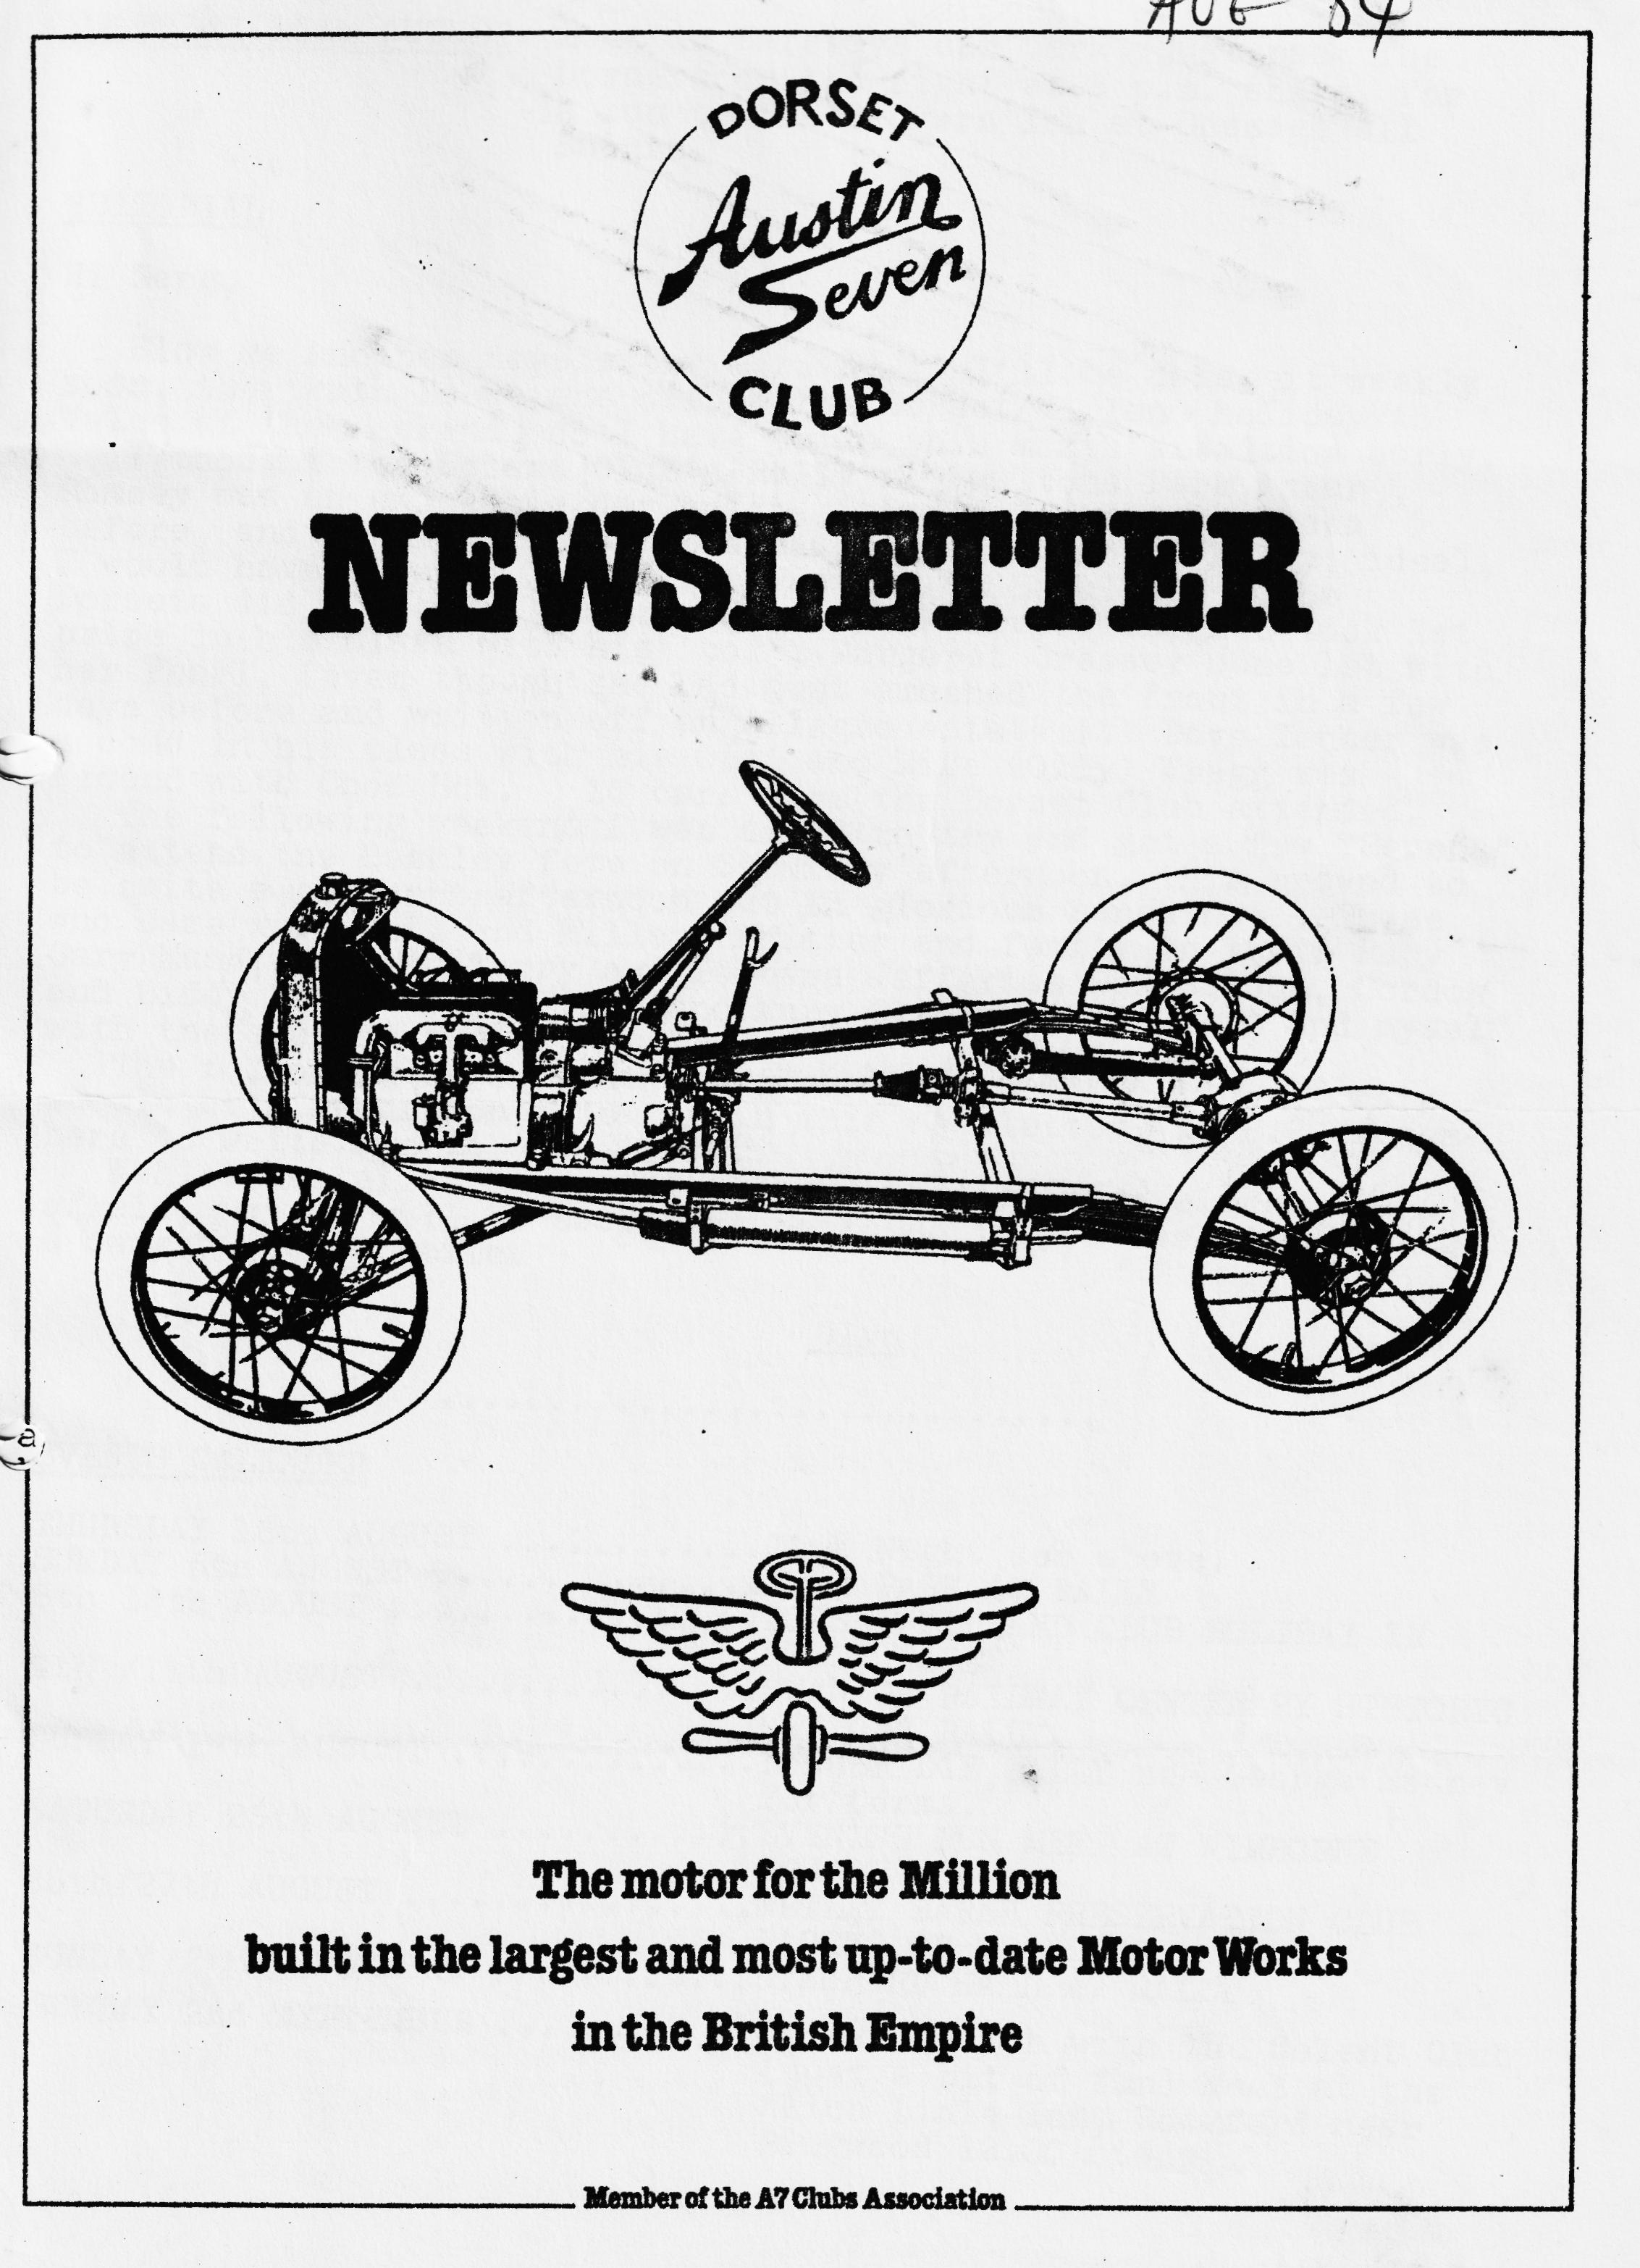
DORSET A7 CLUB NEWSLETTER AUGUST 1984
CLUB NIGHT
THURSDAY 16th AUGUST meet in Safeways car park, just past The Dormers on the right at 8 p.m. sharp, for a run to The Drovers Inn at Gussage All Saints.
EDITORIAL
Hi Gang,
Blow me, another newsletter already! I'll be doing it weekly soon, the truth is we are off on the Dorset/Midland holiday to Wales at the weekend, so I have to do this month's edition early. I thought the Solent Club's Rally at Paulton’s Park, near Romsey was an enjoyable day out. Pat and I had never been before, and we thought it a beautiful setting for a Rally. Ideal, I would have thought, as an alternative to Beaulieu. The Dorsets did quite well in the Concours, Terry Jefferies took 1st prize in his class with his 'Box', Margaret Cressey came 1st with her Pearl, (even though she had just smashed the front in a few days before and written off, an Allegro estate!!) Dave Tanner was second in his class with his Opal and Mike (Oily) Wragg was second with Choc Box. 15 cars from the Dorset Club attended.
The following weekend I was asked to try and get a few "Sevens" to attend the Bashley fete on Saturday afternoon, this proved to be quite a pleasant afternoon out in glorious sunshine. Those who came were Phil and Hillary Whitter and family in their Ruby, Gary Munn, Chummy, Terry and Barbara Jefferies Box Saloon, Gordon and Biddy Brown Ruby; Jimbo and Mary Clenaghan, Tickford and myself with the special and the Opal.
The following day, Sunday, was our run to Durdle Door, there should be a report on this run in this newsletter, if B.C. remembers to write one that is.
Well that’s all from me this month, no piccy page either I'm afraid, but it will be back next month so if you see me pointing a camera at YOU, smile.
Glyn,

EVENTS CALENDAR
THURSDAY 16th AUGUST Club Night see above.
SUNDAY 5th AUGUST SPYE PARK A7 RALLY
6th - 13th AUGUST DORSET/MIDLAND CLUB HOLIDAY IN NORTH WALES
9th /11th AUGUST SWANAGE RAILWAY CENTENARY HISTORIC VEHICLE RALLY.
SUNDAY 19th AUGUST LONGBRIDGE RALLY see George Mooney for forms.
SATURDAY 25th AUGUST EVENING RUN. MEET AT WIMBORNE SQUARE 7 p.m.
25th/27th AUGUST NETLEY MARSH PRESERVATION CLUB PAGEANT OF TRANSPORT
SUNDAY 2nd SEPTEMBER STANFORD HALL A7 RALLY
SUNDAY 2nd SEPTEMBER Cricket match with the Solent Club (just a bit of fun) Meet at the Alice Lisle Inn, Rockford near Ringwood 12.00 midday.
7th 8th & 9th SEPTEMBER ..... .... Beaulieu Auto Jumble.
CHAIRMAN’S CHAT
Our Editor has asked me to write a few words as he said he hasn't heard from me (on paper at least) for a while. Well this year seems to be going well for the club and we have had quite a lot of support on all our events - except the run to Middle Wallop - never fear we are going to arrange it again for next year. On the static rally front we have had the South Wales rally where we gained a few awards (we polish them sometimes!) Beaulieu of course and the new rally organised by the Solent at Paulton Park - a very well run event. Of late our monthly meetings have been runs to various other pubs which are very well supported - I think we had 15 cars on the last one. By the time you get this newsletter the Bristol A7 rally at the new venue of Spye Park will have come and gone. I must say the Bristol rallies in the past have been one of my favourites especially for the Barn Dance.
Well, keep on Sevening. See some of you in North Wales on our Joint holiday with the Midland A7C.
Bernard
RUN TO THE AIRCRAFT MUSEUM AT MIDDLE WALLOP 15th JULY
THREE cars turned up at Ringwood - Glyn, myself and the organisers Bernard & Jackie & co, for the start of a very pretty run up to Lockerly, near Romsey, via many picturesque roads across the New Forest. We arrived at the pub before opening time, so decided to drive around the corner and visit Reg Picket of the Solent Club and to drop in an oil pump of mine for boring out. He made us very welcome and we spent a very interesting ½ an hour looking around his workshop and numerous Austins. After a quick dash back to the pub for opening time, we settled down to a couple of pints and an excellent meal.
The Vine is owned by Ted MacDougall, the ex-Southampton footballer, and has been very tastefully restored; and of course, is a Whitbread house. After lunch we headed on via a good deep ford, through several pretty Hampshire villages to Middle Wallop airfield. They have recently constructed a new building to house the exhibits and, I must say, have certainly excelled themselves. For a pound each we spent about ¾ of a hour browsing around flying a helicopter (so what if it was only a simulator), and listening to air traffic control over the headphones.
After a cup of tea, we headed on home. Thanks to Bern & Jackie for a very interesting day out. It is a great pity that other club members did not make the effort to come, because it must have taken Bernard and Jackie a long time to plan the day. Clearly, they were very disappointed by the lack of response. (Never mind we can do the run again next year Ed.)
Gary Munn

SECRETARIAL
Well, hello folks. Your editor had to ring me as usual to remind me to get my report in for July/Aug.
Today is a red-letter day. No, I don’t mean that letter from the bank. I have started on PINOCCHIO! Before writing this, I removed the remnants of the body and have started to get the chassis ready for restoration. Look out for the next report. Your secretary missed the last committee meeting due to being up in Yorkshire on business, so I am a little bit out of touch really with recent events.
During the month we attended the Fordingbridge Show. A little cluster of A7s were the only pre-war cars to attend - 2 from Solent including Dave Wiltshire, one unknown Opal with more paint than spokes! Gary & Glyn, Richard Collings from Wareham, Phil & Hilary and yours truly. It was a very nice day out but very horsey. You had to watch where you put your feet.
Our next event is Alderholt because we can’t get away to Spye Park. I hope those who are going take the prizes for DORSETS.
In the A7OC July newsletter I notice there is a gent prepared to restore the faces of A7 instruments, your old dial re-sprayed, lettered and varnished. Speedos £3 and C4 Instruments £2. Interested? contact John Mayer, Bourne End.
I note with disdain the amount of criticism coming from the Midlands A7 club concerning other clubs obtaining sponsorship without permission. Who might I ask has to ask their permission and where does it say so? They even seem to have opinions about other information circulating in newsletters. I don’t know why they complain, we don’t when we receive supplementary information from them.
If you need new chassis side members you can even get these now in 12-gauge galvanized steel. Ring Alan Deacon on 0530 39750 for details.
Well folks, that is about it from me this week. I guess you will be rivetted to the Olympian antics in LA. For my part it will be the antics in the garage.
See you club night. Yours, at it again.
George

"BEGINNING"
Having recently taken JT 105 on annual holiday for the first time in my 13 years of ownership, I thought I would jot down a few words of encouragement for those who have yet to venture, unaided, out into the unknown - I am,⁻by the way, writing this extremely slowly as I know the average Dorset member doesn't read very quickly.
Well, with the MOT passed with flying colours (after I had tweaked the trafficators) at the sympathetic Blandford MOT Centre, Charlton Marshall (The proprietor really likes old cars & owns a Morris 8) (what’s that? Ed.) and having purchased a set of Avon Sidecar tyres the week before our departure, I spent tightening up anything which looked as though it might work loose, and squirting oil, grease, petrol and water into the appropriate orifices Wrestled with the idea of re-joining the RAC Recovery Service, but in the end gave the car the benefit of the doubt. Assembled a collection of spares the most likely to, and of course never do, use and reluctantly left my £5 1972 half-shaft behind through lack of space. (Risky, Ed.)
Destination Criccieth North Wales Through complete inability on my part to tell Mickey Mouse's hand from his foot, left Poole at 9.15 and not the scheduled 8.00. Debbie for once had been ready on time, and I'd better say had been waiting patiently for me. With the car well laden, and the suitcases bouncing up and down on the luggage rack, we sped out of town, and in fact covered 29 miles in the first hour. Regrettably this average was not to be maintained. A few miles further on, having wondered for a split few seconds whether the front axle was still attached, we ground to a halt not far from Warminster with a very deflated tyre and I might say ego. Worried. Should have replaced the tubes as well. Visions of tyre popping every 40 miles. With 210 miles still to go we'd never make it. From being a cool, calm, collected motorist a few minutes earlier I rapidly became a hot cross, and oily tyre changer - it would have to have been an off-side tyre, and it would have to have been a busy road, and the jack would have to have been under a load of luggage under the back seat! In due course, the wheel change was accomplished and a new tube secured at a motorbike dealer at Trowbridge. Average speed now down to 22 m.p.h. we sped off in the direction of Bath, through Bradford on Avon, but slowed down a bit when we turned off right just before the city to take the long climb up the A46 towards the M4. Here we amassed a record queue, but in all fairness, we were following a large lorry which we couldn't get by, mainly due to a 3- or 4-mile tailback of vehicles trying to get into Bath and blocking up the other side of the road. Lunch was partaken of at what must be the last hostelry before the motorway, except we didn't get any as the pub was full of Welsh Rugby & cricket supporters going the other way, and who had somewhat monopolized the place. Came 2.30 we were on the M4. (Motorway travel being a new experience in the 7). Didn't manage to pass a thing, except seven moderns broken down on the hard shoulder, and after some 18 miles at 40-45 (brought the average up again) motored over the Severn Bridge into Wales, which on a gloriously sunny day was quite an exhilarating experience. Then up through Chepstow, Abergavenny, Builth Wells? Rhayader, Llanidloes, and after what seemed a very long time indeed Dolgellau. By this time the place names were becoming a bit of a blur, the scenery was wasted on us, and our behinds, despite our original A7 FLOAT-ON-AIR cushions were becoming increasingly numb. Nevertheless we pressed on down into Porthmadog, alongside the Ffestiniog Railway, and arrived KNACKERED and exhausted at Criccieth just after 8,30 p.m. By this time the car was in much better order than the driver.
During the ensuing days we went on excursions to the Ffestiniog & Welsh Highland Railways, visited Glodfa Ganor Slate mine high above Blaenau Ffestiniog (car certainly needed a rest when we got to the top). Regretted not going to Llechwedd instead which people told us was better - the former was cheaper. Found a number of semi-vertical hills which on the ascent gave us plenty of time to look at the scenery. Looked round and were impressed with PORTMEIRION village and on the final day in North Wales we decided to tackle the 3560 feet of Mount Snowdon. Actually, we decided to let the train take the strain, and whilst I thought the £8 fare a bit steep, even for a mountain railway, had in the end to concede the trip was good value and the panoramic views unbeatable. Unfortunately, thanks to Arthur Scargill the trains were running behind time through the poor quality of fuel - seemed to be burning nutty slack and old tyres.
On the way to the railway at Llanberis we found one of the few good Welsh pubs - The GLYNTWRUG Inn (well, it would be wouldn’t it Ed.) at Llanrug, on the A4086 about 4 miles outside Caernarvon with excellent grub and good beer. Opposite is the local garage where the owner proceeded to tell me about his Austin 7 exploits of years ago, and then produced a set of three Austin 7 Springs. He wanted £12 each. He's still got them, although the price may now have gone down.
Following our trip up Snowdon, I decided fully cognizant that this was the feared road of the pre-war motorist, to ascend the Pass of Llanberis - we made it within sight of the summit, but then the radiator boiled up in a spectacular fashion and we were obliged to wait for a while to cool off. Shouldn't have tried to remove the cap with my bare fingers! It was the same day that following a routine inspection I noticed that the U Bolts round the front spring had worked somewhat loose, although the washers were still in place, and the only way I could see to tighten them was by removing the radiator which I accomplished without losing too many of the associated nuts, belts and washers. I then had the inspiration to inspect the distributor drive gears, as since being brought home by the RAC in 1975 with a stripped worm (ooh painful, Ed.) I have been somewhat paranoid about history repeating itself - I needn't have worried because, on removal, the gears seemed, to my untrained eye, to be in pretty good order, and reassuringly coated in black grease, as was my shirt when I'd finished. However, on putting the whole thing back together again, re-timing etc. paranoia set back in once again, as when I started the engine a piercing screech rent the otherwise peaceful air of a quiet Welsh evening. I repeated the process of removing the distributor, retiming etc., started the engine once more and the shrill noise repeated itself with renewed vigor. There I was with a 51-year-old. car further from home than ever before, wishing I had after all joined the RAC recovery service, wondering what the hell I'd do and not daring to confide my worst fears to Debbie who wouldn't have appreciated the situation. Inspiration soon came - I drove down to the local phone box & was soon listening to John Page's re-assuring voice coming over the wires: "Well I don't know, you've got me". Even when I had maneuvered the car to within inches of the phone box, & given an audio demonstration, with a friendly passer by holding open the phone box door whilst I revved the engine, the diagnosis was no more certain....(and to think I pay this man good money to look after my motors) (John assured me the only noise he could hear was the pips and the 5 pence pieces dropping in, Ed.) Anyway, despite the noise the car seemed to go just as well (or as badly some would say), so we decided to continue with the holiday as normal for the following day we had a 140 miles drive down to Pembrokeshire where we had decided to spend, the remainder of the holiday. After about 60 miles into this journey, I twigged that the noise was due to a musical manifold gasket (were they fitted instead of wirelesses? Ed.) Obviously the copper had corroded and made a sort of reed through which air was being sucked, and despite a bit of tweaking with a screwdriver and tightening the manifold nuts I only managed to change the tune and not eliminate it. Since coming home, I have rectified this with parts acquired through Phil Whitter’s excellent spares scheme (I will expect discount after a plug like that).
However, having now gone on at some length, to avoid being cut short by the Editor (Who me Ed.) suffice it to say that we had a second enjoyable week, and the car behaved perfectly. I am now convinced that an Austin 7 sensibly maintained can still offer reliable holiday transport to equate with any modern, and strongly recommend that anyone who has to date been a little wary about travelling long distances unaided should take the plunge and go. We did 1060 miles in 14 days and about 44 m.p.g. but am not so proud about the 6 pints of oil used!
N.B. Good pub at ABERAERON DYFED, The Harbourmaster Hotel, Quay Parade. Delicious and enormous meals, suit Glyn, very reasonable. Good choice of beer.
2. British Rail does some real bargain trips on its Cambrian line. Really scenic Pwhelli, Barmouth, Machynlleth, Aberystwyth etc. Well worth going on. If you don't use it you'll lose it.
Lawrence
LETTERS TO THE EDITOR
The Bashley Village Hall and Sports Ground Association
Spring Cottage, St. Johns Road. Bashley.
29th July, 1984
Dear Mr. Llewellyn,
I would like to thank you, on behalf of our committee, so very much for arranging for some of your members to bring their Austin 7s to our show. I can honestly say that your cars were a great success for our show. Throughout the afternoon they were the most discussed event and today they are what people are talking of most.
Despite the heat, we made before costs (which are big), over £600 yesterday and your members coming certainly helped to hold the people for the afternoon & got them to spend their money. I do. hope you will want to come again next year and when we've arranged a date you will be free.
Yours sincerely, Gill Gould (Sec.)
18, Cobham Way, Merley, Wimborne, BH21 1SJ
30th July, 1984
Dear Ed,
After your appeal last month for contributions to your Newsletter, I suspect that you are now inundated with material for this month's copy.
However, in the event that you have space, I thought it perhaps time that I showed up in print (after all, I haven't been able to show up in an Austin Seven!). To dispel any rumours, I really do have an Austin - it is not just a case that I enjoy Dancing, Barbecues and the occasional drink! However, sadly my ambition to have it on the road (Barbara says that you may want to edit that out) has been thwarted due to a whole series of both minor and major, problems.
I know that after John Stone told me "within a few months you will get it going", he left the district in a hurry!
I now realise that the estimated five-minute job takes five hours and that the only way to remove a woodruff key is to obtain one spares secretary, one Black and Decker drill, three screwdrivers (for breaking to pieces), and a few whiskies to steady the nerves.
Anyway, after getting through one crank, two crank cases, three carburettors, two petrol pumps, three sets of gaskets, umpteen bearings, valves, springs etc. I seem to have a three-bearing engine that works. (well at least it has run for half an hour), so watch out George, there may be two running three-bearing engines in existence.
I am now consoling myself that all that is left is to re⁻upholster and re-fit all of those minor things like doors, windscreens, seats, lights etc. and a quick paint job and then obtain a minor thing called an M.O.T. and then I will be able to take the, big drive (a visit to the Hon. Sec's house sounds an ambitious first run).
Seriously though - no on second thoughts no one with an Austin Seven can be serious, thanks to all of the club members for their advice and assistance. I really am enjoying my hobby (particularly watching Glyn and Gary humping engines about).
Sorry, I won't be able to make next club night as I shall be up to my neck in Greece - no, not a spelling mistake, - have heard that there is an old Austin Seven abandoned at Mount Athos, presumably left there by the Goddess of Love for old Austins - she too must have had some problems.
Best regards,
Brian C. Hooper
Many thanks Brian, I look forward to seeing you in the 7, perhaps at September Club night? Glyn.

SPARES REPORT
NEW
Brake cams are currently in short supply, but I hope to get some at Spye Park. The following new additions have been made to the Spares Scheme:-
HUB SHIELD PLATES
U/J FIXING KIT
SONNET CORNERS
HIGH & LOW COMP KLINGERITE CASKETS
RUBY BONNET CATCHES
BOX BONNET CATCHES
RUBY VENTILATOR FLAP HANDLES
BOX RAD CAP
ESCUTCHEON PLATE (RUBY WHEEL COVER)
RUBY LOCK COVERS
WHEELS NUTS
WHEEL BEARINGS
REAR REFLECTORS (LARGE & SMALL)
PERIOD, BLACK SLEEVING FOR WIRING
PERIOD RED RUBBER IGNITION LEAD

SECONDHAND
I have the following for disposal:-
BOX SALOON BONNET STAY
RUBY RI R WINDOW WINDERS
RUBY WINDER HANDLES
RUBY REAR WINDOW INTERIOR TRIM
SET LATE 17" WHEELS
ETC. ETC

WANTED
RUBY REAR SEAT BACK
RUBY FRONT SEAT SQUABS
See you soon, Phil Whitter, Ringwood 5558

FOR SALE
RARE 5 hp. HAMWORTHY STATIONARY ENGINE 1922 HOPPER COOLED IN WORKING ORDER WITH SOME SPARES. OFFERS AROUND £200. CONTACT PHIL WHITTER ON RINGWOOD 5558 FOR VENDER’S DETAILS.

TYRES
3-50 x 19 tyres £20 plus VAT. D & L. Tyres, 137 Bournemouth Road, Parkstone 742616

SERVICE.

MUNWELLYN’S:- FOR ALL AUSTIN 7 MECHANICAL AND ELECTRICAL REPAIRS PHONE GLYN ON NEW MILTON 613080 or GARY ON PARKSTONE 745951

AUSTIN 7 CLUTCH AND BRAKE RELINING SERVICE BY RETURN OF POST. BERNARD COWLEY, WIMBORNE 887666

MIG, SPOT &,-GAS WELDING SKILLED TECHNICIAN WILL WORK AT YOUR HOME OR IN OWN WORKSHOP, CAR TRAILER ALSO FOR HIRE. PHONE CHRIS SMITH RINGWOOD 78066⁻

RADIATORS
REPAIRED OR RE-CORED. HANTS AND DORSET RADIATORS, 77, STANLEY RD, BOURNEMOUTH 301277

AUSTIN RESPRAYS GEORGE MOONEY BOURNEMOUTH 425989

6 VOLT BATTERIES BERNARD COWLEY WIMBORNE 887666
UPHOLSTERY & TRIMMING COLIN MORRIS, BOURNEMOUTH 524671

