EDITORIAL APRIL 1991
This is the time of year when spanners and greasy rags are forsaken, be it only briefly, for lawnmowers, trowels and spades. Isn't it great to get outdoors in comfort, sniff Spring in the air and anticipate all those Runs and Rallies that lie ahead? It even makes a bit of gardening a pleasure.

There's more this month on tracing electrical faults. Biddy has struck again (reviewing her offering in the car bound for Gatwick then China and Hong Kong!) Pat recalls the March Run and there are more good things to consider.

Keep up the good work.
John

SECRETARIAL
Well Folks,

It was nice to see two 'new' Rubies on the last Club Run, all of a sudden we seem to have a gaggle of them, funny how it goes, a few months ago all Boxes and before that Specials! Fourteen cars on the Run, and as far as I know no problems on what was a fairly lengthy jaunt.

Investigations are still being made into reflective spare wheel covers, I understand Phil Baildon of the A7CA may have an idea. The problem did still remain of Rubies etc, with enclosed spare wheels. However, Stalwart Members Mike and Sue Topham of friendly guest house and excellent tea fame have come up with a 10" magnetic red version of our very own Club badge which is reflective and will fit between number plate and the base of the boot lid. It looks very professional so watch this space for developments.

Well the idea of an Easter holiday fell on stony ground this year, so as a last minute idea one or two of the 'lads' have decided to pop up country in our Austins for a day or two - don't forget the paracetomol, chaps!

My Ruby is progressing well now - sprayed and wings back on. The opening rear quarter lights are receiving attention tonight, not a job I have been looking forward to.

Cheers,

Gary

THIS MONTHS COVER PICTURE is of Mike and Sue Topham's recently rejuvenated
Pearl Cabriolet. It's looking very smart.

THE NORTH DORSET RUN 24TH MARCH 199
Wordsworth's famous poem 'The Daffodils' came to mind as thirteen A7s wound their way through the lanes and villages on the North Dorset Run. Daffodils seemed to be everywhere, much more so than on the official 'Daffodil Run' held every April (this year on April 21st). It was nice to see so many new faces including Dave and Audrey Thorne and Brian Witt and his wife Dawn on their first Run in newly restored Rubies.
I think we overwhelmed the staff at the Stapleton Arms, but Glyn assures me that the beer was good and so was the food when at last it arrived ! Bernard and Jackie took us on a picturesque route back to Wimborne where we all went our separate ways.
Thank you Bernard and Jackie for organising a very pretty Run. Pat Llewellyn


AUSTIN 7 BEGINNINGS -8- A story of Austin folk.

John and Cynthia Page. (Mulliner Box Saloon OW 221 and Ruby AUJ 211)

'I acquired an Austin 7 by chance' - says John. A story of kismet / fate if ever there was one.

Friends of John's parents were arranging the move of an aged uncle to an Old People's Home, sorting out the bits and bobs etc., amongst which was an Austin 7. One which the dear old boy had driven around the Brockenhurst area as a Jobbing Carpenter for some thirty years! Obviously a car of which he was rightly proud, for he gave instructions that a home should be found for it. NOT THE SCRAPYARD!

So it was that John agreed to look at the car to see whether or no anything could be done. First to extricate it from its glove like shed! so tight a fit that the car could only be pushed in and out.

John remembers so well being impressed by the 'funny shape of it, plus the war time, white markings along its wings and bumpers'. (Stirs the memory - maybe someone out there could write a para. or two on these war time markings?) John could not remember having seen a similar car to this one ever before, although he was well used to Rubies and Morris 8s.

Parting with £10, after a chat with the aged uncle, John became in 1966, the proud owner of the Austin 7 which had stood non-running for the past three years. However we who know Austin 7's are not surprised to hear that petrol added; slave battery started, the car was driven, problem free, the ten miles home. In addition it replaced John's push-bike method of getting to work during the following bad weather of the winter. Only was the Austin banished, yet again, to the lonely garage, upon John's job change necessitating a more up-market car for the daily, twenty mile round-trip. Into his father's spare garage - 'out of sight, out of mind'!

(HA!!)

By now we are into the early Seventies when a friend, John Bramwell about to start work on a 1925 Singer, was joined by John in the large garage, together with the Austin. Two years, of one night a week spent fondly restoring the cars. With a very tight budget, 'make and mend' would have been a more apt description. Plus of course, then the cars did not seem worthy of spending good money on. However, they were in fact overhauled, painted and in the case of the Austin, fitted with a new fabric roof.

Here we have to back track a little to a previous Austin Seven story, that of Glyn Llewellyn. Do you remember how he, peeking through his window, spied a neighbour with an interesting car? Well now we slot into the other side of that story, for it was Glyn with his know how of Fabrics who aided John in this particular task! Not only aided him but got himself, you remember, well and truly hooked on Sevens.

I digress further, for I am sure that somewhere along the line John once told me that some kid in the neighbourhood said to him on viewing his precious Seven in the drive, 'My dad doesn't keep his old junk, he takes it down to the tip'. Out of the mouths of Babes and sucklings So, yes now where had we got to?
Glyn in on the scene. All three began to attend the Wessex Vehicle Preservation Society. Here they met and became friendly with Bernard, Lawrence, Roger and a very quiet chap called Mike. All had a mutual interest in Austin Sevens.

This friendship ends the first chapter of John's story; for it was at one of these times that Bernard, thankfully for all we Dorset Austin Seven Club members, uttered his immortal words 'Why don't we start our own Austin Seven Club?'

B.B. March 1991.

P.S. Do you think that the aged uncle had an inkling when he said-NO SCRAPYARD?

FOLLOWING UP on the recent interesting talk on Old Poole by Mr George Blake, this month's Club Run will incorporate a guided walk round Poole in the afternoon and led by Mr Brian Galpin, another very knowledgeable chap.

After the walk, we shall head off together in A7s to Wimborne where Mike and Sue Topham have kindly invited us to tea.

Meet for the Run at Safeway Car Park, Wimborne at 10.30 for 10.45 am.
WORTH MATRAVERS is one of the more attractive Purbeck villages and will be holding its Village Fete on Saturday, 27th June. Chairman of the Fete Committee is Tax Taxis, one of our Club Members.

The fete begins at 2.00 pm when Tax would dearly like a group of A7s to drive round the village as part of the opening ceremony. Cars could then be displayed in a special secure parking area during the fete in the afternoon. In the evening there will be a barbecue.

If there's no clash of dates this would be an interesting and delightful event to support. Tax can tell you more on Club Night if you need more information.

NEW TYRES NEW TYRES NEW TYRES
Club Member Nick Place (Kinson Tyre Service) has the following on offer:
350 x 19 Avon Triple Duty + Michelin Tube -£34.50 all in
450 x 17 Avon Tourist + Tube - £48-50 all in
Ring Nick on Bournemouth 535116.
*******
NEW MEMBERS Welcome to Jane Deeming, Arthur Cox and Roy Birtwistle.

CLUB MEMBERSHIP now stands at 82 plus partners and families - the highest membership that we have had. Wouldn't it be great to see 82 A7s on a Run one of these days?!
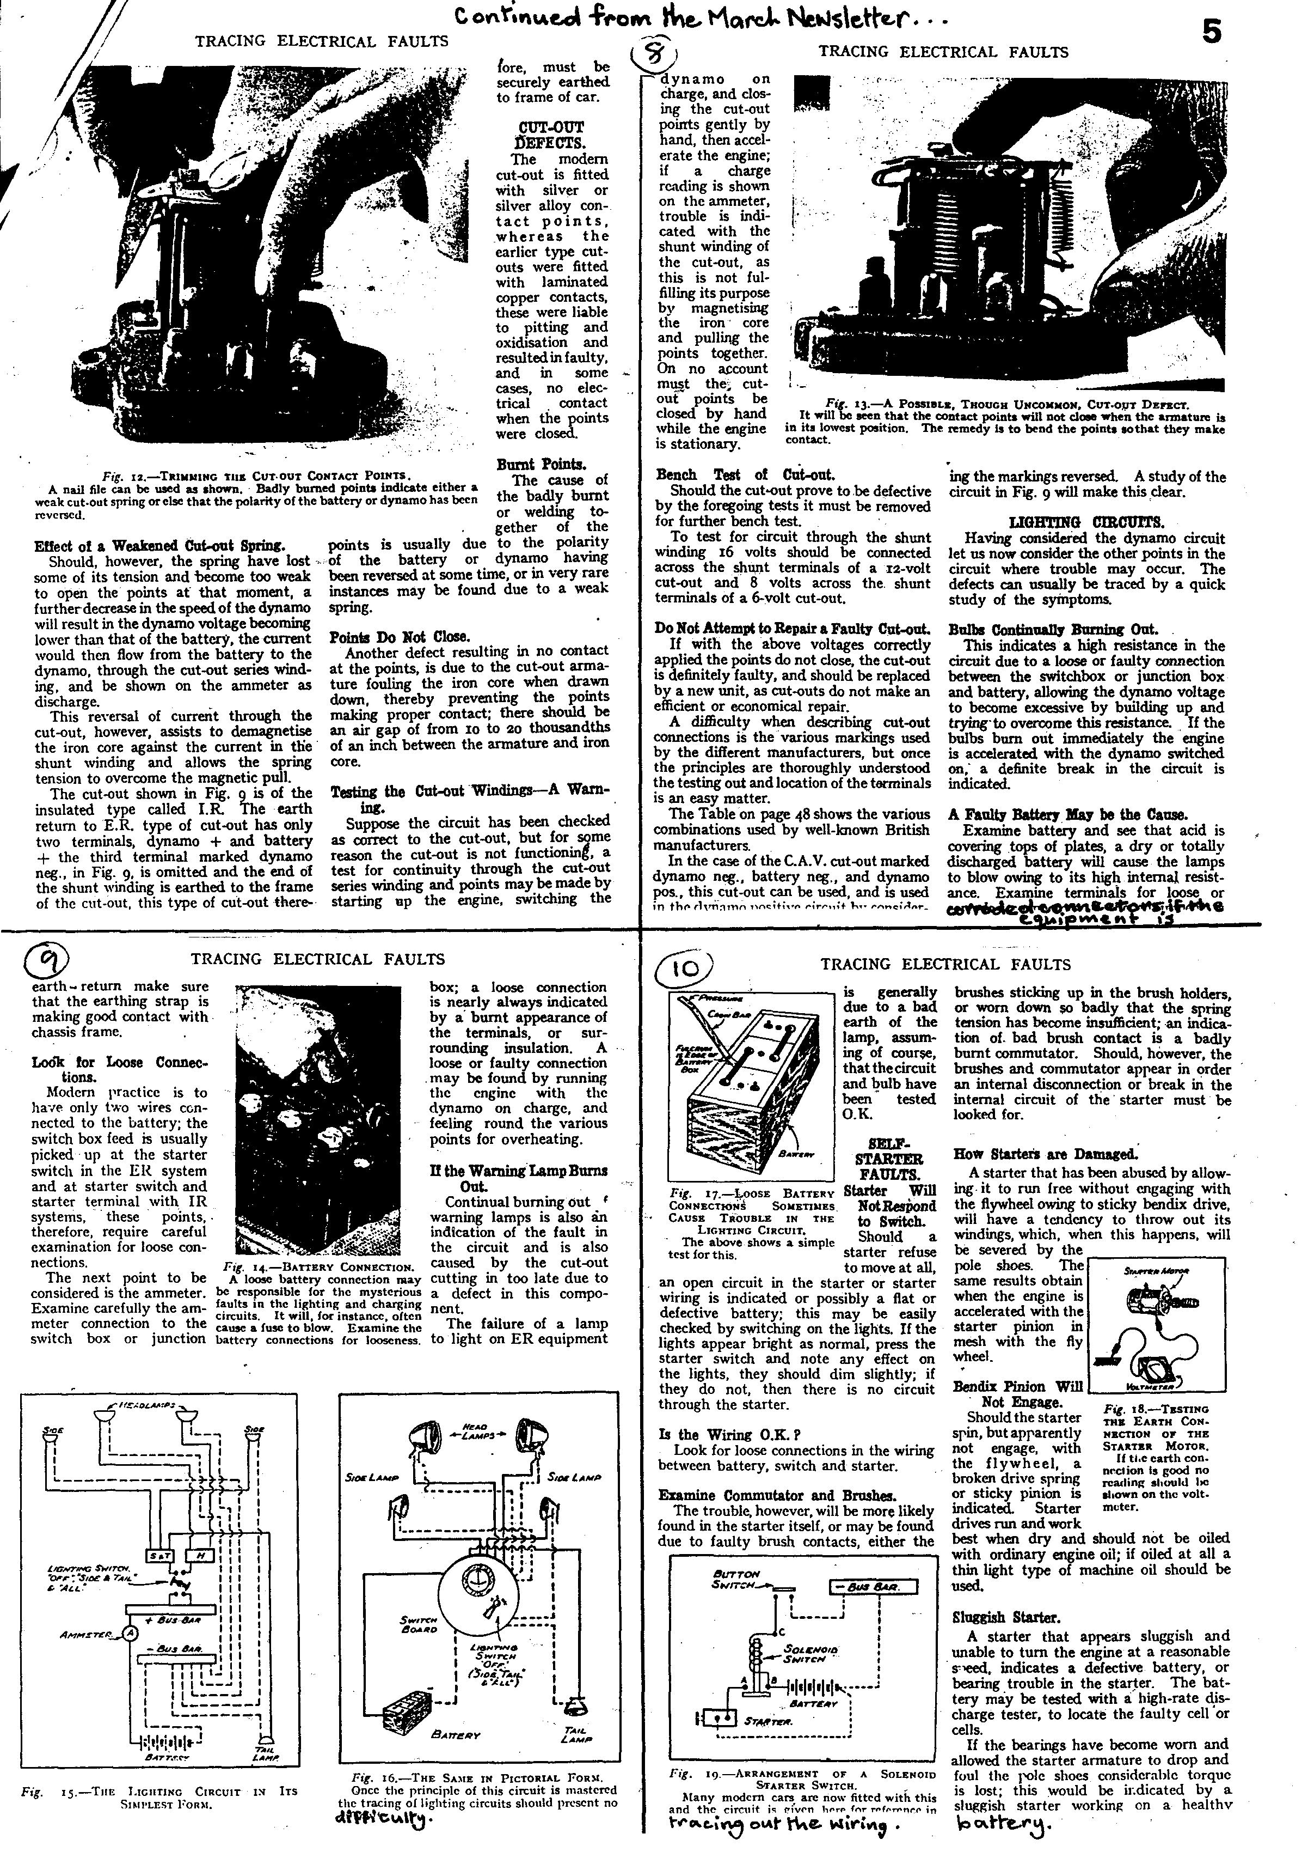

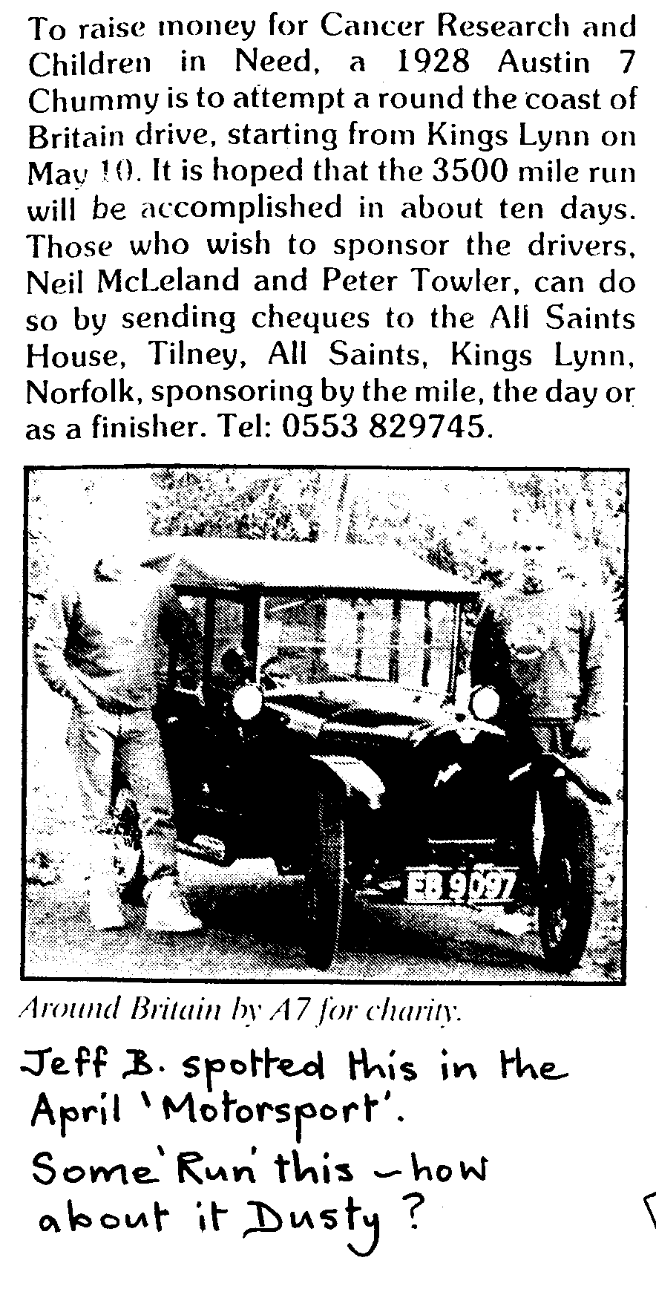

THANKS to those who brought along their photographs last Club Night - very interesting. We must do this again so that more people can see more photographs than they managed this time.

EVENTS
APRIL * Thursday 18th April. CLUB NIGHT Enforced change of arrangements See 'SPECIAL NOTICE' on front cover.

Thursday 25th April. COMMITTEE MEETING at the Tyrrells Ford. 8.30

Sunday 28th April. (A week later than usual.) CLUB RUN. 'Round and About' including guided walk in Old Poole and tea at Mike and Sue Topham's. Meet at Safeway Car Park, Wimborne. 10.30 for 10.45
MAY Thursday 2nd May. '9 to Late' (for those who want to meet for a natter) at the Langton Arms, Tarrant Monkton.

Thursday 16th May. CLUB NIGHT
SEE MAY NEWSLETTER
Sunday 26th May. CLUB RUN TO BLANDFORD CAMP FOR DA7C DRIVING TESTS. Details next month.

JULY Saturday 13th July. Provisional date for Club Barbecue. Additional Rallies etc.:
Sunday 21st April. Hants and Dorset 'Enthusiasts Day'. See within.
Saturday 11th May. 'Early 40s Day' at Interair Flight Centre, Matchams. "Dinner and free to drivers of old cars." Details Nick Place - 535116.
Saturday 27th June. WORTH MATRAVERS VILLAGE FETE. See within.

