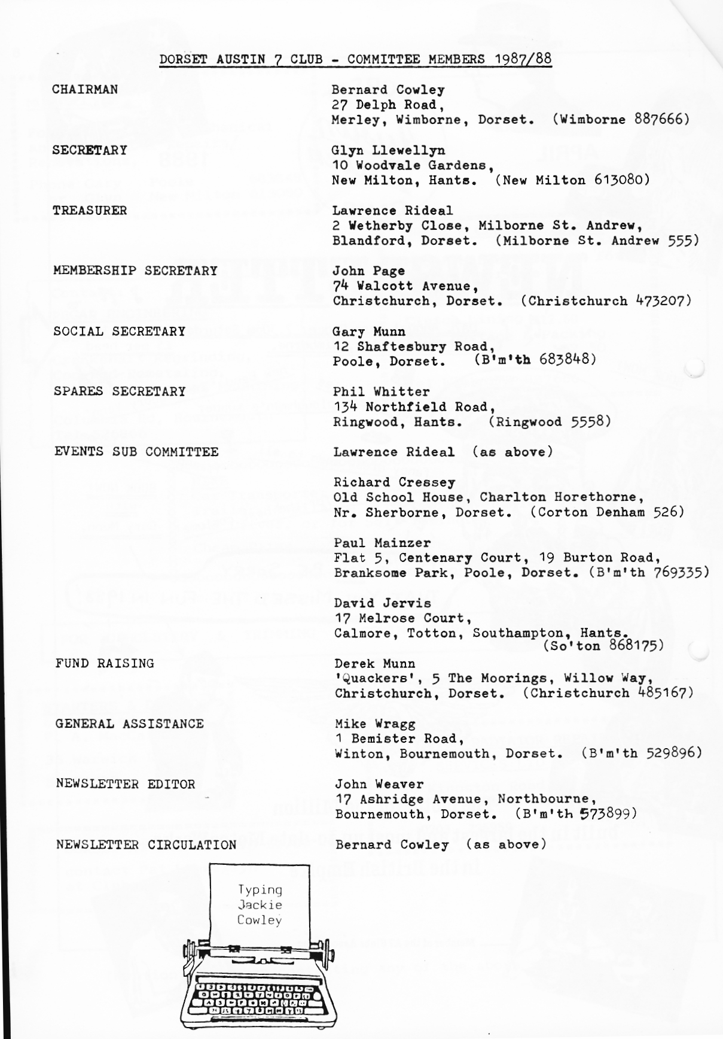
1
EDITORIAL APRIL 1988
This month's Editorial is something of a 'Stop Press' written after our safe return from the Easter Run to Bayeux. All ten A7s and their 27 occupants managed to keep going throughout, fueled either by 'essence' or various bottled 'liquides'. A full account will appear in the May Newsletter. However, just to prove that we were there a'Ouest France' newspaper item and photograph is reproduced this month.
This Newsletter also carries David Whetton's final instalment, so unless someone comes up with some hints or technical tips for May, we may be short of an item. We shall miss David's continuing saga.
Last month's article on the A7 racing cars prompted Bernie to ferret among his books and come up with one on 'The 200 Mile Race of the Junior Car Club, 1921 - 1938', by W.Boddy, from which is reproduced photographs of some of the A7s in the 1924 race and the line up for the start of the first race in 1921 - which in terms of motor racing is going back a bit. . F
Don't forget the Barn Dance. Should be a great evening'
-

John.
. _ ,
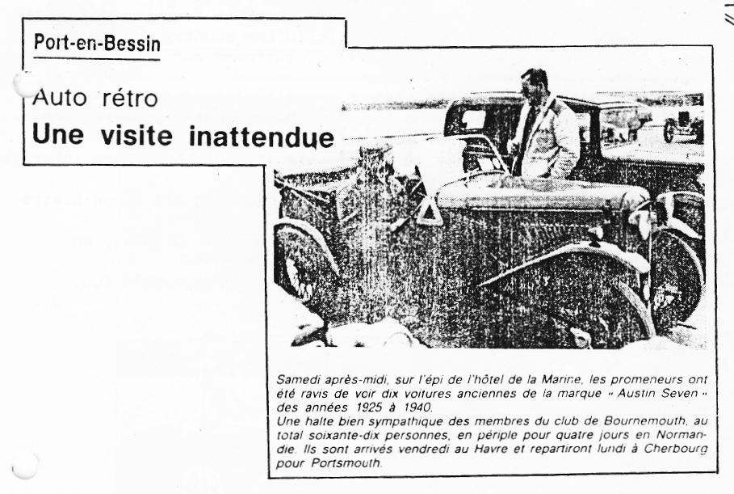
SECRETARIAL
Hi Gang. I had my renewal notice for the Austin 7s insurance from Richardson
Hosken Ltd. 'Direct Ins.⁾ and with a note stating that "with effect from renewal the Insurers have agreed to extend the pºlicy to include dismantled parts/spares without limit, subject to these items being kept in the insured's locked garage". Also it states "We have a unique agreement with Insurers whereby in the event of your vehicle being declared a total loss (uneconomical to repair⁾, the salvage of the vehicle would automatically become your property to retain or dispose of as you see fit. This Clause will apply only to vehicles manufactured on or before December 1965 and the relevant policy endorsement will be issued to the vehicle policy schedule when renewed". This at no extra premium to us; can't be bad.
The Opal is on the road at last, all be it with no side screens as yet, hut I have been promised that they will be ready in time for the French trip. The car attended its first Club function for three years on the March Club Run to the Royal Victoria Country Park, when the new hood got well and truly christened, as it threw it down all afternoon! But it was a good run in spite. (See Jo's account in this Newsletter).
As promised the Club ties are now available at E4.50 including VAT, in various colours with a gold Club motif. Ring Pat Llewellyn for details or see her on Club night. Well that's all from me for another month.
Glyn. `
THE ROYAL VICTORIA COUNTRY PARK RUN - Sunday 20th March

Glyn volunteered me to do the run report again this month so here goes!
Five Austin Sevens, my Morgan and a Citroen Dyane(!) met at the 'Cat & Fiddle' car park on the Sunday morning. We drove up to Totton and met Dave Jervis and Mary who had organised the run. They were being rather brave driving their Austin with the hood down!
We followed them through towns and villages such as Romsey, Ampfield and Owslebury, to name but a few. We stopped for lunch at the 'White Horse' at Droxford where we met Bernard and Jackie. The food was lovely and very good value for money. Paul almost managed to smoke us out by stoking up the open fire with rather too much enthusiasm!
After lunch we followed Dave through villages such as Curdridge and Borley, to the Royal Victoria Country Park at Netley, on the banks of the river Hamble, it was raining by-now and I mean raining!
The Country Park is situated in the grounds of the old Military Hospital. The Chapel, which was in the centre of the hospital, is the only part of the building which is still standing. It has now been renovated and turned into a Museum (it took two years to demolish the hospital).
Dave tells me that the hospital had a corridor running straight from one end to the other and this was renowned for being the longest corridor in the country, possibly the World. The chapel has a tower which now has a new central staircase and a viewing room at the top.
On our way back down the stairs, we looked through a small glass door at what may have been the original staircase. Glyn said, and I quote, "Maybe that's a secret underground passage". Dave said, "It could be if we were not still two storeys up!"
It was a great shame that the weather was so bad because it would have been interesting to walk round the grounds and see the war graves.
We all descended upon the Tea Shop later to recover from climbing all those stairs in the tower (in my case, anyway!)
The weather certainly didn't improve, to say it was torrential is probably an
understatement! We followed Dave back to Totton then made our way home.
Thanks to Dave and Mary for organising such an interesting and enjoyable run.
Jo.
THE MORGAN AND DA7C SKITTLES EVENING

I'd like to thank everyone who came to the Skittles evening between the DA7C and The Morgan Club. I hope that you all enjoyed it despite the slight delay in starting, due to the fact that the Manager had double-booked the Skittle Alley! I'm sure you will be pleased to know that he gave us half our money back and apologised profusely for any inconvenience caused. Thanks again for supporting us.
Jo.
Thanks also to Jo for fixing the match which I'm sure was enjoyed by one and all. Ed.
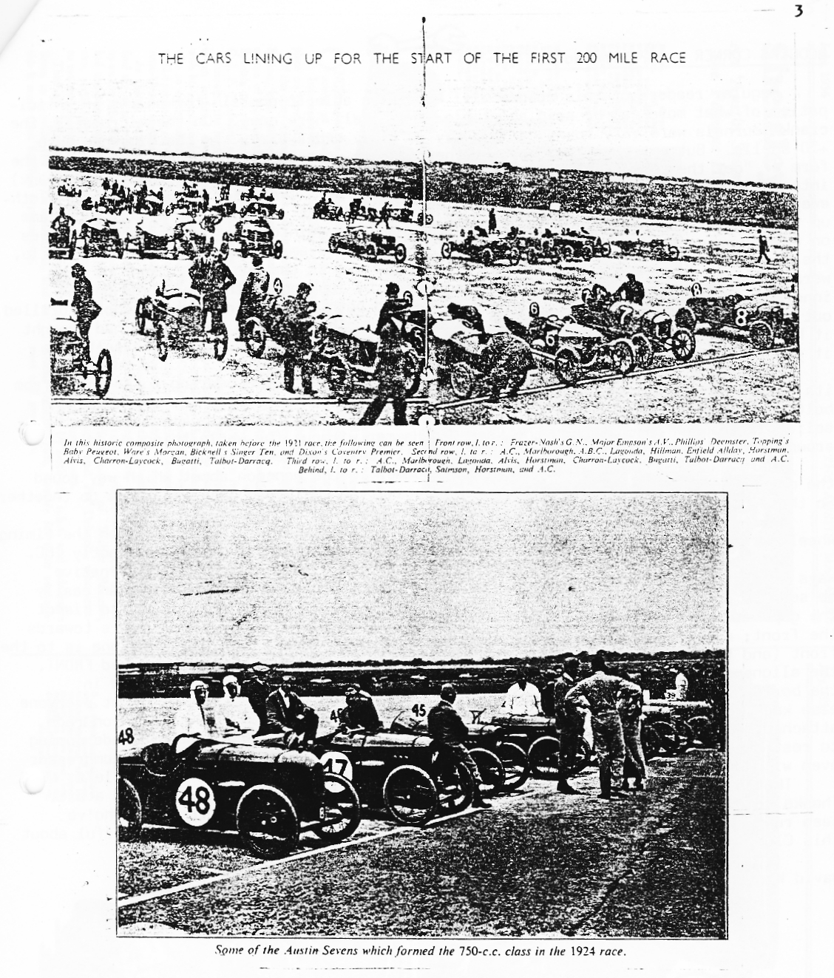
Twelve Years' Service and No Spares Required.
A REMARKABLE tribute to the durability of the British baby car has been received by the Austin
Company in the form of a letter from a Mr. Openshaw,of Bristol, who purchased an Austin Seven in 1924, nearly twelve years ago. The communication in question states :¬
"On April 25th, 1934, your firm received from me the sum of 30/- for fan fittings for my Austin Seven.
"Through cancellation of the order for the fittings, the 30/- was credited to me for any emergency which might arise during my ownership of the car.
"I sold the car on Nov. 30th, 1935, after eleven years perfect service-truly a wonderful investment.
"At your convenience will you kindly look up this matter and refund the 30/- ?"
We are informed that the Austin Motor Company has complied with its customer's request.

4

BODGERS CORNER - Is There No End?

Regular readers of this column will hardly be able to contain themselves in anticipation of what more can be said about big ends. Well here goes. On the micrometer, the crank journals were very round and exactly 30 thou. under-size. In the big ends were +30 shells. But put them together and the con-rods were SOLID. Most advice came in the form of "get the thing re-ground" and the Green Bible recommends "slinging it (the crank) into the night since they can easily be found for 2/6"! I started to gently emery-cloth away a test shell in case there was a high point and that was when the human touch came up trumps over any machine. There was a shelf at the join of the top and bottom halves on which you could put two gin and tonics. On closer examination, after the two G&Ts, the bottom of the big end wasn't even the same colour as the top half. None of them were matching pairs at all - more easily spotted by looking at the bevelling on the inner edge. Apparently, they are made as one and both the bearing and bolt holes drilled out in situ in order to give a perfect alignment. The previous owner (MT) had thought it had been "thrown together" and he was right. So the moral is, if you haven't done it yourself - take nothing for granted.
When faced with the problem of trying to get the rear main bearing outer shell from its housing, I found that by turning it over, on top of its hole in the crankcase and bolting it down the wrong way round, i.e.. sticking out rather than sticking in, I had a solid platform on which to use the Very Big Hammer without the whole thing skidding around and a handy hole through which the shell could emerge gracefully.
There was an argument at Beaulieu last summer in the monsoon about which way round the matched pair of front bearings go. The answer is the broad machined faces go together So that's been solved, but I can't remember who was right.
Another discovery, that I hadn't appreciated from the books, was that when the timing wheels are meshed together with those little circles in line, that is also exactly TDC.
More on big ends: On three bearing engines the con rods have to go alternative
ways so that the shoulders miss the cam lobes. When the block is off, this can easily be seen by peering down into the crankcase from the top. The shoulders have to bisect the gap between the cam lobes and the order will always be: number 1, shoulders towards the front; number two, shoulders towards the rear and so on. i.e.. the front one is to the front (and the rear one will be to the rear!) and, since the pistons are marked FRONT, the alignment doesn't have to be done in situ, the pistons just being rotated in the bores prior to replacing the block. On this matter, I have discovered what everyone else knew, namely that pistons can be fitted into the block from below, with con rods attached, and the whole thing lowered down onto the crankcase, with the big ends coming to rest on their journals. I was surprised to find that I didn't need a ring compressor even with new rings, although I now only have nine and three quarters fingers left.
That's it. Now it's someone else's turn to keep Bodgers Corner going for a bit. Thanks to everyone who has offered invaluable advice and especially to those who've
been rung up in the dead of night with a cry of HELP! But that's what's wonderful about this Club - they all use the same swearword.

David Whetton
REMINDER (YET AGAIN!) Please use your mirror constantly on Club Runs to keep the car behind in view. If he stops you must stop - then all will stop to discover the proem.

It is especially vital to ensure that the car behind is in view if the Run takes a left or right turn. If in doubt WAIT JUST BEYOND THE TURN until the following car appears and you are sure that you have been seen.

Properly followed these simple rules will ensure that nobody gets lost or left behind. Think of the man behind.
Shelsley Walsh
An `Austin Seven' Day on
the Famous Hill Climb
A Closet
(Right)
Ascent. All the Sevens were driven precision and
assurance. Here ^{C.}
L. Goodacre is seen
w the most ^{difficult}
bend where the driver's skill W
paramount factor making a quick ascent
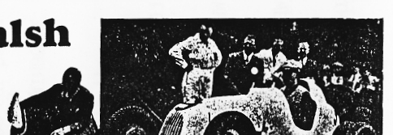
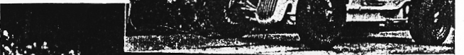

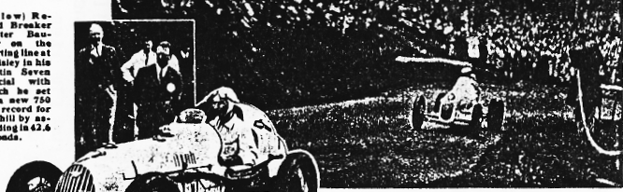

(! e
cord
W.11
mer
"at
Shelsley
A_{u}s_{t}in

which

cc. the oar
seconds
(Above) On the Starting Line. C,L.Goodacre _{in} the over

head •valve
Austin Seven
Speclal with
.hi h he _{_.d.}

the _{fas}test
time In the
- econd run et Shelsley Walsh
ONCE more the Austin Seven dominated the scene at Shelsley Walsh in the famous International Open Hill Climb which took place on June 6th.
Of the sixty or more entries, seven were Austin Sevens, and public interest was stimulated by reason of the fact that three of them were o.h.v. Specials in the able hands of L. P. Driscoll, G J. P. Dodson, and C. L. Goodacre.
Amongst the larger cars there was the prospect of an exciting duel between Raymond Mays, with his record-holding E.R.A., and Hans Stuck, who so spectacularly lowered the record in 1930 to 42.4 seconds, on this occasion driving a 200 h.p. Auto-Unlon instead of an Austro,-Daimler.
As things turned out, the weather had the final say as to what performances would be put up on the hill. Rain started before all the entrants had completed their first climb, and the larger an, particularly the Auto-Union, were unable to use their power to full advantage.
Thus the huge crowd turned to the Austin Seven to provide the day's sensations, and in this It more than fulfilled expectations.
On its first run the aide-valve Austin in the hands of . Walter Boomer, the famous German driver, clocked 42.6 seconds, to set up a new 750 c.c. record for the hill and share with A. F. P. Fane (Fraser Nash) the honour of putting -up the second best performance of the meeting.
Charlie Goodacre, driving an o.h.v. Seven, recorded the next best time, namely 43.2 seconds, followed first by A. N. L. Maclachlan (Austin Seven) with 44.4 seconds, and then by C. J. P. Dodson (o.h.v. Seven), who took 44.6 seconds.
The effect of rain in reducing the speed of the contestants, mainly it appears as a result of wheel spin when starting, is clearly shown by the times recorded for their second climbs.
Charlie Goodacre, who with his o.h.v. Seven made the quickest ascent on the second run, required an extra 4 seconds.
Altogether the Austins gave an excellent account of themselves, and fully deserved the Fray Team Trophy, which was won by the combined performances of Walter Baumer, Charlie Goodacre and Pat Driscoll, who constituted the Austin team.
The ascents by both the o.h.v. and side-valve Sevens were, 1- fact, notable for their smooth-ness
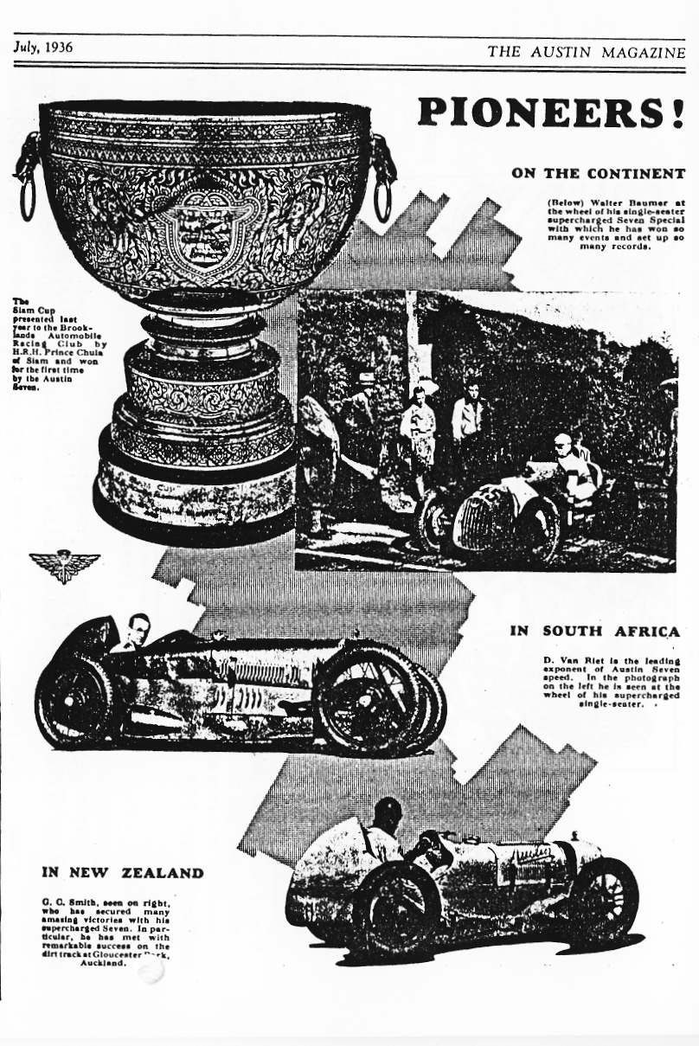
6
ODE TO AN A7

(From the DA7C Newsletter of December 1981 - originator unknown.)

The Seven is my auto, I shall not want ... another It maketh me to lie down in wet places, It annointeth my face with oil, For its sump runneth over. Its rods and its engine discomfort me, It leadeth me into the path of ridicule
for its name's sake.
Yea, though I run down the valleys
I am towed up the hills, • Surely to goodness the darn thing,
Won't follow me all the days of my life,
Or I shall dwell in the house of the insane
for ever.
LOOK OUT FOR Alan Seymour and Miles Shepherd who recently introduced themselves at a Club Meeting.

WHAT ABOUT Jill's change of 'air? Not leading to a change of personality, we hope!

WE HEAR THAT the Chairman is to part company with the Stag. Too 'Yuppie' Bernie?

THAT WAS A SPECTACULAR.. .hammer job on George's front axle in Honfleur. Not only the locals were impressed.
FOR SALE One pair of anti sea-sickness wrist bands. Rather heavily stained, but best offer over 5p secures. Apply Lawrence Rideal
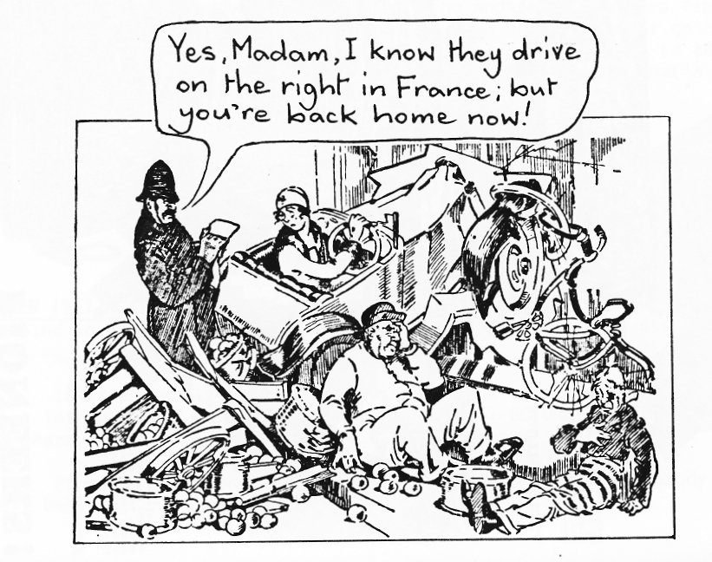
7
EVENTS

APRIL Thursday 21st April - Club Night at the Elm Tree 8.00 pm. A talk on Victorian bicycles by Roger Street.

Sunday 24th April - Club Run to Yeovilton Fleet Air Arm Museum. Meet
at Wimborne Square at 9.45 for 10 am OR at The Old Mill, Sturminster Newton at 11 am.

Thursday 28th April - Committee Meeting at the Tyrrels Ford at 8.30 pm. MAY Thursday 5th May - '8 to Late' The Inn on the Furlong, Ringwood car park.

Saturday 7th May - ANNUAL CLUB BARN DANCE, THE ALLENDALE CENTRE, WIMBORNE 7.30 PM

Thursday 19th May - Club Night. First Evening Run of the year to the Cross Keys, Mannington - Meet at the Elm Tree at 8.00 pm.

Sunday 22nd May - Club Run to The American Museum, Claverton, nr Bath. , Thursday 26th May - Committee Meeting at the Tyrrels Ford at 8.30 pm. WIDER EVENTS

Sunday 12th June - Severn Sevens Group Rally at Altringham Park. Camping available. Details George and Joy Mooney - who will be there.

Sat/Sun 6th/7th August - Alderholt Rally. Entries by 31st May. Forms available from Brian Welden, 30 Manor Road, Christchurch. SF 407

Sat/Sun 13th//14th August - Yeovil Festival of Transport. Closing date 2nd July. Camping available. (This is a big rally). Details George and Joy Mooney.

Sunday 18th September - The RNLI/Olds Motor Group Vintage and Classic Car Rally. Details from Mrs M Paddock, 'Clearstream', Valley Road, Tarrant Keyneston, Blandford DT11 9JE.
Saturday 25th June - Charlton Horethorne Feast Day. Once again we have been asked to arrange a display of vintage and classic cars for our village fete, since many people expressed their pleasure in seeing last year's display. The cars will again be parked on the garage forecourt. Our fete will be opened at 2 pm by Jill Archer (Patricia Greene) of Radio 4's "The Archers" and will include a flower festival in the Church, art and craft exhibitions, cabinet maker's workshop, car boot sale, stalls and sideshows (including "Guess the number of balloons in an A7"). Refreshments will be available and the pub will be open throughout the afternoon (sorry - no Whitbread!) We would be very pleased to see any Dorset A7 Club members on the day and if you would like to come along, perhaps you could let one of us know (tel. 096322526). Last year the Club members who did come found it convenient to stop for lunch at the Queen's Head, Milborne Port, where good food and excellent draught beer is available (no, we're not related to the Landlord!).
Richard & Margaret Cressey
